THE PHYSICAL PROCESSES ACTIVE IN TROPOCAL CYCLONE WAVE GENERATION

Ian Young, University of Melbourne, ian.young@unimelb.edu.au
Ali Tamizi. University of Melbourne, atamizi@student.unimelb.edu.au

INTRODUCTION
In tropical and subtropical regions tropical cyclones represent the major extreme meteorological events, generating winds in excess of 40m/s and significant wave heights above 10m. Such systems are characterized by a well-formed translating vortex wind field with a calm eye and winds that spiral in toward the center of the storm. Despite the apparent complexity of the forcing wind field, observations of waves in tropical cyclones show that there are many similarities to waves generated in relatively simple cases with approximately constant unidirectional winds (Tamizi and Young 2020. It has often been speculated (Tamizi and Young 2020) that this is because nonlinear wave–wave interactions play a dominate role in defining the tropical cyclone directional wave spectrum and hence the significant wave height, as they do for more simple wave generation cases. Despite this speculation and the many observational studies of tropical cyclone wave spectra, no study has yet been able to demonstrate the role of nonlinear wave–wave interactions in tropical cyclones.

This paper aims to address this issue by firstly summarizing the observational database from buoys, and remote sensing systems. A third generation spectral wave model is then used to model typical tropical cyclones and the role played by each of wind input, dissipation and nonlinear interactions is investigated in detail.

OBSERVATIONAL DATASET
This paper will firstly present an extensive observational database obtained from both satellite altimeters and buoys. This combined dataset consists of 36,509 altimeter overpasses of 2,730 tropical cyclones and 2,902 buoy time series recorded during the passage of 353 tropical cyclones (Tamizi and Young, 2020). This dataset covers a broad range of tropical cyclone wind field parameters and shows a consistent picture of the tropical cyclone wave field.

The wave field is asymmetric with the largest waves to the right (northern hemisphere) of the tropical cyclone centre. Waves ahead of the storm tend to radiate out from the intense wind regions of the storm and consist of a mix of remotely generated components and local windsea. Throughout the wave field, directionally skewed spectra dominate, consisting of long period components generated in the intense winds region of the storm and local windseas. However, in almost all cases these different wave components do not become decoupled. There is a continuum of energy from low frequency components to windsea. Also, the integrated one-dimensional forms of these spectra are almost always unimodal and very similar to fetch-limited spectra.

The paper will also review the data from Scanning Radar Altimeter observations (Hwang and Walsh, 2016), which have previously been reported as showing bi or tri-modal spectra. The comparison of these data will be shown to be consistent with the description above.

TROPICAL CYCLONE MODELLING
To investigate the physical processes which control this observed wave generation, we run an implementation of the third generation Wavewatch III (WW3) model. The model shows considerable skill in reproducing the observed tropical cyclone wave fields and the directionally skewed spectra. Examination of the source term balance shows that, although much of the wave field consists of waves which are not locally generated and are receiving no (or very little) local input from the wind, the nonlinear terms continue to couple the remotely generated waves and the local windsea. The cascade of energy from windsea to swell is shown in Fig. 1. The analysis shows that the nonlinear terms play a dominant role in shaping tropical cyclone wave spectra, thus conforming the previous speculation.
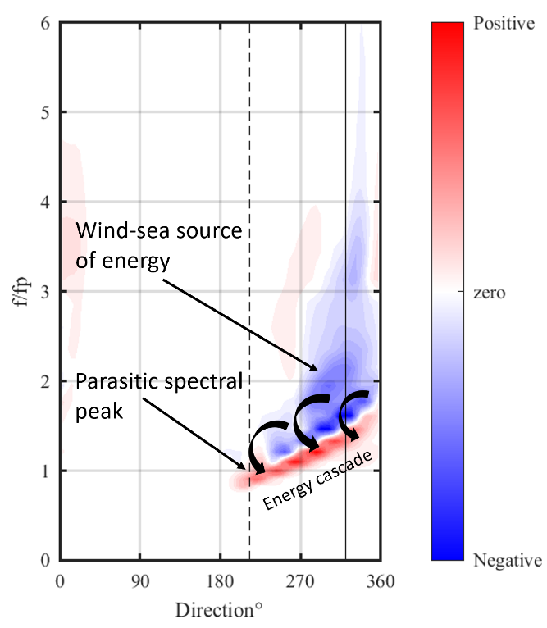
Fig. 1 The nonlinear source term showing the energy cascade from windsea to remotely generated waves in a tropical cyclone.

REFERENCES
Tamizi and Young (2020): The spatial distribution of ocean waves in tropical cyclones, Jnl. Phys. Oceanogr., 50, 2123-2139.

Hwang and (2016): Azimuthal and radial variation of
wind-generated surface waves inside tropical cyclones.
J. Phys. Oceanogr., 46, 2605–2621.

