TRANSITION OF TSUNAMI-LIKE LONG WAVES FROM A BASIN INTO A CHANNEL WITH OUTFLOW JET

Samuel Salemink-Harry, Oregon State University, harrys@oregonstate.edu
Harry Yeh, Oregon State University, harry@oregonstate.edu

INTRODUCTION
Intrusion into rivers is an important aspect of the tsunami hazard. Tsunamis change their waveform and amplitude when they pass through a river mouth, and tend to increase the mean water level for a long duration of time once they have intruded the river (Tolkova et al., 2015). Understanding the ocean-to-river transition of a tsunami is crucial for predicting tsunami effects upstream, although the transition processes are complicated by a variety of factors such as bathymetry, river discharge, vegetation, and man-made structures like jetties and seawalls. To identify key fundamental mechanisms for the tsunami intrusion into rivers, we conduct laboratory experiments of tsunami-like long waves transitioning from a wide basin (ocean) into a narrow channel (river).

EXPERIMENTAL SETUP
Experiments are performed in a wave tank that is 7.3 m long, 3.6 m wide, and 0.30 m deep (figure 1). The tank is subdivided with vertical walls into a channel and a basin. An idealized configuration of the wave tank is chosen for exploration of the physical mechanisms: the shoreline is modeled as a reflective vertical wall, and the river and ocean are modeled as a flat-bottom rectangular channel and a basin. A unique flow-recirculating system is developed to achieve a steady flow field in the basin and the channel. The flow is introduced to the channel by controlling discharges from five independently regulated conduits in order to achieve a uniform flow in the channel that leads to a steady and stable jet into the basin. The Froude number in the channel is 0.094 on the order of natural river tidal outflows. The flow exits the basin near the wave paddles through porous sidewalls then returns to the flow generating apparatus. The outflowing jet is measured using the particle image velocimetry method. Solitary waves are generated by the wavemaker placed at the offshore end; detailed spatiotemporal water-surface profiles are collected using the laser induced fluorescence technique (figure 2).

RESULTS
Our laboratory results demonstrate that refraction of the incident wave drives wave energy towards the center of the out-flowing jet increasing amplitude near the jet and reducing the amplitude in the flank away from the jet. We identify three transition zones: a) rapid wave amplification at the channel mouth that is caused by wave diffraction from the adjacent reflective wall, b) wave transformation in the channel due to a laterally nonuniform intruding wave form, and c) wave propagation upstream with gradual attenuation by friction. The experiments reveal that the incident wave amplifies as well increases its duration and length when it enters the channel. The amplification is greater when the flow discharge is present as in figure 2. The maximum wave amplification occurs during the transition into the channel. For the no flow case, the maximum amplitude occurs outside of the channel mouth, whereas it occurs inside the channel for the flow case. The foregoing behavior can be explained by the difference in wave amplitude between the waves transmitted into the channel and reflected at the vertical shoreline wall which causes wave energy to diffract towards the channel. Consequently, the wave energy transmission into the channel increases. A solitary wave with the smaller amplitude has the longer wavelength, therefore the increase in water-surface elevation starts further offshore than the case of larger amplitude. We found that the maximum relative amplification in the channel is a function of the incident solitary wave length relative to the channel breadth: the longer waves have the greater amplification. The limiting conditions would be minimal amplification when the wave is much shorter than the breadth, while amplitude should approach the condition of the perfect reflection when the wave is extremely long. These findings are important for tsunami-like long-wave intrusion where the wave length scale is comparable or greater than the breadth of the river mouth.

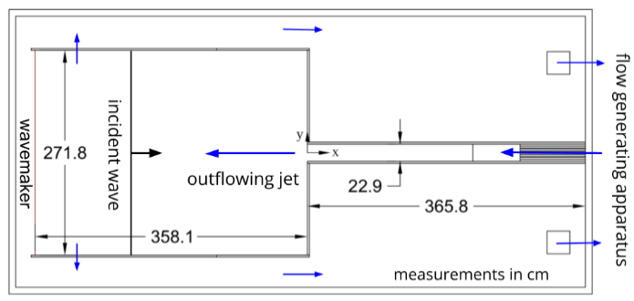
Figure 1 – Experimental setup. A uniform flow is introduced to the channel and is recirculated to maintain a quasi-steady flow field and constant water depth.

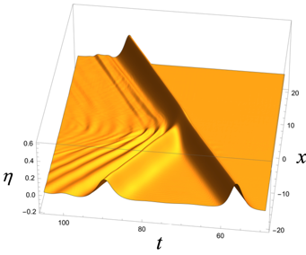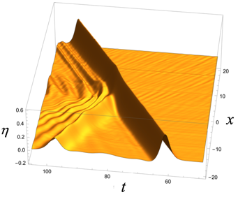
Figure 2 - Spatiotemporal water-surface profiles along the centerline of the channel and the jet (y = 0). The channel mouth is at x = 0. Shown left: no-flow case; right: flow case.

REFERENCES
Tolkova, Tanaka, and Roh (2015): Tsunami observations in rivers from a perspective of tsunami interaction with tide and riverine flow. Pure and Applied Geophysics, 172(3), 953-968.

