**One day ahead wave predictions using a hybrid algorithm of long-short term memory and neural network for marine constructions**

Sooyoul Kim, Kumamoto University, [sooyoulkim@kumamoto-u.ac.jp](mailto:sooyoulkim@kumamoto-u.ac.jp)

Masahide Takeda, Toa Corporation, [m_takeda@toa-const.co.jp](mailto:m_takeda@toa-const.co.jp)

Chisato Hara, Toa Corporation, [c_hara@toa-const.co.jp](mailto:c_hara@toa-const.co.jp)

Hajime mase, Kyoto University, [mase.hajime.q37@kyoto-u.jp](mailto:mase.hajime.q37@kyoto-u.jp)

INTRODUCTION

Recently, marine construction work has increased under complex and strict conditions for large-scale marine sites and facilities. Accurate wave information at the work site is critical to conducting the marine construction safely. In particular, making decisions for the execution of the operation need a significant wave height ranging from 0.5 to 1.0 m as a threshold. However, studies on highly accurate real-time wave height predictions around the threshold are few. The present study developed a hybrid algorithm for real-time wave prediction by combining long-short term memory (LSTM) and artificial neural network (ANN) for the Hitachinaka Port, Japan.

METHOD AND EXPERIMENT

A hybrid machine learning algorithm composed of LSTM and ANN was developed with 24 hrs-ahead global wave forecasts (JMA GWM and NOAA WW3) and its corresponding observations (NOWPHAS) to predict 24 hrs-ahead nearshore significant wave heights at the Hitachinaka Port. First, the LSTM-based wave prediction model was developed with the 24 hrs-ahead global wave forecasts by JMA GWM and NOAA WW3 for input data and nearshore wave data operated by the Nationwide Ocean Wave information network Ports and HArbourS (NOWPHAS) for output data. The LSTM is specialized in time-series predictions with three layers of input, hidden, and output. In particular, the hidden layer has characteristics of training information by memorizing and being oblivious.

Secondly, among the LSTM network-predicted wave heights, the predicted and observed wave heights below 2 m are extracted and used for training the ANN-based wave prediction model to improve the prediction accuracy and preciseness.

To determine the best LSTM-based wave prediction model, we optimized parameters of the epoch number, batch size, length, and dropout over three combinations of input data, JMA GWM and NOAA WW3, JMA GWM, and NOAA WW3, for instance. Once the parameters are optimized, the numbers of units (10 to 2000) and layers (1 to 8) are optimized. The 513 daily wave data from 20th May 2019 to 30th January 2020 were collected for training, while the 118 wave data from 3rd March to 30th April 2020 were tested.

The best ANN-based model was optimized through the numbers of units (10 to 200) and layers (1 to 3) with early stopping, maximum epoch (10000), and minimum gradient (0.000001). A model was trained 20 times over each combination of the unit and layer. The wave heights below 2 m were separated by 70 %, 15 %, and 15 % for training, validating, and testing, respectively.

DISCUSSION

The optimized parameters for the best LSTM model are listed in Table 1, and a wave time series tested by the best LSTM model is shown in Fig. 1. As a result, the correlation coefficient (CC) and root mean square error (RMSE) are 0.9 and 0.379 m (17.59%), respectively. The accuracy of the best ANN model trained by the wave heights predicted by the LSTM model was 0.94 and 0.14 m (13 %) for CC and RMSE, respectively (Fig. 2 and Table 2). Its improvement is significant compared to the 0.81 and 0.33 m for CC and RMSE for the wave heights below 2 m tested by the best LSTM model.

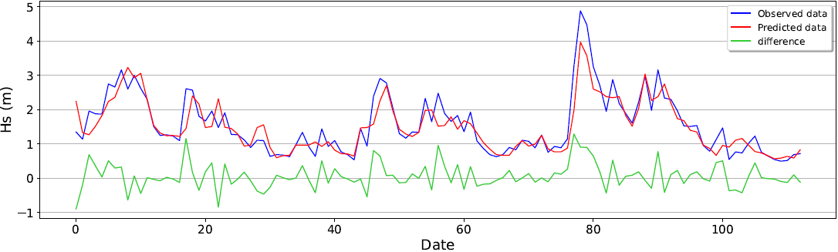

Figure 1 Comparisons of waves between the observations and LSTM model at the Hitachinaka Port



Figure 2 Comparisons of waves below 2 m between the observations and ANN model at the Hitachinaka Port

Table 1 Comparisons of wave accuracies predicted by the best models

|  |  |  |  |
| --- | --- | --- | --- |
|  |  | LSTM | ANN |
| Predicted wave height below 2m | RMSE (%) | 17.7 | 0.13 |
| RMSE(m) | 0.332 | 0.14 |
| CC | 0.81 | 0.94 |
| Predicted wave height | RMSE (%) | 17.59 |  |
| RMSE(m) | 0.379 |  |
| CC | 0.9 |  |