NOWCASTING INFRAGRAVITY WAVE HEIGHT WITHIN A HARBOUR USING AN ARTIFICIAL NEURAL NETWORK

Williams Benjamin, University of Western Australia, ben.williams@uwa.edu.au

INTRODUCTION
Infragravity (IG) waves, sometimes known as “long waves” “low frequency waves” or “subharmonic gravity waves” are waves that are forced in deeper water through subharmonic interactions of sea and swell wave components. These waves are typically quite small (a few centimetres to decimetres) but can excite harbour seiching and amplification due to resonance. This can cause vessels to surge and sway at their berth, straining mooring lines and making loading and unloading difficult.

‘NOWCASTING’ IG WAVE HEIGHT
This paper describes the design, training and application of a Bayesian regularized Artificial Neural Network (ANN) to accurately predict (“nowcast”) IG wave height outside and inside Port Kembla from deep-water swell wave spectral characteristics measured at Port Kembla Waverider Buoy (PKWRB), NSW coast (Williams, 2019).

Figure 1 (upper panel) shows the locations of the deep-water Waverider Buoy, ADCP pressure transducer and RBRsolo instruments inside the harbour used in the analysis. Approximately 7 years of IG wave observations at the ADCP unit and 1 year of IG observations at the RBRsolo pressure transducers were used to construct, train, and validate the ANN over a range of metocean conditions.

BAYESIAN NETWORK ARCHITECTURE
A trial-and-error approach to designing and training the ANN found best predictive performance when deep-water swell wave height, period, wave direction, and information about the strength of the wave grouping (the ‘wave groupiness parameter’, determined from the swell spectral bandwidth) were included in the Bayesian network. This contrasts with other studies that tend to consider the infragravity wave height a function of only swell wave height and period.

Figure 2 shows preliminary comparison of the trained nowcast ANN against validation data for an example location immediately outside of Port Kembla (ADCP-1). The IG wave height is reproduced with a skill score of 0.94 and a Root Mean Square Error (RMSE) of ±1cm. A similar level of accuracy was found for select berths within the Inner and Outer Harbour.

DISCUSSION
The results of the ANN training process and nowcast accuracy will be discussed in the context of a comprehensive field campaign observing infragravity and far-infragravity induced seiching and resonance within the Inner and Outer Harbour of Port Kembla during swell and atmospheric events.
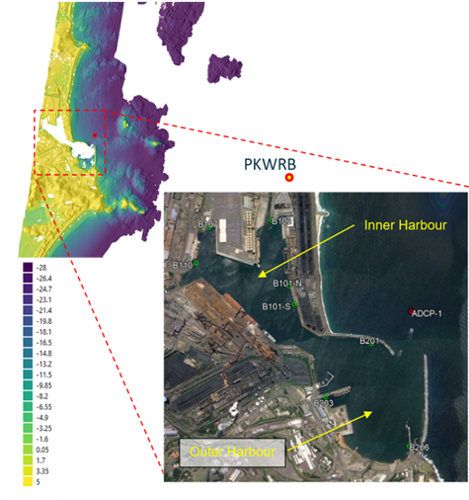
Figure 1 – Upper panel: Bathymetry (m AHD) of Port Kembla and surrounding coastline, showing location of Port Kembla Waverider Buoy (PKWRB) and ADCP unit (ADCP-1) measuring infragravity wave characteristics outside harbour entrance. Lower panel: Positions of RBR solo pressure transducers measuring infragravity wave activity within Inner and Outer Harbours of Port Kembla.

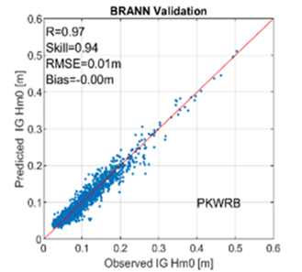
Figure 2 – Comparison of measured and predicted (‘nowcast’) IG wave height at ADCP-1 using the Bayesian Regulated Artificial Network.

REFERENCES
Williams (2019): Predicting Infragravity Wave Height in Harbours using Artificial Intelligence. Proceedings of the 2019 Coasts and Ports Conference, Hobart, Tasmania.

