Environmental contour establishment based on openly available EMODnet wave and wind data following Heffernan and Tawn methodologies.

Joachim S. Bach, Foreseas ApS., Joachim.bach@fore-seas.com

Introduction
In this paper, I present methodologies and routines for inference of environmental contours based on openly available data from the European EMODnet service, specifically wind and wave timeseries from oil platform 6200146. The theoretical basis is outlined in (Hans Fabricius Hansen, 2020), and (Janet E. heffernan, 2004), forming the basis for this paper.

The conditional marginal distribution models, known as environmental contours, is established based on measured wind and wave heights, at platform 6200146 located in the North Sea. The data is provided through the openly available data platform, EMODnet.

The environmental contour model is established by fitting univariate distributions to each data-series independently, whereafter an extremal dependence structure is established following methodologies outlined in (Janet E. heffernan, 2004).

Theory
Marginal distribution models for estimating extreme weather conditions are outlined through the Fischer-Tippet-Gnedenko theorem, stating that independently occurring, ordered marginal variates asymptotically approach the generalized extreme value distribution. See eq. (1)

 | $$P\left(x;μ, ξ,ψ\right)=exp\left\{-{\left(1+ξ\frac{x-μ}{ψ}\right)}^{-\frac{1}{ξ}}\right\} , ψ>0$$ | (1)

Where µ is the location parameter, ψ is the scale parameter >0 and ξ is the shape parameter. Size of the shape parameter determines which type of extremal distribution, (Fréchet, Gumbel or Weibull) the tail behavior converges towards. Inference of the empirical extreme value distributions are based on least squares fitting from extremes extracted utilizing annual max series. Ranking the extreme values are performed utilizing the approximate unbiased estimator called the Gringorten plotting position, (Gringorten, 1963), see eq. (2).

 | $$\frac{r-0.44}{n+0.12}$$ | (2)

For this paper, inference on wave and wind time-series are assumed to follow the type-1, marginal Gumbel distribution. The Gumbel distribution is unconstrained maximally, which physically is inconsistent with wind speeds occurring on the planet.

The environmental contour is established from the measured data-series through Gumbel space transformations and dependence hierarchies. After establishment, the inverse transformation is utilized to construct environmental contours of return period levels, Tr = {5, 10, 50, 100} years for combinations of wind and wave events.

The covariates existing from the inferred variables of wind and wave, are acknowledged to exist, but are not considered in the present paper.

For return period values above 100 years, the underlying time-series is insufficient in providing reliable estimates. As a remedy, the Markov-Chain Monte-Carlo sampling techniques can be utilized to sample from the inferred variable space.

Data
As an example, time series utilized for this study, measured timeseries of H_{1/3}, and horizontal wind speed is utilized. The data have been quality controlled internally and is generally available on the EMODnet website for download.

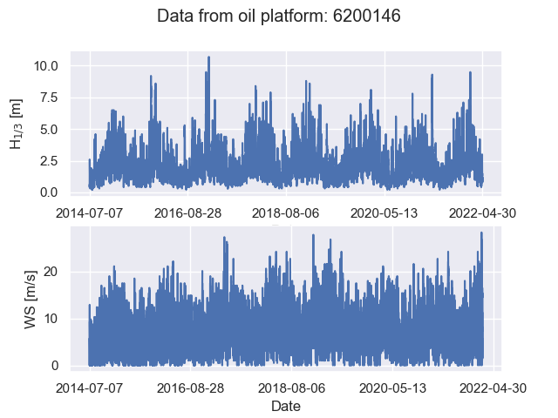
Figure 1 –top: timeseries data of H_{1/3} in [m]
bottom: Horizontal mean wind speed [m/s]

Utilizing annual max extraction techniques for peak detection on the above time-series, the peaks are then ranked and a type 1, Gumbel, unconstrained, extreme value distribution is fitted to ranked variates utilizing least-squares methodologies. The shape and scale parameters are outlined in Table 1 and resulting fits with ranked variates are displayed in figures 2-3.

Table 1 - Fitted parameters for the Gumbel type 1 extreme value distribution
Variate | ξ | ψ
H_{1/3} [m] | 8.23 | 1.10
WS [m/s] | 23.43 | 2.85
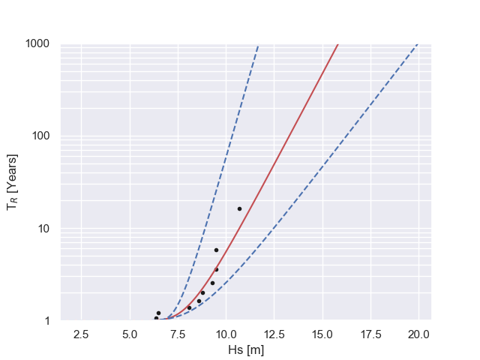
Figure 2 - Least-squares fitting of type 1 Gumbel extreme value distribution with 10.000 bootstrap, 95% confidence intervals.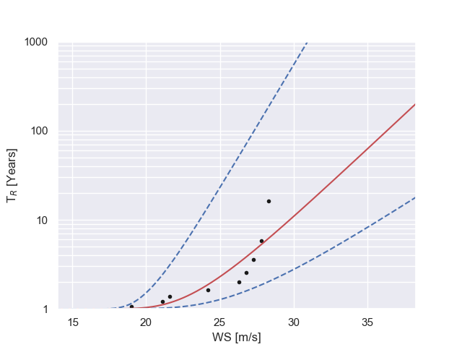Figure 3 - Least-squares fitting of type 1 Gumbel extreme value distribution with 10.000 bootstrap confidence intervals for wind speed distribution.
The inferred Gumbel distributions are Laplace transformed utilizing methodologies from (Caroline Keef, 2012) see eq. 3
 | $$Y_{i}=\left\{\begin{aligned}\log\left\{2F_{i}\left(X_{i}\right)\right\} for X_{i}<F_{i}^{-1}(0.5) \\ -\log\left\{2\left[1-F_{i}\left(X_{i}\right)\right]\right\} for X_{i}≥F_{i}^{-1}(0.5)\end{aligned}\right.$$ | (3)

Where Yi has Laplace marginal distributions. The dependence model is the following:

 | $$Y_{-i}=α_{i}Y_{i}+{\left(Y_{i}\right)}^{β_{i}}Z_{|i}$$ | (4)

Where, Z_{|I} is a d-1 dimensional random variable with distribution function G_{|I} and is independent of Y_{i}.

The empirical joint distribution function G_{|I} is estimated nonparametrically using the empirical joint distribution of observations available following eq. (5)

 | $$Z_{|i}=\frac{Y_{-i}-\hat{α_{i}}Y_{i}}{Y_{i}^{\hat{β_{i}}}}$$ | (5)

After inversion of the Laplace transforms. The environmental contour establishment can be drawn allowing for interpretation of the relevant risk levels associated with the given probability level.

Conclusion
This abstract outline a brief overview of the theory, methodology and timeseries utilized for establishing environmental contours for high return period values ranging from Tr= {5, 10, 50 ,100} years.

References
2022, I. (2022). Climate Change 2022: Impacts, Adaptation, and Vulnerability. Contribution of Working Group II to the Sixth Assessment Report of the Intergovernmental Panel on Climate Change. Cambridge University Press. In Press.
Gringorten, I. I. (1963). A plotting rule for extreme probability paper. Journal of Geophysical Research, 813-814.
Hans Fabricius Hansen, D. R. (2020). Directional–seasonal extreme value analysis of North Sea storm conditions. Ocean Engineering.
Janet E. heffernan, J. A. (2004). A Conditional Approach for Multivariate Extreme Values. Journal of the Royal Statistical Society, 497-546.

