Channel Concentration and its Impact on Nearshore Wave Conditions

Ben Modra, Water Research Laboratory, UNSW, b.modra@wrl.unsw.edu.au

Channel concentration is an important wave process in coastal regions. It occurs when a shallow water wave approaches a deep channel at a shallow angle, producing a localized region of increased wave height at the edge of the channel, and the early onset of wave breaking.

Channel concentration can occur at dredge channels, so is of particular significance to port entrances and surrounding infrastructure, especially for breakwater heads. It also occurs at natural features such as submarine canyons, particularly where the canyon is perpendicular to the coastline. The Nazaré surf break is one spectacular example, where a narrow range of swell directions concentrate along the Nazaré canyon to provide exceptionally large wave conditions at the coast.

In contrast to refraction or channel reflection, channel concentration is not well documented in the available literature. The first known study of the effect was by Zwanborn and Grieve (1974), who observed it in an extensive modelling program of the Richards Bay harbour. They observed an increase in wave height on the seaward edge of the channel batter. Yu et. al., (2000) and Li et. al., (2000) compared a physical model to a Boussinesq model of a harbour, and also showed wave concentration along the channel. Another study (Misra et. al., 2008), compared numerical and physical models of channel concentration. This noted that phase averaged (spectral) models do not capture channel concentration, and Boussinesq or physical models should be used.

While these studies show wave concentration as a significant coastal process, there is insufficient information on the process to provide general design guidance for its consideration in harbour projects. As such, there is still the need to use design tools such as physical modelling to ensure the site specific wave conditions are characterised correctly.

A physical model study of proposed reclamation works at the Port of Townsville was conducted at UNSW’s Water Research Laboratory (WRL) in Sydney, Australia. The study included 3D modelling of the harbour region, 2D modelling of a bund wall, and Quasi-3D modelling of the bund elbow. The 3D model demonstrated that both channel concentration and reflection are significant processes for wave conditions at the port.

Through a series of tests incorporating a range of wave directions (2° to 30° to the channel), and including monochromatic, JONSWAP and dual-peak wave spectra, we were able to characterise conditions which induced channel reflection, and those which resulted in channel concentration.

Monochromatic waves with approach angles to the channel of up to approximately 15° provided the strongest wave concentration effect (see Figure 1). Along the channel boundary, waves could be seen to turn so that the wave crest was perpendicular to the channel, and steadily increased until the inception of wave breaking. The region of wave breaking was observed to extend from the upper edge of the channel batter to approximately one wavelength seaward. Wave breaking and non-linear wave effects at the channel boundary produced a secondary, low period wave energy that was released into the channel, however this was much lower than the incident wave energy, and very little energy was observed to release back to the shallow water region.

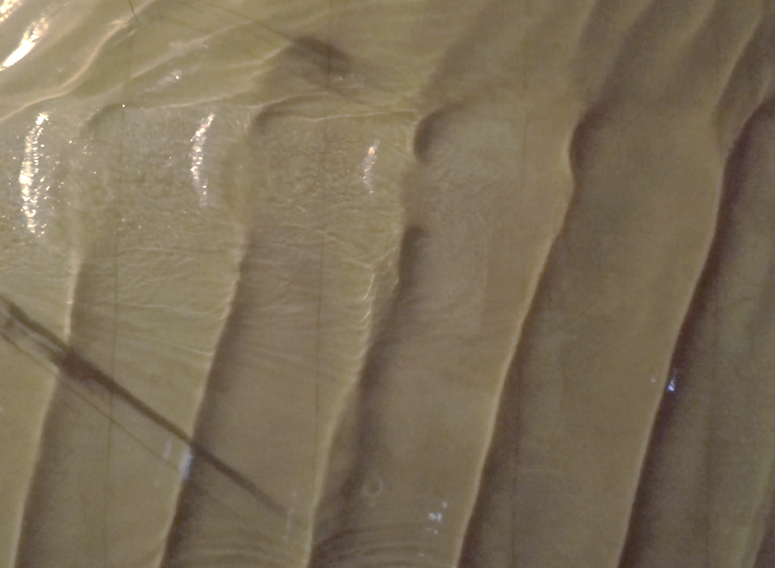
θ
SHALLOW REGION
DEEP CHANNEL
INCIDENT
WAVE
WAVE CONCENTRATION
Figure 1 – Channel concentration recorded in the model

With wave approach angles between approximately 15° and 25° provided a transition region, with both channel concentration and reflected waves observed. For angles between approximately 25° and the critical angle for reflection as defined by Snell’s law, the channel provided channel reflection as evidenced by a classic diamond wave pattern.

The observed patterns of channel concentration and reflection were analogous to the so called mach-stem effect in coastal engineering as described by Weigel (1964) and others. A mach-stem occurs when waves approach a hard boundary (a seawall for example) at a shallow angle, producing a large increase in wave height at the boundary. The pattern of increasing wave height perpendicular to the boundary and the range of angles for reflection and concentration closely align between the mach-stem effect and the channel concentration observed in the model. It is likely that the reflection from the channel and the reflection from a hard boundary provide similar wave-wave interactions resulting in the increased wave height.

Broad spectra and directionally spread waves make the effect difficult to observe, and typically results in the transmission of some wave components and a smaller increase in wave height at the channel. However, even under bimodal wave conditions it was shown that channel concentration provided an increased the wave climate at the channel edge. A significant reduction in wave energy within the channel was also measured. This aligns with the results of Misra et. al. (2008), which showed that channel concentration is affected by the wave spectra as well as directional spreading of the wave.

The Townsville model included two distinct channel boundaries, one for the approach channel and one for the berth pocket. This provided a complex superposition of incident waves, reflected wave and channel concentration depending on the approach angle, see Figure 2.

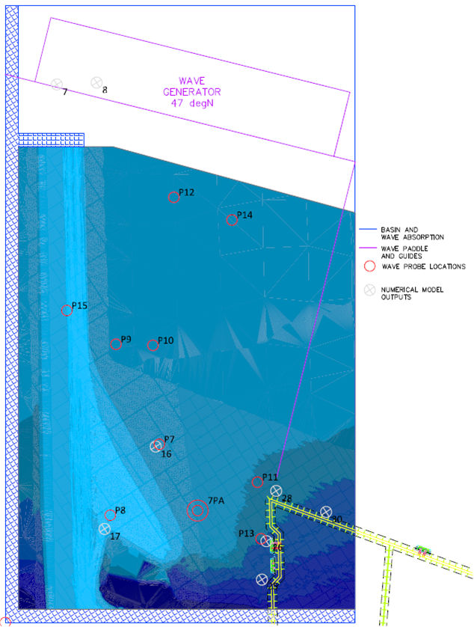
CONCENTRATION
INCIDENT WAVES
Figure 2 The Port of Townsville model layout

To aid in the understanding of the resulting wave climate, a 7-probe array was developed to allow the extraction of the 2D wave spectrum, see Figure 3. Analysis of the 7-probe array data was performed using DIWASP (DIWASP manual v1.4), which provides a number of directional spectra estimation techniques, see Figure 4.

There are many approaches to estimation of the directional spectrum (Benoit, 1993), providing a range of robustness, accuracy and computational time. Analysis techniques can be fickle, and sensitive to data errors and pre-processing. Based on guidance by Benoit (1993), the DIWASP manual, and WRL’s experience in 3D physical modelling, the Iterative Maximum Likelihood Method (IMLM) was selected as the primary analysis method for this study. This is a fast and robust method, that generally provides similar results to highly accurate but less stable methods such as the Extended Maximum Entropy Method (EMEP) or Bayesian Direct Method (BDM).

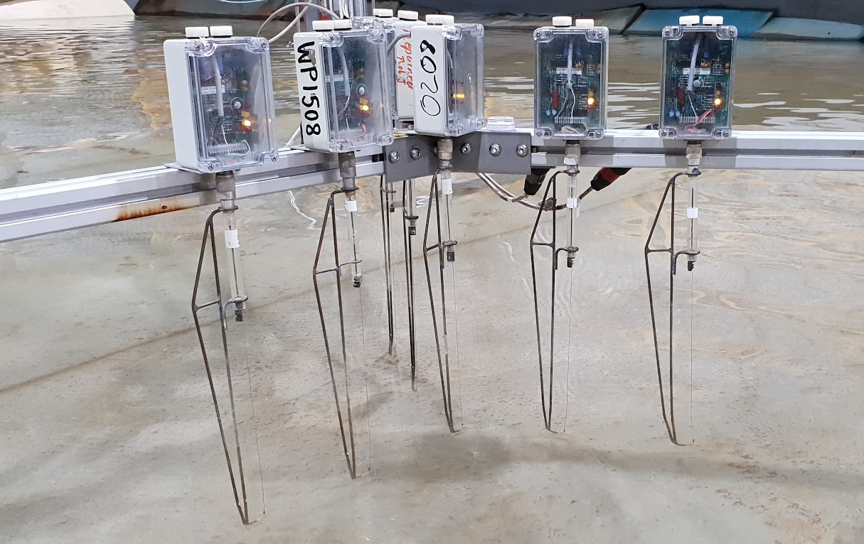
Figure 3 7-probe array developed to measure the directional spectra
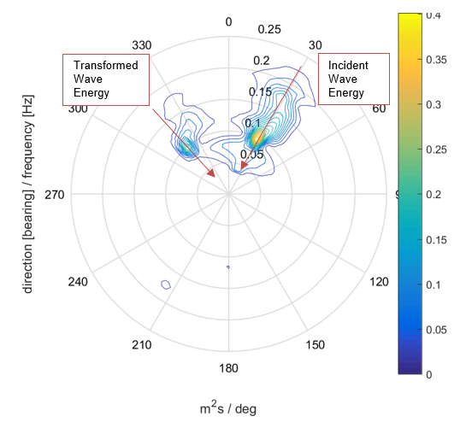
REFLECTION
Figure 4 Directional spectra plot showing the incident wave energy and the energy transformed by the channel

The results showed that channel reflection and channel concentration can significantly transform the local waves, resulting in multidirectional wave fields and higher design wave conditions. For the specific conditions studied, an increase in wave height of up to 30% was measured. In addition to increasing wave heights, channel concentration and reflection was shown to redirect wave energy to otherwise sheltered regions. The areas of increased wave energy due to the transformed energy, as well as those areas of reduced wave energy due to sheltering by the channel was corroborated by observations of wave action at the coastline during a storm (Nielsen et. al., 2011).

This study shows that channel concentration and reflections should be an important consideration for infrastructure and coastal management wherever dredged or natural channels occur. There is a need for further research to develop design guidelines for the consideration of channel concentration in coastal studies. Until this is done, design tools such as physical modelling or Boussinesq numerical models should be used to ensure the site specific wave conditions are characterised correctly.

REFERENCES
Benoit, M. (1993) Practical comparative performance survey of methods used for estimating directional wave spectra from heave-pitch-roll data. Proc.23rd ICCE Vol 1. ASCE pp.62-75

DIWASP, a directional wave spectra toolbox for MATLAB®: User Manual. Research Report WP-1601-DJ (V1.1), Centre for Water Research, University of Western Australia

Li Y., Liu S., Wai O., Yu Y. (2000) Wave Concentration by a Navigation Channel. Applied Ocean Research

Misra, K., Shubhra & Driscoll, Andrew & Kirby, James & Cornett, Andrew & Lomonaco, Pedro & Sayao, Otavio & Yavary, Majid. (2008) Surface gravity wave interactions with deep-draft navigation channels - Physical and numerical modeling case studies. Proceedings of the Coastal Engineering Conference.

Nielsen A., Bonner R., Berthot A. (2011) Wave Energy Reflections off Dredged Channels 34th World Congress of the International Association for Hydro- Environment Research and Engineering

Wiegel, R. (1964). WATER WAVE EQUIVALENT OF MACH-REFLECTION. Coastal Engineering Proceedings, 1(9), 6. https://doi.org/10.9753/icce.v9.6

Zwanborn and Grieve (1974) Wave Attenuation and Concentration Associated with Harbour Approach Channels

