The January 2022 Tonga-Hunga Ha’apai tsunami waves on the east coast of Australia, and comparison to previous events

Sam Maddox, Manly Hydraulics Laboratory (MHL), sam.maddox@mhl.nsw.gov.au.com
Gareth Davies, Geoscience Australia (GA), Gareth.Davies@ga.gov.au

TONGA-HUNGA HA’APAI VOLCANIC ERRUPTIONS
On 15 January 2022 the Hunga Tonga-Hunga Ha’apai underwater volcano erupted. The eruption (M_{L}5.8) generated pressure and surface waves that travelled across the globe. Figure 1 is the satellite imagery at the time of the eruption showing the scale of the blast.

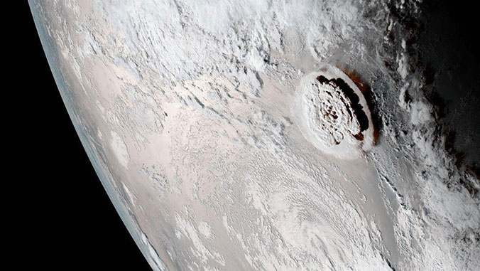
Figure 1 – Satellite imagery of the Hunga Tonga volcano eruption (NOAA)

IDENTIFYING TSUNAMI WAVES
The eruption generated an atmospheric pressure wave that wrapped around the earth multiple times and was detected globally at atmospheric pressure gauges (Lynett, 2022). A tsunami was also generated at the volcano itself via some combination of the explosion and mass movements. Using tide-gauge datasets available at MHL and other agencies, Davies (2022) has run theoretical models for arrival times of both the atmospheric pressure wave and the landslide waves highlighted in Figure 2. The model is using the epicenter location zero point along with linear shallow wave theory where the atmospheric pressure forcing is represented with a constant-depth atmosphere (320 m/s).

If we compare the model to the captured data in the case of NSW and MHL operated gauges. The measured first barometric disturbance at the Kingscliff, NSW barometric gauge using a 15 min time series was at 17:15 EST corresponding with the calculated initial estimated time from the model being 17:05 EST. The resulting landslide wave arrival time was initially detected at the Tweed Heads, NSW tidal gauge using a 1 min time series at 19:43 EST with the initial estimated model data being 21:05 EST. Further unpacking of the modelled wave times will be looked into.

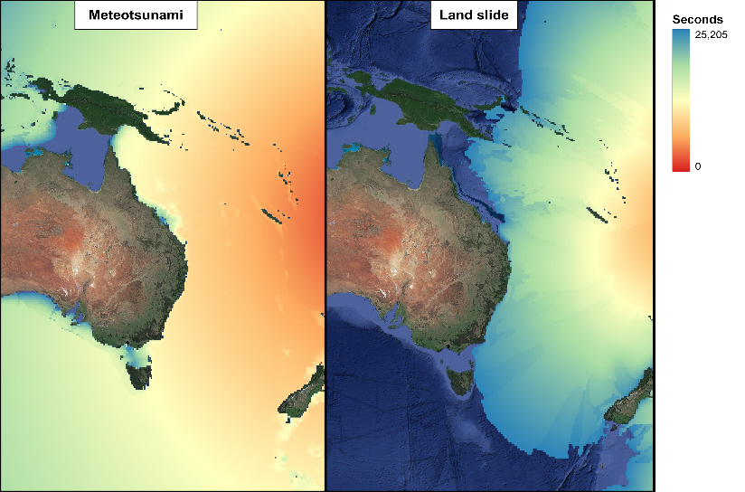
Figure 2 – Davies, 2022 Modelled pressure and tsunami wave travel times post based on the epicenter location and t = 0

TIDAL MEASUREMENT IN NSW
MHL has a vast network of ocean tide, offshore tide, and barometric pressure gauges in NSW. The Tonga-Hunga tsunami waves were measured through the entire NSW coastal network. Figure 3 is a residual contour plot of MHL tidal gauges spanning the coast. The tsunami wave effects were greatest on the mid northern coast of NSW with anomalies measured to 0.5m in open bays and enclosed harbours. The secondary seiche waves occurring in bays with smaller areas such as Crowdy Head and Coffs Harbour are evident in Figure 3 where the tsunami wave resonance can be seen in the residual.

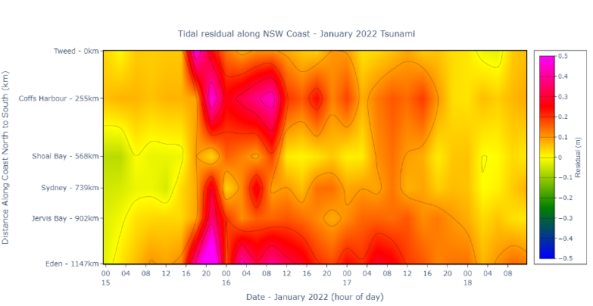
Figure 3 – NSW coast tidal gauge residual contour plot during tsunami event

The east coast of Australia was also subject to the effects of a low pressure generated swell that may have created a multitude of wave signals during the tsunami event. Tsunami waves can have different properties depending on the source processes whilst the location of the tide gauges bathymetry of deep to shallow water is also a factor. In Figure 4 we have run spectral analysis on 3 of the MHL tidal gauges to show the different effects on different tidal gauges on different sections on the NSW coast. Figure 4 a) Tweed Heads gauge which is located inside a river mouth. The effects of the tsunami wave are minimal, and signal is lost inside the swell. The propagation of any swell or tsunami wave propagates upstream. Figure b) Eden gauge located at the bottom of the state of NSW in an open bay, the continual increase of amplitude over period indicates that there are several wave signals here with not just the tsunami or any resonance but a swell event as well. Figure 4 c) Coffs Harbour gauge which is located inside a smaller harbour area with a tighter entrance where once the initial tsunami disturbance has penetrated the wave can be seen to have energy past the 55 min period as the seiche wave resonates within.

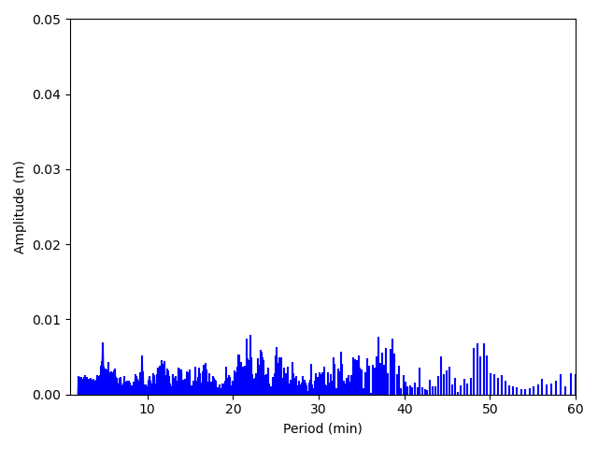
a)
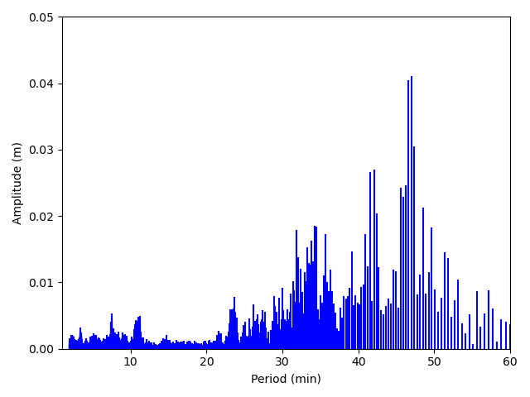
b)
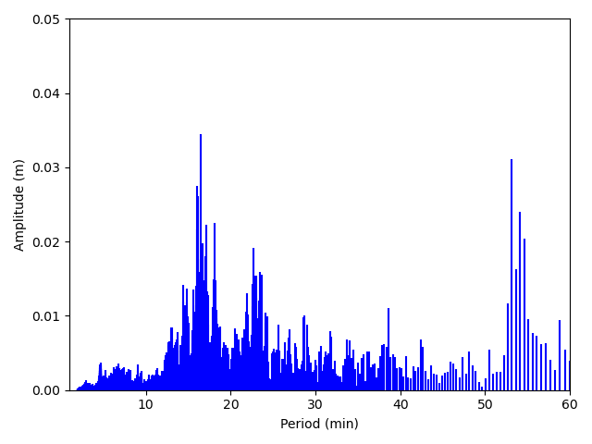
c)

Figure 4 – Spectral analysis on a) Tweed Heads 1 min data, b) Eden 1 min data, c) Coffs Harbour 1 min data.

The ocean tide gauges have several data sets accessible to the public with 15 min averaging, 1 min averaging and 1 second instantaneous data on several open bay gauges. With historical datasets dating back to as far as 1914 in the case of Fort Denison, we are able compare previous notable tsunami events (Japan 2011, Chile 1960) and the relative wave heights. However, to properly interpret these datasets, it is necessary to understand how the temporal resolution of measurements affects the tsunami signal. Rabinovich (2011) showed the descending relationship between measured wave height and energy to increasing time intervals for sampling. For example, 15 min datasets are subject to miss waves with 12 min periods, such as those measured in Crowdy Head Bay during the Tonga-Hunga tsunami. Figure 5 is a snapshot of this theory with 1 second instantaneous data overlayed on 1 min and 15 min averaged data. The wave peaks are lost in the 15 min dataset with as the 1 min averaged set measures up to approximately 0.4m higher on the smaller period waves which are not captured. It is also possible to see the harmonic wave in the sub minute period with the 1 second data.

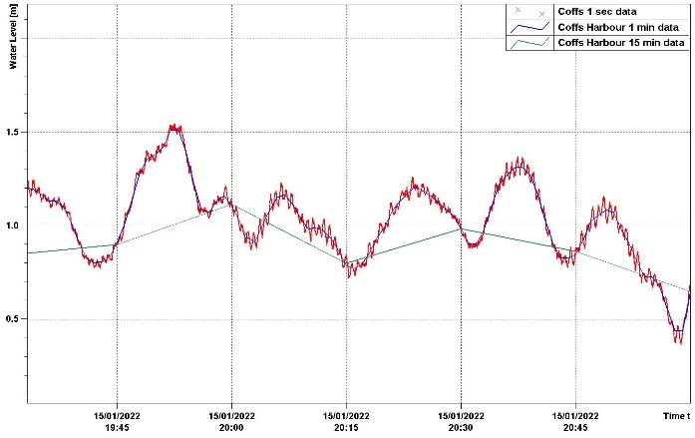
Figure 5 – Coffs Harbour 1 sec, 1min and 15 min water level data during the tsunami event

TSUNAMI WAVE IMPACTS IN NSW
MHL also has a wide coastal rivers and lakes flood gauge network in NSW. With several priority estuary systems setup on 1 min data logging such as Lake Macquarie we conduct analysis on whether the tsunami has propagated upriver or has a harmonic setup in a coastal lake. Unpredicted anomalies such as tsunamis can have a great effect in coastal lakes with smaller tidal ranges as it can cause unforeseen inundation.

REFERENCES
Rabinovich, Candella (2011): Energy Decay of the 2004 Sumatra Tsunami in the World Ocean, Pure and Applied Geophysics, vol. 168, pp. 1919-1950.
Lynett, P. et al. (2022) DiverseTsunami genesis Triggered by the Hunga Tonga-Hunga Ha’apai Eruption. Nature https://doi.org/10.1038/s41586-022-05170-6

