CLIMATE CHANGE IMPACTS ON REEF TOP ISLANDS

Stuart Bettington, Royal HaskoningDHV, Brisbane Australia, stuart.bettington@rhdhv.com
David Baldwin, Torres Strait Island Regional Council, Cairns Australia, david.baldwin@tsirsc.qld.gov.au

BACKGROUND
It is generally understood that climate change, particularly sea level rise, is a threat to communities and habitats on low lying tropical islands. However, the full nature of this threat is not well understood. These islands have been created by met-ocean forces on the reef platforms and represents the culmination of a dynamic balance between these forces and the supply of sediment over thousands of years. This paper assesses the impact of climate change on the reef top hydrodynamics and coastal morphology of reef top islands.

ISLAND CREATION AND MORPHOLOGY
Coral atolls and cays form on reef tops from the carbonate sediments made up of the skeletal remains of molluscs, foraminiferans, coral, and Halimeda (Parnell et al 2010). This biota feeds the sediment supply to the reef platform where waves, currents and winds push the sediments around. The distribution of sediments on the reef platform represents a balance between sediment supply and the loss of sediments from the platform (washed off the reef platform) which governs the size, shape and location of islands.

Island dynamics are strongly influenced by the seasons, with the tropics dominated by two wind climates, aligning to a wet and dry season. This results in the island foreshores experiencing annual erosion and accretion cycles. The location of the islands on the reef top reflects a balance between these conflicting seasons.

Due to the reef levels, ocean swell waves rarely reach the island foreshores without breaking on the reef edge. During high water levels, increased energy passes onto the reef top. The highest water levels occur during extreme wave events, when wave induced setup results in inundation of islands (see Figure 1), depositing sand and raising the islands.

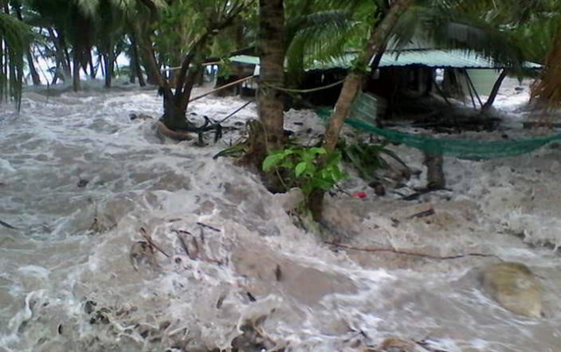
Figure 1 – Cyclonic event resulting in wave inundation providing a critical aspect to island formation, image of Tropical Cyclone Pam swamping Nanumea in 2015
CLIMATE CHANGE IMPACTS
The impacts of climate change are a threat to the future of reef top islands. The critical issues include:

- Increased water levels changing the energy balance and reef top morphology.
- Sea level rise leading to flooding, groundwater contamination and increased wave energy.
- Reduced ecological vigor of reef systems impacting supply of sediment.
- Possible changes in climate altered seasonal winds, and changes in cyclone frequency or intensity.

These ultimately lead to shoreline erosion and inundation issues. Below the first two impacts are discussed through a case study of reef top morphology and observations of flooding and groundwater contamination.

REEF TOP MORPHOLOGY IMPACTS
An assessment of the reef top morphology was undertaken for two coral cays in the Torres Strait. The islands are Poruma (Coconut Island) and Masig or (Yorke Island). In the Torres Strait the South-easterly winds and waves occur from March to November while North-westerly conditions during the wet season occur from December to February.

Combining the water level and wave climate statistics with the sediment characteristics, the adopted wave transformation inputs for the CERC formula were determined. The above data resulted in the estimated present day sediment transport rates as presented in Table 1.
Table 1 – Present day sediment transport potential
 | Masig | Poruma
NW Season | 11,100 m³/a | 8,700 m³/a
SE Season | 11,300 m³/a | 7,600 m³/a

The results show that the system is in balance. During the dry season the south easterly waves drive sand to the north western end of the islands, primarily along the south coast. Conversely, during the shorter more intense wet season sand is pushed to the south east, along the north coast. This mechanism typically results in a clockwise direction of sand transport around the island. This transport regime is why groynes so dramatically impact the coastal processes on these islands.

The impacts of sea level rise, when specifically applied to the coastal morphology, result is increased rates of sediment transport due to increased energy crossing the reef. However, as seen in Figure 3 the rate of increase is not equal. This leads to an imbalance which, in the Torres Strait will result in sediments being forced towards the north west of the islands and off the reef the platform, starving the islands of stable sand reserves.
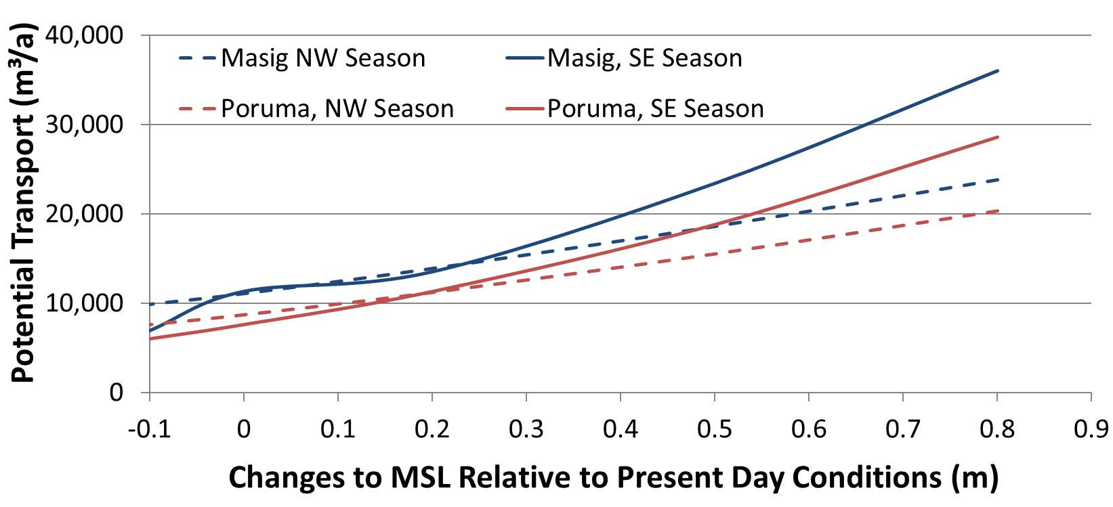
Figure 2 – Impact of Sea Level Rise on Seasonal Longshore Sediment Transport Potential (Source AECOM 2019)

Reef top islands have natural defense mechanisms, with vegetation and beach rock formations helping to resist erosive forces. These systems do fail under persistent attack. Examples in Figures 3 and 4 reveal that this can ultimately lead to the islands being diminished and lost.

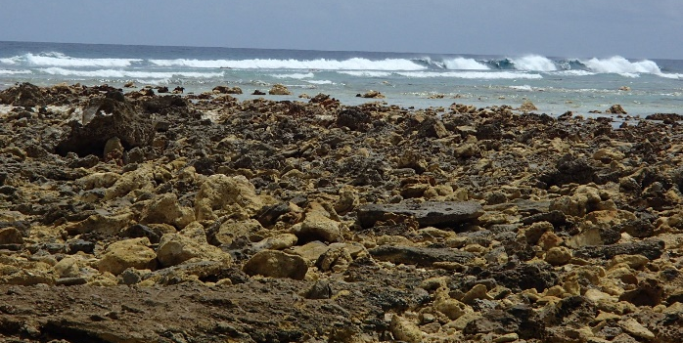
Figure 3 – A reef top island destroyed revealing beach rock rubble on Funafuti Atoll (Tuvalu)

GROUNDWATER AND FLOODING IMPACTS
The cays and atolls are formed by marine forces resulting in ground levels not much above the tidal reach. As described above the islands can periodically anticipate flooding during extreme events. Within the island fresh water lenses from that are vital to the ecology of the islands. A significant issue from sea level rise is the increased frequency and severity of marine flooding events.

The increase in water levels in the ocean does not directly translate to equivalent increases in reef top storm levels, with greater depths reducing the lift caused by wave setup. This was assessed for a cay in the Cook Islands (ref Royal HaskoningDHV 2022) where using the below equation (ref Blacka 2015) the average water levels on the reef tops were found to be less than the increase in sea levels. For a 0.9 m sea level rise reef top water levels were forecast to increase by 0.6 to 0.7 m.

$${\overline{η}}_{r}=\frac{3}{64π}K_{P}\frac{g^{1/2}H_{o}^{2}T_{o}}{{\left({\overline{η}}_{r}+h_{r}\right)}^{3/2}}\left[1-K_{R}^{2}-4πK_{r}^{2}\frac{1}{T_{o}}\sqrt{\frac{\left({\overline{η}}_{r}+h_{r}\right)}{g}}\right]$$
Despite the moderate degree of attenuation the increased frequency and intensity of inundation events is major threat to the ecology and communities of the islands. The issue of flooding is fairly obvious but the contamination of the ground water is extremely difficult to manage and is very significant to the future of the communities.

SUMMARY
Coral cays and atolls have developed since sea levels stabilised 8,000 years ago, raised up to as low level islands to levels just above tides by extreme storms. Their size and location of the reef reflects a dynamic stability between sand supplied by the living reef and the morphology on the reef platform. These islands face numerous threats from both climate change and other anthropogenic impacts. This paper examines these threats with a focus on changes to reef top morphology and the assessment of inundation threats with real world examples.

REFERENCES
AECOM (2019): Coastal Assessment for Poruma and Masig - Sand Transport Rates on Coral Cays in the Torres Strait, prepared for Torres Strait Island Regional Council.

Blacka, Flocard, Splinter, Cox. (2015): Estimating Wave Heights and Water Levels inside Fringing Reefs during Extreme Conditions, Australasian Coasts and Ports 2015.

Parnell, Smithers, Duce (2010): Coastal Erosion and Inundation in the Central Island Group (Masig, Poruma, Warraber and Iama), Torres Strait: Science Supporting Adaptation – Technical Report, . Marine and Tropical Sciences Research Facility, Cairns (pp. 136)

Royal HaskoningDHV (2022): Nassau Harbour Improvement Basis of Design, prepared for Infrastructure Cook Islands.

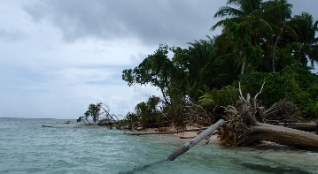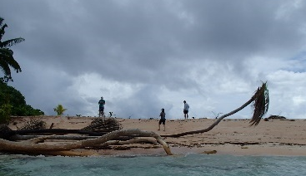Figure 4 Severely impacted small island on Funafuti Atoll acter cyclonic waves cause significant erosion and loss of vegetation.

