THE IMPACT OF RESTORED FRESHWATER INFLOW ON TIDAL DISTORTION IN A SHALLOW ESTUARY

Mojgan Razzaghi, University of Waikato, mr179@students.waikato.ac.nz
Shari L Gallop, University of Waikato, shari.gallop@waikato.ac.nz
Karin R Bryan, University of Waikato, karin.bryan@waikato.ac.nz
John L Largier, University of California, Davis, jlargier@ucdavis.edu

BACKGROUND
Te Awa o Ngātoroirangi (the Maketū Estuary) in the Bay of Plenty of Aotearoa New Zealand has had multiple major shifts in the salinity regime, associated with a long history of engineering works on river inflows. The Kaituna River was diverted out of the estuary in 1957 to prevent flooding, resulting in degradation of the estuary, including increased sedimentation, loss of tidal channels, decreased flushing, saltwater intrusion and ecological decline. However, in 2020 and 2021, a total of 20% of the river flow was restored back into the estuary in two stages through 12 control gates, with a key driver being to restore the mauri (life force) of the estuary and kaimoana for tangata whenua (Māori people of the land). This study focuses on the immediate effects of the partial (13%) restoration of the Kaituna River flow on the tidal distortion at 5 sites throughout the estuary.
One of the issues before the partial freshwater restoration was infilling of the estuary with sediment. Infilling can be driven by flood-dominant tidal asymmetry and thus changes to asymmetry are a focus of this study. According to Friedrichs and Aubrey (1988), if 0° < 2$M_{2}$-$M_{4}$< 180°, the estuary is termed ‘flood-dominant’ and exhibits shorter floods and necessarily higher velocity flood currents. If 180° < 2$M_{2}$-$M_{4}$< 360°, the estuary is ‘ebb-dominant’ with shorter, higher velocity ebb tides, where $M_{2}$ and $M_{4}$ are the fundamental and first harmonic phases.
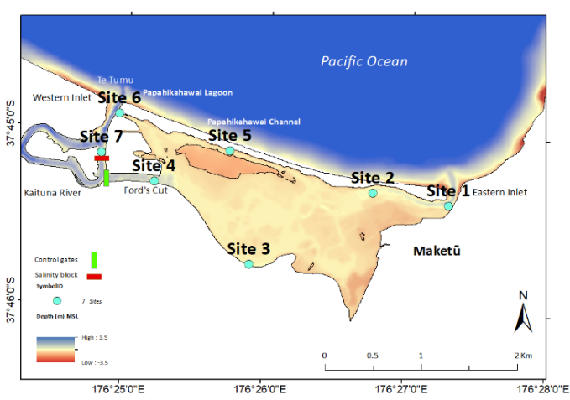
Figure 1 – Bathymetry map of the Maketū Estuary

METHOD
Water level and current velocity data were collected between 23rd January and 3rd March 2020 from 7 sites (Figure 1). In order to evaluate tidal distortion in the estuary before and after the partial freshwater restoration, two approaches were taken: (1) using the tidal velocity asymmetry (TVA) method, the ratio of peak flood current speed to peak ebb current speed was calculated for for 3 sites (with TVA>1 representing flood dominance and <1, ebb dominance); and (2) the phase and amplitude of the M2 and M4 constituents was extracted with Utide for all 5 sites.

RESULTS
Based on the TVA method, at Site 2 (Figure 1), ebb dominant currents shifted to weak flood dominance (in terms of TVA) after the partial freshwater restoration (Figure 2a). Site 3 (Figure 1) showed the biggest shift to flood dominance (Figure 2b) and Site 4 (Figure 1; closest to the gates), remained ebb dominant after the partial freshwater restoration with little change (Figure 2c). However, no change was observed after freshwater restoration using the Friedrichs and Aubrey method (Table 1) although the additional freshwater flow accounts for a higher depth-and-tide-averaged outflow.
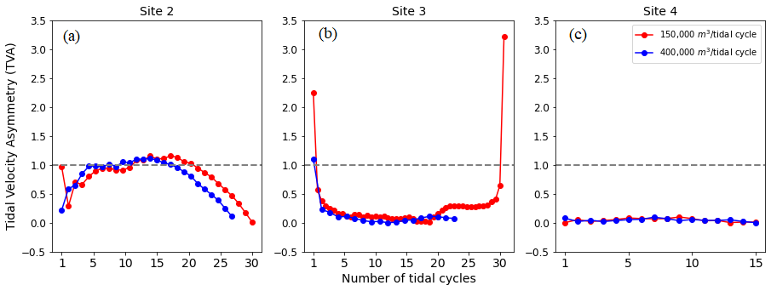
Figure 2 – TVA before (red) and after (blue) the partial freshwater restoration: (a) Site 2, (b) Site 3, and (c) Site 4.

Table 1 – Flood/ebb results for 5 sites
Sites | 2$M_{2}$-$M_{4}$ (before) | 2$M_{2}$-$M_{4}$ (after) | Asym
Site 1 | 109 | 90.74 | flood dominant
Site 2 | 126 | 90.74 | flood dominant
Site 3 | 58 | 57.7 | flood dominant
Site 4 | 44.8 | 52.1 | flood dominant
Site 6 | 54 | 58 | flood dominant

REFERENCES
de Ruiter, Mullarney and Bryan (2022). The effects of wind‐generated currents on velocity asymmetry in tidal basins with varying geometries. Earth Surface Processes and Landforms, 47(1), 193–208.
Friedrichs, & Aubrey (1988). Non-linear tidal distortion in shallow well-mixed estuaries: a synthesis. Estuarine, Coastal and Shelf Science, 27(5), 521–545.

