INFLUENCE ON EVENT-SPECIFIC CALIBRATION DATA IN MODELLING SUBAERIAL STORM EROSION UNDER COMPLEX BATHYMETRY

Hyeok Jin, GeoSystem Research Corp, hyeokjin@geosr.com
Kideok Do, Korea Maritime and Ocean University, kddo@kmou.ac.kr
Inho Kim, Kangwon National University, kimih@kangwon.ac.kr
Tae-Soon Kang, GeoSystem Research Corp, kangts@geosr.com
Heung-Bae Choi, GeoSystem Research Corp, hbchoi@geosr.com

INTRODUCTION
Key parameters in the process-based model for morphological changes during storm events (i.e., XBeachX, Roelvink et al., 2018) should be adjusted to simulate morpho-hydrodynamics to a specific area of interest, leading to site-, profile-, and event-specific calibration. Although 2-dimensional simulations (area model) eliminate variability in calibrated parameters along with each profile in complex bathymetry, the degree to which datasets having different wave conditions influence model performance is still unclear in the area model at a given parameter space.
The main objective of this study is to examine the influence of event-specific calibration data (single storm event and storm clusters) in modelling subaerial storm erosion under complex bathymetry. Using bathymetric field data over four different storm conditions, this study presented guidance for the selection of event-specific data in modeling calibration.

STUDY AREA
Field observations and numerical simulations were conducted on Maengbang Beach (latitude 37.40˚ N, longitude 129.21˚ E), the east coast of Korea. This area consists of crescentic bars although the beach state intermittently changes due to a series of storms (Figure 1). Wave data was observed from AWAC located at a water depth of 30 m. Bathymetric surveys were conducted before and after each storm event using RTK-GNSS for the subaerial area and high-precision GNSS and echo sounder for nearshore and foreshore bathymetry.

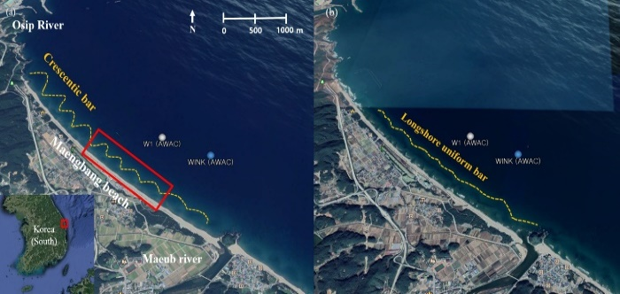
Figure 1 – Meangbang beach with crescentic bars (left) and longshore uniform bar (from Google Earth).

STORM EVENTS
This study uses wave height of 2.5 m and time interval of 12 hours between storms as a threshold to define an individual storm and the storm power index to quantify the impact on wave height and storm duration. Five typhoons (Figure 2) and extratropical low pressures during the survey period corresponded the storm definition above, consisting of two single and two clustered storm events.
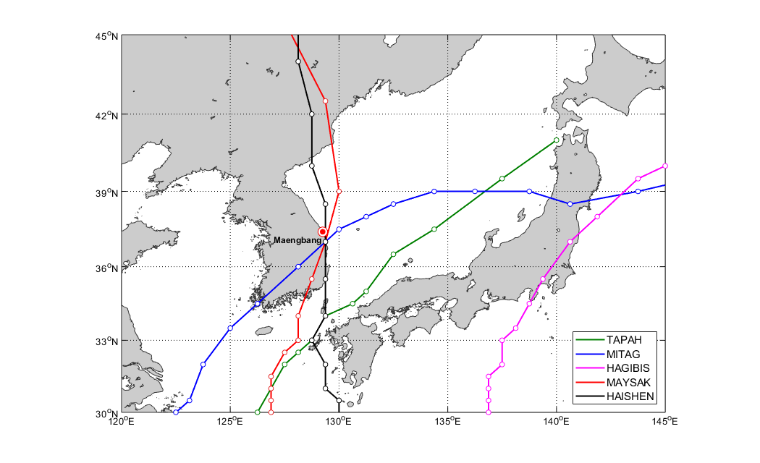
Figure 2 – Five typhoons induced during survey period (March 2017 - September 2020).

NUMERICAL SIMULATION
Four storm events described above were modelled using a wave-averaged version of XBeachX with four adjustable parameters (facua, alpha, gamma, gamma2), producing 384 parameter sets. BSS, likelihood of BSS, and Kolmogorov-Smirnov(K-S) D statistic (Simmons et al., 2017) were used to quantitatively analyze general model performances, the sensitivity of each parameter set, and reliable parameter ranges in varying storm events.

INFLUENCE OF EVENT-SPECIFIC DATASETS
Sensitivity analysis with statistical methods used showed how sensitive the model results are depending on observation properties used in model input. Cumulative storm power and resultant erosion volume are closely correlated with overall model sensitivity compared to other features in datasets (e.g., wave directions, pre-storm beach state, and the time interval between bathymetric surveys) in the study site. This result may provide priority for the consideration of calibration data in modelling storm erosion under complex bathymetry.

ACKNOWLEDGMENT
This research was partly supported by the National Research Foudation of Korea (NRF-2022R1I1A3065599) and the project titled ‘Establishment of the Ocean Research Station in the Jurisdiction Zone and Convergence Research’, funded by the Ministry of Oceans and Fisheries.

REFERENCES
Roelvink, McCall, Mehvar, Nederhoff, Dastgheib (2018): Coastal Engineering, ELSEVIER, vol. 134, pp. 103-123.
Simmons, Harley, Marshall, Turner, Splinter, Cox (2017): Coastal Engineering, ELSEVIER, vol. 125, pp 28-41.

