COASTAL DUNES CHANGES ALONG THE WESTERN COAST OF EUROPE

Olivier Burvingt, University of Bordeaux, France, olivier.burvingt@u-bordeaux.fr
Bruno Castelle, University of Bordeaux, France, bruno.castelle@u-bordeaux.fr

INTRODUCTION
Coastal dunes are natural barriers buffering storm waves, protecting coastal communities from flooding and rising sea level, and providing a valuable source of biodiversity for the surrounding environment. Significant dune erosion caused by storm waves and high water levels generally takes place over hours or days, while post-storm recovery can take years or decades (Houser et al., 2015). Although coastal dunes have received quite a lot of attention over the last decades, knowledge gaps remain, and our understanding and predicting capacity of long-term (years to decades) coastal dune evolution remain limited. The large diversity of coastal dunes along the Atlantic coast of Europe and the sequence of extreme storms observed during the 2013/14 winter, considered as the most energetic storms since at least 1948 (Masselink, 2016), represent a unique opportunity to study the spectrum of coastal dune response and recovery from an extreme winter.

METHODOLOGY
A large dataset of high-resolution airborne LiDAR topographic surveys collected from 2011 to 2020 at 8 study sites spread along the Atlantic coast of Europe (Fig. 1) was used herein. The 8 stretches of coastal dunes selected for this study are located, from north to south (Fig. 1), at Formby beach (Merseyside, UK), Penhale(Cornwall, UK), Gwithian (Cornwall, UK), Notre-Dame-des-Monts (Vendée, France), Carcans (Gironde, France), Lacanau (Gironde, France), Truc Vert (Gironde, France) and Lette Blanche (Landes, France). These coastal dunes are all facing NW-W and are therefore fully exposed to Atlantic storms. They vary in size (from 100 to 300 m wide), in height (culminating from 10 to 60 m) (Fig. 1), and back sandy beaches with different beach states and geological settings (e.g. from fully open to embayed beaches). Sediment volume changes (V) were computed from the LiDAR data to assess their responses to, and recovery from, the extreme winter of 2013/2014.

RESULTS
Pre-storm and post-storm dune profiles extracted from LiDAR data show that the extreme storms of the 2013/14 winter caused severe erosion at the different study sites. Although the 8 study sites are not presented here, three representative examples are presented in Figure 2. Dunes that are higher than 20 meters (Penhale, Gwithian, Carcans, Lacanau, Truc Vert, Lette Blanche) are characterized by significant dune scarp (from 10 to 20 meters high), and dune foot positions retreated landwards by ten of meters (from 5 to 20 meters). Dune crests were largely eroded at lower dunes that range from 10 to 20 meters high, like Formby and Notre-Dame-de-Monts.
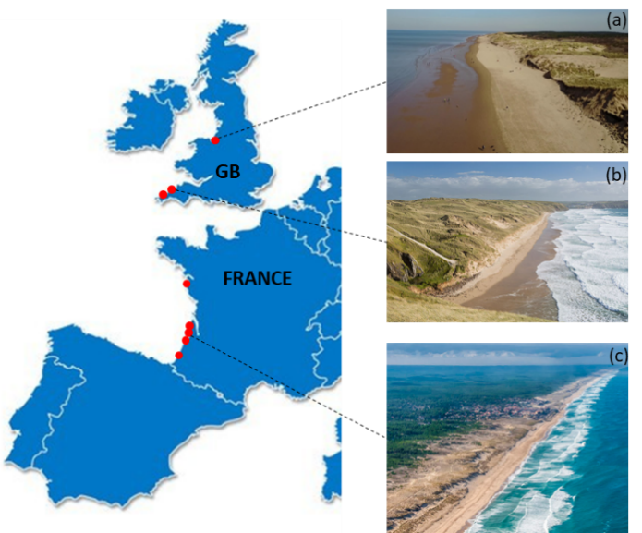
Figure 1 – Location map and aerial pictures of three of the study sites: (a) Formby, (b) Penhale, and (c) Lacanau.

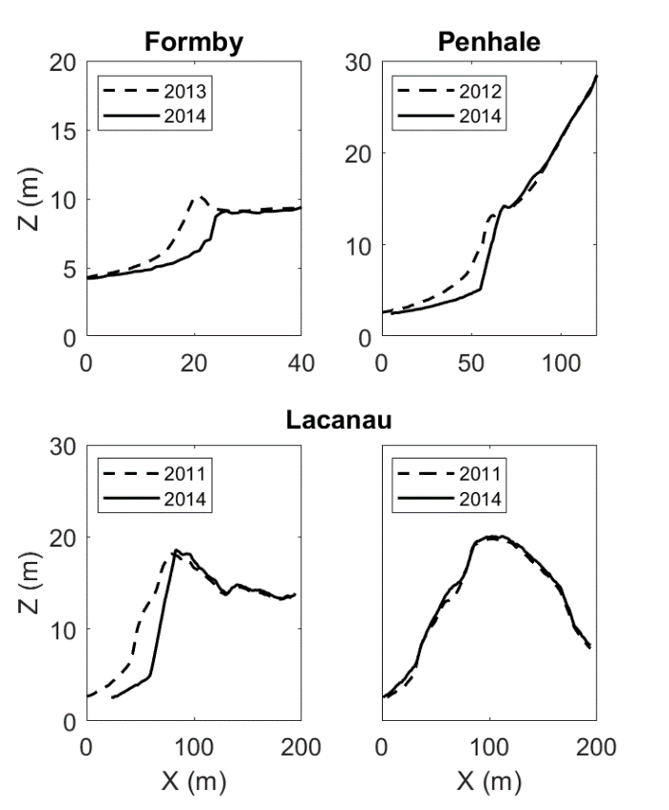
Figure 2 – Pre-storm and post-storm dune profiles extracted from LiDAR data at 3 study sites.

Dune profiles also show that storm response can significantly vary along a stretch of dunes within the same study site (e.g. Lacanau, Fig. 2). Although there are only very few examples of accretion, many profiles of the dunes do not show erosion over the 2013/14 winter compare to adjacent and severely eroded areas exposed to the same offshore wave forcing.
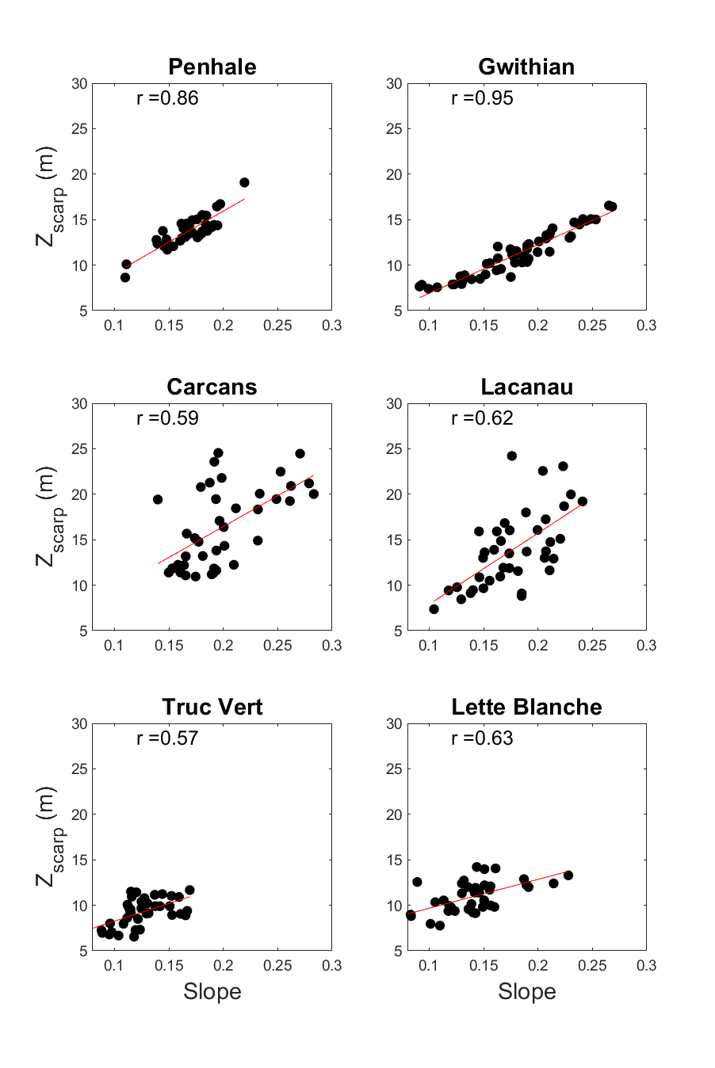
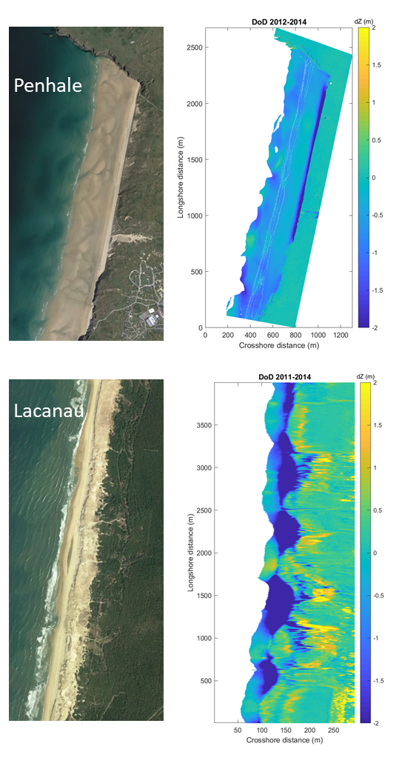
The difference between pre-storm and post-storm LiDAR digital elevation models (DoDs) give the opportunity to examine the alongshore variability in storm response among the different study sites. Two contrasting examples are presented in Figure 3 and show that the alongshore variability in storm response can be either null (e.g. Penhale) or can be characterized by megacusps that are hundreds of meter long over several kilometers (e.g. Lacanau).
Figure 3 – Satellite images and difference of pre-storm and post-storm LiDAR digital elevation models at two study sites (Penhale and Lacanau).

Among the 8 study sites, the 4 most northern ones (Formby, Penhale, Gwithian, Notre-Dame-de-Monts) show limited alongshore variability in storm response while the 4 southern ones (Carcans, Lacanau, Truc Vert, Lette Blanche) show significant patterns of alongshore variability in storm response.
As mentioned above, large dune scarping was observed at 6 of the study sites (Penhale, Gwithian, Carcans, Lacanau, Truc Vert and Lette Blanche) while the whole face and crest of the dunes were eroded at two of them (Formby and Notre-Dame-de-Monts). For the 6 study sites where dune scarping was observed, correlations between the post-storm scarping height (Z_{scarp}), identified on 40 dune profiles for each site, and the corresponding pre-storm dune face slope were examined (Fig. 4). These correlations were much stronger (r= 0.86 and r= 0.95) at study sites where the alongshore variability in storm response was limited compare to sites with strong alongshore variability (from r = 0.57 to 0.63).

Figure 4 – Post-storm dune scarping height (Z_{scarp}) against the pre-storm dune face slope at 6 study sites.

Sand volume time series were averaged and computed at the 8 study sites from 2011 to 2020 (Fig. 5). Except from dunes at Formby and Lette Blanche, the 2013/14 winter represents the most erosive event over the study period (from -20 to -300 m³/m).

Figure 5 – Multi-annual time-series of sand volumes, V (m³/m), at the 8 study sites.

These time series showed that the volume of sand recovered from this stormy period was very variable between the different study sites. Dunes either fully recovered (Notre-Dame-de-Monts, Truc Vert, Lette Blanche), or only show partial recovery (Penhale, Gwithian, Carcans, Lacanau) or even further erosion (Formby). Although full recovery was short (2-3 years) at Notre-Dame-de-Monts, Truc Vert and Lette Blanche, many years or even decades will be necessary before coastal dunes at Penhale, Carcans and Lacanau fully recover the sand volumes lost during the 2013/14 winter.
A recent study exploring the multi-annual recovery of a large number of beaches following extreme storms showed that the magnitude of intertidal beach volume recovered was well correlated with the storm erosion volume (Konstantinou et al., 2021). Similarly, the magnitude of the storm response expressed in sand volume changes averaged over each studied dune was compared against the volume of dune sand recovered over the 6 subsequent years (2014-2020) for the 8 study sites (Fig. 6). Results show that the volumes of sand recovered over coastal dunes are not necessarily correlated to the magnitude of the storm response at these coastal dunes (r= -0.24), suggesting that other controlling factors, which must be investigated, play a more important role on dune recovery processes.
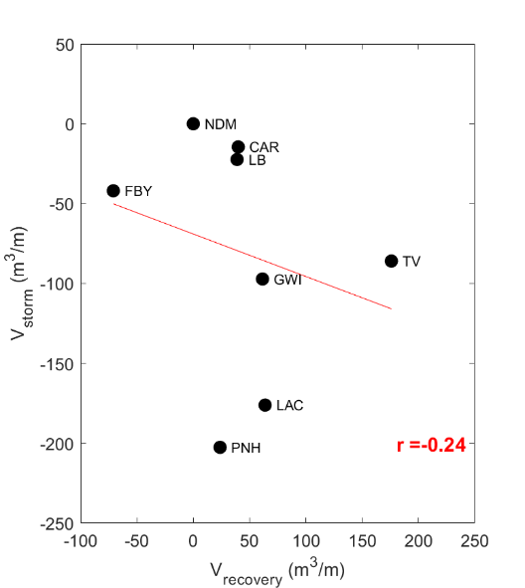
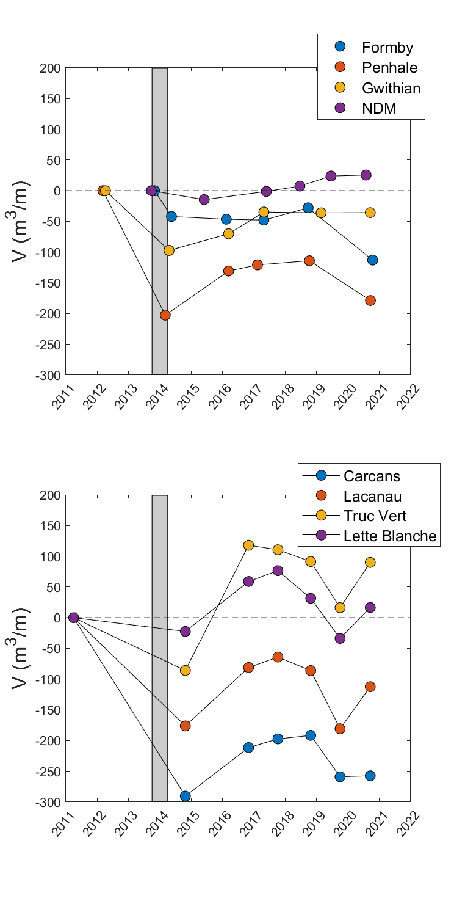
Figure 6 – Volume changes caused by the 2013/14 winter (V_{storm}) against volumes changes over the subsequent 6 years (V_{recovery}) from 2014 to 2020.

CONCLUSIONS
This study explored, for the first time, the storm response and multi-annual recovery of coastal dunes at a continental scale. Although the storm response was found to be site specific, and possibly show strong variations within the same study site, regional coherency in erosive processes was observed. Dune scarping was found to be mainly controlled by the dune slope at wide and embayed beaches where nearshore sandbars are alongshore uniform (e.g. Penhale and Gwithian). Along beaches with rhythmic sandbars (e.g. Aquitanian coast), erosion is mainly controlled by the nearshore bathymetry leading to the formation of large megacusps. The magnitude of recovery over the 6 years following the extreme storms varies strongly between study sites and did not show any regional coherency. Dunes fully recovered after 2 or 3 years at some of the study sites, while other dunes are likely not to have not fully recover before a decade. Further research on long term trends of shoreline change and sediment availability, based on satellite imagery, will be explored to attempt explaining such variability in recovery among the different study sites.

REFERENCES
Houser, Wernette, Rentschlar, Jones, Hammond, Trimble (2015): Post-storm beach and dune recovery: Implications for barrier island resilience. Geomorphology, vol. 234, pp. 54–63
Konstantinou, Stokes, Masselink, Scott (2021): The extreme 2013/14 winter storms: Regional patterns in multi-annual beach recovery. Geomorphology, vol. 389, 107828
Masselink, Castelle, Scott, Dodet, Suanez, Jackson, Floc’h (2016): Extreme wave activity during 2013/2014 winter and morphological impacts along the Atlantic coast of Europe, Geophysical Research Letters, AGU, vol. 43, issue 5, pp. 2135-2143.

