Investigation into the Mechanisms of Crest Growth on Gravel Berms

Oliver Foss, University of Bath, O.Foss@bath.ac.uk
Christopher Blenkinsopp, University of Bath, C.Blenkinsopp@bath.ac.uk
Paul Bayle, BGRM France, P.Bayle@bgrm.fr

Introduction
The continual sea-level rise predicted over the next century poses a significant threat to coastal regions. Preserving the coastline will require innovative coastal protection techniques and structures. A potential defence is to introduce artificial gravel beaches (Loman et al., 2010), or dynamic revetments (Bayle et al., 2020), a gravel berm placed at the high tide berm(Bayle et al., 2020).
A key feature of these types of defences is their ability to maintain the berm elevation relative to the water level (figure 1). As the water level rises, the structure is overtopped by waves which drives sediment up and over the berm crest peak. This leads to elevation gain for the berm and limits the landward excursion of waves.
Berm crest behaviour has only been recorded at frequencies that do not allow wave-by-wave analysis of the process and the resultant ‘snapshot’ profiles may not be representative of the true variability of gravel berms. Through application of continuous 2-D Lidar monitoring on several active gravel berms this paper addresses this gap. It presents new findings related to sediment transport at the berm crest, the morphodynamic behavior under wave attack and a conceptual model for berm state.

Methodology
Three berms were monitored as part of this work. The first two were dynamic revetments constructed in the GWK Large Wave Flume and subjected to wave attack and an increasing water level. The two revetments varied in terms of gravel composition: well-sorted smooth cobbles (DynaRev, fig. 1b), (Bayle et al., 2020) and poorly-sorted angular cobbles (DynaRev-2 fig. 1c). Sub-aerial beach profiles were recorded at 25 Hz with a spatial resolution of 2.5 cm and ± 5 mm vertical accuracy. The final site is a natural composite beach berm at Borth in Wales (UK) which has been continuously monitored throughout 2022 at 2hz.
In all cases a continuous shoreline was extracted to calculate wave runup and Lidar allowed wave by wave extraction of exposed beach profile at each run-down limit. These profiles were used to extract the crest elevation and sediment volume that passed the crest (sediment flux) for each wave event. Key overtopping event types were identified and analysis of preceding conditions were used to gain insight into berm growth.

Results
The berm constructed using poorly-sorted angular material developed a peaked crest in response to overtopping and had higher variability in crest height and sediment flux (fig.1a)., By constrast the well-sorted rounded berm steepened but did not grow relative to the rear of the berm. This difference is primarily due to sediment composition, smaller sediments have a higher mobility under wave action providing the bulk of material found in the berm crest.
Wave-by-wave analysis of the crest growth for the poorly-sorted angular revetment indicated that it was caused by a small number of runup events that overtopped the crest bringing up material (fig. 1a,c), depositing material behind the crest. This allowed the crest to be subsequently rolled back by smaller overtopping waves while gaining elevation. For each water level, the crest would approach a maximum crest elevation before avalanching down the seaward slope of the revetment (fig. 1c, 6.5,11,14 h). In each case this was preceded by a gradual steepening of the seaward face.

Conclusion
This works represents a wave-by-wave analysis of gravel berm response to wave attack. Sediment composition directly influenced berm shape in response to water level rise. In turn, if a berm developed a peaked crest, it displayed high variability in crest elevation.
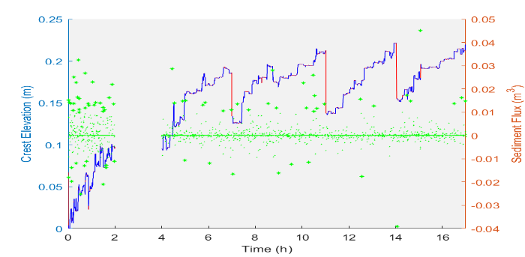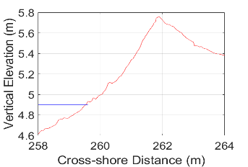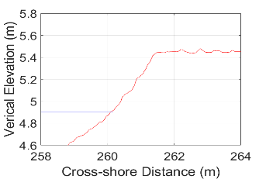
c)
b)
a)

Figure 1 – a) (Left axis) Crest Elevation gain with time for poorly-sorted angular dynamic revetment during water level increase, where blue indicates wave overtopping and red indicates no overtopping. (Right axis) Sediment Flux on a wave-by-wave basis denoted by the green stars. Berm profile for poorly-sorted angular material (b) and well-sorted, rounded (c), blue line represents still water level.

REFERENCES
Bayle, P.M., Blenkinsopp, C.E., Conley, D., Masselink, G., Beuzen, T., Almar, R., 2020. Performance of a dynamic cobble berm revetment for coastal protection, under increasing water level. Coast. Eng. 159, 103712.
Loman, G.J.A., van Gent, M.R.A., Markvoort, J.W., 2010. Physical Model Testing of an Innovative Cobble Shore, Part I: Verification of Cross-Shore Profile Deformation. Third Int. Conf. Appl. Phys. Model. Port Coast. Prot. 10.

