S2SHORES: A PYTHON LIBRARY FOR ESTIMATING COASTAL BATHYMETRY

Erwin W. J. Bergsma, Earth Observation Lab, French Space Agency (CNES), Erwin.Bergsma@cnes.fr
Rafael Almar, IRD-LEGOS, Rafael.Almar@ird.fr
Alain Giros, French Space Agency (CNES), Alain.Giros@cnes.fr
Solange Lemai-Chenevier, Earth Observation Lab, French Space Agency (CNES), Solange.Lemai-chenevier@cnes.fr
Gregoire Thoumyre, IRD-LEGOS, Gregoire.Thoumyre@legos.obs-mip.fr
Stephanie Artigues, Earth Observation Lab, French Space Agency (CNES), Stephanie.Artigues@cnes.fr
Thierry Garlan, French Hydrographic Office (SHOM), Thierry.Garlan@shom.fr
Romain Degoul, THALES Services Numériques, romain.degoul@thalesgroup.com

INTRODUCTION
Understanding coastal zone dynamics covering large spatial and dense temporal scales is paramount to understand and mitigate emerging coastal issues relating to climatological changes. However, the uncertainties on the coastal zone risks are still too large to predict effectively impacts on an overall increasing coastal population. Prediction, by deploying numerical models for waves, tide, and currents in the coastal zone, requires accurate and up-to-date bottom boundary conditions (bathymetry) to simulate coastal hydrodynamics accurately, let alone predict morphological change.

To measure bathymetry, the application of traditional methods, like RTK-GPS echo soundings, is not feasible at a regional to a global scale with an appropriate revisit (Bergsma et al., 2022) in a labour and cost-effective manner. Earth observation is thus promising and rather essential to monitor the coastal zone effectively (Melet et al., 2020) with a variety of space-borne measurements for coastal engineering purposes (Turner et al., 2021).

There are three main approaches for estimating coastal bathymetry using satellite sensors: 1) linking water depth to a spectral response (colour), 2) underwater photogrammetry and 3) linking wave kinematics to a water depth. The first one is the most developed and applied to satellite optical imagery since the 1970s (Lyzenga 1978) while it remains reasonably limited to non-turbid waters and relatively shallow water due to colour saturation in deeper waters (Caballero et al. 2019). The second approach, underwater photogrammetry, is even more limited to clear waters and rather complicated, given the angle deflection under water (Hodul et al., 2018). The use of wave kinematics from satellite optical imagery is relatively new (Abileah 2013, Almar et al., 2019, Bergsma et al., 2019, 2021), and has the potential to accurately estimate depth in deeper waters and turbid conditions. Here, we present S2Shores (Satellite to Shores), a python library that detects and extracts local wave parameters (geometry and kinematics) to derive coastal bathymetry.

S2SHORES
S2Shores is a packaged python library that contains the core codes to derive wave field characteristics and estimate bathymetry (WKB). Base papers (Almar et al., 2019, 2022, Bergsma et al., 2019, 2021) outline the physical principles behind the derivation of the wave characteristics and bathymetry. S2Shores is developed on and optimised for satellite optical data characterised by sparse temporal sampling in time when compared to general wave dynamics. Its application, however, is not limited to satellite only and can be used for shore-based video camera systems and UAVs (drones). The structure of S2Shores aims to be agile with the subsequent processing steps:

- Image processing and data curation
- Wave geometry detection – statics
- Wave motion detection – dynamics
- Depth retrieval through inversion

We aim to keep this base structure while maximising agility in terms of input, processing possibilities and potentially outputs (not depth only). For example, the input image and processing should support any kind of sensor, optical, radar or other. In addition, the wave geometry part currently contains a method to detect wavelength(s) (number) and wave direction(s); but the object-orientated structure of the code allows any other detection method to do the same; perhaps adding more geometry-related parameters, methods that better detect or detect more efficiently. The same holds for all processing steps.

S2Shores currently contains three methods to estimate wave-characteristics, which share their aimed physics but differ in the aimed measurement. For example, the spatial correlation aims to detect a Δx (spatial displacement) and the spectral method a Δφ (spectral phase shift) over a small time delay Δt (Bergsma et al., 2019, 2021). The third, a temporal method, reconstructs a local time series by making a spatio-temporal link between the wave pattern and its displacement (Almar et al., 2019). Grouping identical procedures in objects, streamlines the code while also achieving homogenisation. As an example, while one wave dynamics method searches Δx and the other Δφ, they are intrinsically linked as the equation at the bottom of Figure 1 shows. When two measurements are obtained, the third one is automatically deducted and the physics solved. The time delay (Δt) is either a given between two images, or as in the case of the optical satellite Sentinel 2, has to be calculated requiring raw information on the satellite. Roll, yaw, pitch and position are not publicly available and, thus, an accurate estimation of the detector band delay (Δt) depending on the satellite’s latitude is made available after Binet et al, (2022). With the time delay to our disposal, we only need one more measurement to solve the system of equations. In Figure 1, we have added the combination Δx, Δt and T but one should be aware with only 2 or a few frames/images and thus points in time, to deduct T directly from the imagery would be a very challenging task. Shore-based video systems, space-borne (quasi-) videos (Almar et al. 2022) or video approximations (Gawehn et al. 2022) enable this approach but here we focus on temporally sparse sampled data.

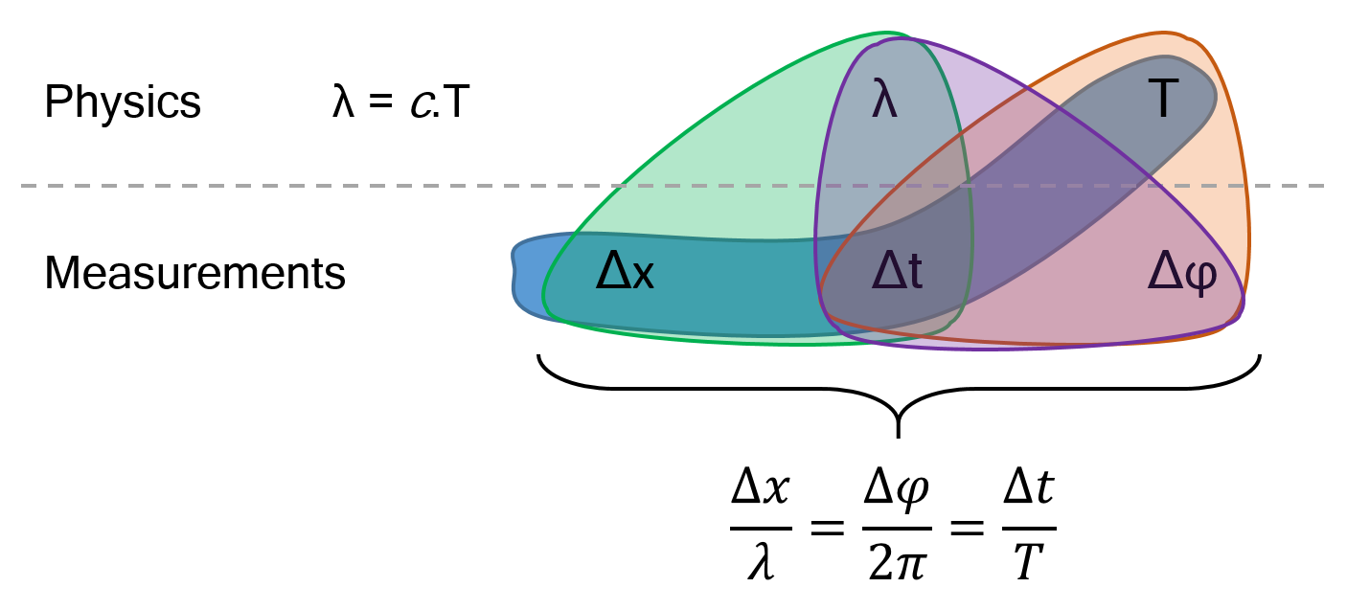
Figure 1 – Schematic overview of the separation between physics: wavelength (λ) and wave period (T), and the measurable parameters using satellite imagery. Notably, Δφ can be spatial as well as temporal depending on what series the spectral analysis is deployed.

Additional measurement, for example the ocean’s free surface and/or wave height, should be structured in the same way. The wave height is a physical parameter, and following Almar et al., (2021) can be estimated through measuring view-angles (which are delivered with the publicly available LEVEL1C Sentinel 2 products).

There is also a certain need for speed if one wants to deploy this bathymetry estimation tool at large regional (Daly et al., 2022) to global scales (Almar et al. 2021). To do so, S2Shores is optimised/parallelised using a Dask parallelisation (Rocklin, 2015). The code is in principle developed to run on servers, particularly for a large-scale implementation, but is well adapted to run on a local machine. To give an order of magnitude, the result shown in Figure 2 ran in 89,20 seconds on a HPC cluster, using 5 Dask-jobs with each 8 cpu-nodes, that cut the scene in 36 parts. On land we do not calculate a bathymetry, and we stop the calculation, resulting in ≈3.25 effectively used cpu-nodes and approximately 9,5 GB associated memory.

RESULTS
Figure 2 shows an example result of S2Shores covering an area in the order of 4400 km² of water around the Gironde (MGRS-tile 31TXR) at 500x500 m resolution. This resolution is similar to the world atlas (Almar et al. 2021) but the resolution itself is numerically unlimited however, one needs to pose the question if the wave conditions can resolve sought morphological features. For the performance per detection method or inversion, we refer to the base papers pointed out earlier. The depth estimation result in Figure 2 represents a single estimation method, in this case the spatial correlation for a single layer. Single layer in this case means, for each point we take the single most radiometrically energetic direction, estimate the propagation for that direction so on, and so forth. Notably, all methods, but particularly the spectral method, can generate multiple depth estimations per point, considering the possible multitude of wave patterns at a given point. Hence, for the single method, single layer, unfiltered result in Figure 2 we do see some estimation noise in the deepest and shallowest parts of the domain. Similarly, diagonal lines of absent depth estimations, following the satellite’s orbit, accentuates the interface between two detectors (Sentinel 2 has 12 detectors and 12 detector bands --more details in the ESA User manual or Binet et al, (2022)).
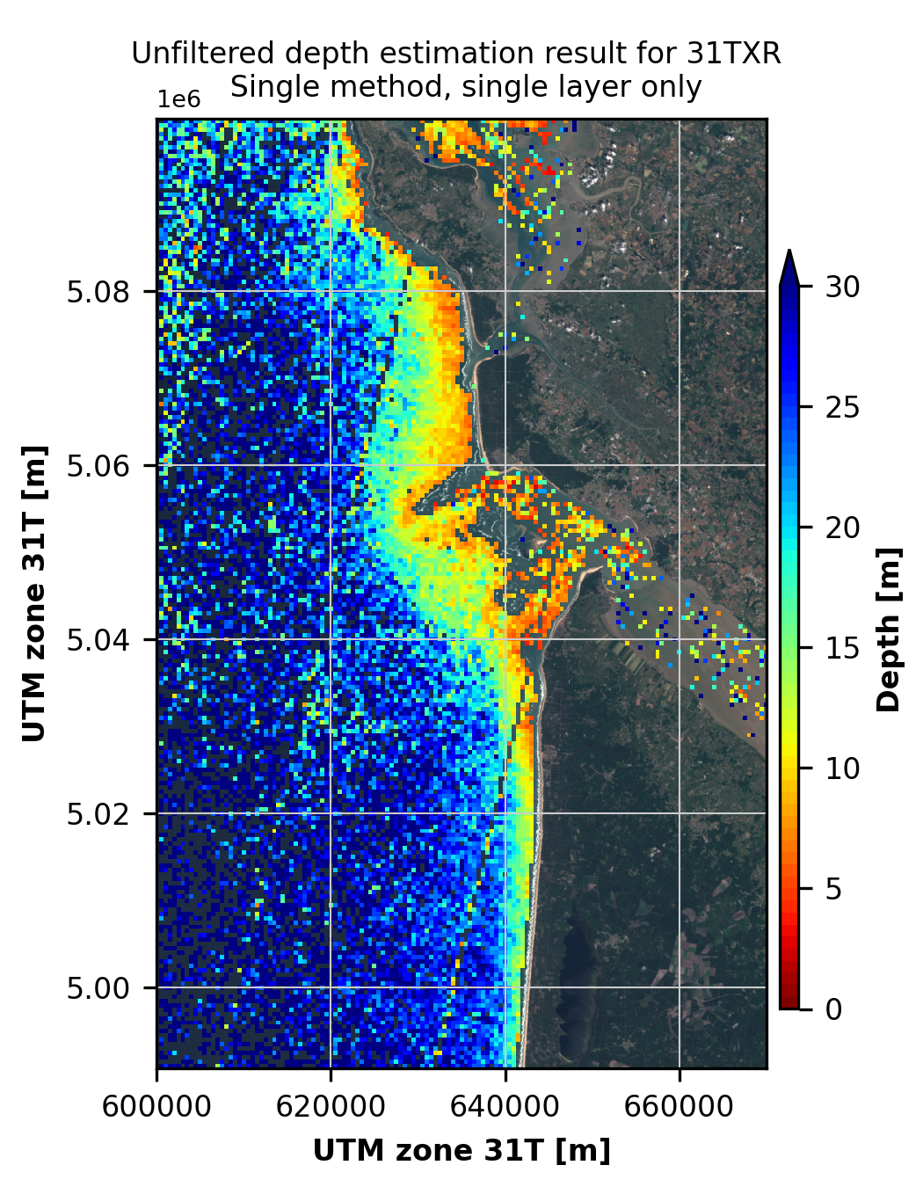
Figure 2 – A single method, single layer, thus unfiltered, depth estimation result using S2Shores around the Gironde delta, stretching from the North of Ile d’Oléron to just North of Lacanau, at the French Atlantic coast. Image used: Level 1C Sentinel 2, tile 31TXR on 22 June 2020 at 10H56.

Nonetheless, the estimated bathymetry performs according to the expectations. Without any filtering, for example including estimations in the estuaries, S2Shores estimates morphological features in the challenging Gironde estuary (e.g. linked to wave-current interactions). For the moment of image acquisition, with those waves, the offshore depth limit for the inversion was around 30 m water depth. In the shallowest waters, 0-10 m, 37% of the estimates are within the IHO standards (IHO, 2020). That seems a low percentage, but these standards are strict and often a challenge for satellite derived bathymetry methods to conform to. Between 10 to 20 m water depth, these inversion methods currently work most optimally. An r² of 0.97, a bias of 0.51 m, NMAD of 2.98 m and a RMSE of 3.84 m reflects this performance. Bear in mind, these are single method, single layer, and unfiltered, non-assimilated results.

PERSPECTIVES
S2Shores is a work in progress, a tool designed to evolve dynamically incorporating new methods and approaches in an object-orientated manner. One can think of better ways to detect the geometry or wave motions, estimation of the ocean’s free surface as mentioned before but also inversion formulae or approaches. Currently, S2Shores contains depth inversion through the linear dispersion relation, due to the lack of a measured amplitude, but one can think of non-linear or other formulae as well. Local instantaneous assimilation, on point-by-point basis, instantaneous spatially coherency of a single date to reduce noise and eliminate faulty depth estimates as well as multi-temporal assimilation have the potential to improve significantly overall performance of bathymetry estimations (van Dongeren et al., 2008; Holman et al., 2013). Usable satellite optical imagery from, for example regular acquisitions of Sentinel 2, depend on the cloud coverage, satellite orbits and wave conditions but have the potential to deliver multiple estimates per month (Bergsma and Almar 2020). Complemented by tasked satellite imagery, e.g. Pleiades (Neo) or worldview, the overall precision (and accuracy) is to improve further. Eventually leading to a coastal monitoring tool enabling small and large-scale analysis of morphodynamics, engineering applications and climatological impacts.

CONCLUSION
We present a new, state of the art, python library S2Shores for bathymetry estimation using (but not limited to) satellite data. This work sets out the principle framework of S2Shores, processing structure and current implementations. The object-orientated structure and parallelisation streamlines the processing enabling large-scale applications. The outline for further improvements guides near-future research/engineering efforts. To accelerate and promote efforts and support open science this bathymetry estimation library will be open to the public, to use, modify, and contribute.

ACKNOWLEGDEMENTS
As part of the code development and Dask optimisation, we are indebted to the High-Performance Computing team at CNES: https://centredecalcul.cnes.fr/en/data-processing-centre. S2Shores is developed in the framework of a cooperation between CNES, IRD-LEGOS and Shom.

REFERENCES
Abileah, (2013). Mapping near shore bathymetry using wave kinematics in a time series of worldview-2 satellite images. In: 2013 IEEE International Geoscience and Remote Sensing Symposium - IGARSS. pp. 2274–2277.
Almar et al. (2019). Wave-derived coastal bathymetry from satellite video imagery: A showcase with Pleiades persistent mode. Remote Sensing of Environment, 231, 111263
Almar et al. (2022). Coastal Topo-Bathymetry from a Single-Pass Satellite Video: Insights in Space-Videos for Coastal Monitoring at Duck Beach (NC, USA). Remote Sens., 14(7), 1529
Almar et al. (2021). Global satellite-based coastal bathymetry from waves. Remote Sensing, 13(22), 4628
Bergsma et al. (2019). Radon-Augmented Sentinel-2 Satellite Imagery to Derive Wave-Patterns and Regional Bathymetry. Remote Sens. 2019, 11, 1918.
Bergsma and Almar (2020). Coastal coverage of ESA' Sentinel 2 mission. Advances in Space Research.
Bergsma et al. (2021). Coastal morphology from space: A showcase of monitoring the topography-bathymetry continuum. Remote Sensing of Environment, 261, 112469.
Bergsma et al. (2022). Wave variability along the world’s continental shelves and coasts: monitoring opportunities from satellite Earth observation. Advances in Space Research.
Binet et al. (2022). Accurate Sentinel-2 inter-band time delays. ISPRS Annals of the Photogrammetry, Remote Sensing and Spatial Information Sciences, -1-2022, 57-66.
Caballero et al. (2019). Preliminary assessment of turbidity and chlorophyll impact on bathymetry derived from sentinel-2a and sentinel-3a satellites in south Florida. Remote Sensing 11 (6).
Daly et al. (2022) The New Era of Regional Coastal Bathymetry from Space: A Showcase for West Africa using Sentinel-2 Imagery. Remote Sensing of Environment.
van Dongeren et al. (2008). Beach wizard: Nearshore bathymetry estimation through assimilation of model computations and remote observations, CoastalEng., 55, 1016–1027
Gawehn et al. (2022). Depth Inversion from Wave Frequencies in Temporally Augmented Satellite Video. Remote Sens. 2022, 14, 1847
Hodul et al. (2018). Satellite derived photogrammetric bathymetry. ISPRS Journal of Photogrammetry and Remote Sensing. Vol 142, pp. 268-277.
Holman et al. (2013). cBathy: A robust algorithm for estimating nearshore bathymetry. J. Geophys. Res. 118, 1–15.
International Hydrographic Organization (2020) IHO Standards for Hydrographic Surveys, Edition 6.0.0, September 2020. Monaco, International Hydrographic Organization, 41pp.
Lyzenga (1978). Passive remote sensing techniques for mapping water depth and bottom features. Appl. Opt. 17 (3), 379–383
Melet et al. (2020). Earth observations for monitoring marine coastal hazards and their drivers. Surveys in Geophysics, 41(6), 1489-1534.
Turner et al. (2021). Coastal Engineering in the satellite era. Coastal Engineering, 167, 103919
International Hydrographic Organization (2020) IHO Standards for Hydrographic Surveys, Edition 6.0.0, September 2020. Monaco, International Hydrographic Organization, 41pp.
Rocklin, M. (2015). Dask: Parallel computation with blocked algorithms and task scheduling. In Proceedings of the 14th python in science conference.

