LABORATARY STUDY OF THE VERTICAL RETREATING SAND WALL OBSERVED IN COASTAL FLOW SLIDES

Xiamei Man, David P Callaghan, Peter Nielsen, The University of Queensland, x.man@uq.edu.au

Coastal flow slides have been reported around the world (Mastbergen et al., 2019; Nédélec et al., 2022), often at over-steepened banks subject to strong tidal flows, pose threat to coastal communities and infrastructure (Lulla, 2017). With sea level rise caused by climate change, these flow slides are expected to occur more frequently in more sites worldwide.
Amity Point Beach, North Stradbroke Island (27º 23’ 35’’S, 153º26’23’’E), about 40 km from Brisbane, Australia, have experienced regular coastal flow slides for more than 40 years (Eberhardt, 1978). The frequency is once every two to three weeks and the flow slide location is fixed at the end of the L-shaped rock wall (Figure 1).

Together with observations at Amity Point beach field site, small-scale flow slides are simulated in laboratory by tilting metal box filled with sand and fluid. The key questions investigated by the laboratory work include:

CORRELATION BETWEEN RETREATING WALL VELOCITY AND SAND, FLUID CHARACTERISTICS
In the micro-scale flow slide process, sand grains are pulled out of the vertical wall by gravity, which produces expanding pores behind the grains. These expanding pores result in a pressure gradient, pushing surface grain inwards and fluid into the expanding pores. This multi-phase process involves both physics of sand and fluid, also the sand/fluid mixture. In this study, four types of sand and two types of fluid (water and silicone oil) were adopted to simulate small-scale flow slides. The dataset produced by this study leads to a correlation between retreating sand wall velocity and sand, fluid characteristics including sand density, sand grain size, sand compaction and fluid viscosity.

SAND COMPACTION AND FLOW SLIDE OCCURRENCE
An important question of coastal flow slide is the sand compaction. There have been studies claim coastal flow slides occur in compacted sand (Alhaddad et al., 2020), while existing field data at Amity Point Beach shows coastal flow slide occur with loose sand. To tackle this question, this study measures the friction angles and hydraulic conductivities of four types of sand from loosen to compacted status. These four types of sand are of different grain sizes and densities.

Together with the field observation, this study will provide insight into the micro-scale mechanism of coastal flow slide, which is useful for coastal erosion prevention and mitigation.

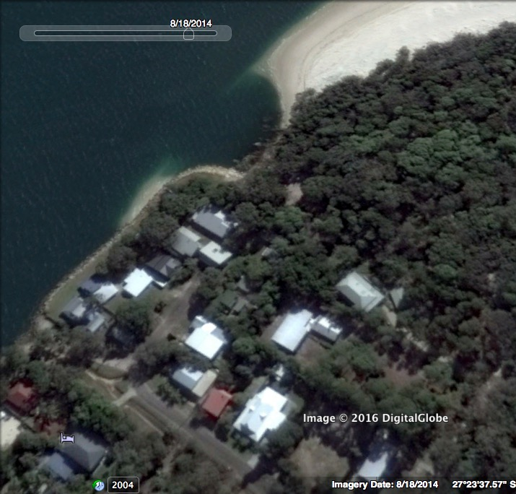
Figure 1 – Photo of Amity Point beach shortly after a flow slide event. Image date: Aug 18, 2014.

REFERENCES
Alhaddad, S., Labeur, R. J., & Uijttewaal, W. (2020). Breaching Flow Slides and the Associated Turbidity Current. Journal of Marine Science and Engineering, 8(2).
Eberhardt, J. (1978). Erosion at Amity Point-an example of shoreline recession in a tidal inlet.
Lulla, F. (2017). Observations and Influence of Breach Height and Wall Velocity of Retrogressive Breach Failures eroding the Shoreline at Amity Point, Australia.
Mastbergen, D. R., Beinssen, K., & Nédélec, Y. (2019). Watching the Beach Steadily Disappearing: The Evolution of Understanding of Retrogressive Breach Failures. Journal of Marine Science and Engineering, 7(10).
Nédélec, Y., Fouine, P., Gayer, C., & Collin, F. (2022). Time-Lapse Camera Monitoring and Study of Recurrent Breaching Flow Slides in Cap Ferret, France. Coasts, 2(2).

