APPLICATION OF A NUMERICAL MODEL AND BATHYMETRIC INVERSION ALGORITHMS TO ENHANCE UNDERSTANDING OF NEARSHORE CHANGE

Elora M. Oades, Queen’s University, elora.oades@queensu.ca
Ryan P. Mulligan, Queen’s University, ryan.mulligan@queensu.ca
Margaret L. Palmsten, U.S. Geological Survey, mpalmsten@usgs.gov

INTRODUCTION
During extreme wave events, shoaling occurs farther from shore, extending the surf zone width and intensifying wave breaking (Thornton and Guza, 1983; Mulligan and Hanson, 2016). Nearshore bathymetry is difficult to monitor when the surface wave height approaches or exceeds the breaking limit, which is proportional to the ratio between the wave height (H) and water depth (d). Amphibious vehicles and other vessel-based techniques such as the Coastal Research Amphibious Buggy (CRAB) (Birkemeier et al., 1984) and the Lighter Amphibious Resupply Cargo (LARC) (Forte et al., 2017) platforms, provide high-quality bathymetric surveys but are infrequent and are unsafe for use when significant wave height (H_{s}) exceeds 1.5 m; a common wave height on exposed beaches in even low energy wave events. Remote sensing using digital cameras is an inexpensive way to gather continuous observations of the surf zone and calculate water depths based on phase speed. This study investigates the robustness of the newly released version of cBathy (Holman et al., 2013; Holman and Bergsma, 2021), a bathymetric inversion algorithm. cBathy is employed in moderate to energetic wave conditions using synthetic water level data generated by the non-hydrostatic numerical phase resolving model, SWASH (Simulating WAves till Shore) (Zijlema et al., 2011; Gomes et al., 2016; Fiedler et al., 2019).

BACKGROUND
The interpretation of wave signals by imagery is described by the Modulation Transfer Function (MTF). One such visual signature is the oscillation of pixel intensity that can be exploited to interpret the wave field and underlying bathymetry. This relationship, however, is disrupted during wave breaking as the pixel intensity rapidly changes; the low-intensity signal of an unbroken wave face jumps to high pixel intensity due to foam. This disruption has been a primary limitation of cBathy application to optical imagery as the surf zone often dominates the visual field.

An important and promising feature of cBathy is the potential to track storm-induced morphological change, literature is consistent in showing that cBathy’s lowest RMSE values are obtained when incident wave height (H₀) remains below a 1.2 m threshold (Stockdon and Holman 2000; Holman and Haller, 2013; Brodie et al., 2018; Bak et al., 2019), which is significantly less than wave energy during even low to mid-energy storms. While previous research has included mid-high energy wave conditions, conclusions have been unanimous in excluding high-energy wave heights from cBathy’s valid range of recommended use. In this work, we aim to improve the bathymetry estimates during storm events, without eliminating these periods as recommended by previous work. The first step in that effort is to isolate the errors introduced by optical imaging of waves from the errors related to depth-inversion and the limitations of the linear dispersion relation. This is achieved using the phase-resolving numerical model (SWASH) to generate synthetic wave data to test the cBathy algorithm.

METHODS
cBathy is a depth-inversion algorithm that remotely senses bathymetry (h) by estimating incoming frequency (f) and wavenumber (k) from a time series of incoming wave data (Holman et al., 2013). Wave data is usually represented by pixel intensity, collected at camera-based (optical) remote sensing stations. The Argus station at the study site at the US Army Corps of Engineers Field Research Facility (FRF) in Duck, NC, consists of six temporally synchronized high-resolution video cameras which sit atop a 43 m tall tower and transfer data to a computer station.

To remove disruptions to the MTF from the optical sensing data type, the cBathy algorithm has also been forced with synthetic water surface elevation data generated by SWASH, the numerical wave-flow model that resolves free-surface flows. Here, we force SWASH with known bathymetry collected within a week of the energy events and nine simulations are conducted with H_{s} ranging from 0.37 m to 3.39 and T_{p} from 6.3 s to 12.4 s.

The spatial distribution of wave breaking represented by the simulations is determined using SWASH’s ‘breakpoint’ output: the breakpoint, B, is a binary array that masks nodes where breaking occurs. Wave breaking is modelled as a hydraulic bore or a moving hydraulic jump in which the vertical free surface speed (∂ζ/∂t) is tracked. Wave breaking, B, is initiated when the wave celerity exceeds a certain fraction (α) of the shallow water celerity and ceases when ∂ζ/∂t decreases below a lower value (β), as defined by Eq. 1:
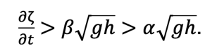
(1)

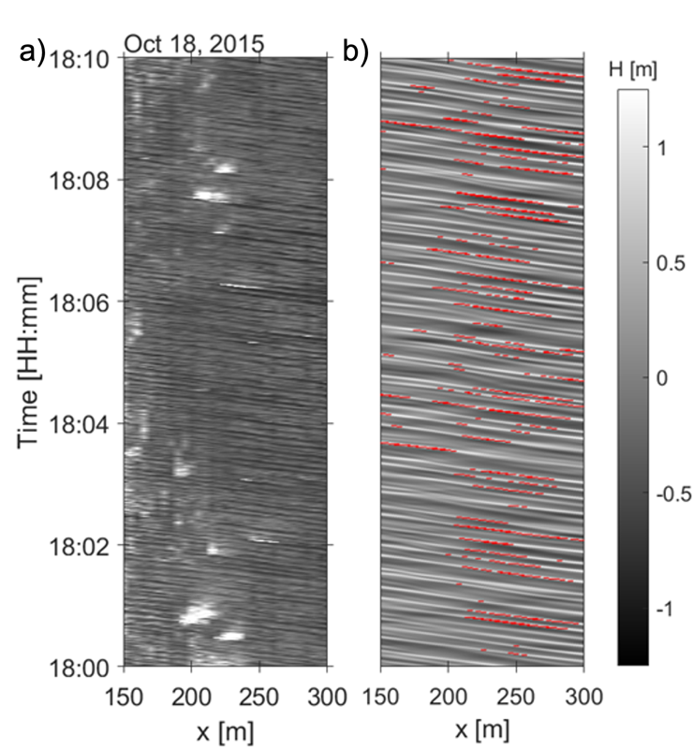
where ζ is the instantaneous free surface elevation measured from the still water level, and h, is the total water depth (where h = ζ + d). These parameters, wave breaking onset and cessation values (α, β), were expanded wider than defaults (0.3, 0.6 to 0.2, 0.7) to generate a breakpoint mask that more closely resembled the breaking-induced white foam observed in the Argus timex (10-minute average time exposure) images over the same period. At grid points where wave breaking is activated, calculations are hydrostatic and conserve momentum to represent energy dissipation most accurately at the wavefront.
Figure 1 – Timestacks at the y = 700 m transect from 18-October-2015 from a) Argus video imagery; b) SWASH’s water surface elevation with the breakpoint binary array (B) superimposed in red.

RESULTS
Delineating areas of high wave breaking occurrence in both data types allows us to investigate whether there exists a causation between wave breaking and depth estimate errors. Focusing on the results for one time (18-Oct-2015 18:00), the bulk incident wave characteristics measured at the 11 m AWAC are: H_{s} = 1.34 m; peak spectral period T_{p} = 6.3 s; peak wave direction from shore normal θ_{p} = 25°, and mean sea surface elevation η = +0.65 m. For this case, Fig. 1 shows 10-minute timestacks of the optical and synthetic data. Synthetic wave breaking is superimposed in red, for an easier comparison of breaking coverage. In the synthetic numerical data (Fig. 1b), breaking is initiated slightly farther out in the x-direction but does not persist for as long once it is initiated, compared to the optical observations. This could be due to changes in the bar position since the previous survey (Fig.1a), 3 days prior to the simulation time. In optical data, wave breaking occurs within the 250 m line in the x-direction and white foam stays visible for several seconds until the turbulence and aerated region dissipates.

The results of cBathy V2.0 depth estimates for both data input types are compared to nearshore surveys over the overlapping area of the data types (ranging from x = 100–500 m in the cross-shore direction. Comparison of survey depth to SWASH-generated depth estimates for cBathy V2.0 (Fig. 2 a-b) indicates SWASH’s ability to capture characteristics of wave breaking (Fig. 2 c-d). The differences between cBathy and survey values indicate that errors due to wave breaking near the bar, present in results from optical data are not present for the synthetic case. The bar location is well resolved at all times, with overall depth estimates remained within ± 0.5 m of survey values.

Certain frequency-dependent error metrics such as skill (s) are computed at each pixel location. Skill is cBathy’s proxy for how accurate its depth estimate might be and provides a parameter by which to filter out results. During the highest wave events, optical inputs produced lower skill (0.75), suggesting lower skill may be related to more intense wave breaking. By investigating the frequency (f) and wavenumber (k) pairs calculated with cBathy, the data tends to agree with the linear dispersion relation, particularly at lower values of the breaking index.

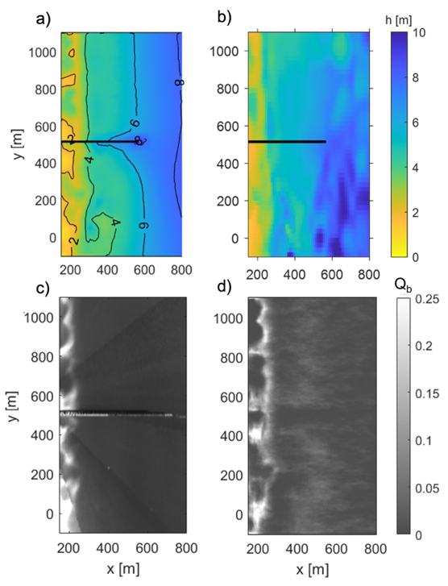
The overall performance results are described by the variation in root-mean-squared errors (RMSE) with significant wave height, and with depth. These results show that RMSE are dependent on water depth, significant wave height, and domain coverage by breaking waves. cBathy V2.0 consistently performs better than the preceding version, when comparing depth estimates to survey observations. The present study demonstrates the algorithm’s robustness during larger wave events (H_{s} ≤ 3.4 m), and presents opportunities to expand the current use.

Figure 2 – Sample results using data from mid-October, 2015 at the FRF in Duck, NC; showing a) bathymetry from 10-15-2015; b) cBathy V2.0 depth-estimates using SWASH data; c) Argus timex image; and d) breaking index, calculated using SWASH.
REFERENCES
Birkemeier, and Mason (1984): The CRAB: A unique nearshore surveying vehicle. Journal of Surveying Engineering, 110(1), pp.1-7.

Fiedler, Smit, Brodie, McNinch, and Guza (2019): The offshore boundary condition in surf zone modeling. Coastal Engineering, vol. 143, pp.12-20.

Forte, Birkemeier, and Mitchell (2017): Nearshore survey system evaluation. ERDC-CHL Vicksburg United States.

Gomes, Mulligan, Brodie, McNinch (2016): Bathymetric control on the spatial distribution of wave breaking in the surf zone of a natural beach. Coastal Engineering, vol. 116, pp. 180-194.
Holman, Plant, Holland (2013): cBathy: A robust algorithm for estimating nearshore bathymetry. Journal of Geophysical Research: Oceans, vol. 118, pp. 2595-2609.
Holman, Bergsma (2021): Updates to and performance of the cBathy algorithm for estimating nearshore bathymetry from remote sensing imagery. Remote Sensing, vol. 13, pp. 3996.
Mulligan, Hanson (2016): Alongshore momentum transfer to the nearshore zone from energetic ocean waves generated by passing hurricanes. Journal of Geophysical Research: Oceans, vol. 6, pp. 4178-4193.
Thornton, Guza (1983): Transformation of wave height distribution. Journal of Geophysical Research: Oceans, vol. 88, pp. 5925-5938.
Zijlema, Stelling, Smit (2011): SWASH: An operational public domain code for simulating wave fields and rapidly varied flows in coastal waters. Coastal Engineering, vol. 58, pp. 992-1012.

