STORM AND TSUNAMI OVERWASH SEDIMENT TRANSPORT INFERRED FROM RECENT DEPOSITS

Bruce Jaffe, US Geological Survey, bjaffe@usgs.gov SeanPaul La Selle, US Geological Survey, slasalle@usgs.gov

INTRODUCTIONS
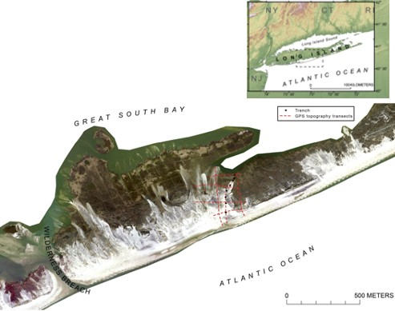
Overwash deposits from storms and tsunamis record information about sediment transport and flow that can be used to inform hazard assessments. Here we explore deposits from two extreme wave events: (1) the 2012 Hurricane Sandy, a Category 5 hurricane that is the largest storm in the Atlantic basin on historical record, and (2) the 2011 Tohoku-oki tsunami, created by a 9.0 Mw earthquake, that was up to 20 m high at the coast.

STUDY AREAS
Overwash was investigated at two study areas: (1) eastern Fire Island for Hurricane Sandy (Figure 1) and
(2) the coastal plain near the Sendai Airport, Honshu, Japan, for the Tohoku-oki tsunami (Figure 2). Both areas have low-lying inland areas fronted by coastal dunes.

METHODS
Field and laboratory methods were used to document features of the storm and tsunami overwash deposits. Field methods included describing and photographing trench walls, surveying topography using differential GPS (DGPS), and collecting sediment samples and cores for laboratory analyses (Richmond et al., 2012; La Selle et al., 2017). Laboratory investigations included grain size analysis of both surface and subsurface samples, and X- ray Computed Tomography (CT) scans of cores to document internal structures. In addition, sediment transport modeling was also carried out using both forward and inverse numerical models.

RESULTS AND CONCLUSIONS
Hurricane Sandy deposits in eastern Fire Island range from 1 m thick near the shore (~150 m inland) to 1 cm in the back-barrier marsh (350 m inland). Deposits, primarily composed of thin laminated beds (1-20 mm thick) indicate deposition by bedload transport. The seaward trenches contained a decimeter-scale thick base that was a well sorted, medium sand, with very similar grain-size distributions compared with “old” dune sample, suggesting that erosion of the dune in the early stages of overwash was the primary source of sediment for the washover fan. Both suspended and bed load transport likely contributed to formation of the base.
Tohoku-oki tsunami deposits generally thinned inland ranging from ~30 cm thick near the shore (0.2 to 1 km) to <1 cm thick at 3 km inland. In contrast to Hurricane Sandy deposits, post-tsunami deposits were typically not laminated and exhibited fining up grain size trends indicative of suspended load transport.
Sediment transport differences between Hurricane Sandy and the Tohoku-oki tsunami were reflected in their overwash deposits. Further studies may be able to unlock additional information about sediment transport and flow differences between storms and tsunamis.

Figure 1 – Study area for Hurricane Sandy overwash investigation on Fire Island, New York, showing DGPS topography transects (dashed red lines) and trenches (black dots). Modified from La Selle et al. 2017.
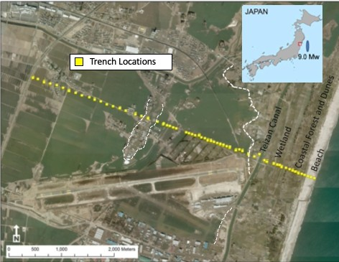
Figure 2 – Study area for Tohoku-oki tsunami overwash investigation at Sendai Airport, Honshu, Japan, showing trenches and the major morphologic boundaries. Modified from Richmond et al. 2017.

REFERENCES
La Selle, Lunghino, Jaffe, Gelfenbaum and Costa (2017): Hurricane Sandy washover deposits on Fire Island, New York, USGS Open-File Report 2017-1014, pp. 38.
Richmond, Goto, Fujino, Nishimura, Sugawara, Tappin, Witter, Jaffe, Chagué-Goff, Szczuciński, Yulianto and Goff (2012): Erosion, deposition, flow characteristics, and landscape change on the Sendai, Japan coastal plain resulting from the March 11, 2011 Tōhoku-oki tsunami, Sedimentary Geology 282, pp. 27-39.

