ENGINEERED FRINGING REEFS: ENGINEERING WITH NATURE SOLUTIONS FOR COASTAL EROSION CONTROL

Matthew Allen, Subcon International Pty Ltd, matt@subcon.com
Justin Geldard, University of Western Australia, justin.geldard@research.uwa.edu.au
Ryan Lowe, University of Western Australia, ryan.lowe@uwa.edu.au
Christopher Beaton, City of Cockburn, cbeaton@cockburn.wa.gov.au

INTRODUCTION

Over the past decade there has been extensive growth in the proposed use of ecosystem approaches to mitigating coastal hazard risks. However, quantitative guidelines for nature-based solutions are lacking, tend to focus on one solution only and this is impeding uptake.

Conventional engineering approaches typically rely on fully emergent breakwaters or seawalls like rubble mounds, caissons or panel attenuators that use concentrated, high energy methods to reflect and/or violently break wave energy. However, naturally occurring fringing reefs (coral or rocky) which protect vast portions of the world’s coastline from coastal erosion are typically submerged or partially emergent structures that attenuate energy though distributed energy mechanisms: drag dissipation and low energy wave breaking (Lowe, 2021). Drag is typically provided by canopies such as coral, macro algae or seagrass. Distributed wave breaking is the result of the reef morphology which typically causes a wave to break and reform multiple times over a wide area.

Multi-functional engineered reefs were designed and installed at two sites, Mon Choisy, Mauritius and C.Y. O’Connor beach in Western Australia. The reefs are designed replicate ecosystem services provided by naturally occurring reefs. The design considers the benefits provide by the reef canopy and a porous substrate morphology, as well as habitat for reef associated fishes. Dune restoration and revegetation also featured in the implementation. Testing, modelling and field trials at two sites, investigated optimal reef morphologies and the performance benefits provided by canopies to wave attenuation. Design guidelines are being developed with support of the Australian Research Council. 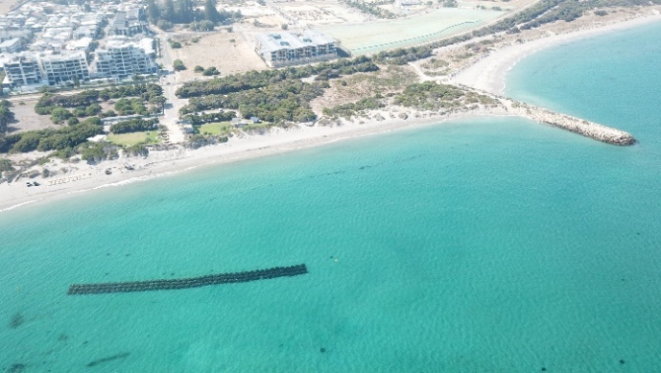Figure 1 – Aerial view of C.Y. O’Connor Fringing Reef
REEF ENGINEERING

Field observations and modelling at both sites demonstrated the efficacy of a low crested structure in reducing energy reach the beaches. Influence of storm surge and tides on transmission were quantified. This enables the design to consider how wave transmission varies through the tide cycle, rather than conservatively considering coincident peak conditions.
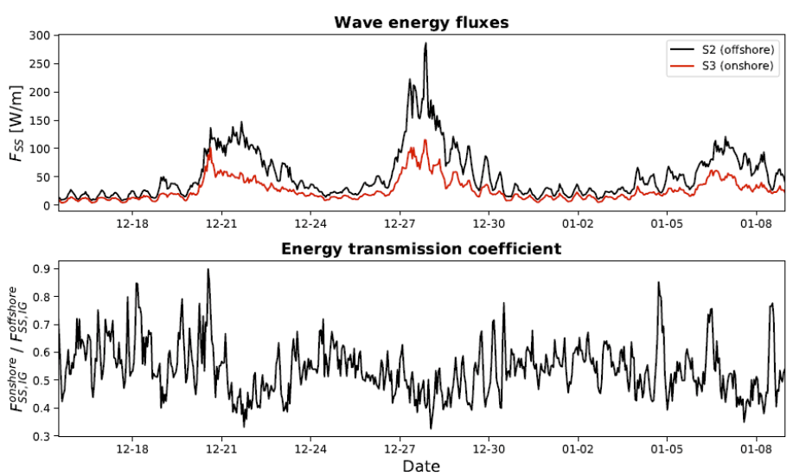
Figure 2 – Monitoring at Mon Choisy found wave energy transmission coefficients reach values down to ~0.4. [3]
Potential negative impacts were also investigated. The distance of the reef from the shore line plays a key role in the development of wave driven currents occurring in the lee. Too close proximity to shore can cause divergent flows which can negatively impact sand accretion.
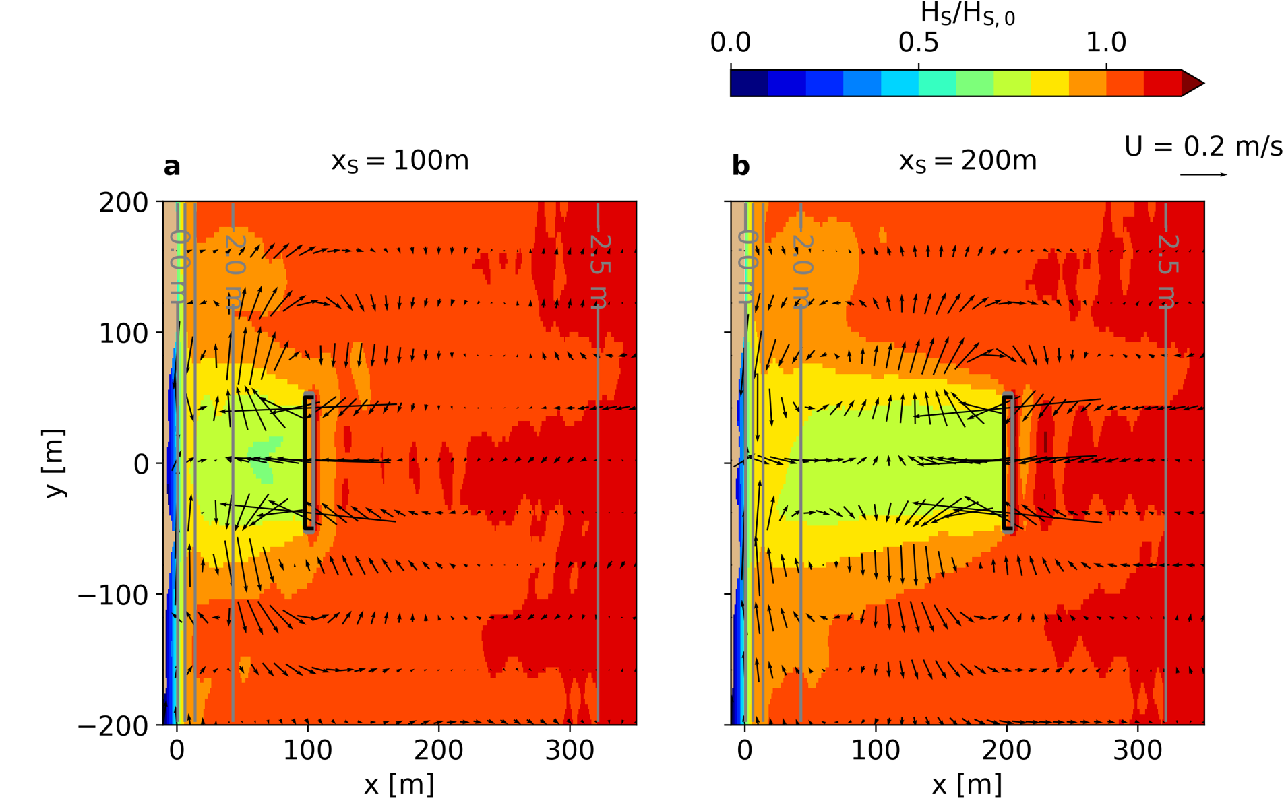
Figure 3 – Coupled wave-circulation modelling of reefs located at two distances from shore.

TESTING

Model testing of Subcon’s Bombora Reef modules at UWA’s Coastal and Offshore Engineering Laboratory was used to determine transmission coefficients at peak high tide, mean sea level and peak low tide. The influence of relative freeboard, wave steepness, degree of submergence and relative reef width on wave transmission was investigated and compared against existing data sets on both submerged breakwaters and different artificial reef modules (Geldard 2021).

Testing is continuing considering new reef module profiles including looking at the influence of canopies of coral and shellfish on rugosity, drag and wave transmission. By quantifying the performance improvement in transmission coefficient due to biofouling, we hope to include these in the design specification and thereby build a business case for nature based solutions such as shellfish seeding and coral outplanting.

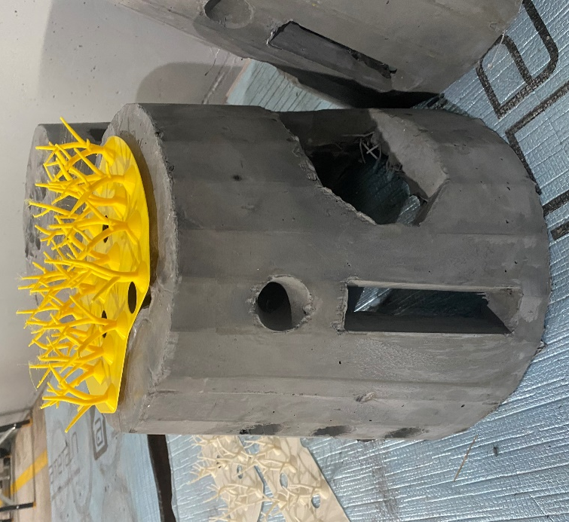
Figure 4 – Coral Canopy Transmission Coefficient Testing

PRACTICAL APPLICATIONS

Extensive beach erosion at both CY’ O’Connor and Mon Choisy Beaches impacted accessibility and amenity, threatening coastal communities and local economies.
Both sites are remediated with the construction of engineered reefs and dune restoration programs, Mon Choisy in 2019 and C.Y. O’Connor in 2022.
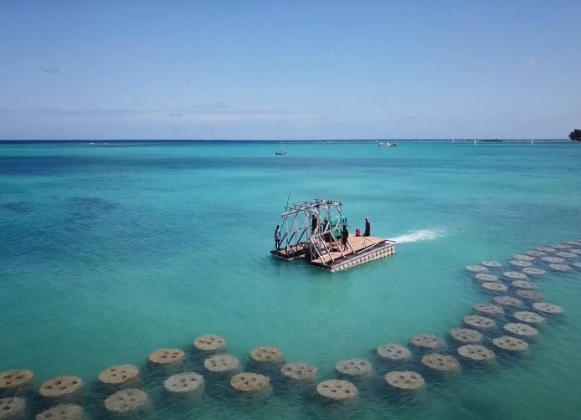
Figure 5 – Installation at Mon Choisy

Monitoring
Monitoring at Mon Choisy was conducted by UWA and is currently underway at CY O’Connor. Mon Choisy transmission coefficients as low as 0.4 were achieved (Figure 2).

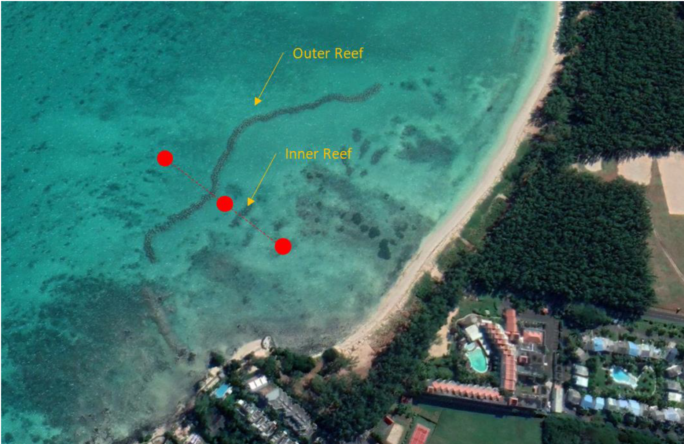
Figure 6 – Monitoring at Mon Choisy

REFERENCES

[1] Borrero, et al. (2016: Design and Assessment of Climate Change Adaptation and Erosion Control Measures for

[2] Mon Choisy Beach, Republic of Mauritius, 13th International Coral Reef Symposium, Honolulu, Hawaii.

[3] Geldard, et al. (2021): Performance of Engineered Wave Attenuating Reef Structures, Australasian Coasts & Ports.

[4] Lowe (2021): Advancing predictions of nearshore processes within coastal ecosystems, 2nd Sea State CCI User Meeting

