**AN INTER-COMPARISON STUDY OF GREEN AND GRAY STRUCTURE EFFECTS ON OVERLAND FLOW FLOODING AND FORCE ON COASTAL BUILDINGS**

Hai Van Dang, Hanyang Univerisity, [dangvanhai@hanyang.ac.kr](mailto:dangvanhai@hanyang.ac.kr)

Sungwon Shin, Hanyang Univerisity, [sungwshin@hanyang.ac.kr](mailto:sungwshin@hanyang.ac.kr)

Hyoungsu Park, University of Hawaii, [hpark9@hawaii.edu](mailto:hpark9@hawaii.edu)

Tori Tomiczek, United States Naval Academy, [vjohnson@usna.edu](mailto:vjohnson@usna.edu)

Daniel. T. Cox, Oregon State Univerisity, [dan.cox@oregonstate.edu](mailto:dan.cox@oregonstate.edu.)

Dong-Soo Hur, Gyeongsang National Univerisity, dshur@gnu.ac.kr

INTRODUCTION

Coastal communities have been prone to extreme inundations generated by storm surges and tsunamis. Especially inundated overland flows adversely impact low-lying areas. Therefore, mitigation solutions are essential in protecting human lives and infrastructures. So far, hard structures (gray structures) have been widely used to protect coastal communities against severe flooding. Recently, Natural and Nature-Based Features (NNBF, green structures) also have been studied for flood hazard mitigation, such as mangroves (Tomiczek et al., 2020), dunes, reefs, etc. However, the inter-comparison studies of gray and green structures in the flooding and force reduction have not been investigated sufficiently. Therefore, the present study investigated the physical and numerical model comparison of gray and green structures regarding flooding hydrodynamics and forces on the buildings.

LARGE SCALE EXPERIMENT

A scaled physical model was carried out in the Directional Wave Basin (48.8 m long, 26.5 m wide, 2.1 m deep) at Oregon State University. An offshore piston-type wavemaker generated long transient waves with different wave amplitudes, and surge levels, then flowed over a 1/20 slope beach and inundated an idealized coastal city with a series of buildings. The experiments have been conducted with varying configurations: (1) baseline (no mitigation); (2) seawall (SW); (3) submerged breakwater (SB); (4) both a seawall and a submerged breakwater (SWSB); mangrove forests arranged in (5) four rows (4M); and (6) eight rows (8M) (Figure 1a). In addition, load cells (LCs), pressure sensors (PGs), wave gauges (WGs), ultrasonic wave gauges (USWGs), and acoustic doppler velocimeters (ADVs) were installed offshore and built environments to obtain a synoptic data set of hydrodynamics (Figure 1b).



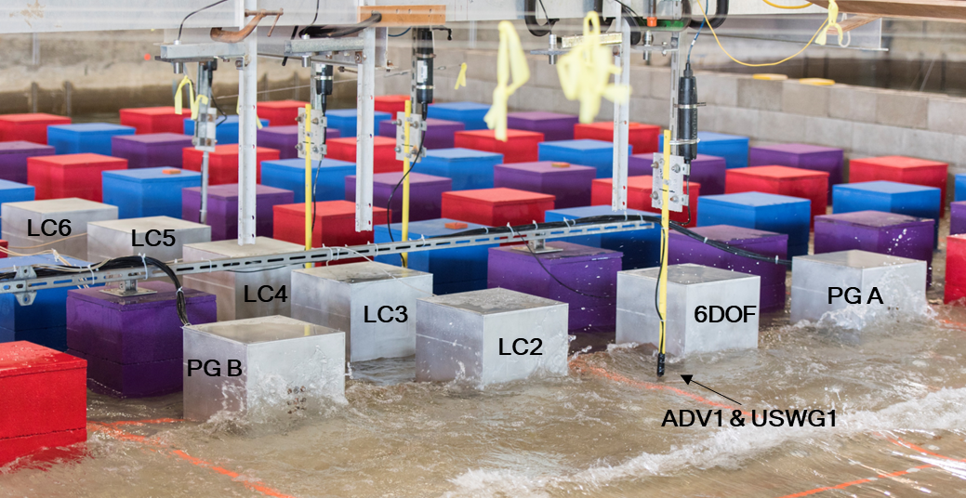

**(b)**

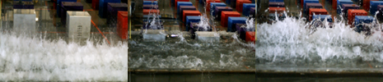

**(c)**

**(e)**

**(d)**

Figure 1 – Schematic representation (not to scale) and snapshots of physical setup (a, b) and snapshots of wave breaking in three different wave cases (c, d, e).

Figure 2 represents an example of time histories of horizontal forces measured at the first five building rows in the constructed environment for an offshore water depth of 0.98 m and wave amplitude of 2.1 m. As shown in this figure, structural configurations induced later arrival times and reduced forces of the overland flow exerted in building arrays compared to the baseline case. Significantly, the arrival time in the gray structures was relatively delayed in the green structure conditions.

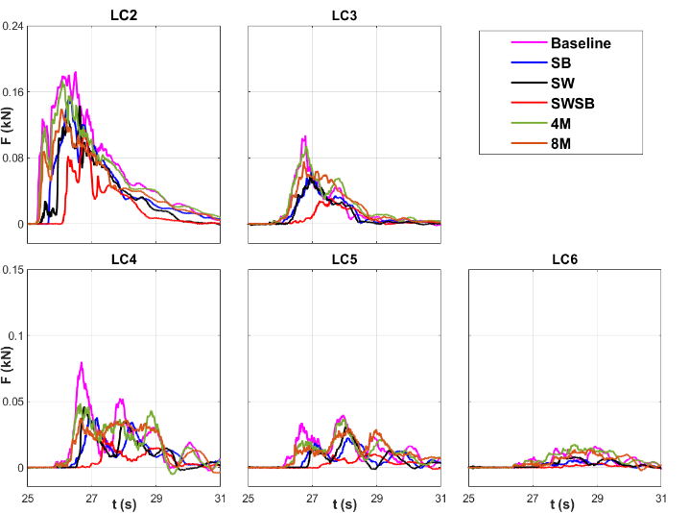

Figure 2 – Time series of horizontal forces measured by LC2-6 for baseline and structural configurations.

To examine the effectiveness of each flooding mitigation alternative in reducing horizontal forces on the building rows, the force reduction factor (FRF) was utilized in this study. The FRF was defined as a normalized maximum force recorded in the countermeasure configurations by the maximum baseline force, a similar concept suggested by Moris et al. (2021). Figure 3 compares green and gray structures in the force reduction factors during the first five building rows. FRFs monotonically decreased with an increase in the cross-shore distance. A significant FRF reduction up to four times was observed from 33.3 m < *X* < 35.7 m (cross-shore distance between the first and fourth rows).

The results indicate that 4-row mangroves (4M) induced a larger FRF than individual gray structure configurations (SB and SW). In comparison, 8-row mangroves (8M) showed a relatively similar value in the first row. Significantly, the FRF observed in the most seaward row is the smallest at the combined condition (SWSB). Compared to the baseline, the percentages of force reductions were 7, 20, 23, 25, and 38% for the 4M, SB, SW, 8M, and SWSB in the first array, respectively. Thus, this combined gray configuration significantly mitigates wave forces on coastal buildings. Interestingly, mangroves with eight rows (8M) showed a slightly better force reduction performance than individual SB and SW configurations.

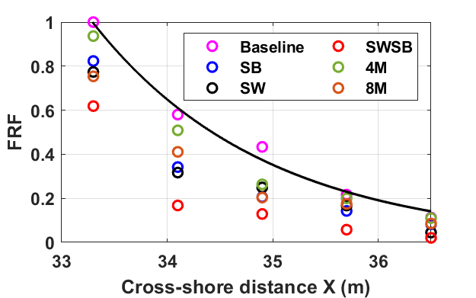

Figure 3 – Cross-shore variation of FRF.

NUMERICAL SIMULATION

The olaFlow-based model, developed in the OpenFOAM platform (Higuera et al. 2015), was employed in the present study to better understand overland flow hydrodynamics in the built environment. The numerical model was first validated using the experimental data and then used to investigate the flow patterns around building arrays that the physical experiments could not measure due to instrument limitations. olaFlow model solves Reynolds Average Navier-Stokes (RANS) equations by the finite volume method (FVM) and tracks the free surface displacement from water-air phases using the Volume of Fluid (VOF). A turbulence closure solver *SST k-ω* was utilized to simulate the complex water movement.

Figure 4 shows an example of snapshots for simulated free surface elevations corresponding to the velocity at different time instants for the combined gray structure (SWSB) and 8-row mangrove configuration. The interesting time instants were selected at *t* = 26 s and 26.5 s, where maximum forces in the blocks of the first building rows were observed for the 8M and SWSB configuration, respectively.

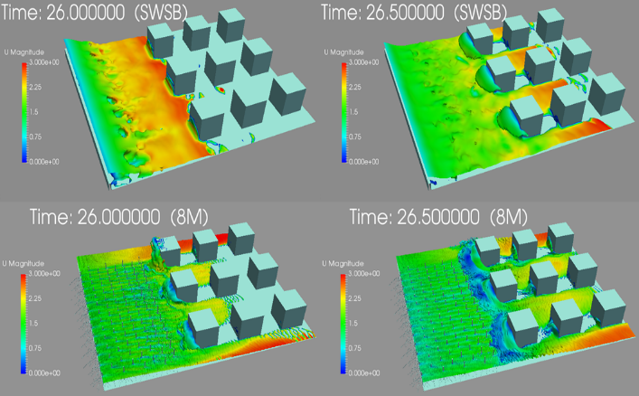

Figure 4 – 3D visualization of overland flow propagation at time instants for the SWSB and 4M configurations

The preliminary numerical results have a good agreement with the experimental results. Figure 5 shows an example comparison of the time series of measured and simulated forces and maximum forces in the first building row over six configurations for a wave condition with an incident wave amplitude of 2.1 m. Figures 5a-f confirm that the olaFlow model well reproduced the time series of horizontal forces measured in the vertical building of the first row for both durations and peak magnitudes. Little difference in numerical and experimental maximum forces was observed for six different configurations (Figure 5g), which ranged from 0.3% to 5.8%. Furthermore, the presentation includes preliminary comparison results of gray and green structures.

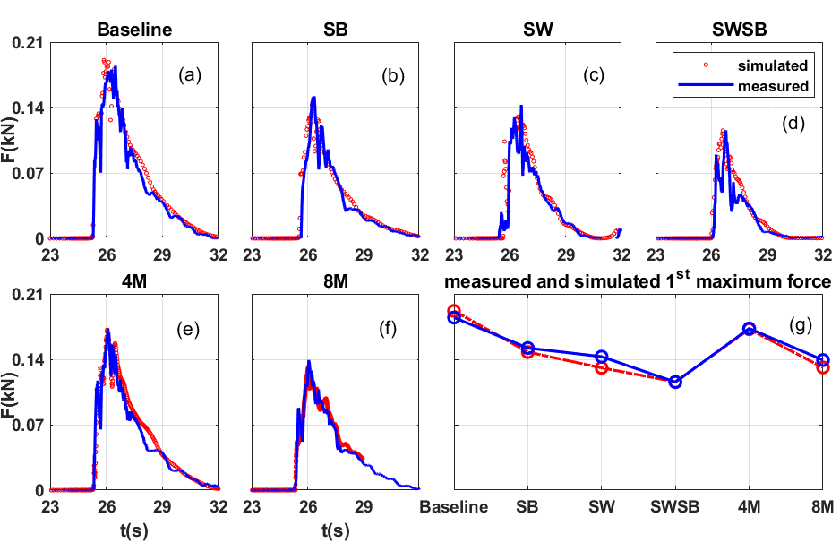

Figure 5 – Comparisons of measured and simulated force in the first building row.

ACKNOWLEDGMENT

This research was supported by the National Research Foundation (grant number: 2022R1F1A1071641), Korea, and BK21 FOUR, Korea.

REFERENCES

Higuera, P., Losada, J.I., Lara, L.J. (2015): Three-dimensional numerical wave generation with moving boundaries, Coastal Engineering, ELSERVIER, vol. 101, pp. 35–47

Moris, J., Kennedy, A., Westerink, J. (2021): Tsunami wave run-up load reduction inside a building array. Coastal Engineering, ELSEVIER, vol. 169, 103910.

Tomiczek, T., Wargula, A., Lomónaco, P., Goodwin, S., Cox, D., Kennedy, A., Lynett, P. (2020): Physical model investigation of mid-scale mangrove effects on flow hydrodynamics and pressures and loads in the built environment. Coastal Engineering, ELSERVIER, vol. 162, 103791.