DEALING WITH AN EXISTENTIAL THREAT FROM CLIMATE CHANGE AT EBEYE, MARSHALL ISLANDS: STRUCTURAL PROTECTION AGAINST STORM EROSION AND WAVE OVERTOPPING

Patrick Lawless, Royal HaskoningDHV, pat.lawless@rhdhv.com
Gary Blumberg, Royal HaskoningDHV, gary.blumberg@rhdhv.com

Matt Blacka, UNSW, m.blacka@wrl.unsw.edu.au
Francois Flocard, UNSW, f.flocard@wrl.unsw.edu.au

BACKGROUND
Located in the Pacific between Australia and Hawaii, the Republic of Marshall Islands (RMI) is one of the World’s smallest, most isolated and vulnerable nations. Ebeye, a small low-lying and densely populated island on Kwajalein Atoll (Figure 1), is at risk from coastal inundation and erosion due to swell waves and typhoons. Impacts will be magnified as sea levels rise.
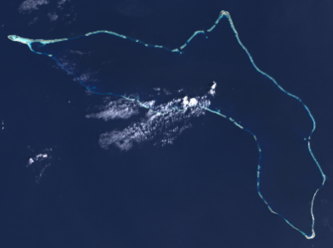
Figure 1 - Kwajalein Atoll showing Ebeye

The Pacific Resilience Program (PREP) for Pacific Islands, funded through World Bank, is implemented to strengthen early warning, create a framework for climate and disaster resilience, and improve post-disaster response. RHDHV is retained by RMI Ministry of Works as the Designer to deliver the Ebeye Coastal Protection Engineering Design and Construction Supervision project under PREP. At the time of writing, the 2-year design investigation is at the Detailed (90%) Design stage.

This paper addresses:

- Objectives and Level of Service (LOS)
- Concept Design and Multi-Criteria Analysis (MCA)
- Preliminary Design
- Budget limitations and value engineering to optimize the Preliminary Design
- Physical modelling to assist with Detailed Design

OBJECTIVES AND LEVEL OF SERVICE (LOS)
Deltares (2016) investigated coastal risk for Ebeye, identifying several protection options. The Terms of Reference (TOR) for the project outlines objectives including delivery of maximum benefit for the available budget, attracting competitive interest in the works, and accommodating construction risks. To manage environmental impact, the TOR requires all imported materials to be sourced outside of RMI.

The key engineering performance LOS standards include design life, acceptable structural damage and wave overtopping, and time-dependent climate change effects including sea level rise and changes in typhoon intensity.

The preference is for the protection works to extend along the full oceanside shoreline of Ebeye, a distance of 2km. However available budget and the presence at Ebeye of an existing well-constructed revetment which is planned to remain without the need for upgrade, has culminated in a slighter shorter length structure totaling 1.8km.

CONCEPT DESIGN AND MCA
From a long list of 20 coastal protection concept options, consultations and technical enquiry shortlisted 10 options that were ranked through an MCA. The following 5 options were carried through to Preliminary Design:

- Shoreline concrete cube revetment
- Shoreline concrete block vertical seawall with deflector
- Shoreline Seabee revetment
- Shoreline tetrapod revetment
- Reef flat concrete block breakwater with companion riprap shoreline structure

PRELIMINARY DESIGN
Preliminary Design included a refinement of water levels (tide and infragravity effects) and wave penetration (typhoon and swell) across the reef flat, informed by an updated coastal risk assessment (Deltares, 2021). Preliminary geotechnical investigations were undertaken to characterise the levels and strength of the reef hardpan.

Typical sections for the 5 preliminary design options are shown in Figure 2 to Figure 6, and the preliminary design general arrangement is depicted in Figure 7.

BUDGET LIMITATIONS AND VALUE ENGINEERING TO OPTIMISE PRELIMINARY DESIGN

Based on QS advice, all of the preliminary design options were significantly over budget at between $79M and $112M compared to the proposed construction budget of $36M including $6M contingency (all USD).
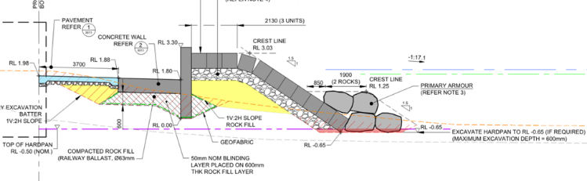
Figure 2 - Shoreline concrete cube revetment

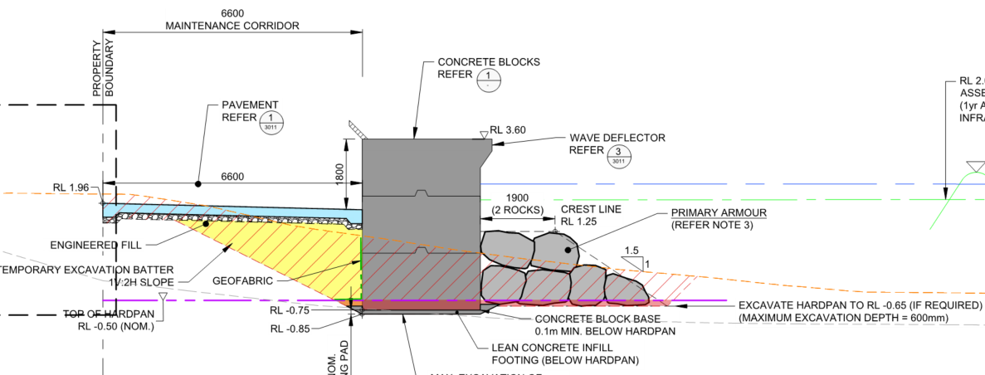
Figure 3 - Shoreline concrete block vertical seawall with deflector

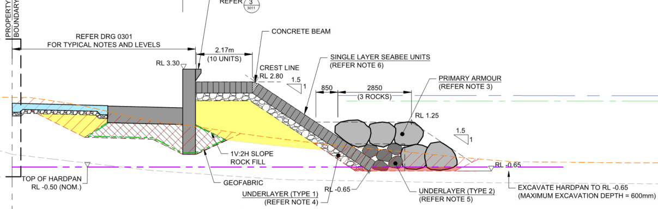
Figure 4 - Shoreline Seabee revetment

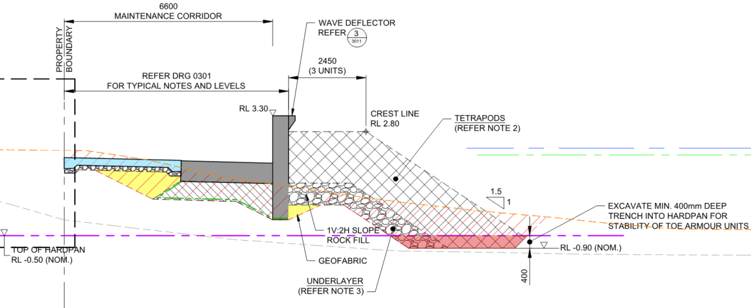
Figure 5 - Shoreline tetrapod revetment

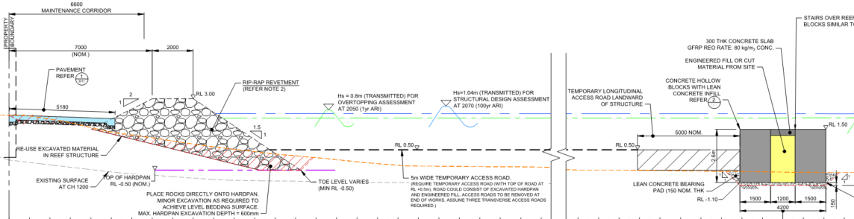
Figure 6 - Reef flat concrete block breakwater with companion riprap shoreline structure

A range of factors resulted in the costing increase including cost pressures from COVID, particularly for remote projects, factoring of quarantine into shipping rates which by mid 2022 had increased at least 4x over a period of 2-3 years, availability of a new (2019) LiDAR survey which showed that the foreshore level was approximately 0.7m lower than was previously understood thereby requiring considerably more material to achieve the structure crest level to deliver the required wave overtopping performance.

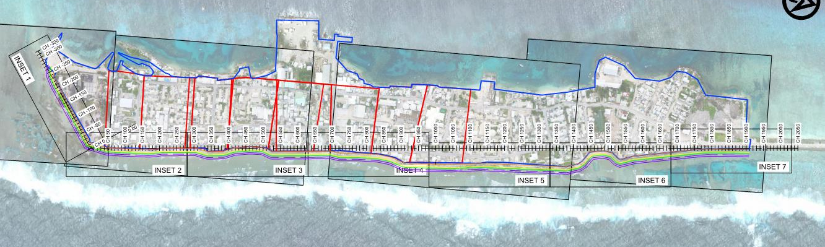
Inset below
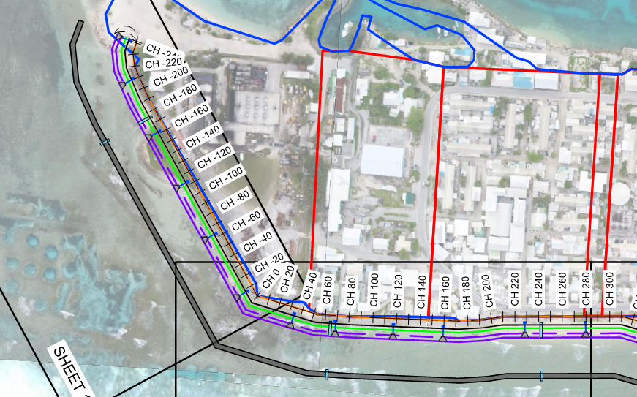
Figure 7 - Preliminary design general arrangement. Typical detail shown at southern end. The reef flat breakwater option (Figure 6) is shown separated approximately 30m from the shoreline. The northern-most 300m of the study area is protected by the Existing Well-Constructed Revetment (EWCR).

It was understood that relying on physical modelling would not bring the project into budget and value engineering was undertaken to examine ways to modify the designs to reduce cost. RHDHV identified a hierarchy of savings with options.

PHYSICAL MODELLING TO ASSIST WITH DETAILED DESIGN
The TOR recognised that coastal design guidelines were limited for atoll environments and identified the opportunity for the Designer to include physical modelling as part of the detailed design. Undertaken by the University of New South Wales Water Research Laboratory (WRL) in their 1.2m wide random wave flume (Figure 8), the key objectives of the modelling included analysis of the following for a range of extreme wave and water level scenarios:

• wave characteristics and transformation as waves cross the reef
• reef-top water levels, including sustained wave setup and low frequency (infragravity) components
• influence of excavated pits within the reef flat
• revetment armour stability and wave loading
• wave overtopping rates
• optimisation of coastal protection designs.

To overcome scaling challenges, modelling was undertaken in two phases:

Phase 1: A full-profile wave/water level processes model (1:50 scale) to simulate complex wave and water level processes across the full reef profile. This model was driven by incident extreme wave and water level conditions for open water outside of the fringing reef and
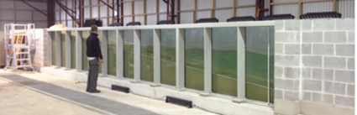
Figure 8 - Modelling undertaken at 1.2m wide flume at Water Research Laboratory, University of NSW

simulated the waves passing across the fore-reef slope, reef crest and platform. This model was used to provide a reliable (slightly conservative) estimate of dynamic reef-top wave and water level conditions, including processes such as wave breaking/decay, wave setup, and infragravity waves, and a qualitative assessment of wave overtopping.

Phase 2: A nearshore reef-top wave/structure model (1:15 scale) of the nearshore/reef-top zone only, primarily used for investigating wave/structure loading and armour stability, and quantifying wave overtopping. This model was driven by nearshore wave and water level conditions only, as determined from the Phase 1 model.

Phase 1 testing was completed for 3 distinct reef-flat configurations, including 2 different reef-flat widths (Narrow Reef Flat NRF, 110 m and Wide Reef Flat WR, 150 m), and the presence or absence of excavated pits in the reef-flat, relevant to existing unprotected and protected (EWCR) shorelines. To be conservative, reef flat widths adopted for NRF and WRF were minima for the site. A total of 9 tests were undertaken during Phase 1.

At the most landward wave measurement location on the reef-flat, significant wave heights (H_{s}) were measured at approximately 60% for 1yr average recurrence interval (ARI) and 20% for 100 and 200yr ARI, of the incident wave heights outside of the reef. The influence of an excavated pit on nearshore wave heights for the NRF profile was found to be relatively minor, with an increase of approximately 0.2m in H_{s} inshore of the pit for all tested conditions. Negligible difference was observed in nearshore wave setup water levels.

Wave runup during large wave/infragravity occurrences exceeded the average +2.3m MSL shoreline crest level on the NRF profile for all test conditions, resulting in wave overtopping. The average wave overtopping rate was approximately 0.2m³/s/m for the 1yr ARI 2050 condition. The shoreline was observed to be completely submerged during higher ARI events (100yr ARI 2070 and 200yr ARI 2070) with average overtopping rates around 2m³/s/m.

Wave overtopping of the crest of the EWCR for the WRF during 1yr ARI conditions was also observed with overtopping approximately 0.01m³/s/m for 2022 sea levels, increasing to approximately 0.02m³/s/m for 2050 sea levels, demonstrating the impact of sea level rise. The EWCR was also observed to be completely submerged during the 100yr ARI 2070 condition, with average overtopping rates of approximately 1m³/s/m.

Phase 2 testing considered the performance of a range of vertical seawall and revetment configurations. All testing was undertaken for NRF only since this was associated with slightly higher waves along the shoreline. Phase 2 examined overtopping performance and armour stability of the following coastal protection structures:

• Vertical wall with deflector (Figure 3), with crest levels ranging from +2.55m to +3.6m MSL, and presence of rock or concrete toe apron
• Sloping revetments with a rock armour (M50 = 3.0t), and crest levels ranging from +2.5m to +3.0m MSL (revetment only in Figure 6)
• Sloping revetment with concrete armour units (1.3t Tetrapods) and +2.7m MSL crest level
• Influence of back promenade levels (0.8m or 1.8m MSL) on structure stability
• Overtopping reduction from installation of a detached breakwater 30m offshore.

Ten overtopping tests were conducted for 4 vertical seawall and 3 rock revetment configurations. Lowering of the vertical wall crest level from +3.6m to +2.8m MSL resulted in an increase in average overtopping rate from 0.001m³/s/m to 0.017m³/s/m, and up to 0.033m³/s/m for +2.55m MSL crest height. Overtopping rates on the rock revetement structure were observed to increase from 0.029m³/s/m to 0.072m³/s/m when lowering the crest height from +3.0m to +2.5m MSL. The detached breakwater was observed to significantly reduce overtopping (from 0.033m³/s/m to 0.009m³/s/m for the vertical wall with +2.55m MSL crest as well as nearshore wave heights (50% reduction).

Ten structure stability tests were conducted for 3 vertical seawall and 7 revetment configurations. The 15t mass concrete blocks used in the vertical seawall design (Figure 3) displaced under 200yr ARI 2070 conditions. Minor damage levels on the rock revetment (2%) were observed with the presence of a solid +1.8m MSL back promenade. Significant increase in damage (12%, major) to the rock revetment was observed when tested with a scoured (+0.8m MSL) back promenade level, due to reduced crest support. The installation of 4t Rock Bags (Kyowa Rock Bags or equivalent) on the leeside of the rock revetment crest allowed a reduction in rock revetment damage (down to 5%, minor) when tested under the same conditions. The 1.3t Tetrapod revetment was observed to sustain significantly higher damage levels than the rock revetment.

PROJECT STATUS
At the time of writing, RHDHV was developing a 90% design for two options; Figure 3 comprising 2 blocks, and Figure 6 with no block breakwater.

REFERENCES

Deltares (2016): Coastal Risk Assessment for Ebeye, Technical report 1230829-001, edition B

Deltares (2021): Coastal Risk Assessment for Ebeye, Update based on 2019 LiDAR elevation data, 11205176-002-ZKS-0004, 29/9/21

