TECHNOLOGY-DRIVEN APPROACH TO THE MODELLING AND DESIGN OF ARTIFICIAL SURF REEFS

Evan Watterson, Bluecoast Consulting Engineers, evan@bcoast.com.au
Michael Thompson, University of Queensland, michael.thompson2@uq.net.au
June Gainza, Bluecoast Consulting Engineers, june@bcoast.com.au
Heiko Loehr, Bluecoast Consulting Engineers, heiko@bcoast.com.au

INTRODUCTION
Most coastal protection projects consider amenity outcomes. Increasingly, surf amenity has become an important consideration. Artificial reefs have been promoted as creating coastal protection, surf amenity and ecological outcomes, however, delivering artificial reefs that provide sustained improvement in wave quality for surfing has proven challenging. This paper presents a novel and technology-driven approach for the design of artificial surfing reefs using the Southern Ocean Surf Reef (SOSR) project as an Australian case study. This proposed artificial reef at Middleton Beach, Albany consists of a submerged rock reef structure, the design of which has resulted from extensive investigations to optimise its performance. The investigations have led to general findings, which can be useful for the design of future artificial reefs and for other coastal projects where surf amenity is a consideration.

THE APPROACH
The approach was developed following experience gained from the design of the Palm Beach Artificial Reef (PBAR) project. Since construction in 2019, the evidence to-date indicates that the PBAR is the first artificial reef structure to deliver both high-quality surf amenity and coastal protection outcomes. While all aspects of the artificial reef design, including location, volume and shape were considered in the design investigations for the SOSR project, the approach presented herein focuses on the shape of the reef. Physical and numerical modelling were employed to better understand the effect of reef shape on wave breaking characteristics both over and inshore of the structure.

The non-hydrostatic wave-flow model SWASH (Smit et al., 2013) was used to test a range of reef shapes to evaluate breaking length, speed, peel angle and surf zone hydrodynamics during a range of wave and water level conditions at the Middleton Beach site. Key over-structure model parameters were calibrated based on extensive observations collected from the PBAR, including wave transmission, wave-driven currents and wave peel tracks applying an innovative technology that tracks individual wave breaking using a permanent shore-based CCTV camera (Thompson et. al, 2021). Wave peel tracks (WPT) observed over the PBAR were compared to WPTs extracted from the SWASH simulations. The verified SWASH model allowed for efficient testing of numerous reef shapes, with the best performing shape (Figure 1) selected for scale model testing.

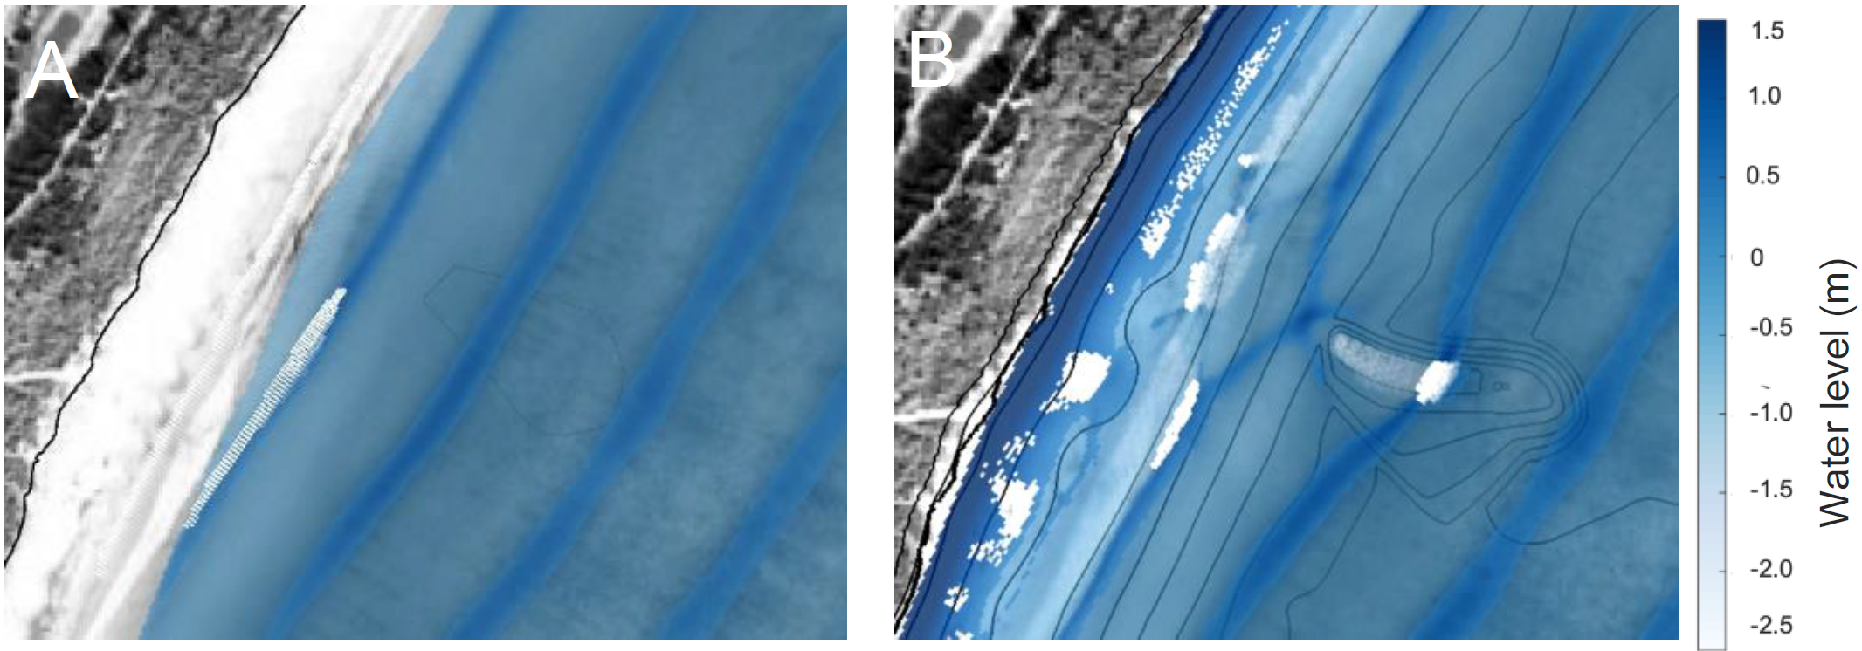
Figure 1 – Modelled sea surface and wave breaking pattern for base case (A) and final reef design (B).

Physical modelling was undertaken of two reef shapes, shape (H) that emerged from the initial SWASH simulations as well as a second shape (I) that was optimised following an iterative process using physical and numerical modelling. The WPT algorithm was adapted for laboratory footage and SWASH simulation outputs for verifying key over-structure parameters for reef H (Thompson et. al., 2022). Further reef shape testing and optimisation was completed using the refined SWASH model before physical modelling testing of the refined reef shape I (Figure 2).

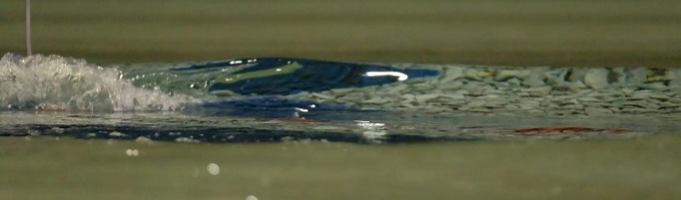
Figure 2 – Photographs of wave breaking over the reef shape I with spectral wave conditions (Hs=2.0, Tp=12s) at MSL.

CONCLUSION
Results found that the SWASH model, when combined with WPT technology, was a valuable tool for valuating breaking mechanics of artificial reef surf breaks and designing and optimising the reef shapes that can be verified in physical modelling. While detailed in nature the approach has proven successful in overcoming previous challenges in artificial surf reef design. By adopting future technology into the approach, design development efforts and costs of future artificial reefs and other related coastal projects may be reduced.

REFERENCES
Smit, Zijlema and Stelling (2013): Depth-induced wave breaking in a non-hydrostatic, near-shore wave model. Coastal. Engineering, Elsevier Vol. 76, pp. 1-16.
Thompson, Zelich, Watterson and Baldock (2021): Wave Peel Tracking: A New Approach for Assessing Surf Amenity and Analysis of Breaking Waves. Remote Sensing 13(17), pp. 3372.

Thompson, Atkinson, Watterson, Naderi, Loehr and Baldock (2022): Quantifying the Design Performance of Surfing Reefs and Sand Mounds using Wave Peel Tracking. Journal of Coastal Engineering (unpublished)

