INVESTIGATING DEBRIS TRANSPORT DURING EXTREME COASTAL EVENTS

Gizem Ezgi Cinar, University of Southern California, cinar@usc.edu
Patrick Lynett, University of Southern California, plynett@usc.edu

INTRODUCTION
Past extreme coastal events such as the 2004 Indian Ocean Tsunami, the 2011 Tohoku Tsunami and the 2018 Hurricane Michael demonstrated the significance of understanding the debris generation and its transport and impacts during coastal disasters. Although there are many studies on debris loading and impact for damage assessments, very few studies focus on predicting the motion of debris. Nearly all experimental debris motion studies consider tsunami-like flows for the hydrodynamic conditions. Therefore, we still have a major gap in the literature for debris transport under the combined effect of currents and wind waves.
In 2018, Hurricane Michael hit Mexico Beach, Florida and completely washed away the local pier. A post event survey was conducted and the pieces of pier debris were identified carefully. The pier debris spread a very large area due to the combined effects of waves, currents, and wind (Figure 1). The physical model experiments attempted to recreate the dispersion of this pier debris to better understand the transport of debris during extreme wave and current events.
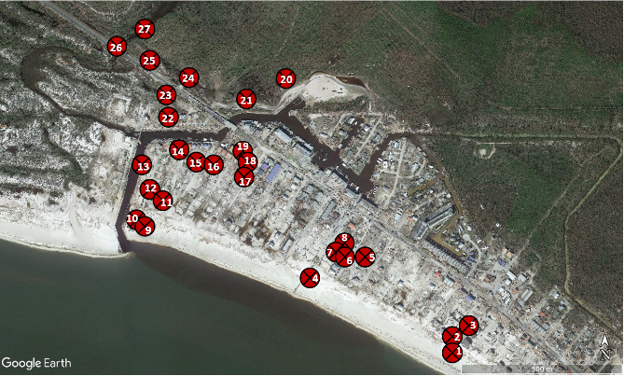
Figure 1 – Final positions of the pier debris (red dots) identified in the field survey conducted after 2018 Hurricane Michael

EXPERIMENTAL SETUP
A series of experiments have been conducted in the Directional Wave Basin of Hinsdale Wave Research Laboratory at Oregon State University, Oregon, USA. Figure 2 shows the general layout of the experimental site. The bathymetry started flat from the multi-directional piston-type wavemaker which was located at x=0 m until it reached x=11.3 meters. Then, 1/20 slope of 20 meters long profile continued. Another flat section of 10 x 10 meters elevated 1 m from the bottom of the basin was created to represent Mexico Beach in the debris experiments as an area of interest (AOI). For this study, an experimental configuration of overland flow with and without a structural array was considered to examine the debris motion. This setup was tested under the hydrodynamic conditions of only-current and combined current and waves for the most appropriate schematic representation of Mexico Beach.

Experiments were repeated 30 times with consistency.
For each trial, a total number of 39 debris specimens were placed as a line source at offshore part of the basin as representing the local pier at Mexico Beach. Each of the wooden debris specimens had dimension of 15cmx15cm and they soaked in water to increase their weight. Debris were released instantaneously using a false floor in a repeatable way. Visual data were collected with 4 overhead video cameras mounted on a steel frame located right above the AOI.

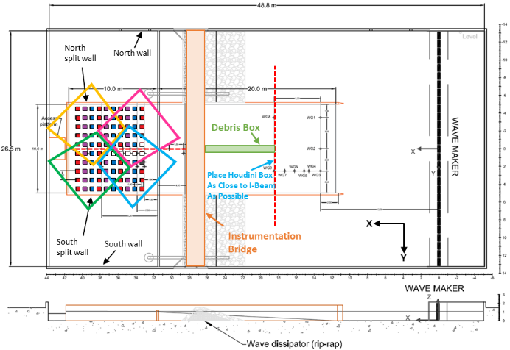
Figure 2 – Layout of the experimental area

RESULTS
Visual analysis of spatial and temporal displacement of floating debris was studied performing object detection and tracking by using OpenCV and MATLAB routines. The relationship between the debris spreading and nearshore hydrodynamic conditions was established. The spreading angle for different color set particles was calculated to better understand the lateral movement and make a comparison with the proposed spreading angle in current practice. Moreover, the effect of structural array on debris trajectories was examined and it was observed that structural array had a significant effect on debris dispersion.

CONCLUSION
Debris particles showed wider variance around the mean, associated with the standard deviation of the trajectory as the particles propagated inland. The debris with no obstructions and free flow path moved essentially parallel to the flow direction. When waves were involved, debris particles showed a much larger lateral spreading. Offshore dispersion of particles with the structural array configuration was higher than the trials without the structural array configuration. Debris particles entered the structural area in scattered positions with a random nature. As they move forward between blocks, their distribution got closer to Gaussian which implies they had a lower risk of hitting structures.

