EXPERIMENTAL STUDY ON WAVE-INDUCED SCOUR IN FRONT OF SLOPING COASTAL STRUCTURES AND THE INFLUENCE OF BED PROTECTION

Wisse Goedhart, Delft University of Technology, Van Oord, wisse.goedhart@vanoord.com
Bas Hofland, Delft University of Technology, b.hofland@tudelft.nl
Coen Kuiper, Delft University of Technology, c.kuiper@tudelft.nl
Wouter Ockeloen, Van Oord, wouter.ockeloen@vanoord.com
Matthieu de Schipper, Delft University of Technology, m.a.deschipper@tudelft.nl

The erosion of the seabed in front of coastal structures induced by waves can lead to multiple types of failure in stability or function of the structure. On this topic most research has been done into erosion in front of vertical structures (e.g. Xie, 1981). For sloping structures a knowledge gap exists in the understanding of the processes that lead to erosion of seabed material directly in front of the structure. Available studies for sloping structures were done with regular waves (e.g. Sumer and Fredsøe, 2000) or for a low number of irregular waves (e.g. Den Bieman et al., 2019).
In this study the main parameters that lead to development of scour in front of sloping structures are investigated. Additionally a method is presented that will help with predicting maximum scour depth when designing a sloping coastal structure.

Two distinct types of scour are found in front of sloping structures. Being: (1) the standing wave pattern scour, and (2) the downrush flow scour. This second type of scour is not observed for vertical structures as here no significant run-up and run-down of waves is present.
The first type of scour is found to primarily depend on the wave reflection coefficient as the reflection of waves results in standing waves in front of the structure, influence of the wave reflection coefficient on maximum scour depth is found to follow a quadratic relation. In confirmation with earlier findings of Jantzen (2020). For larger wave reflection coefficients a more distinct standing wave pattern forms and the maximum standing wave scour depth increases.
The second type, downrush flow scour, is found to directly depend on multiple parameters of which the relative water depth, the wave steepness, the wave reflection, the roughness of the structure and the permeability of the structure are most important. For more rough structures there is less run-down of waves on the surface of the structure leading to lower flow velocities at the toe. As a result, for these cases less material will be removed and a lower maximum downrush flow scour depth can be expected. Maximum scour depths at the toe of smooth impermeable structures are found to be about twice as large as for rough permeable structures. Opting for a rough structure when designing a sloping structure can therefore greatly reduce maximum scour directly at the toe of the structure.

In addition to these two types of scour a large-scale morphological change was observed. The direction of this transport varied depending on the wave steepness. The change was observed to remain constant over time for up to at least 90,000 waves.

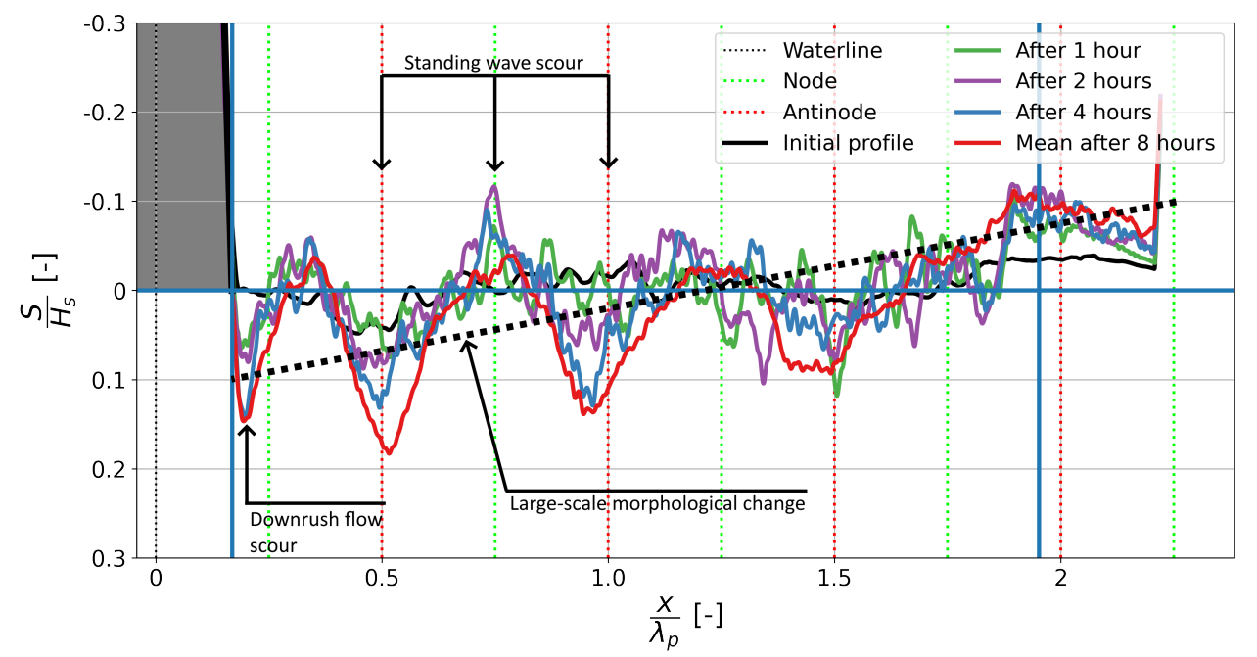
Figure 1 – Observed scouring processes

A design formula based on earlier work is presented that allows the prediction of maximum scour depth for both cases. A relation is found with the reflection coefficient and the number of waves during which a substantial amount of scour occurs. The design formula from Jantzen (2020), which is based on work by Xie (1981), is slightly adjusted to include these influences. The required amount of waves is found to depend on the amount of material that has to be removed and is linked to the wave reflection coefficient. In this way the predictive performance of the formula is improved for tests results for different types of sloping structures and wave conditions.
The formula is found to perform best for predicting the scour depth at the firs anti-node of the standing wave pattern, in front of the structure. Performance for the maximum scour depth directly adjacent to the structure is slightly less but still good

Influence of the bed protection is found to be different for sloping structures than for a vertical wall. The amount of scour in front of the protection is found to depend on the location of the end of the protection layer compared to the standing wave pattern, similar to vertical wall cases. A difference is observed when using a bed protection layer with a length of 3/8 times the peak wave length (measured from the waterline) where a hole forms directly in front of the protection. For vertical wall cases no scour directly in front of a protection layer with this length was observed by Xie (1981).

REFERENCES

Den Bieman, van Gent and Hoonhout (2017): Physical model of scour at the toe of rock armoured structures. Coastal Engineering, 154:103572.

Jantzen (2020): Experimental study on the influence of bed protections on scour depth and scour development in front of sloped embankments. Master’s thesis, Delft University of Technology, The Netherlands

Sumer and Fredsøe (2000): Experimental study of 2d scour and its protection at a rubble-mound breakwater. Coastal Engineering, 40(1):59–87.

Xie (1981): Scouring patterns in front of vertical breakwaters and their influences on the stability of the foundation of the breakwaters. TU Delft, Faculty of Civil Engineering and Geosciences, Hydraulic Engineering.

