THE TIDE IS HIGH: NEW INSIGHTS ON COASTAL FLOODING TRENDS AND FUTURES

Ben Hague, Australian Bureau of Meteorology, ben.hague@bom.gov.au

INTRODUCTION
Coastal flood frequencies are expected to increase around the world due to sea-level rise (SLR). This is largely related to the emergence of tidal flooding, where coastal flood thresholds are exceeded by astronomical tides alone. We will discuss the concept of tidal flooding and the observed trends from Australia and the United States. We then apply a new risk assessment framework (Hague et al. 2022) to identify which locations are most vulnerable to chronic flooding due to SLR this century. Finally, we discuss the implications of a global application of this framework for coastal engineering and management applications.

ThE Rapid Assessment Framework for Frequent Flood Transitions with SLR (RAFFFTS)
Following the climatology-based approach of Sweet et al. (2018) we develop coastal flood projections at global tide gauges. Through correlation analysis with these projections, we find that future flood frequency is a linear function of three parameters: freeboard, tidal range, and storminess factor. Applying the resultant equations to the global GESLA v3 dataset (Haigh et al. 2022) yields the analysis in Figures 1 and 2.
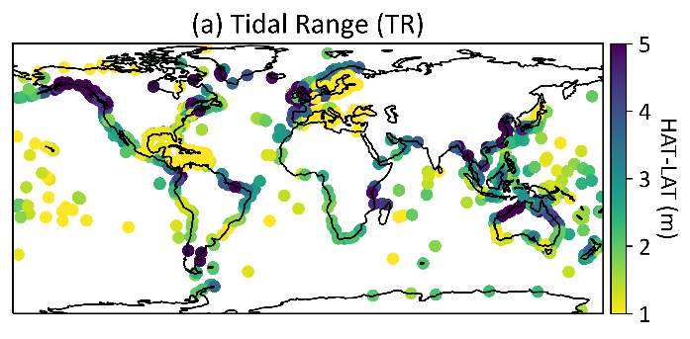
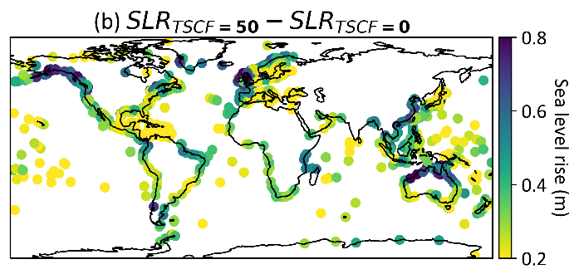
Figure 1: Global tidal range values (a, upper) and projections of SLR required for 50 annual TSCF days post emergence, using climatology-based methods (b, lower).

Freeboard parameterizes the changes in heights of high tides under SLR, relative to local flood thresholds, and determines when tidal flooding first emerges. Tidal range (TR, Figure 1a) is the heights between highest and lowest astronomical tides over a reference period. It parameterizes tidal variability and is linearly related to the frequency of tide-sufficient coastal flooding (TSCF, Figure 1b). Storminess Factor (SF, Figure 2a) is the 99th percentile skew surge divided by the tidal range. It parameterizes the ratio of non-tidal to tidal variability and is linearly related to the frequency of surge-driven coastal flooding (SDCF, Figure 2b).
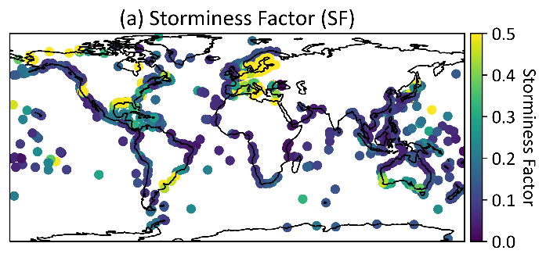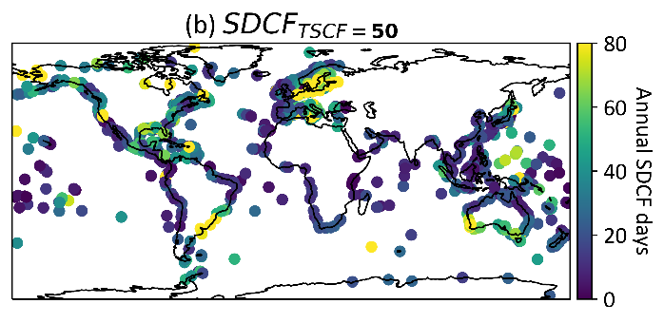
Figure 2: Global storminess factor values (a, upper) and projections of annual CF days, using climatology-based methods (b, lower).

IMPLICATIONS OF RAFFFTS
RAFFFTS demonstrates that impact information is essential to deliver the time-bound projections required for timely and less costly adaptative responses. The dominance of tidal processes for high-frequency flood impacts means that new methods will be required to supplement existing coastal risk assessment tools like return periods, amplification factors and allowances. The onset and rapid intensification of tidal flooding evident in coastal flood projections mean a major shift in the processes that lead to coastal flooding is underway, arising directly from SLR. Importantly, future coastal flood hotspots may differ from the locations most at risk today.

REFERENCES
Hague, McGregor, Reef, Jakob, Jones, Murphy (2022): The global emergence of chronic high-tide flooding: projections and frameworks to identify hazard drivers, Earths Future (in review).
Haigh, Marcos, Talke, Woodworth, Hunter, Hague, Arns, Bradshaw, Thompson (2022): GESLA Version 3: A major update to the global higher-frequency sea-level dataset. Geoscience Data Journal. DOI: 10.1002/gdj3.174
Sweet, Dusek, Obeysekera, Marra (2018): Patterns and Projections of High Tide Flooding Along the U.S. Coastline Using a Common Impact Threshold, Technical Report NOS CO-OPS 086, NOAA, Silver Spring, MD., USA.

