STORM TIDE IN A DATA RICH COASTAL EMBAYMENT
FINDING THE MISSING SURGE

Mitchell Smith, BMT, Brisbane Australia, mitchell.smith@bmtglobal.com
Zachariah Couper, BMT, Brisbane Australia, zac.couper@bmtglobal.com
Ian Teakle, BMT, Brisbane Australia, ian.teakle@bmtglobal.com
Daryl Metters, Coastal Impact Unit DISTI, Brisbane Australia, daryl.metters@qld.gov.au

CONTEXT
Numerical modelling of storm tide within Moreton Bay has consistently underestimated peak tide gauge level observations by up to 40% during extreme events. Scientific debate regarding the source of this “missing” contribution hypothesizes it to result from one, or a combination, of the following factors:
- The potential for surge enhancement due to wave breaking and wave-current interplay at the Spitfire Banks and eastern entrances of Moreton Bay (Treloar, 2011);
- Limitations of our current wind surface stress parameterisation for surge generation in extreme conditions (Nielsen, 2011);
- The potential of long wave seiching and resonance effects being present in the bay but not adequately resolved by existing hydrodynamic modelling; and
- The disturbance of existing offshore geostrophic currents by extreme weather events and their 3D interaction with the continental shelf and nearshore bathymetry.

This study tests these hypotheses by undertaking a series of integrated hydrodynamic and spectral wave modelling experiments, supported by high quality gridded wind, observed water level and wave data at sites throughout Moreton Bay and the Southeast Queensland coast. The case studies are the regional surge responses during the passages of Ex. Tropical Cyclone Oswald, Ex. Tropical Cyclone Debbie and Tropical Cyclone Oma. Testing of these hypotheses will contribute to an improved understanding of the key processes required to model storm surge accurately in other similar coastal embayments.

EXPERIMENTAL DESIGN
A series of model experiments was completed for each storm to estimate the potential contribution of regional geostrophic influence, wave breaking interaction and surface wind stress sensitivity to the overall measured residual results at each tide gauge (Smith, 2015). Additional sensitivity experiments were conducted to ascertain likely model error due to resolution and parameter selection. Model results were compared to available water level, wave and water level residual data following spectral analysis.

DATA AVAILABILITY AND ANALYSIS
Fortunately, the study area is data rich containing six continuous wave monitoring buoys and water level/tide gauges (refer Figure 1). Spectral analysis of the water records reveals the presence of long wave seiching in Moreton Bay and the influence of wave- current interaction. Spectral and Fourier Decomposition analysis was also performed across the model domain to isolate long wave mode shapes and transient activation levels during cyclone passage. Comparison was made between modelled and observed long wave activation to isolate the surge generating components ‘missing’ in the model results.
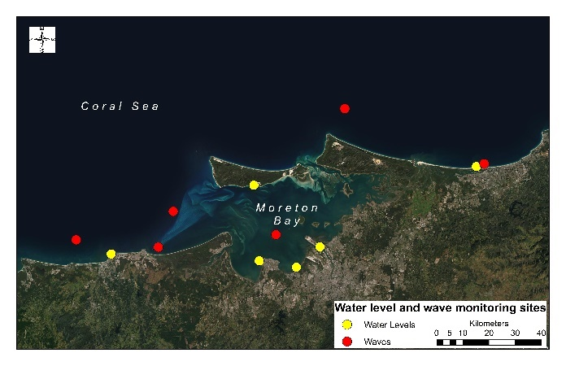
Figure 1 – Moreton Bay Monitoring Sites

RESULTS
Overall, the shape and magnitude of the experiments with breaking-wave influences activated provide a better match to measured residuals than do experiments with tide plus surge only, supporting the theory of wave-surge interaction. Of the wave-surge experiments those with Stokes Drift enabled matched observed residuals to within 10%, highlighting its importance in reproducing storm surge in semi-open coastal embayments such as Moreton Bay. 3D model coupling with ocean circulation models did not provide a significant improvement in predictions.

REFERENCES
Nielsen, Callaghan & Baldock, (2011), Downward transfer of momentum by wind-driven waves, Coastal Engineering, vol. 58, no. 12, pp. 1118–1124.

Smith (2015), Southeast Queensland Storm Tide Response to Ex. Tropical Cyclone Oswald, Engineering and Sciences Department, University of Southern Queensland.

Treloar, Taylor & Prenzler (2011), Investigation of wave induced storm surge within a large coastal embayment – Moreton Bay (Australia), Coastal Engineering Proceedings, vol. 1, no. 32.

