ANCIENT AND CONTEMPORARY COASTAL ENGINEERING STRUCTURES
UNIQUE TO AUSTRALIA

James Carley, Water Research Laboratory, School of Civil and Environmental Engineering, UNSW Sydney, james.carley@unsw.edu.au
Nicole Larkin, NLarkin Design, nlarkin.design@gmail.com
Angus Gordon, Coastal Zone Management and Planning, sandgus@optusnet.com.au
Ron Cox, Water Research Laboratory, School of Civil and Environmental Engineering, UNSW Sydney r.cox@unsw.edu.au

INTRODUCTION
This paper presents ancient and contemporary coastal engineering structures which are relatively unique to Australia. While aspects of these structures or similar structures occur elsewhere, their development or evolution within Australia has been globally unique.

The following classes of coastal structures are discussed:
- Indigenous fish traps;
- Ocean pools;
- Wave trap beaches;
- Fixed trestle, jet pump sand bypass plants;
- Groin modifications for surfing.

INDIGENOUS FISH TRAPS
Indigenous Australians have continuously occupied the continent for at least 65,000 years. Weirs and fish traps on rivers have been dated to at least 6,600 years before present (DoEE, 2017). Numerous fish traps are also present on the coast, with Rowland and Ulm (2011) documenting hundreds on the coast of present-day Queensland. With sea level having been up to 120 m lower than present during early occupation, relict coastal fish traps are likely to have accompanied those remaining on rivers, but would now be substantially under water. Fish traps are present in all states of Australia, but the lower wave climate of Queensland may be one factor in their greater abundance there.

OCEAN POOLS
There are approximately 60 ocean pools located in New South Wales (NSW), mostly between Newcastle and Wollongong, and 15 located on Sydney’s Northern Beaches (Figure 1). Most NSW ocean pools were built from the late 1800s to early 1930s. The last new construction was at Cronulla in the 1960s, which was rebuilt in the early 1990s. However, most ocean pools in urban areas are renovated at intervals of 10 to 20 years. Only South Africa has a comparable number, with small numbers in Europe, UK, South and Central America.

Ocean pools provide engineering challenges. Their water quality historically depended on tidal interchange and wave flushing, which in turn is dependent on the height of their walls relative to sea level, the prevailing wave climate and the Spring-Neap tidal cycle. In recent decades, most ocean pools in NSW have been upgraded to incorporate pumps to reduce some of this variability. Most ocean pools are managed by local councils, and heavily-used pools have to be regularly drained at low tide (often at night) and then re-filled using fixed or movable pumps to manage water quality. When the pools are drained, their walls are also cleaned and any sand that has been washed in is removed. This means ocean pools require management, particularly in high use times such as summer. Carley et al (2019) polled asset owners and found that most NSW ocean pools required maintenance of AUD$50,000 to $150,000 per annum, with the works in some council areas being undertaken at night to minimize disruption to pool users. Interestingly, whereas most swimming pool operations require an associated Lifeguard for swimmers’ safety, ocean pools are legally exempt as it is recognised that such control is not practical. Compared with contemporary aquatic centers and municipal pools, ocean pools are financially economical community assets.

To improve flushing, some councils have reconfigured some ocean pools by lowering the seaward edge, thereby increasing the quantity and frequency of overwash. However, this may lead to an increased hazard for pool users, in particular those who delight in trying to “surf” the overwash (colloquially known as “chain surfing”). It may also result in increased sand and wrack transport into the pool, and the overwash and subsequent wave reflections inside the pool may make lap swimming more difficult. Contemporary ocean pool design seeks to balance the above variables and supplement flushing with a pump.

WAVE TRAP BEACHES
Gourlay (1996) claimed the wave trap beach (Figure 2) within trained entrances as an Australian invention. Almost all trained entrances constructed in Australia since the 1970s have included these features.

The concept involves a rapid expansion of the waterway once inside the entrance by increasing the separation of the breakwaters (jetties) thereby improving the opportunity to increase the wave crest length and hence, by the associated wave diffraction, reducing the energy continuing up the main channel into the harbor. The energy so deflected from the main channel is then allowed to dissipate within the side “wave traps” formed between the expanded breakwater (jetty) configuration and the internal training walls bordering the main channel (Figure 2). A coincidental benefit of this type of entrance configuration is sheltered beaches within the wave traps. These beaches are very popular particularly for families with young children.

Given the tidal flushing of the main channel and the marine life associated with the environment created by the breakwaters (jetties), there is the potential for predators such as sharks to be attracted. Often “shark nets” are fitted across the entrance to the wave traps.
Again, as with the ocean pools, wave trap beaches cannot be practically serviced by Lifeguards and so their use is at the risk of persons using them. However, the sheltered wave trap beaches are also proximate to sometimes high velocity tidal and river flows, introducing different hazards to open coast beaches. The shark netting can have the additional benefit of enclosing the beach and limiting swimmer movement. Wave trap beaches also need to have well maintained signage warning of dangers.

FIXED TRESTLE, JET PUMP SAND BYPASS PLANTS
Boswood and Murray (2001) documented 53 sand bypass plants operating globally as at 1997. The sand bypass plant at the Nerang River entrance, Gold Coast, Queensland commenced operations in 1986 and is considered to be the first fixed trestle, jet pump sand bypass plant in the world. This bypasses ~500,000 m³ of sand per year. This was followed by the Tweed River sand bypass project (TRESBP) (Figure 2) which commenced in 2001 and has bypassed 500,000 to 700,000 m³ of sand per year.

Both bypass systems feature two stage systems whereby the sand is first picked up from a fixed trestle structure on the updrift (southern) side, constructed across the surf zone using jet pumps, the cross shore location of which can be altered along the trestle as required. The pumps discharge into a flume on the trestle which delivers the sand/water mix to a shore based conventional sand pumping “slurry” system which transfers the sand, by pipe under the channel to the downdrift (northern) side of the entrance. In each case the downdrift delivery is different, with the Tweed operation having a more flexible arrangement involving a number of discharge points which can be alternated depending on which downdrift beach is best served at the time. Such flexibility is not required at the Nerang as the discharge is onto an uninhabited region of South Stradbroke Island (Minjerribah).

As with all bypass systems, the operation of both systems requires constant maintenance, and operation of the jet pumps can provide challenges, particularly when higher amounts of debris are in the water.

In the case of the Tweed, the trestle configuration does not allow all the sand from updrift beach and surf zone to be captured, and so from time-to-time, additional dredging of the entrance channel, by conventional means is required (Figure 2) in order to maintain navigability.

Popular surf breaks are present on the updrift (southern side) of each entrance, while world class surf breaks are present on the downdrift (northern) side of each entrance.

GROIN MODIFICATIONS FOR SURFING
Kirra Point groin on the Gold Coast was constructed in 1972 for the purpose of stabilizing Greenmount Beach. While not part of the original design, it assisting in forming one of the best surfing waves in the world. The groin was shortened by 30 m in 1996, in anticipation of the nearby TRESBP commencement of bypassing in 2001. The surf quality at nearby Snapper Rocks improved with the sand bypass plant (the “Superbank”), however, the surf quality diminished at Kirra. A community campaign to “bring back Kirra” resulted in 30 m of groin being reinstated in 2013 at a cost of AUD$800,000.

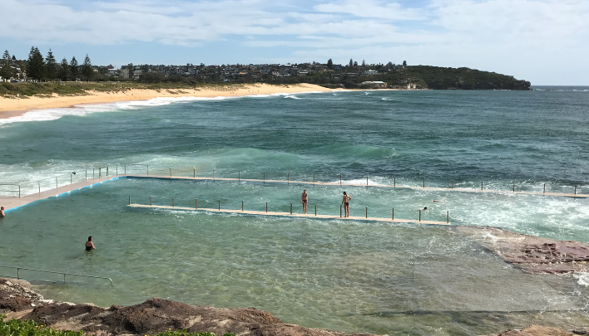
Figure 1 – Ocean pool at Curl Curl, Sydney, Australia

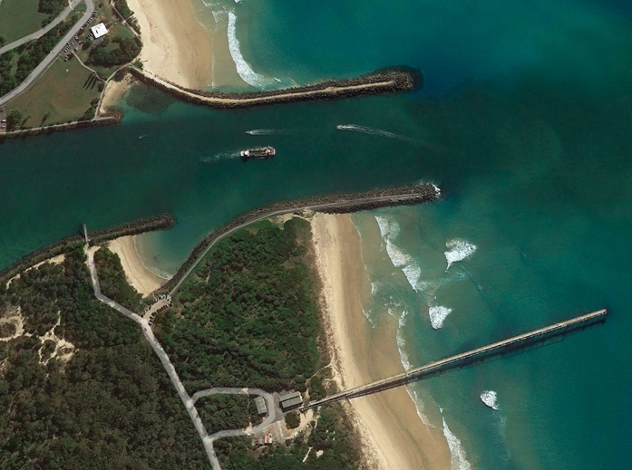
Figure 2 – Tweed Heads showing the wave trap beaches on either side of the entrance, the fixed trestle bypass system and a conventional dredge clearing the navigation channel

REFERENCES
Boswood and Murray (2001), World-wide Sand Bypassing Systems: Data Report (Compiled 1997) Coastal Services technical report R20.
Carley, Coghlan, Drummond and Larkin (2019), Ocean Pools – Contemporary Coastal Engineering Meets the Steam Age, Australasian Coasts & Ports 2019 Conference – Hobart
Department of the Environment and Energy (DoEE, 2017), Budj Bim Cultural Landscape: World Heritage Nomination.
Gourlay (1996), History of Coastal Engineering in Australia, in Kraus (ed) History and Heritage of Coastal Engineering, ASCE.
Larkin (2019), https://www.nicolelarkin.com/the-wild-edge/
Rowland and Ulm (2011), Indigenous Fish Traps and Weirs of Queensland, Queensland Archaeological Research, Vol 14.

