WAVE DRAG COEFFICIENT USEFUL FOR NATURE: SEAGRASS-BASED COASTAL PROTECTION DESIGN IN ESTUARIES

Alice Twomey, The University of Queensland, a.twomey@uq.edu.au
Katherine O’Brien, The University of Queensland, k.obrien@uq.edu.au
David Callaghan, The University of Queensland, dave.callaghan@uq.edu.au
Megan Saunders, Oceans and Atmosphere, CSIRO, megan.saunders@csiro.au

Globally, more than 100 million people live within the low elevation coastal zone, which is increasingly at risk of flooding and erosion due to sea-level rise. Wave attenuation provided by coastal ecosystems, including seagrass, mangroves, and saltmarsh, has been well studied in coastal engineering literature, but results are often not comparable due to differences in experimental methods, reporting units and a lack of complete published datasets.
Many coastal ecology and conservation studies aim to qualitatively quantify the value of these ecosystems for coastal protection. However, without data reported in a comparable format, quantitative values are not finding their way into the ecology literature, contributing to the misconception that ‘rules of thumb’ exist for predicting coastal protection.
To alleviate the challenges of non-comparable data and incomplete datasets, the drag coefficient (C_{D}) is a useful tool to quantify and compare wave attenuation provided by different ecosystems. Using seagrass as a case study, we conducted a meta-analysis of 119 seagrass-wave attenuation studies both in the field and in laboratory experiments, of which 11 were eligible for inclusion in our study (Twomey et al., 2020). For each dataset, we calculated missing values and determined the drag coefficient using the Dalrymple et al. (1984) model for energy dissipation by rigid cylinders accounting for vertical variations in vegetation (shoot height, width, density). For typical seagrass found in the tropics and subtropics, drag coefficients varied from 0.02-5.12 with an average C_{D} of 0.74. By differing the ten variables used to calculate C_{D}, this work graphically illustrates that there is no simple rule of thumb for predicting the wave attenuation provided by coastal ecosystems (Figure 1). Specifically, the wave period, meadow length, shoot density, shoot width, and canopy height were identified as affecting the attenuation provided by the ecosystem.
Whilst providing a valuable framework for coastal engineers for comparing wave attenuation studies using different species, locations and with missing data, this research also has implications for ecology. This study clearly shows there is no simple rule of thumb used to predict wave attenuation and highlights the importance of understanding coastal hydrodynamics, bridging some of the information gaps between coastal engineers and ecologists.
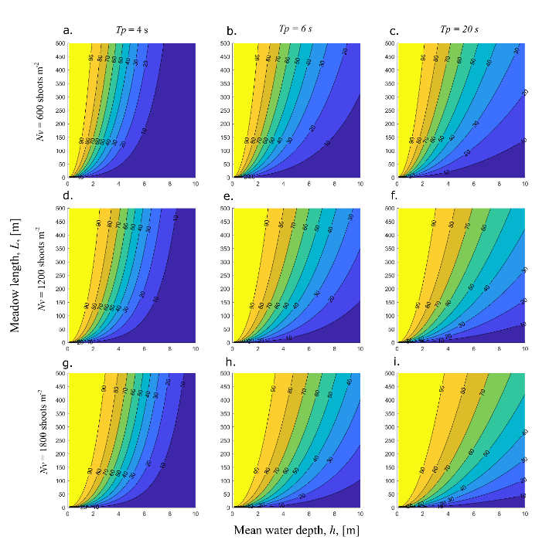
Figure 1 – Contours of wave height reduction (%) over the distance of a seagrass meadow as a function of mean water depth (h, horizontal axis) and meadow length for (C_{D} = 0.74; h_{v} = 0.5 m, H_{rms1} = 0.5 m) and wave peak period (T_{P} = 4, 6, 20 s) and shoot density (N_{v} = 600, 1200, 1800 shoots m⁻²) (Twomey et al. 2020)

REFERENCES
Dalrymple, R. A., Kirby, J. T. & Hwang, P. A. 1984. Wave Diffraction Due to Areas of Energy Dissipation. Journal of Waterway, Port, Coastal, and Ocean Engineering, 110, 67-79.
Twomey, A. J., O'Brien, K. R., Callaghan, D. P. & Saunders, M. I. 2020. Synthesising wave attenuation for seagrass: Drag coefficient as a unifying indicator. Marine Pollution Bulletin, 160, 111661.

