**PALM BEACH SHORELINE PROJECT: INNOVATIVE COASTAL MANAGEMENT SOLUTION**

Shannon Hunt, City of Gold Coast, [shunt@goldcoast.qld.gov.au](mailto:shunt@goldcoast.qld.gov.au)

Greg Britton, Royal HaskoningDHV, [greg.britton@rhdhv.com](mailto:greg.britton@rhdhv.com)

Dan Messiter, Royal HaskoningDHV, [dan.messiter@rhdhv.com](mailto:dan.messiter@rhdhv.com)

Paul Prenzler, Royal HaskoningDHV (formerly City of Gold Coast), [paul.prenzler@rhdhv.com](mailto:pprenzler@goldcoast.qld.gov.au)

Sam Knight, SMEC (formerly City of Gold Coast), [sam.knight@smec.com](mailto:sam.knight@smec.com)

Evan Watterson, Bluecoast Consulting Engineers, [evan@bcoast.com.au](mailto:evan@bcoast.com.au)

INTRODUCTION

Palm Beach is a four kilometre beach located on the Gold Coast, Queensland, Australia. Since the 1960’s there have been numerous significant erosion events that have threatened infrastructure and impacted on recreational beach amenity.

Historically Palm Beach had the lowest long-term volume of sand available in the active beach and dune system. This has meant that severe storms or prolong periods of high energy ocean swell can deplete available sand reserves and erode the beach back to the seawall.

As this section of coastline is highly developed with low, medium and high-density developments and infrastructure, there was significant risk to coastal assets, tourism and recreational amenity and to city image and reputation. This Paper discusses the planning, design and construction of a project that provides both effective coastal protection and benefits to the local community, including enhanced surfing opportunities.

PALM BEACH SHORELINE PROJECT

The City of Gold Coast (the City) commenced the Palm Beach Shoreline Project (PBSP) to develop a sustainable solution to coastal hazards and improve surfing amenity. Additionally the project sought to minimize environmental and social impacts, and to be cost effective and sustainable.

The PBSP included feasibility assessment, concept design and detailed design based on a targeted data collection program to support an innovative ‘multiple lines of evidence’ design approach.

The City established a Subject Matter Expert panel to support delivery of this innovative project. The panel included industry experts with experience in coastal and hydraulic modelling, maritime structure design and construction, coastal legislation and policy, dredging and beach nourishment. The formation of this expert panel assisted the City in moving through subsequent project phases and ensuring the project objectives were met.

FEASIBILITY STUDY

The Project Feasibility Study was completed in 2013. The study reviewed research data and coastal management reports related to Palm Beach to assess the feasibility of various coastal management options. A total of 18 options were identified, with seven shortlisted for further assessment.

The study concluded that the most sustainable outcome for the management of the Palm Beach shoreline was beach nourishment stabilised with an artificial reef.

CONCEPT DESIGN

The concept design was completed in March 2014. This included a detailed assessment of three options:

* beach nourishment;
* beach nourishment stabilised by a nearshore structure (i.e. artificial reef); or,
* beach nourishment stabilised by two artificial headlands (alternative option).

Based on the assessment and technical expert recommendations, beach nourishment stabilised by a nearshore artificial reef (refer Figure 1) was recommended as the preferred solution. The City endorsed this coastal management solution in 2014.

DETAILED DESIGN

This stage involved a series of major investigations to refine and complete the detailed design of the beach nourishment and artificial reef. Royal HaskoningDHV (RHDHV) were engaged as the principal design consultant to deliver the Design Reference Report documenting the detailed design.

The investigations to complete the detailed design adopted a ‘multiple lines of evidence’ approach, involving additional data capture and analysis, numerical modelling of coastal processes, and physical modelling. This approach provided confidence in the design solution and its performance outcomes by allowing for verification between the various investigations.

The investigations refined the location and dimensions of the artificial reef taking advantage of the focusing of wave energy that occurs due to the influence of the natural reef further offshore.

The Design Reference Report stage of the project was supported by the Danish Hydraulic Institute (numerical modelling); the Water Research Laboratory (physical modelling); the Queensland Government Hydraulics Laboratory (physical modelling), and industry experts.

BEACH NOURISHMENT

The PBSP included beach nourishment of Palm Beach with approximately 470,000m3 of sand placed in the nearshore zone. The beach nourishment works was undertaken between May and September 2017 in conjunction with the larger Gold Coast Beach Nourishment Project.

Sand was sourced from offshore reserves and delivered to site by bottom placement and rainbowing from a trailer suction hopper dredge. Most of the sand was place in the southern compartment of Palm Beach to allow for longshore transport to move the sand north over time.

The final sand placement was delivered to the artificial reef site to assist with construction of the artificial reef.

CONSTRUCTION

Coastal engineering projects of this nature are complex and challenging. To minimise risks associated with the project, the City engaged a construction contractor through an expression of interest followed by an Early Tenderer Involvement (ETI) process with the short-listed tenderers. This process enabled ETI participants to work collaboratively to develop value engineering, construction innovation, risk controls and mitigations. The ETI workshops allowed ETI participants to work collaboratively with the City’s representatives and principal design consultant to provide feedback on the designs and project solutions. The ETI workshops were attended by the City’s principal design consultant, and other subject matter experts engaged by the City.

The objectives of the ETI delivery model were to enable the City to retain control and responsibility for design throughout the construction phase. The process also facilitated de-risking of the construction phase, and ensure that the artificial reef would be constructed with the design intent and to specifications. The process also enabled a risk adjusted tender price following completion of the ETI phase.

A joint venture between Hall Contracting and Heron Construction was awarded the tender for a lump sum of $18 million. Construction of the Palm Beach artificial reef commenced in May 2019 and was completed in September 2019 using a backhoe dredger (Figure 2 and Figure 3). Detailed survey was captured throughout construction to facilitate final certification of the structure (Figure 4).

RHDHV provided engineering certification of the artificial reef construction. This involved analysis of hydrographic survey information, inspection and testing of armour rock, and site inspections, to ensure construction of the artificial reef met the specified requirements.

Delivery of the PBSP included substantial stakeholder engagement and communication activities to inform and educate the community in relation to the project.

PROJECT OUTCOMES

The City has been monitoring beach and surfing conditions following completion of the PBSP. Initial results indicate that the project has resulted in positive benefits to beach width and surf amenity (refer Figure 5).

The project has demonstrated that an artificial reef can be designed and constructed to provide a sustainable solution to coastal hazards and improve surfing amenity.

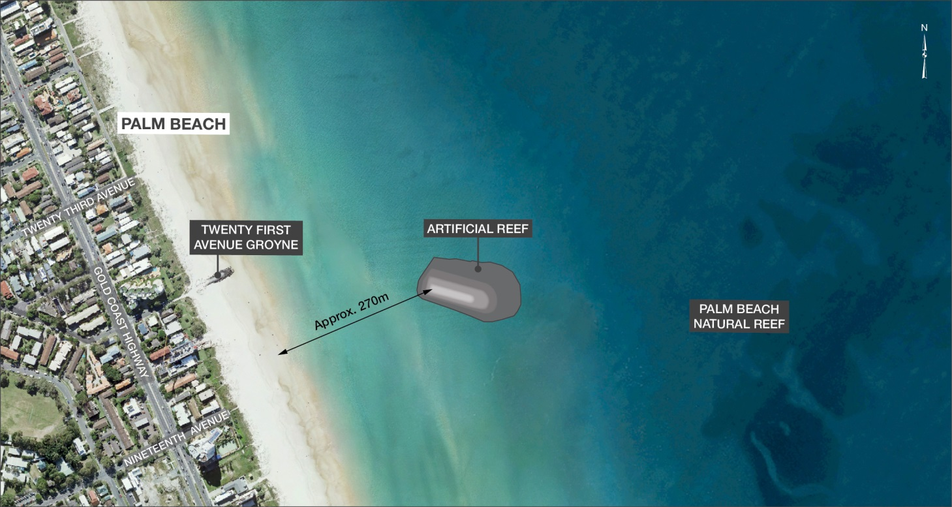

Figure 1 - Location and orientation of the artificial reef.

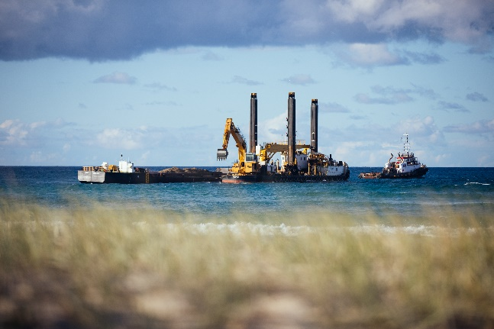

Figure 2 – Backhoe dredger and split hopper barge placing rock at the reef site.

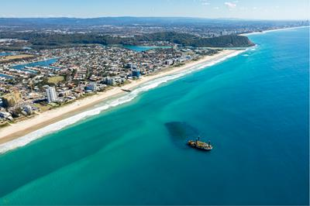

Figure 3 – Backhoe dredger at the reef during construction.

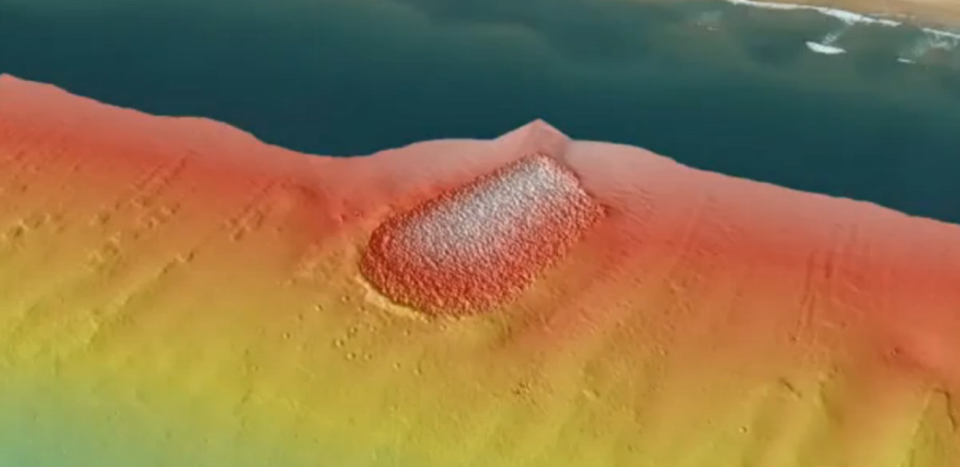

Figure 4 – Final survey of the completed reef structure.

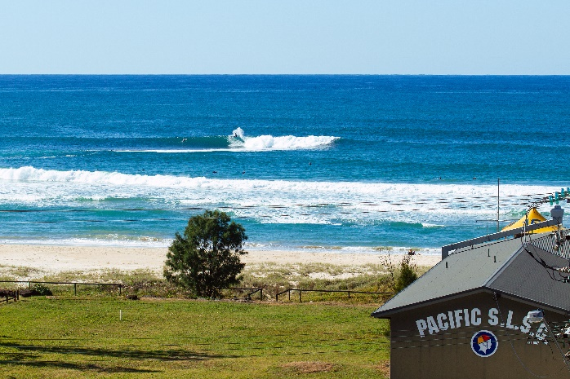

Figure 5 – Wave breaking and surf amenity on Palm Beach Reef.