BIG COASTAL MANAGEMENT REQUIRES BIG COASTAL MONITORING:
TWO DECADES OF OPERATIONAL COASTAL IMAGING AT AUSTRALIA’S GOLD COAST

Chris Drummond¹, c.drummond@wrl.unsw.edu.au
Matt Blacka¹, m.blacka@wrl.unsw.edu.au
Ian Turner¹, ian.turner@unsw.edu.au
1. Water Research Laboratory, School of Civil and Environmental Engineering, UNSW Sydney

BACKGROUND
2022 marks over two decades since the construction of the Narrowneck multi-purpose reef at the Northern Gold Coast, Queensland. The reef was implemented in 2000 in parallel with 1.1 million m³ of beach nourishment which is one of the most innovative and large-scale coastal management projects in Australia (Boak et al. 2000). Effecting beach management works of this scale also required implementation of a cutting edge coastal monitoring program, with the Water Research Laboratory (WRL) working alongside Gold Coast City Council to establish an Argus camera system at Surfers Paradise in 1999 (Figure 1)(Turner et al, 2004). At the time, this station was the forefront of coastal monitoring technology, providing weekly shoreline position, intertidal morphology and rectified imagery of the beach.

A GROWING MONITORING NETWORK
In 2001 the Tweed River Entrance Sand Bypassing Project operationalised a permanent sand bypassing system across the Tweed River entrance at the southern end of the Gold Coast, making way for pumped transfer of ~500,000 m³ of sand from northern NSW onto the southern Gold Coast beaches, every year. WRL’s Argus program was expanded in 2002 to provide monitoring and operational beach measurements to inform sand pumping, with four new monitoring stations installed at Duranbah, Snapper Rocks, Coolangatta, and Kirra and Palm Beach.

BIG, BIGGER, BIGGEST MONITORING NETWORK
The camera-based beach monitoring program has been maintained for over two decades now, providing one of the longest running and most comprehensive beach data sets in Australia. Of particular interest is that the data documents the changes experienced on an actively managed stretch of coast, where innovative coastal protection structures are combined with continuous beach nourishment to meet a diverse spectrum of coastline management needs. Council’s ambitious coastal management works have continued with the Gold Coast Beach Nourishment Project in 2017 seeing 3 million m³ of sand placed on the Gold Coast beaches, and the construction of a second artificial reef at Palm Beach in 2019. Further expansion of the network has occurred including a remote solar powered camera system on South Stradbroke Island and low cost camera systems installed on lifeguard towers to estimate beach visitation using machine learning. The system is now the world’s most advanced and large-scale camera-based coastal monitoring network with complete coverage of the entire coastline of the Gold Coast. The Coastal Imaging program currently provides operational imagery from 47 cameras across 10 different monitoring stations. The network of fixed position GigE cameras delivers oblique snap-shot images of the beaches to Council officers every 15 minutes, along with half-hourly collection of time exposure imagery and time-accelerated video clips. Automated transfer and data storage is via AWS, and the imagery and data sets available to Council officers via an online dashboard system that allows visualisation of near-real-time coastal conditions and beach statistics, recent changes to the beaches, and comparison with long term trends. Automated analysis of the images is undertaken hourly to produce a range of near-real-time operational data sets including:
- mapping of shoreline position;
- counts and mapping of beach users
- predicted location and mapping of rips;
- rectified imagery and time-lapse animations.

Importantly, the monitoring system now provides Council with aerial imagery and measurements of the complete 32 km of beaches within the littoral drift dominated sediment compartment, every hour of the day. Monthly and seasonal animations of the merged-rectified imagery also provide visualisation of the migration of sandbars, morphological features and other sediment transport processes within the complete compartment. This paper reflects on two decades of monitoring system advances, and presents the challenges and capabilities in operating such a significant beach monitoring network over such a long period of time.
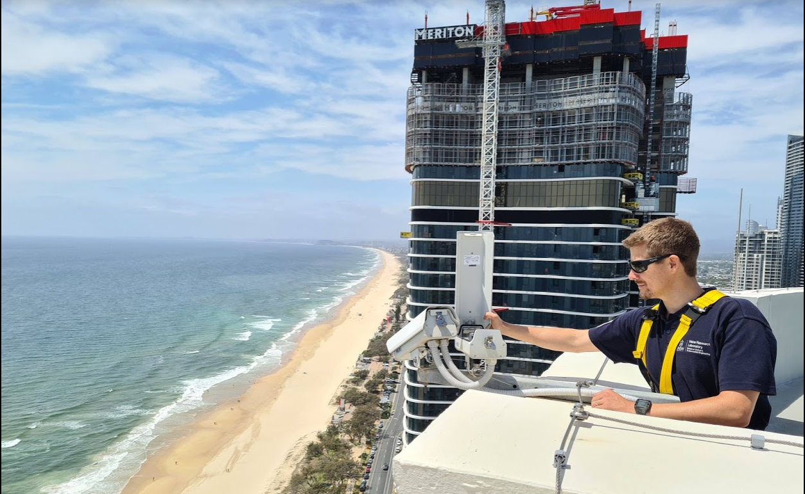
Figure 1 – Coastal imaging station at Surfers Paradise

REFERENCES
Boak, McGrath, Maffey and Jackson (2000) The Northern Gold Coast Beach Protection Strategy, Proc. 10th NSW Coastal Conference, Yamba

Turner, Aarninkhof, Dronkers, McGrath (2004) CZM Applications of Argus Coastal Imaging at the Gold Coast, Australia. Journal of Coastal Research: Vol 20,

