GRAY LEADS TO GREEN IN THE BLUE: BUILDING INFRASTRUCTURE TO ENHANCE COASTAL HABITAT

Tundi Agardy, Baird, tagardy@baird.com
Kevin MacIntosh, Baird, kmacintosh@baird.com

In discussions about best practices in coastal management and sustainable development, structures that are used to build and protect coastal habitats and properties are often referred to as gray infrastructure, distinct from the green infrastructure provided by nature. This green infrastructure includes natural habitats such as mangroves, coral reefs, shellfish reefs, saltmarshes, and seagrasses - all of which have been demonstrated to maintain shorelines, balance hydrology, buffer land from storms, improve water quality, and provide recreational and aesthetical values. Concerns arise when built infrastructure damages such beneficial habitats, as can happen if designs are inadequate or poorly planned. The result is that much of the current narrative around gray/green infrastructure has created a false and dangerous dichotomy: green infrastructure is labelled a ‘nature-based solution’, while gray infrastructure is portrayed or perceived by certain stakeholders as the opposite (sometimes implying that engineered solutions are not long-term solutions at all, but rather short-term solutions that can pose long-term problems).

In fact, both gray and green infrastructure can deliver benefits such as shoreline stabilization, water quality maintenance, enhancement of aesthetic values, and risk reduction. However, built infrastructure is generally assumed to be more costly than natural infrastructure, and is sometimes also perceived as providing fewer values. In a sense this creates stand-offs between conservationists and coastal engineers – when the two communities should be working together to find optimal gray/green solutions.

Gray infrastructure can not only work hand-in-hand with natural habitat to provide the benefits listed above, it can be designed in such a way as to ‘improve nature’ by allowing restoration and recovery of degraded ecosystems. Innovative designs in coastal engineering can enhance ecosystem recovery, improve ecosystem health, and enhance the flow of benefits that are generated by nature. Recognizing this, we propose a shift in the conversation, away from pitting gray against green, and toward a multi-faceted approach that uses engineering design to enhance natural habitat.

Herein we describe three examples of coastal engineering projects in Barbados that have kickstarted ecological recovery and improved environmental health, with the result that gray infrastructure has led to expanded green infrastructure in the marine (blue) environment. All three projects were funded by the Government of Barbados and managed by the Coastal Zone Management Unit and include: 1) a 1.3 kilometer coastal boardwalk (Rockley) with built-in run-off filtration; 2) flow-through groynes, a pair of submerged breakwaters, and a fluidizer that has expanded beach areas and improved the conditions in a coastal lagoon and adjacent bay (Holetown); and 3) a series of breakwaters in other west coast locations that have stabilized beaches used by residents, tourists, and wildlife alike.

1. A small-scale example: Rockley Boardwalk
The Rockley boardwalk (Figure 1) on the south coast of Barbados has been widely lauded as an example of a successful hard engineering response to coastal erosion. However, coastal planners are increasingly avoiding hard engineering where climate change adaptation is required, looking instead to a combination of hard and soft engineering (Mycoo and Chadwick, 2012). What may be overlooked, however, is the fact that the construction of the boardwalk has created new and expanded beaches that facilitate adaptation to sea level rise. These expanded beaches improve recreational access, enhance security, and create habitat for wildlife such as shorebirds and nesting sea turtles. In addition, the boardwalk’s drainage system was engineered specifically to reduce land-based sources of pollution and has resulted in improvements in water quality in the nearshore environment. This is a tangible, and much valued, example of how built infrastructure can enhance natural habitat, in both quality and quantity.

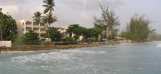

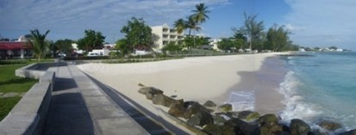
Figure 1 - Before (top) and after (bottom) photos of a portion of the Baird-engineered Richard Haynes boardwalk

2. Multiple habitats restored through gray infrastructure in one site: Holetown beach expansion and shoreline stabilization
In the second example, a series of structures were designed and built in the Holetown area to stabilize the eroding beaches adjacent to Folkestone Marine Park, on Barbados’ west coast. The structures included flow through groynes (Figure 2).

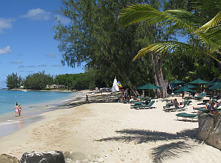
Figure 2 - Flow through groynes in Holetown Bay

A pair of submerged breakwaters were subsequently installed to stabilize the bay’s beaches further to the south. These submerged breakwaters were designed to minimize the impacts on the ‘view to the sea’ while performing the necessary beach stabilization, and they have succeeded in creating stable, wide beaches for public benefit, and have also minimized the turbidity that had been affecting offshore corals, thereby allowing natural recovery of some shallow water patch reefs nearby. The breakwaters have had the added benefit of providing colonizing habitat for corals, sponges, and gastropods, as well as nursery and adult habitat for fishes (see Figures 3 and 4).

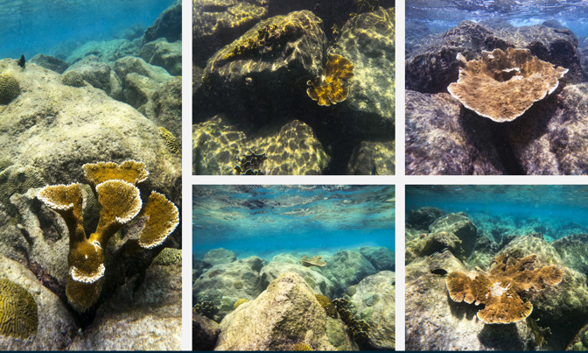
Figure 3 - Colonization of the submerged breakwaters by various coral genera

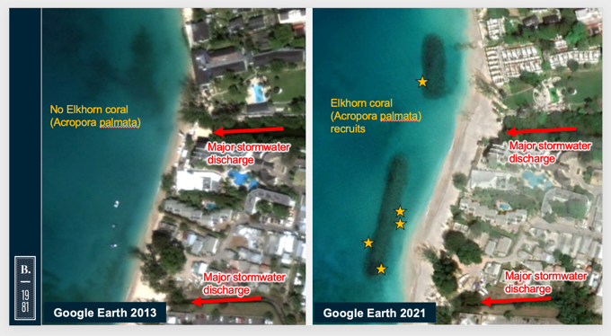
Figure 4 -Locations of new Acropora palmata colonies, on the two submerged breakwaters in Holetown (Before L; After R)

Additionally, a fluidizer installed at the mouth of a small lagoon just to the north of one of the breakwaters also contributes to maintenance of the beach. The lagoon is at the mouth of a watershed that drains run-off from the steep catchment inland; this watershed carries sediments and other pollutants to the lagoon, which are then suddenly released to the sea during rainfall events. As the lagoon became degraded after being cut off from the sea, the mangroves and other vegetation in it were less able to filter pollutants before reaching the shore. The intent of the fluidizer is to allow water exchange and regular flushing to improve the water quality in the lagoon itself.

3. Creating new habitat: multiple beach restoration projects along the west coast
The third example describes works in progress, with several beach stabilization projects along Barbados’ west coast.

The beaches at Heywoods, to the north of Holetown, have been subject to periodic erosion, especially in response to strong north swells. Further beach instability is thought to have been caused by inadequate breakwaters and drainage systems that had been installed at the site decades prior. The solution to these patterns of erosion was to design and install a set of submerged breakwaters. These were designed to minimize impacts on nearshore fish nursery habitat - specifically platform corals providing extensive and important habitat for young fishes. The structures were also physically designed to accommodate coral colonies that were moved from the construction footprint.

The structures at Heywoods have stabilized, created expanded beaches, with values delivered to the public and to biodiversity (see Figure 5). With high success rates for translocated coral colonies, there is now greater coral cover than before construction, and the corals are showing significant growth. In addition, natural colonization by young coral recruits and sponges is already evident three years after the installation of the structures. Long-term monitoring studies will continue to provide data on coral recovery, trends in fish populations, and water quality (MacIntosh et al, 2022; this volume).

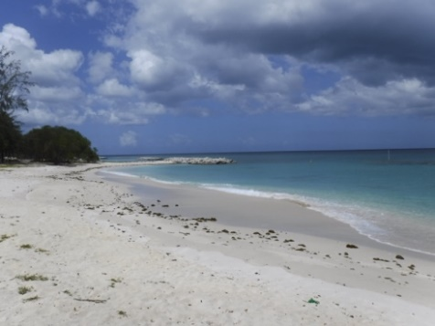
Figure 5 - Expanded beaches at Heywoods

On Barbados’ west coast, a private landowner has financed the necessary studies to create a gray solution to erosion of their property. Submerged breakwaters were designed to combat erosion of the shoreline and restore beach habitat, with the least disturbance to benthic habitat offshore. The structures were placed in areas without living coral and designed in such a way as to be unobtrusive to the viewscape.

Whereas the Heywoods structures have been in place for 3 years, these structures have only recently been installed. The immediate effect of the structures has been to create beach habitat where there hasn’t been beach in years. This habitat is already being valued - not just by the landowner and the wider public for beach access, but by Barbados’ flagship sea turtles, which utilize the area for nesting (Figure 6).

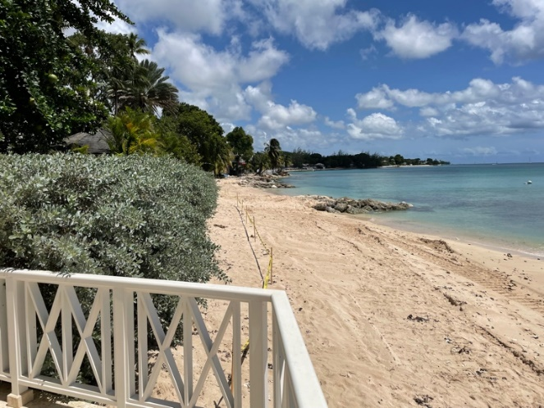

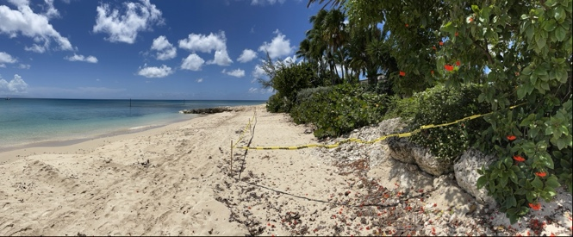
Figure 6 - Project site showing beaches where high water previously came to the vegetation line; yellow flagging tape marks extensive sea turtle nesting

While it is too soon to quantify the ecological restoration that mitigating the erosion of the shoreline at this location will catalyze, monitoring programs are in place to determine trends in water quality, as well as to ascertain the extent to which new beach areas are providing important habitat for sea turtles and shorebirds. The Coastal Zone Management Unit of Barbados now has detailed baseline data and several monitoring datasets, which it can use as a base for a long-term monitoring program to better understand both ecology and management effectiveness.

These examples in Barbados, addressing slightly different challenges brought about by rising seas and increased shoreline erosion show that gray solutions can drive environmental enhancement and localized ecosystem recovery. Coastal structures can stabilize shorelines, prevent erosion, and create space for colonization by mangroves, seagrasses, corals, and other foundational marine species. The structures themselves can contribute to improving water quality, creating the enabling conditions for ecosystem recovery. Additionally, expanded high-quality beaches provide space for residents and tourists, and for flagship marine species like sea turtles and shorebirds. A positive social impact also results from improved aesthetics that foster pride and help build a conservation ethic, leading to stronger adherence to environmental policies and better waste management. In the blue domain of the oceans and coasts, gray can indeed lead to green.

REFERENCES
MacIntosh, Brewster, and Agardy (2022). Multi-year monitoring to distinguish environmental impacts due to waterfront construction from ambient environmental change. ICCE 2022.
Mycoo, Chadwick (2012). Adaptation to Climate Change: The Coastal Zone of Barbados, Maritime Engineering, UK Volume 165 (Issue 4) pp 159-168.

