DEEP LEARNING TO PREDICT TSUNAMI HEIGHT AT THE SHORELINE USING OCEAN BOTTOM PRESSURE DATA

Willington Renteria, University of Southern California, wrenteri@usc.edu
Patrick Lynett, University of Southern California, plynett@usc.edu

Real-time tsunami prediction is a required component of a tsunami warning system. Several advances have been made to improve prediction in the tsunami warning process, including precomputed databases and the assimilation of deep-ocean observations (DART buoys) into numerical modeling (Bernard & Titov, 2015). These improvements aim to accurately and quickly predict the time and height of the tsunami wave impact.
Here, two deep learning models (DLM) are developed to predict the maximum tsunami height at a local/long shoreline from four time series observations of ocean bottom pressure data. These two DLMs were trained/tested with the results of 1300 tsunami simulations of Cascadia Subduction Zone (CZS) earthquakes, including their inundation and runup on the coast. The training dataset is composed of 1040 scenarios and the testing dataset id of 260 scenarios.
The tsunami simulations used as initial conditions the sea surface perturbation, generated from the dataset of potential earthquakes along the CZS developed by (Melgar et al., 2016). The numerical model used for these simulations was the nonlinear shallow-water version of Clawpack, Geoclaw (LeVeque et al., 2011).
Results of numerical simulations are used to train the supervised DLMs with input features from synthetic ocean bottom pressure data (i.e., produced by those models at four different locations in the Cascadia zone). In the first case, for a real application, one could use the DART buoy data (instead of the synthetic data used here) to predict the tsunami height at the coastline without needing a numerical model of the event.
First, from three time windows of 15, 30, and 45 minutes of data (i.e., synthetic offshore data) the model predicts the maximum wave height at the coastline along the West Coast of the United States. This DLM model has a mean absolute error of 0.20, 0.19, 0.17 m in the testing subset of 260 scenarios. The DLM for this application is a neural network trained with the available data and optimized by a root mean square propagation algorithm.
Second, with the same three windows of time, we use the synthetic offshore pressure data with a stacked DLM to predict the maximum wave height at the Crescent City coastline. The optimized DLM yields a reduction in the mean absolute error in the tsunami height prediction across 260 testing sources in Crescent City. This stacked DLM is composed of a neural network and autoencoder. The neural network is used to get a first approximation of the maximum tsunami height, and the autoencoder is used to improve the results.
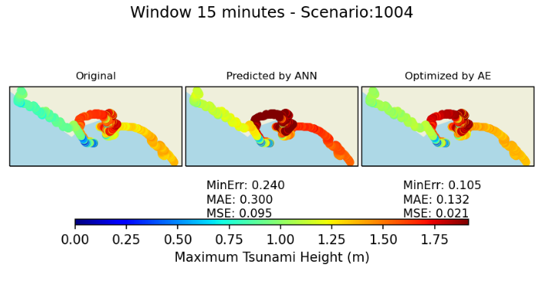
Figure 1 – Neural Network & Encoder tsunami height (m) prediction with 15 minutes of data, for the scenario No. 1004 at Crescent City.

The testing mean absolute errors for the three input durations were 0.67, 0.53, and 0.46 m, respectively, in the neural network part. To improve the predictions, these outcomes are passed to a stacked autoencoder. As an example, for the scenario No. 1004, the MAE went from 0.3 to 0.13 m after the autoencoder (Figure 1).
These initial results indicate that the offshore pressure data contains more information relevant to onshore hazard, and thus we investigate the DLM with this input data further
This DLM is capable of predicting the tsunami height with just the information from a few ocean bottom pressure devices. The methodology could be applied to other tsunami sources as it requires only the time series of the tsunami passing near the location of the DART buoys.
REFERENCES
Bernard, Titov (2015). Evolution of tsunami warning systems and products. Philosophical Transactions of the Royal Society of London. Series A: Mathematical, Physical, and Engineering Sciences, 373(2053), 20140371.

LeVeque, George, Berger (2011). Tsunami modelling with adaptively refined finite volume methods. Acta Numerica, 20, 211-289.

Melgar, LeVeque, Dreger, & Allen, (2016). Kinematic rupture scenarios and synthetic displacement data: An example application to the cascadia subduction zone. Journal of Geophysical Research. Solid Earth, 121(9), 6658-6674.

