TWEED SAND BYPASSING TRANSITION PROJECT

Matthew Harry, Maritime, Transport for NSW, matthew.harry@transport.nsw.gov.au
Adrian Barwick, Maritime, Transport for NSW, adrian.barwick@transport.nsw.gov.au
Bruce Harper, Department of Environment and Science, Queensland, bruce.harper@des.qld.gov.au

BACKGROUND
The Tweed River is located in New South Wales, Australia, just south of the state border with Queensland (Figure 1). The Tweed River Entrance Sand Bypass Project, aka Tweed Sand Bypassing (TSB), was formulated to overcome problems caused by the extension of the Tweed River entrance training walls in the 1960s (Dyson et al., 2001). These issues were primarily: the interception of natural longshore movement of sand, resulting in loss of sand supply to the southern Gold Coast beaches; and sand movement into the river entrance with consequential impacts on vessel navigation. TSB is a joint initiative of the New South Wales and Queensland State Governments. The TSB is similar to the nearby Gold Coast Seaway Sand Bypass (GCSSB) that was commissioned in 1986 to stabiles the Nerang River entrance (Clausner, 1989). Together, these two facilities have come to represent best practice outcomes in sustainable coastal management.

In 1998, private sector participation in the TSB project was invited on a Build Own Operate and Transfer (BOOT) basis. Contracts were awarded to a consortium led by McConnell Dowell (the Operator) to design, construct and operate a sand bypass system until September 2024. Construction began in 2000 and the system began operating in 2001. The TSB fixed bypass system continues to be operated under a Concession Agreement (CA) between the Governments and the Operator until 30 September 2024 and is legislated to operate in perpetuity by acts of Parliament in NSW and Queensland. At expiry of the CA the system will be transferred to the Governments. The Operator is obliged under the terms of the CA to:
- maintain a Clear Navigation Channel as defined in the Agreement;
- deliver sand to the southern Gold Coast beaches in accordance with annual orders placed by Governments;
- maintain the fixed system for the duration of the Agreement; and
- hand over the fixed system to the Governments at the end of the concession period at no cost to the Governments.

A Transition Project was established by TSB to identify the most appropriate operational system / model post-expiry of the CA and to ensure ongoing effective coastal management that meets the legislated objectives. The Transition Project has provided a unique opportunity to improve how TSB functions through the exploration of available options and analysis of historical operational performance. The Transition Project was divided into four Phases mapping out detailed investigations, decision making milestones and implementation requirements to ensure operation of TSB post-2024.

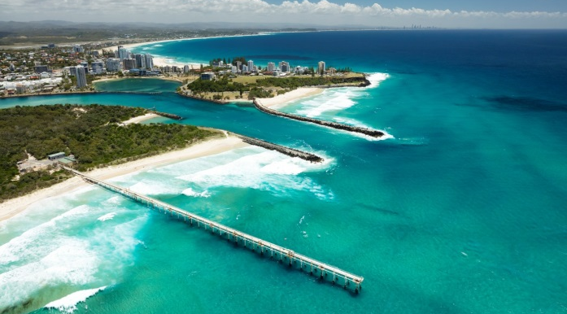
Figure 1 – Tweed Sand Bypassing located at the Tweed River and southern Gold Coast Beaches, Australia

PHASE 1: REVIEW OF PAST OPERATIONS (late 2018 to June 2020)
Phase 1 consisted of a review of past operations through eight specialist consultancy engagements and the compilation of a Phase 1 summary report. The engagements were as follows:
- Assessment of Performance Against Project Objectives
- Economic and Social Impacts of TSB
- Governance and Contractual Review
- TSB Asset Assessment
- TSB and GCSSB Review
- Financial Review
- TSB Environmental Review
- Stakeholder Engagement and Consultation
- Phase 1 summary

The investigation, ‘Assessment of Performance Against Project Objectives’, developed Key Performance Indicators (KPIs) to quantify the effectiveness of sand bypassing and dredging since the commencement of TSB. This included comparisons between sand supplied by the system to longshore sediment transport, analysis of beach profiles and beach amenity downdrift of the sand transfer system, and quantification of time that the navigation channel was compliant with defined dimensions. The KPI results demonstrated that overall, TSB has been successful in meeting legislated objectives.

The ‘Economic and Social Impacts of TSB’ investigation sought to identify the economic and social benefits associated with the activities in the Tweed River entrance, and of tourist and resident use of beach and surf amenity in the project area. The investigation also estimated the potential impact of alternative sand management scenarios (change in operations and coastal control structures). It was estimated that the economic value of beach and entrance usage in the project area (under the current base case of TSB being operational) was over $200M. The majority of this value is related to beach and surf amenity. It was also estimated that alternative scenarios (e.g. dredge only or return to pre 1960’s scenario) would result in economic losses.

A ‘Governance and Contractual Review’ determined the effectiveness of the Governance arrangements, and the CA between the Governments and the Operator. The current Governance framework involves a Working Group of diverse parties that sets strategic project priorities, an Advisory Committee that recognises community feedback, and a range of legislative mechanisms that Governments use to assess ongoing management of TSB as a whole. It was found that the Governance framework has been effective overall albeit with some inflexibility. The Contractual framework that primarily consists of the CA was found to be effective in shifting financial, whole of life and operating risks to the Operator. Nevertheless, it was demonstrated that this limited the Government’s ability to respond to social, environmental, and economic issues. Also due to the long-term nature of the CA the operations were somewhat limited in aligning with the dynamic nature of the coastal environment.

The ‘TSB Asset Assessment’ involved a comprehensive review of the project’s Asset Management Plan and asset management system. The investigation also reviewed clauses of the CA relevant to asset condition at handover. It was recommended that the Operator and the Governments work together to update asset management systems prior to handover and to investigate additional handover standards that do not form part of the CA.

The objective of the ‘TSB and GCSSB Operation Review’ was to compare these two sand transfer systems to better understand any operational differences and to identify possible improvements to TSB. One of the primary findings related to the desirability of increasing the density of the transferred sand slurry at the TSB facility, which would in turn reduce the required daily pumping time, energy use and operating costs.

The ‘Financial Review’ compared operating costs between TSB and the GCSSB. It was found that the cost per m³ of delivered sand is more expensive for TSB. Contributing reasons for the additional cost included transfer of risk (dredging, maintenance etc), expected rate of return for the operator, and overhead costs. Making allowance for these additional costs it was found the cost per m³ of delivered sand was comparable.

The ‘TSB Environmental Review’ focused on the environmental management framework of the project. This incorporated the environmental approvals context, operational environmental management system, and the TSB’s extensive environmental monitoring program. Key recommendations of the review included rationalisation/ consolidation of TSB’s environmental management plans, implementation of trigger-based monitoring where appropriate, and replacement of some monitoring activities with alternative technologies.

A ‘Stakeholder Engagement and Consultation Report’ detailed a qualitative and quantitative analysis of the community’s awareness of and sentiment towards TSB. The results of the stakeholder engagement investigation indicated that overall, the local community believes that TSB is effective at sand management within the entrance and on local beaches (Figure 2).

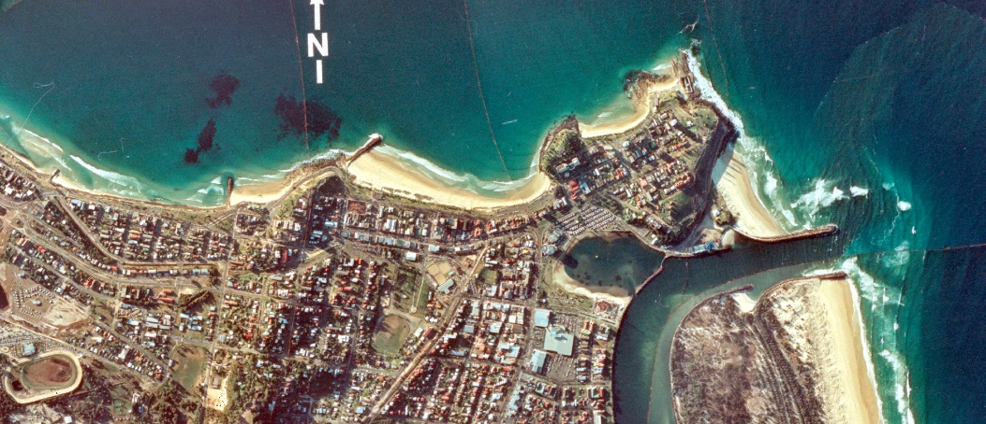
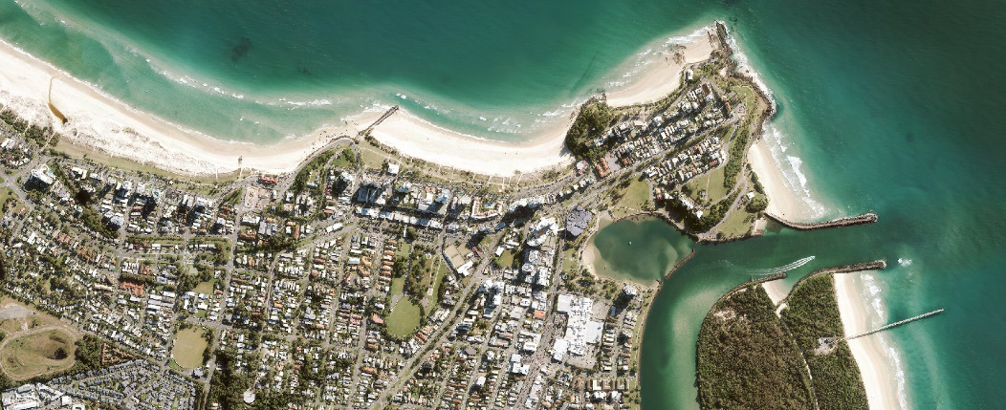
Figure 2 – The Tweed River entrance and southern Gold Coast beaches pre-TSB (1982, top) contrasted against the current coastal environment (2021, bottom)

The conclusion of Phase 1 was development of a summary report in preparation for future options identification. The summary report identified interdependencies between the workstreams described in each specialist report and outlined the key considerations for the Phase 2 analysis. The report also provided recommendations for environmental and approval matters, and tasks to be completed prior to handover.

PHASE 2: OPTIONS IDENTIFICATION (July 2020 to November 2021)
Phase 2 consisted of options identification and evaluation. A shortlist of Infrastructure, Governance and Contract options were developed, and options were subjected to financial, risk and impact assessments (Cardno, 2021).

Infrastructure options were split into three categories: Base case; modifications and improvements to existing operations; and alternatives to current operations. The infrastructure options longlist of 16 options was evaluated, resulting in 4 candidates. Examples of improvements to the system include optimisation of jet pump sequencing and increasing sand slurry density, while construction of an offshore breakwater with a dredged sand trap was an example of an alternative system of operation. The shortlist comprised of the Base Case, Base Case with Improvements, Jetty Extension and Additional Jet Pumps, and Restarting Jet Pump 1 (an existing shoreward jet pump). The Base Case was selected as the preferred Infrastructure option. Other options were discarded through the financial assessment, and recognition that some improvement can be implemented at a later date following additional investigation. For example adaptation to future projected climate change is an important operational consideration that will not be constrained under the preferred option.

Governance options were shortlisted to four out of the seven initially identified. These include the Base Case (continue existing governance arrangements between the Governments); Base Case with Improvements such as amending legislation to add a strategic focus and formalising local government representation; establishment of a New State Authority; and establishment of a New Corporations Act Company. The Base Case was selected as the preferred Governance option.

Contract options were simply split into two categories, Base Case (extension of current Concession Agreement) and Alternatives to Current Concession Agreement. The Contract options relate to the day-to-day operational control of the sand transfer system, responsibility for maintenance, asset management, major and minor contract administration, and resourcing of operational staff. Options included the Base Case; a New Public Private Partnership (PPP); D&C short-term contracting; DCM integrated delivery and operations contract; GCSSB contract; and Government oversight of delivery. The financial assessment discarded most options, and the preferred Contract option selected was Government oversight of delivery (practical implication is three new government operational staff to undertake operations and maintenance with the support of the existing TSB government team).

Combinations of all options (Infrastructure, Governance and Contracts) were ranked, and the preferred option represented the lowest Net Present Cost without risks above the risk assessment threshold. Sensitivity testing was completed for all combinations and no major changes to outcomes were identified. It is expected that under the preferred option there will be a reduction in ongoing expenditure, an increase in operational flexibility, improved integration of operations and management, and there will be no constraints under the preferred option to pursue improvements (Infrastructure or Governance). The preferred option will see the continued operation of the sand transfer system, existing governance arrangements continue, and Government overseeing delivery and contracting of TSB.

PHASE 3: PREFERED OPTION PREPARATION (July 2021 to April 2023)
Phase 3 is underway and includes preparation for implementation of the preferred option. There are a significant number of tasks to be completed across a variety of fields ranging from approvals, systems, resourcing, asset management and procurement.

A draft TSB strategy has been developed and sets out the key themes for the period 2024 to 2029. The strategy references outcomes, measures and actions and will guide all TSB activities for that time period. The strategy falls within a hierarchy of documents that includes Objectives (Acts, Vision etc), Strategy (Themes and priorities), Plans (how and when), Procedures (how), and Supporting Information (specifications, drawings, checklists, registers, forms etc.). To formalise this arrangement and the subsequent suite of documents, a TSB Management system is being developed that maps the location and hierarchy of all documents that are required to operate, maintain and administer TSB. The production of the documents that will comprise the TSB Management system is underway and consists of transfer of existing documentation from the Operator (where applicable) along with the drafting of new documentation as required.

Along with the above work, significant effort is being applied to the transfer and/or establishment of various items including land access arrangements, approvals, permits, environmental management, asset handover, staffing, IT, procurement and contract administration.

PHASE 4: IMPLEMENTATION OF NEW SYSTEM (April 2023 to September 2024).
Following completion of Phase 3, Phase 4 will encompass the implementation of the new system. It will involve implementation of the work completed in Phase 3 and the formal transition out of the Concession Agreement into the new operating model.

Successful completion of the Transition Project will ensure that the local coastal environment and the Tweed River entrance will continue to be effectively managed into the future. The progression of the Transition Project and completion of Phases 1 & 2 has highlighted the successes of TSB to date. The positive findings ensure that there is confidence in the current operation of the system and demonstrates that Government agencies across state borders and at various levels can work together to manage a long-term coastal management initiative. The partnership with the private sector has also been largely successful when considering the difficulty in establishing and continuing to deliver an operation as complex as TSB. Although there have been challenges working within the long-term contractual arrangement, all parties have been able to make it work even as the coastal environment and community expectations have evolved. Under the preferred operating model post 2024, TSB will be able to respond to these changes more readily to ensure project objectives continue to be met to benefit the coastal environment and local community.

REFERENCES
Cardno (2021): Phase 2 Options Report, Prepared for Tweed Sand Bypassing
Clausner (1989): Jetty Sand Bypassing Nerang River Entrance, US Army Engineer Waterways Experiment Station
Dyson, Lawson, Victory, Connor (2001): Sand bypassing the Tweed River entrance: an overview, Proceedings of Coasts & Ports 2001: 310-315

