Interpretable Artificial Intelligence for Rip Current Detection and Localization

Neelesh Rampal, National Institute of Water and Atmospheric Research, Neelesh.Rampal@niwa.co.nz
Christo Rautenbach, National Institute of Water and Atmospheric Research, Christo.Rautenbach@niwa.co.nz
Tom Shand. University of Auckland, t.shand@auckland.ac.nz

ABSTRACT
A rip current is a strong, localized current of water which moves along and away from the shore. Recent studies have suggested that, in Australia, drownings due to rip-currents claim more lives than bushfires, floods, cyclones, and shark attacks (Brander et al., 2013). Identification of rip currents is important for both surf lifesavers/lifeguards when making decisions on where to designate safe swimming areas and for the general public when deciding on where to swim when lifeguards are on patrol. Our motivation is to enable better real-time detection of rip-currents to assist and improve decision-making and reduce the potential for loss of life. Our approach is to develop an artificial intelligence (AI) algorithm that both identifies whether a rip-current exists in a video or image, but also localizes where that rip-current occurs. While there have been some significant advances in AI for rip-current detection and localization (e.g. de Sliva et al., 2021), there is a lack of body of research ensuring that an AI algorithm can generalize well to a diverse range of coastal environments and marine conditions. Furthermore, to build trust in AI we need to ensure that AI algorithms are learning the correct features from data. In our study, we overcome the technical challenges above by using interpretable AI, which enables better model development and improvement. The key challenge is ensuring that the training data - from which the AI algorithm learns to predict the occurrence of rip-currents - is diverse and encompasses rip-currents in a wide variety of environmental settings. Failure to address this results in poor model generalization and successful detection in only a narrow set of pre-trained conditions. Because generating and manually labelling rip-current training data is time consuming, we make use of an open-access aerial catalogue of rip-currents (de Sliva et al., 2021).. However, real-world cameras are not aerial and rather oblique. To overcome this issue, we augment the aerial imagery by applying a wide variety of randomized image transformations (e.g. perspective, rotational transforms and additive noise), which dramatically improves model performance. To account for a diversity of environmental settings, we synthetically generate and add random fog, shadows and rain to the rip-current images. This in total increases our training data size at least 10-fold. Our approach extends one-step further than traditional AI algorithms, by using Interpretable AI. This method enables us to determine the pixels and thus location in an image that most influenced the prediction made by the algorithm. Interpretable AI is useful for two key aspects of rip-current detection: 1) predicting and locating where rip-currents occur, and 2) examining deficiencies in the algorithm, and identifying areas of potential improvements in the data/model (Figure 2). Through informing model / data development, Interpretable AI has dramatically improved the accuracy of our algorithm, which is can correctly classify and localize rip-currents over 90% of the time when validated on independent videos from surf-cameras from oblique angles. An example of the predictions made by Interpretable AI are shown in Figure 1. Future aspirations are to apply the rip-current algorithm to longstanding camera archives on beaches, to enable us to understand the metocean conditions that correlate to rip-current occurrences and to deploy the algorithm on low-angled cameras located on beaches to better replicate the view that the public and lifeguards have when detecting rip-currents.

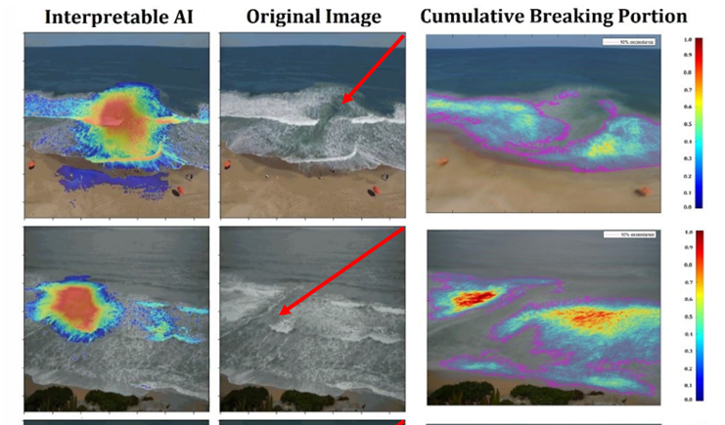
Figure 1 – Example of the interpretable AI algorithm identification of where a rip-current exists from a camera on a beach.
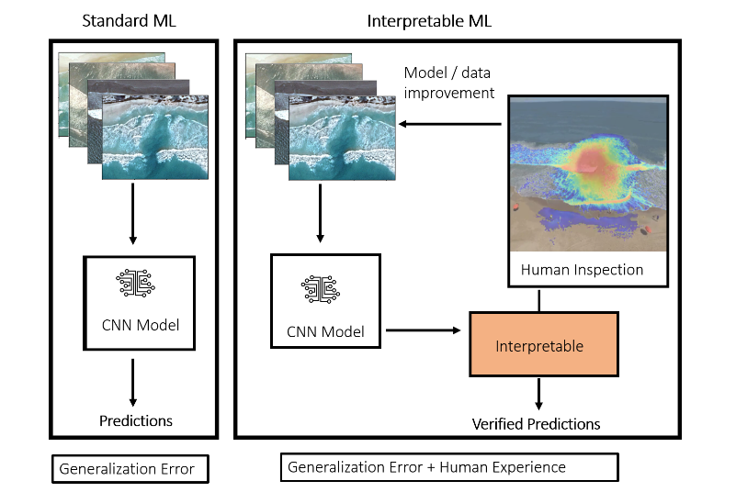
Figure 2 – The improvements of using interpretable AI instead of traditional AI.

REFERENCES
Brander, R. Dominey-Howes, D., Champion, C., Del Vecchio, O., and Brighton, B. Brief Communication: A new perspective on the Australian rip current hazard. Natural Hazards and Earth System Science, 2013; 13 (6): 1687

de Silva, A., Mori, I., Dusek, G., Davis, J., & Pang, A. (2021). Automated rip current detection with region based convolutional neural networks. Coastal Engineering, 166, 103859.

