A MIXED METHOD TRADITIONAL KNOWLEDGE STUDY OF COASTAL FACTOR CORRELATION TO DECLINING SEA ICE IN RESOLUTE BAY, NUNAVUT

Alexandra Forsythe, University of Ottawa, Canada. afors059@uottawa.ca
Ioan Nistor, University of Ottawa, Canada inistor@uottawa.ca

INTRODUCTION
Canadian Arctic environments suffer severe consequences from global climate change. As sea surface and air temperatures rise, sea ice extent and thickness continue to decline, resulting in longer ice-free seasons. Ford et al. (2004) found Indigenous communities within Arctic Canada are particularly vulnerable to environmental changes caused by climate change, due to their traditional culture and its ties to the land. Many Inuit communities are still heavily reliant on a sustenance economy and traditional knowledge of hunting, trapping, and fishing [Laidler et al. 2009]. The socio-economic impacts of changing sea ice to Inuit communities include but are not limited to dangerous ice conditions, changes in species migration patterns, loss of travel and hunting routes, loss of roads and community infrastructure due to increased wave attack from ice free bays, and food insecurity [Cuerrier et al. 2015]. Predictions of future RCP scenarios and sea ice loss can be done with neural networks and coupled numerical atmospheric, ocean and sea ice models [Hu et al. 2018, Nichol et al. 2021]. These methods however are only capable of predicting sea ice loss on large global and arctic wide scales, and not on a community scale. Due to the remote nature of Canadian Arctic communities, there are limited quantitative data available for calibration of predictions. However, local Inuit hunters, trappers, and elders hold a plethora of knowledge on the sea ice and coastal environment within their communities.

OBJECTIVES AND NOVELTY
This study seeks to answer the question, can coastal factors be correlated to declining sea ice through scientific and traditional knowledge methods. The present study examined (1) historical trends in, (2) lived experience and traditional knowledge of, and (3) correlation between, sea ice and the coastal environment in Resolute Bay, Nunavut Canada.

METHODS
Coastal factors in this study include, bathymetry, air temperature, sea surface temperature, storm frequency, shoreline geometry, fetch, current, wave, and wind magnitude and direction. Sea ice characteristics are defined as, freeze-up timing, break-up timing, length of open water season, floe edge length, and sea ice thickness distribution. Interviews were conducted in Resolute Bay, Nunavut, Canada. Participants were required to rank on a binary scale, whether the factors listed above had increased, decreased, or remained the same over their lifetime. Additionally, interviewees participated in a group session to document on maps, typical coastal and ice patterns in their communities. Finally, individual semi-structured interviews were conducted to identify outlier events in coastal or ice behavior and impacts these changing conditions have had on the community. Community members also identified to researchers during a guided tour where the ice is typically thinner, rendering hunting and travel more dangerous.

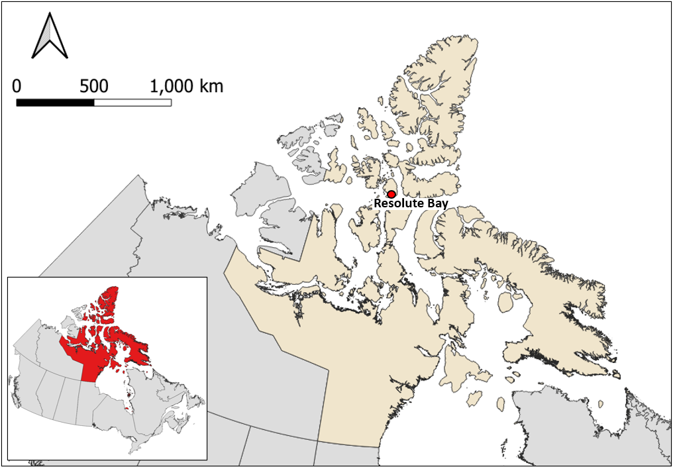

Figure 1 – Community interview locations, Resolute Bay, Nunavut, Canada.

RESULTS
Interviews are being conducted in the spring of 2023. The responses are to be analyzed for consensus between community members and compared to the trends in quantitative data. Correlation between any coastal factors and the decline in sea ice thickness, recession of the flow edge, and lengthening of the open water season will be identified.

CONCLUSION
Outside the new understanding of local sea ice characteristics, the expected significance of these inferences is within the correlation of physical parameters to sea ice change. Any correlation between parameters could be used in future research to analyze predictive trends in sea ice loss at a community scale due to global climate change.

REFERENCES (selected)
Hu, Sun, Chan, and Myers (2018): Thermodynamic and dynamic ice thickness contributions in the Canadian Arctic Archipelago in NEMO-LIM2 numerical simulations, The Cryosphere, vol. 12 no. 4, pp 123-1247.

Cuerrier, Gerin-Lajoie, Brunet, and Downing (2015): The Study of Inuit Knowledge of Climate Change in Nunavuk, Quebec: A Mixed Method Approach, Human Ecology vol. 43 no. 3 pp 379-394.

