FLOOD MODELLING USING CSIRO DATA61’S MODELLING TOOLKIT CFAST - A CASE STUDY OF THE RIVERVIEW FAMILY CARAVAN PARK IN VICTORIA

Vihan Weeraratne, CSIRO Data61, Vihan.Weeraratne@csiro.au
Raymond Cohen, CSIRO Data61, Raymond.Cohen@csiro.au
Mahesh Prakash, CSIRO Data61, Mahesh.Prakash@csiro.au
Warren Chapman, Barwon Coast Committee of Management, warren@barwoncoast.com.au

PROBLEM STATEMENT
The Riverview Family Caravan Park (RFCP) sits on the eastern bank of the Barwon River Estuary in Ocean Grove, Victoria, Australia and is managed by the Barwon Coast Committee of Management (BCCM). The Park is susceptible to inundation during extreme weather events including catchment flooding from the Barwon River and storm surges from the Bass Straight (Figure 1). To protect from this river inundation there is a levee bank consisting of a rock revetment (seawall) with an elevated shared trail along its crest. This inundation risk will increase with climate change induced sea level rise (SLR), therefore, the BCCM was concerned with quantifying the long-term effectiveness of the elevated shared trail adaptation and to assess proposed flood risk management strategies such as further elevating the shared trail and the implementation of a detention basin.

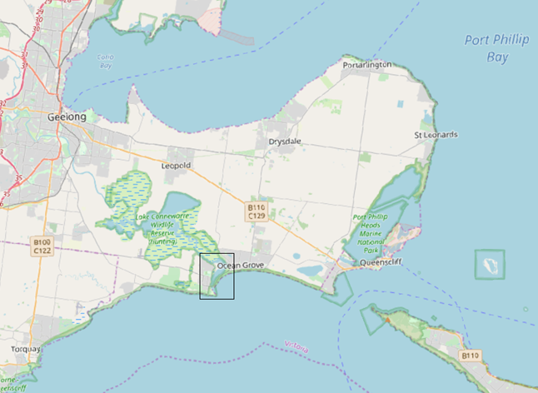
Figure 1 Location of the RFCP, black rectangle shows the study region in relation to the Bellarine Peninsula

METHODOLOGY
This study used detailed hydrodynamic and hydraulic modelling utilising the City-based Flood Adaptation Solutions Tool (CFAST) developed by CSIRO Data61 (Prakash et al., 2019) to determine the inundation risk posed by different scenarios with different adaptations applied. Specifically, the pipe network in the RFCP was included in the modelling using the hydraulic modelling component of the toolkit which was coupled with the hydrodynamic modelling considering the overland flow as a result of catchment flow, storm surge and rain on grid components. The effectiveness of the existing elevated shared trail/sea wall (with crest level 2.4 m AHD) and three proposed crest levels (2.7, 3.0 and 3.5 m AHD) were each determined in modelling scenarios with different SLR (Baseline Sea Level, 0.2, 0.4, 0.6, 0.8, 1.1 and 1.4 m). The combination of 7 SLR cases and 4 crest levels resulted in 28 simulation ensembles. Two additional adaptations were similarly considered (Figure 3), Adaptation A with an extended elevated shared trail, along the northern boundary of the caravan park: and Adaptation B with additional lowering of the northern carpark by 300 mm to act as a flood detention basin whilst protecting the interior of the RFCP with an extended sea wall.

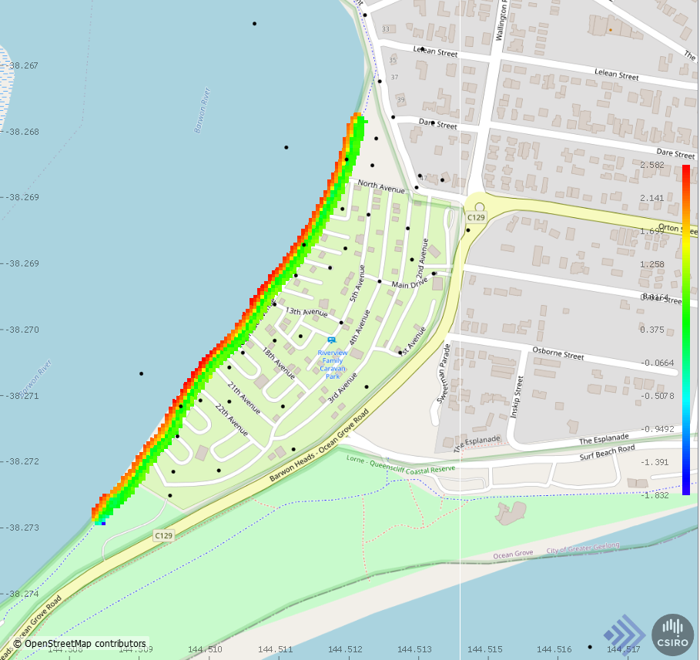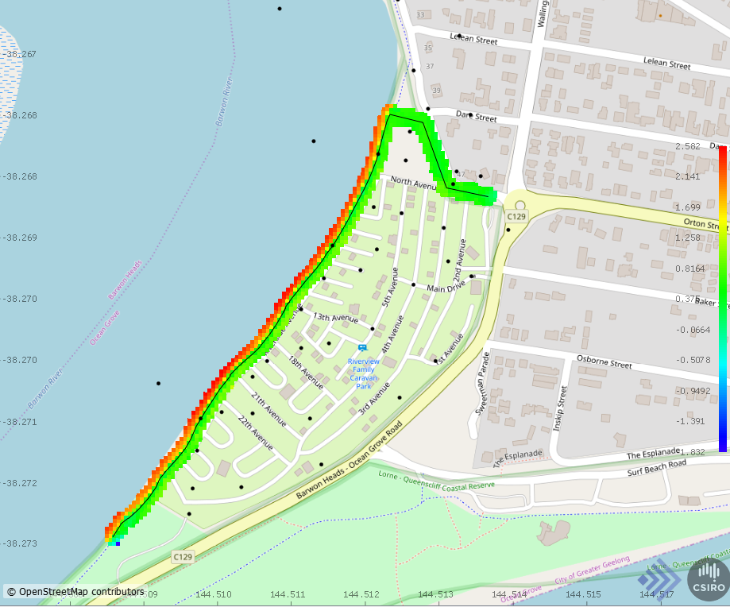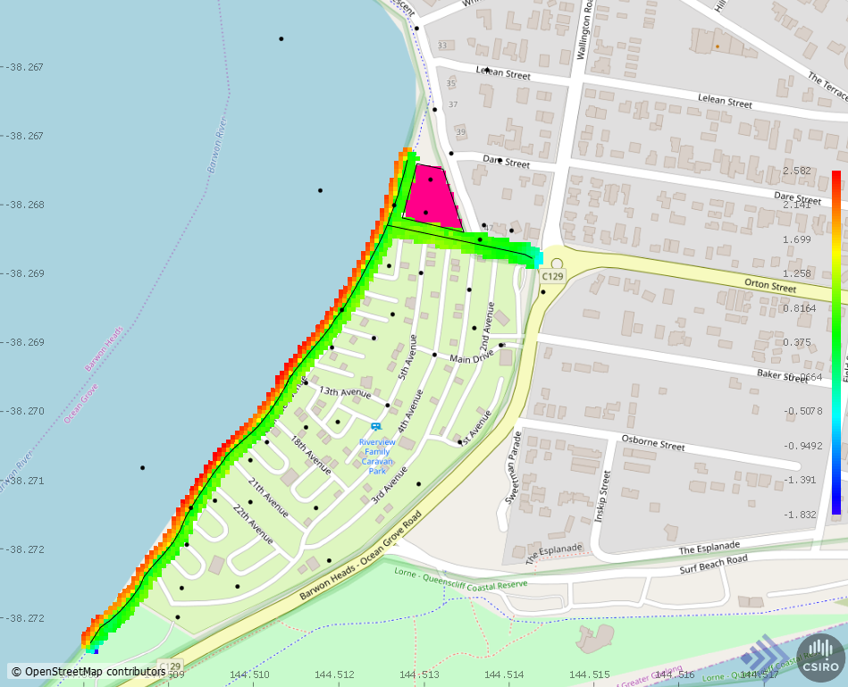
(c)
(b)
(a)
Figure 2 The 3 considered adaptation options (a) existing baseline adaptation structure: elevated shared trail/sea wall (b) Adaptation A with extended shared trail/sea wall and (c) Adaptation B: extended shared trail/sea wall with lowered car park for flood detention
The 3 adaptation cases each consisted of 28 simulation ensembles as mentioned. The fixed input flood parameters in the study consisted of; ocean storm surge combined with coastal tides at 1% AEP, Barwon River flow rates at 99th percentile average flow rate, rainfall at 10% AEP and geospatial information of the region which included DEMs of the above ground terrain and the bathymetry data for the Barwon River and the surrounding coast.

RESULTS AND DISCUSSION
The simulation ensembles were run on the CSIRO computer clusters to produce detailed flood predictions for each scenario including information for flood depths (Figure 3), flow speeds, flow hazard and flood retention times. The overall effectiveness of each adaptation case across each of the respective 28 ensemble cases considering sea wall crest level height and SLR scenario is summarized in Figure 4. The effectiveness of the existing ‘Baseline Adaptation’ case is significantly reduced beyond the critical 0.4 m SLR scenario, with high levels of inundation seen in the higher SLR cases. The inundation for the Baseline Adaptation case is mostly due to high tidal levels. Comparing the additional two adaptation options (A and B), both adaptations resulted in similar scenarios where the existing revetment crest level (2.4 m AHD) was effective in preventing heavy inundation within the park for SLR cases of up to 0.8 m. A revetment/levee level of at least 2.7 m AHD was required for the SLR cases of 1.1 m and 1.4 m. Once the revetment is overtopped at a high tide level, the drainage of the inundation levels occurred slowly due to the presence of only two one-way flow pipes within the caravan park to drain the water within the Caravan Park to the Barwon River.

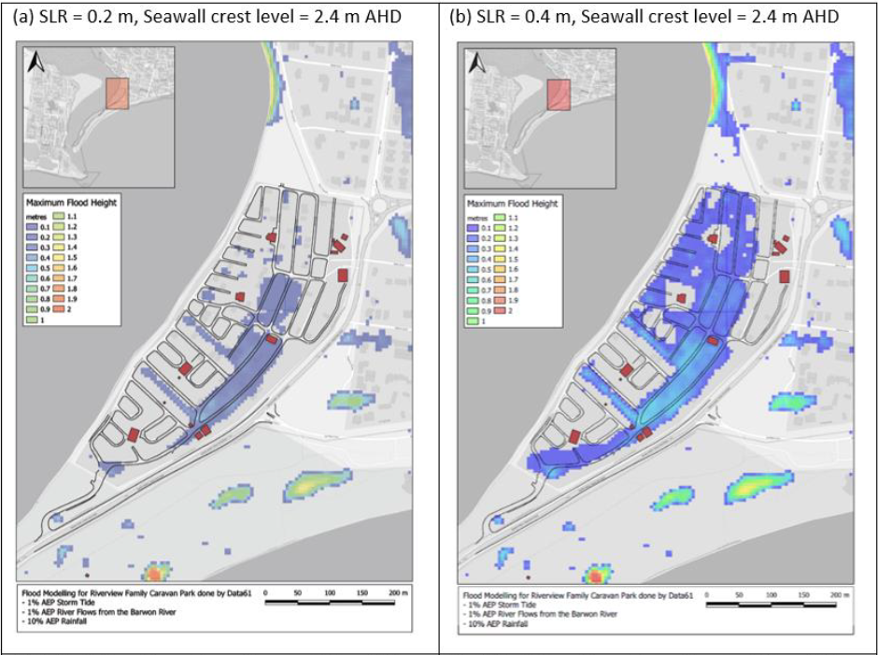
Figure 3 Maps of the maximum flood depth for the Baseline Adaptation with shared trail/sea wall crest level of 2.4 m AHD showing the changes with SLR (a) SLR = 0.2 m (b) SLR = 0.4 m

CONCLUSIONS
The proposed alternative adaptation options, Adaptation A and Adaptation B provide a clear advantage to the existing Baseline Adaptation in minimizing flood levels within the caravan park in extreme flood events. Moreover, the results of this study show the critical sea level rise values that each adaptation option is effective for, thus providing information for decision making by BCCM and other stakeholders investing in future adaptation infrastructure.

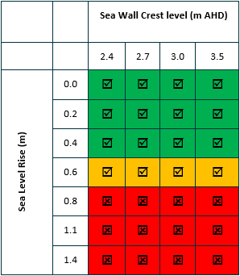
(a)
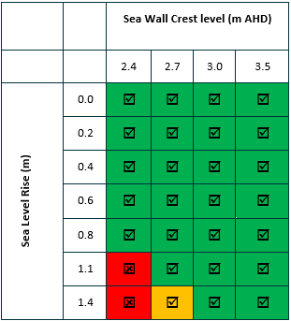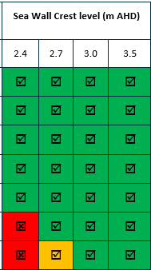
(c)
(b)
Figure 4 Overall assessment of adaptation adequacy for different sea wall crest levels under different SLR scenarios, green ticks are fully protective, amber ticks are only partially effective and red crosses are non-protective cases. (a) Baseline adaptation (b) Adaptation A and (c) Adaptation B

REFERENCES
Prakash, Cohen, Hilton & Khan (2019). An evidence based approach to evaluating flood adaptation effectiveness including climate change considerations for coastal cities: City of Port Phillip, Victoria, Australia. Journal of Flood Risk Management, 13(S1). https://doi.org/10.1111/jfr3.12556

