HYDRODYNAMIC MODELING OF AN INLET WITH ESTUARINE SHORELINE PROTECTION

Anna Wargula, United States Naval Academy, wargula@usna.edu
Liliana Velasquez-Montoya, United States Naval Academy, velasque@usna.edu
Jessica Nangle, United States Naval Academy, m224764@usna.edu
Elizabeth Sciaudone, North Carolina State University, ejsciaud@ncsu.edu
Elizabeth Smyre, Dewberry, esmyre@dewberry.com
Tori Tomiczek, United States Naval Academy, vjohnson@usna.edu

BACKGROUND
Tidal inlets are dynamic systems, leading to engineering challenges in maintaining navigability and protecting infrastructure on adjacent shorelines. Interventions to stabilize tidal inlets are commonly used worldwide. It is known that many inlet stabilization techniques may lead to changes in the circulation and morphology of the inlet and adjacent shorelines (Toso et al., 2019). Most studies have focused on the implications for ocean-side dynamics; changes in the hydrodynamics on the estuarine side of the inlet are less understood.

STUDY SITE AND MOTIVATION
Oregon Inlet, located on the Outer Banks of North Carolina, USA, separates the Atlantic Ocean from the Albemarle-Pamlico Sound. The inlet is 1-km wide and reaches depths up to 16 m. A terminal groin was built in 1989 along the southern shoulder of the inlet to prevent migration of the channel. Bimonthly aerial images since 2003 suggest that the estuarine shoreline south of the inlet has been eroding at a rate of up to 4 m/year due mostly to the migration of a flood channel, herein referred to as the “south flood channel.” The ongoing erosion is causing the loss of wildlife habitat on the adjacent barrier island and increasing the proximity of a highway to the estuarine waters.

METHODS
In this study, a field-calibrated hydrodynamic numerical model based on Delft3D (Lesser et al., 2004) is used to explore the effectiveness of six estuarine erosion mitigation designs: seawall, bendway weirs, terminal groin extension, jetties, flood channel relocation, and island restoration. These alternatives were chosen due to a spatial scale (> 50 m) that is resolved in the computational domain. The seawall was modeled as a 1-km thin dam along the edge of the eroding estuarine shoreline. Four bendway weirs were schematized as 2D weirs with crests at -4.5 m (NAVD88) extending 80 m cross-channel and angled into the stronger ebb currents of the south flood channel. The terminal groin extension was designed as a thin dam that extended across the width of the south flood channel entrance. The jetties were schematized as 800-m long thin dams extending into the ocean with a 300-m long weir with a crest at -0.04 m (NAVD88) and a deposition basin. The channel relocation design involved the infilling of the south flood channel using dredged material taken from another flood channel. The island restoration design involved building back the estuarine side of the barrier island to its 1989 position. The six designs were modeled over a month-long period, considering the effects on hydrodynamics only. “Effectiveness” was defined by examining the reduction in time that channel flows near the estuarine shoreline are erosive according to the Hjulström diagram. Changes in circulation across the inlet system are also explored.

RESULTS
Depth-averaged, along-channel velocities for the six designs were compared at the south flood channel to determine effectiveness in reducing erosive flows (Figure 1). In the present condition, the south flood channel currents exceeded the erosive threshold (0.2 m/s) during 50% of the modeled period. The terminal groin extension, channel relocation, and island restoration designs nearly eliminated velocities above the erosive threshold and were therefore rated as highly effective. However, currents at the entrance to the channel in the island restoration design were nearly 3 times higher (1.5 m/s), which may lead to a rapid evolution of a new flood channel. Jetties were moderately effective (exceeded erosive flows 26% of the modeled period). Seawalls and bendway weirs were least effective, with minimal (<8%) impact on current magnitudes.

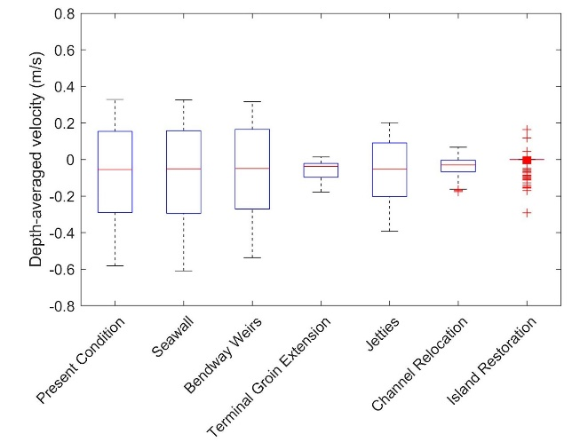
Figure 1 – Box-and-whiskers plot of depth-averaged along-channel velocity versus present condition or mitigation alternative designs at the south flood channel.

This paper will discuss the effects of the different erosion mitigation alternatives on the hydrodynamics across the flood delta and the inlet’s main channel. The results of this work are exploratory in nature and illustrate the impacts that hardened (“gray”) and nature-based (“green”) engineering interventions can have on complex barrier island-inlet systems.

REFERENCES
Toso et al. (2019): Tidal inlet seafloor changes induced by recently built hard structures. PloS one, 14(10), e0223240.
Lesser et al. (2004): Development and validation of a three-dimensional morphological model. Coast. Eng. 51, 889-915.

Edit link: https://www.formpl.us/form/6315062157377536/edit/2209886064

