APPLICATION OF THE MODIFIED LINEAR SUPERPOSITION METHOD FOR TIDE AND STORM SURGE INTERACTION — TROPICAL AND EXTRA-TROPICAL CYCLONES

Christopher Bender, Taylor Engineering, Inc, Jacksonville Florida USA, cbender@taylorengineering.com
Ashley Kauppila, Taylor Engineering, Inc, Jacksonville Florida USA, akauppila@taylorengineering.com
Don Resio, Jacksonville Florida USA, donresio@gmail.com

INTRODUCTION
Areas in the mid- and north-Atlantic coast of the United States can experience storm surge during both tropical and extra-tropical (ET) cyclones. The cyclones vary in their generation area, energy source, wind field structure, and surge duration. Both types of cyclones interact with the local tide forcing that can feature a relatively large tide range of approximately 6 to 8 ft, depending on location.

Coastal modeling efforts have applied different ways to handle the interaction of storm surge and tides. In relatively deep water, tidal superposition can be considered an approximately linear process (with the storm-generated water level added to the tide level providing a reasonable total water level). However, in shallow water with restricted access to the ocean, tide and surge superposition can be nonlinear such that simple addition of surge and tide proves inaccurate. The paper and presentation provide an extension of previous work that developed the Modified Linear Superposition (MLS) Method to analyze the interaction of the storm surge with the tide. The method is designed to produce accurate, unbiased results while at the same time not requiring excessive computer resources and time.

METHODOLOGY DEVELOPMENT
Many previous methods of including tidal contributions in statistical estimates of coastal storm surges have used models that couple storm surges with tides at a small number of randomly sampled phases. Applying a small number of samples can introduce substantial aleatory uncertainty into the total water levels in areas where tide ranges are of comparable magnitude to the storm surges, such as much of the U.S. East Coast. The authors applied a data set (developed for FEMA) consisting of 50 historical ET cyclones and over 230 synthetic tropical cyclones. To develop the MLS Method data, the study team executed 8 of the ET cyclones at 4 different tide phases and executed 10 of the tropical cyclones at 6 different tide phases. The team selected the tide phases such that half approximately coincided with high tide and the other half with low tide. The analysis examined tide-only, surge-only, and tide coupled to surge model results at 34 stations located by the authors to cover the spatial extent of the study area and to include both open coast and sheltered inland waterways.

ANALYSIS
To obtain station-specific generalized relationships for all storms, we developed a regression relationship between the nonlinear deviation and the normalized maximum linear superposed water level. This approach preserves the separation of the predictors from the predictands, while allowing the user to visualize effects due to variations in depth, bottom friction, and tidal variations during a particular storm at a particular site. In this approach, we were able to compare the features of regression equations developed for tropical cyclones and ET cyclones. With the station-specific, and cyclone type-specific regression equations determined, the authors applied tide-only and cyclone-only simulations to develop water level versus frequency curves. The analysis applied a simple linear superposition method and the new MLS method. The results show the influence of the regression-derived nonlinear correction at each station with results varying by station and cyclone type depending on the stations location and depth.

RESULTS
The results allow examination of the nonlinear tide effects and how the differences in tropical cyclone and ET cyclone surge signals influence this interaction. The analyses indicate that obtaining a result with the same range of accuracy as the linear combination of a surge and all possible tidal phases would require about 100 simulations as the standard deviation reduction depends on the square root of the number of executions. Importantly, the stations selected for this study cover a wide range of coastal features, which suggests that the results of this study provide a defensible methodology for a wide range of coastal areas along the U.S. East Coast.
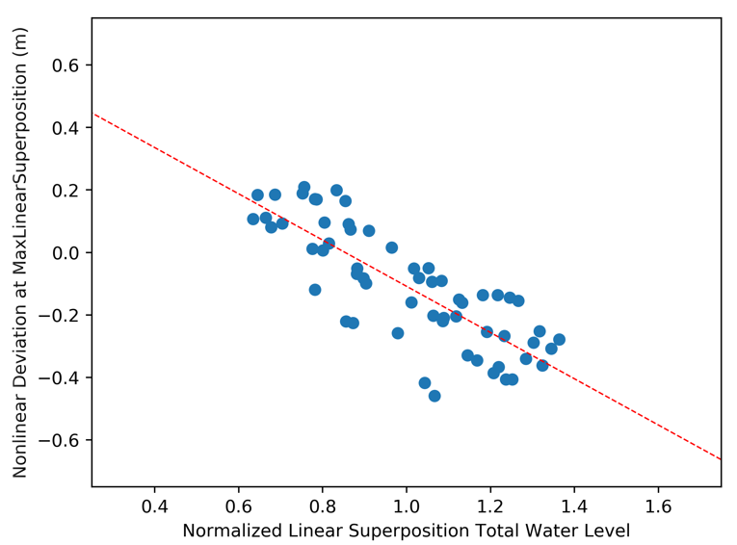
Figure 1.MLS Method Scatter Plot and Regression Line for 10 Tropical Cyclones Executed at 6 Tide Phases with Results at NOAA The Battery, New York, USA.

