COASTAL MAREJADAS FORECAST SYSTEM, VALIDATION AND INSTITUTIONAL LINK IN CHILE.

Mauricio Molina, Universidad de Valparaíso, mauricio.molina@uv.cl
Catalina Aguirre, Universidad de Valparaíso, catalina.aguirre@uv.cl
Sebastian Correa, Universidad de Valparaíso, sebastian.correa@uv.cl
Matias Quezada, Universidad de Valparaíso, ECOTECNOS S.A mquezada@ecotecnos.cl
Daniela Manosalva, Universidad de Valparaíso, mquezada@ecotecnos.cl
Pablo Vilches, Universidad de Valparaíso, pablovilchesgo@gmail.com
Diego Becerra, Universidad de Valparaíso, diegobecerragodoy@gmail.com
Daphne Vargas, Universidad de Valparaíso, daphne.vargasg@gmail.com

A LOCAL MAREJADAS FORECAST SYSTEM
Marejadas, defined as the combination of waves and tides that affect the usual socio-economic activities on the coast and that can cause damage to its infrastructure (Molina, 2020), becomes relevant since the beginning of the past decade on the Chilean coast due to several events that occurred between 2013 and 2017. Considering that, a local wave forecast (MarejadasUV) was developed by Universidad de Valparaíso in Valparaíso bay, Chile (marejadas.uv.cl), to distinguish wave magnitude along the coast. Combined whit tide forecasting and coastal geometry, the forecast system was capable to evaluate hourly run-up and overtopping for the next seven days, which allows implementation of an impact scale for communication purposes (Molina, 2020).

INSTITUCIONAL LINK
In 2020, national funding (FONDEF) was won to review the forecast system (MarejadasUV) and to incorporate different national institutions to perfect its behavior and organizational operability. The project started in December 2020 and includes governmental agencies such as Emergency Office (ONEMI), the Fishing (SERNAPESCA and SUBPESCA) and Marine works (DOP – MOP); Chilean Navy departments such as the Meteorological service, Oceanographic Service (SHOA) and Valparaíso port authority; and other institutions such as Viña del Mar Municipality, Valparaíso Lifeboats, and ECOTECNOS S.A., an environmental studies company. Each of them represents all parts of the coastal ecosystem covering marine authority, emergency and safety agencies, measurements and coastal users (Figure 1).
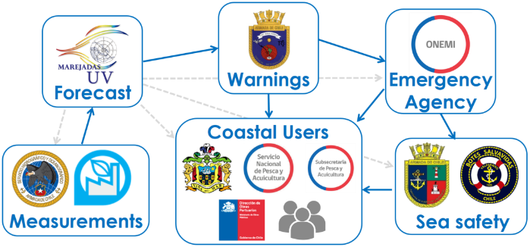
Figure 1– Institutional interaction scheme and their interaction during Marejadas event.

This project is the biggest collective coordination effort in Marejadas in Chile for non-port zones, and it is being an opportunity to share experiences to improve the institutional capabilities to face Marejadas challenges. Even though costal work is focused on Valparaíso Bay, its results could be extended to all the country.

WAVE AND TIDE FORECASTING VALIDATION
An ADCP and a tide station were bought whit the FONDEF project and whit this, a 40-day comparison was made in Valparaíso Bay (33.0°S) whit other open forecast systems (Wisuki, Windguru, Windy and Windfinder) to evaluate the capabilities of MarejadasUV (Figure 2).

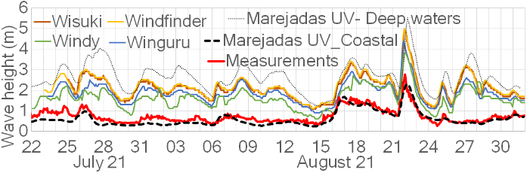
Figure 2 – Wave forecast and measure comparison in Valparaíso Bay, Chile, July 22nd, 2021 to august 31st, 2021.

The comparison shows that MarejadasUV has a better behavior than other open forecast systems, which overestimated the measure whit magnitudes similar to deep waters forecast. This process was repeated in Tocopilla (22.1°S) and Quintero (32.7°S) whit similar results.

MAREJADAS IMPACT FORECAST VALIDATION
The impact forecast through the impact scale proposed by Molina (2020) was validated using video recording and a post-Marejadas survey of the events occur in the austral winter and summer of 2021 and 2022, observing a good capability to describe the maximum impact expected for a specific coastal location. This has an important connotation because coastal users declare that receiving impact warnings give a better compression of the event risk than the warnings using wave heights.

MAIN REMARKS
MarejadasUV is a successful experience and tool for disaster risk reduction due Marejadas, communicating to coastal users expected impacts in a specific coastal location. ADCP measures and camera records are one of the few measurements in the southeastern Pacific margin and provide a platform to articulate the Chilean inter-institutional cooperation.

REFERENCES
Molina, M. (2020). MAREJADAS (COASTAL STORMS) IMPACT SCALE FOR WARNING SYSTEMS. Coastal Engineering Proceedings, (36v), management.44. https://doi.org/10.9753/icce.v36v.management.44

