From experiment to intervention: scaling up marine eco-engineering

Mariana Mayer Pinto, University of New South Wals, m.mayerpinto@unsw.edu.au
Melanie Bishop, Macquarie University, melanie.bishop@mq.edu.au
Katherine Dafforn, Macquarie University, katherine.dafforn@mq.edu.au
Maria Vozzo, CSIRO, maria.vozzo@csiro.au

INTRODUCTION
Effective coastal policy requires communication among scientists, managers, stakeholders and policy makers. The need for interdisciplinary cooperation is increasingly recognised as a vital aspect to sustain coastal environments and economies into the future (Naylor et al., 2012). It is estimated that built structures in the marine environment cover at least 32,000 km² and will increase to nearly 40,000 km2 by 2028 (Bugnot et al., 2020). Not only do built structures have detrimental impacts on communities at the site of construction (Chapman, 2003), impacts may operate across broader scales by fragmenting habitats and altering species distributions that in turn, interrupt trophic connectivity and provision of ecosystem services (Bishop et al., 2017). There is growing recognition that eco-engineering – the incorporation of ecological principles into the design of these structures – might mitigate certain negative impacts of built structures. However, most studies to date have largely been limited to single sites or small-scale manipulations. To produce ecological benefits at meaningful scales, more eco-engineering sites, and interventions of greater area and permanency are needed. Nevertheless, to scale up effectively, science needs to inform both the management of eco-engineering interventions that are applied at scale and the policy that enables the scaling up of these interventions.

AIMS
Here, we use lessons learned from mmore than 20 years of eco-engineering projects in Sydney Harbour to present a pathway for how to connect science and scientific findings to inform management interventions and policy, to optimize and facilitate the scaling up of eco-engineering worldwide. We use the Living Seawalls, a large-scale eco-engineering project, as a case-study. Living Seawalls comprise modules, mimicking the habitat features of natural shorelines (e.g. rock pools, crevices; Fig. 1) that are fitted in scalable mosaics onto built structures. The complex surfaces increase the habitat area for growth of marine life (Bishop et al, in press).

SCALING-UP
First, small-scale experiments and meta-analyses were used to build systems knowledge and proof-of-concept for possible eco-engineering solutions. Next, the findings of these experiments were presented to stakeholders, designers and engineers to identify key concerns and develop a product that satisfied the needs and concerns of stakeholders. Fostering communication among a broad selection of stakeholders, including local policy makers and governments, is also essential to the success of the project. A key challenge of scaling up marine eco-engineering is the jurisdictional complexity of coastal areas. The complex governance structure of marine structures can prohibit meaningful action. Identifying the relevant network of ownership and jurisdictional bodies is crucial to both the establishment of large-scale installations and their maintenance over long time periods. The identification of a supportive early adopter allowed an initial site-scale application of the new product. Finally, the identification of a champion (our early adopter) for the approach assisted with getting others on board, as did our collection of preliminary data documenting the benefits of scaling up. Scientific discoveries are necessary to the identification of problems in natural environments, but solutions cannot be achieved without management interventions and permissible policies.
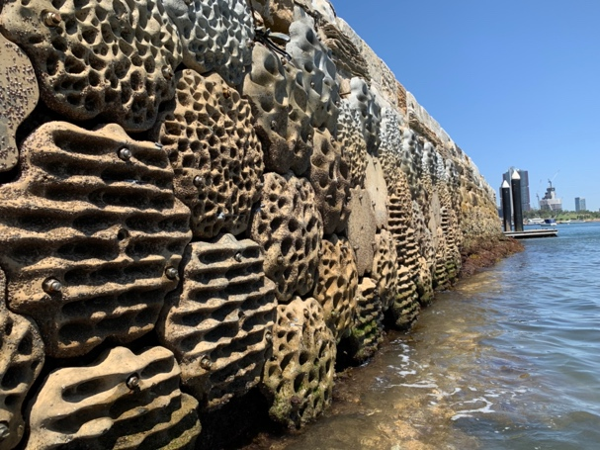
Figure 1 – Living Seawalls installed in 2018 at Sawmillers Reserve, Sydney Harbour.

REFERENCES
Bishop, Vozzo, Mayer-Pinto, Dafforn (in press). Complexity-biodiversity relationships on marine urban structures: reintroducing habitat heterogeneity through eco-engineering. Philos T R Soc B.
Bishop, M.J., Mayer-Pinto, M., Airoldi, L., Firth, L.B., Morris, R.L., Loke, L.H.L., Hawkins, S.J., Naylor, L.A., Coleman, R.A., Chee, S.Y., Dafforn, K.A., 2017. Effects of ocean sprawl on ecological connectivity: impacts and solutions. J. Exp. Mar. Bio. Ecol. 492, 7–30.
Bugnot, Mayer-Pinto, Airoldi, Heery, Johnston, Critchley, Strain, Morris, Loke, , Bishop, Sheehan, Coleman, Dafforn (2020). Current and projected global extent of marine built structures. Nat. Sustain.1-9.
Naylor, Coombes, Venn, Roast, Thompson (2012). Facilitating ecological enhancement of coastal infrastructure : The role of policy , people and planning. Environ. Sci. Policy 22, 36–46.
Chapman (2003). Paucity of mobile species on constructed seawalls: Effects of urbanization on biodiversity. Mar. Ecol. Prog. Ser. 264, 21–29.

