THE JOURNEY FROM THEORY TO APPLICATION IN COASTAL MANAGEMENT
– A REGIONAL PERSPECTIVE FROM SOUTH WESTERN AUSTRALIA

Stuart Barr, Shore Coastal, stuart@shorecoastal.com.au

BACKGROUND
This paper traces the journey from theory to application in several projects undertaken in a regional area of Western Australia.

This includes design and construction of coastal rock revetments, low profile geotextile sand container groynes, and beach nourishment projects.

The importance of understanding the subtleties of coastal dynamics in a particular area, the application, and limitations of widely applied coastal engineering practices, and the importance of positive relationships with experienced local contractors in delivering coastal projects is outlined.

COASTAL ROCK REVETMENTS
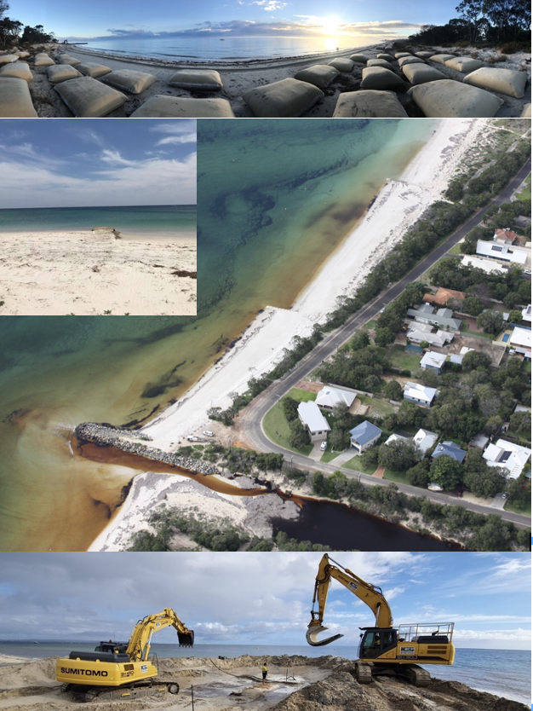
The City of Busselton have constructed many lateritic ironstone coastal rock revetments along the 35km low lying sandy foreshore of Geographe Bay. These have typically been constructed in response to local instability associated with migration of nearshore sand bars and depositional sand lobes. In some areas of the bay, structures built in the 1970s in response to erosion pressures, are now 200m from the shoreline due to decades of accretionary processes. In other areas of the bay there are longer term sediment deficits and older coastal rock revetments in these locations require refurbishment.

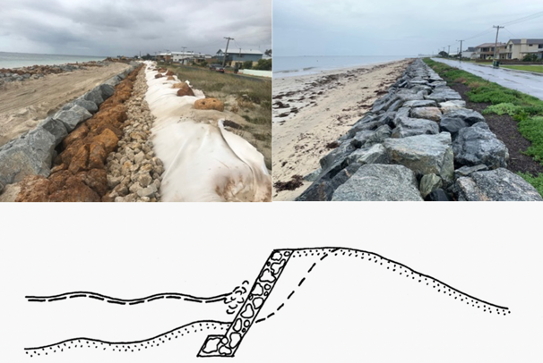
The original structures are typically poorly graded dumped Lateritic Ironstone rock structures with armour sizes less the 2T. Theoretical stability equations suggest the refurbished structures require armour sizes exceeding 6T (which is not available). The performance of existing ‘undersize’ structures in events with >10yrARI and physical modelling provides confidence in the use of smaller armour.
Figure 1 – Coastal Rock Revetment During Construction (showing filter rock, reused Lateritic Ironstone inner armour interlocked with an outer layer of Granite Armour) and at completion.

However, stability in refurbished structures has
been optimized by using higher density armour rock (granite), flatter slopes, and experienced contractors
who have the capacity to achieve, through careful placement, a high quality of armour interlock (i.e., effectively special placement).

Structure crest levels are reasonably low to maintain amenity and views, with the capacity for the structures to be raised in the future in response to sea level rise being incorporated in the design.

GEOTEXTILE SAND CONTAINER GROYNES
Coastal erosion associated with local sediment deficits along sandy beaches of Geographe Bay is mitigated using low profile geotextile sand container groynes. This is not suitable at all sites along the coastline, particularly where downdrift erosion from the terminal eastern groyne may cause problems. However, groyne fields are designed on scales associated with the potential for nearshore transverse sand bars to provide a compensating onshore supply to downdrift areas.
Figure 2 – Coastal Stabilisation with Low Profile Geotextile Sand Container Groynes, Busselton, Western Australia. Typically, 70 Sand Containers per groyne.
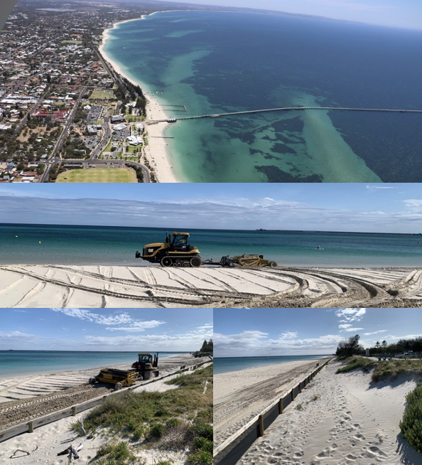
Groyne spacing is typically much larger than theoretical equations, which allows a greater length of coastline to be stabilised for a lower cost.

The low-profile geotextile sand container groynes are more stable under storm events, where storm surges more than 1 meter are observed, and they effectively become submerged structures.

Relatively short emergent structures tend to allow reasonable sediment bypassing, balancing updrift stabilisation and downdrift impacts. These structures are also effectively hidden in the beach and soft underfoot, maintaining beach amenity.

Experienced local contractors familiar with typical designs allow high quality structures to be regularly built, with particular attention given to the quality of bag filling and closures.

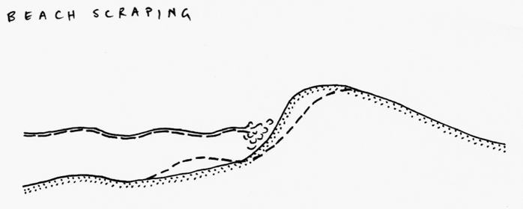
The project at Abbey in 2021 was an example of applying the theoretical concept of mitigating erosion locally by trapping alongshore littoral material, and applying local engineering and construction experience to stabilise a
beach. This included the design of a low point in the structures towards the landward end to encourage local overpassing of sediments to mitigate both downdrift erosion, risk of out-flanking and minimising the difference in sand levels throughout the year for beach users walking along the shoreline.

BEACH AND DUNE NOURISHMENT
Coastal erosion along Geographe Bay is influenced by natural alongshore variability and downdrift erosion from long groynes and a local harbour.

Beach nourishment is use widely to replenish eroded beaches. This has typically been undertaken with imported commercial sand supplies. Limited resources and higher cost have placed a greater emphasis on sourcing littoral material from depositional areas along the coast. This material has a suitable grain size for stability and is washed of fines.

However, careful assessment is required of borrow area to ensure beach scraping operations are not removing excessive littoral material.

The Project in West Busselton in 2021 was an eroding coastal with narrow buffers immediately updrift of the Busselton Jetty beaches, an international tourism site. Careful consideration was given to limiting volumes harvested, the timing of operations, and environmental monitoring.

In terms of application, local contractors had progressively developed innovative beach scraping machinery which made these operations highly efficient for beach and dune nourishment.

Figure 3: West Busselton Foreshore and Beach Scraping Operations to Rebuilt an Eroded Dune Updrift of an International Tourism Site.

The availability of this technology has informed the design of enhanced coastal dunes to mitigate coastal inundation impacts.

Theoretical knowledge, engineering experience and contractor innovation are being used locally to align theory and application in coastal management.

REFERENCES

Barr, Eliot (2011) Busselton Coastal Protection, Australasian Coast & Ports Conference, 2011.

Barr, Staples, Eliot, Darby, Abrahamse & Stul (2017)
Adaption to Coastal Inundation in a Low Lying Highly Dynamic Regional Area, Australasian Coast & Ports Conference, 2017.

