DIGITAL TWINNING AS A DECISION SUPPORT TOOL FOR RESILIENCE PLANNING OF COASTAL INTERMODAL TRANSPORTATION NETWORKS

Anibal Tafur, Rice University, tafur@rice.edu
Jamie E. Padgett, Rice University, jamie.padgett@rice.edu

INTRODUCTION
Intermodal freight transportation networks (seaport-road-rail) constitute the economic backbone of coastal communities. Seaports, which are the main drivers of these networks, account for approximately 80% of global trade by volume (UNCTAD 2021). In the United States, seaports play a particularly significant role in the national economy by supporting 31 million jobs and accounting for approximately 25% of the GDP (AAPA 2018). Furthermore, severe storms pose a threat to about one-third of seaports worldwide. In the US, ports on the US Gulf and East Coasts have historically experienced severe storm damage; for instance, the ports of Gulfport, MS, and New Orleans, LA, were both heavily impacted by Hurricane Katrina in 2005, one of the costliest hurricanes in record ($125 billion in economic losses) (PEER 2006). Climate change and sea level rise (SLR) are expected to further worsen these hurricane effects, underscoring the importance of risk and resilience modeling under current and future climate conditions.

Resilience assessment has recently attracted considerable attention among researchers, since decision makers are becoming more aware of its usefulness as a comprehensive tool for high-level planning in disaster-prone areas (Bocchini et al. 2014). Previous studies addressing resilience of seaports include Becker (2013) and Balbi (2018), although integration with other transportation systems (such as road and railway networks) is lacking. Nair et al. (2010) leverage flow network models to explore the interaction of container ports with other inland systems, but they fail to include additional types of commodities (such as liquid or dry bulk), and to incorporate probabilistic damage models to more accurately capture uncertainty in disruption of network links. Additionally, while several decision support tools for minimizing post-event port disruptions have been proposed in the literature (Ursavas 2014), they mainly focus on resource optimization for container terminals under undisrupted conditions. Zhou et al. (2021) present a decision support system based on digital twinning and resilience analysis, although the presented framework lacks intermodal integration and consideration of natural hazards.

From the current state of the literature, it is observed that despite their importance, intermodal transportation networks remain unserved with comprehensive tools that support high-level planning for resilience of existing and future infrastructure under hurricane scenarios. To address these gaps, this paper proposes the implementation of a decision support tool based on digital twinning, which is able to predict system performance in terms of resilience, given three main inputs: hazard intensities, budgetary constraints, and the characteristics and topology of the network.

PROPOSED METHODOLOGY
For transportation applications, a digital twin is a data-driven analytic system that incorporates physical models, historical data and simulation techniques to replicate the performance of a real-world network for monitoring, analyzing and testing purposes (Gao et al. 2021). Figure 1 shows the main features and characteristics of the proposed tool.

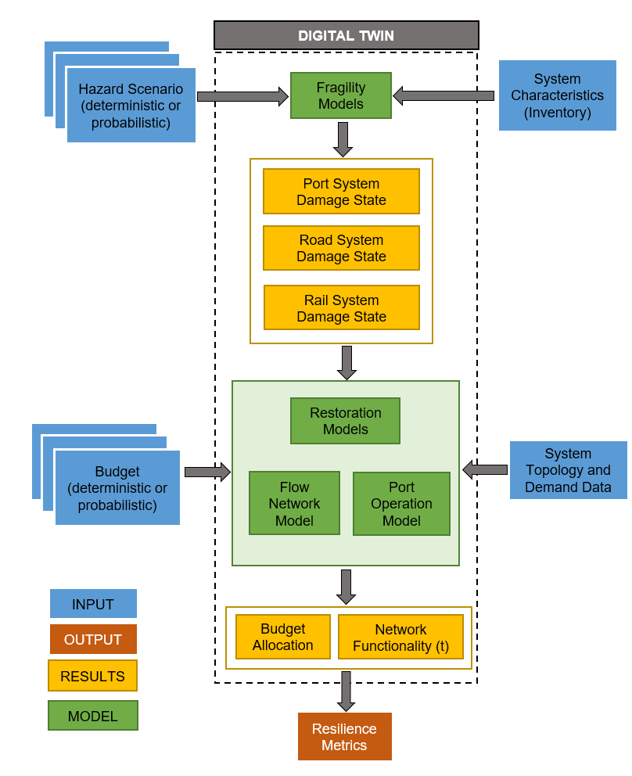
Figure 1 – Schematic description of the proposed digital twin

This digital twin provides an abstraction of the real intermodal network, with links representing the port terminals, roadways, railways and bridges. Each of these links are modelled as susceptible to damage by the considered storm hazard scenario. Functionality over time of these components is informed by their respective fragility and restoration functions. For the case of port terminals, specific operation models are leveraged given the complexity of the interaction among port sub-components, namely, berth and storage units (Tafur et al. 2022).

The digital twin simulates the network performance in two main stages. The first stage consists of realizing the damage states of the network components, taking as input the storm hazard intensities (i.e., storm surge, wave height, wind speed and current speed), and the inventory information, which contains key structural and qualitative parameters for each component. Fragility models take these inputs and provide estimates of damage likelihood, which can subsequently be realized using Monte Carlo simulations.

The next stage is concerned with resource allocation, where the provided budget input (which can also represent a combined monetary/resource input) is assigned to recovery activities on a subset of components, seeking optimality of network performance. Three important models are leveraged hereby. Restoration models provide estimates of restoration cost and time, given the initial damage state of each component and their assignment of recovery activities, informing their functionality over time. A port operation model combines berth and storage damage and functionality to produce an overall functionality estimate for a port terminal. A flow network model takes link functionality estimations, with potential recovery actions, and provides the optimal flow paths to maximize satisfied demands using an optimization-based approach.

Finally, resilience is quantified using the index described by Bochini et al. (2014), which measures the ability of a system to withstand and recover after a disruption. This is mathematically represented by the integral of the time-varying system functionality over a defined recovery time horizon. Since this tool is intended for high-level planning, the selected functionality metric is the network satisfied demand.

To demonstrate the use of the proposed methodology, a hypothetical intermodal network for seaport-road-rail freight located on the Gulf Coast of the United States is analyzed. The results of probing the digital twin for different combinations of hazard and budget conditions (which may be defined either probabilistically or deterministically), provide insight into the relationship between resource availability, hazard intensity and network resilience, thus aiding decision makers to better understand risk and exposure, and conduct better-informed cost-benefit analysis. Furthermore, the digital twin can be employed to identify key vulnerabilities to storm hazards in an existing system, and estimate the effectiveness of potential mitigation measures, among other decisions of interest to stakeholders.

CONCLUSION
A first step towards a comprehensive digital twin tool to better support resilience planning of coastal intermodal networks (seaport-road-rail) is presented in this work. The proposed methodology addresses two main gaps encountered in current literature regarding digital twin methods for transportation: the consideration of coastal hazards through the use of fragility and restoration models, and the resilience analysis at community scale through the coupling of port systems with other inland modes of transportation, namely road and rail. This tool thus contributes to recent multi-disciplinary initiatives in community resilience (Sutley et al. 2017), where a major emphasis has been placed on comprehending how physical, economic, and social systems interact and influence community recovery after a storm event for a wide range of infrastructure systems. The key parties interested in using this tool while planning for mitigation of current transportation infrastructure subject to storm hazards, as well as design of future infrastructure, include private freight operators, federal and state government agencies, and transportation researchers. An important path forward for this framework is the possibility to be integrated into open-source community resilience tools such as IN-CORE (Lee et al. 2019), which provides stakeholders with open access state-of-the-art methods and models to better support their decision-making processes.

REFERENCES
AAPA. (2018). Exports, Jobs & Economic Growth.
Balbi, A., Repetto, M. P., Kammouh, O., & Cimellaro,G. P. (2018). Resilience framework for seaport infrastructure: Theory and application. Proceedings of the 9th International Conference on Bridge Maintenance, Safety and Management, IABMAS 2018, (April),1928–1933.
Becker, A. H. (2013). Building Seaport Resilience for Climate Change Adaptation: Stakeholder Perceptions of the Problems, Impacts, and Strategies (Doctoral dissertation. Stanford University.
Bocchini, P., Frangopol, D. M., Ummenhofer, T., & Zinke,T. (2014). Resilience and Sustainability of Civil Infrastructure: Toward a Unified Approach. Journal of Infrastructure Systems,20(2), 04014004.
Gao, Y., Qian, S., Li, Z., Wang, P., Wang, F., & He, Q. (2021, July). Digital Twin and Its Application in Transportation Infrastructure. In 2021 IEEE 1st International Conference on Digital Twins and Parallel Intelligence (DTPI) (pp. 298-301). IEEE.
Lee, J. S., Navarro, C. M., Tolbert, N., Kim, Y. W., Naraharisetty, V. V. G., Wang, C., ... & Fredricksen, M. (2019). Interdependent Networked Community Resilience Modeling Environment (INCORE). InProceedings of the Practiceand Experience in Advanced Research Computing on Rise of the Machines (learning)(pp. 1-2)
Nair, R., Avetisyan, H., & Miller-Hooks, E. (2010). Resilience Framework for Ports and Other Intermodal Components. Transportation Research Record: Journal of the Transportation Research Board,2166(1), 54–65.
PEER Committee. (2006). The Impact of Hurricane Katrina on Mississippi’s Commercial Public Ports and Opportunities for Expansion of the Ports (Report to the Mississippi Legislature). Joint Committee on Performance Evaluation and Expenditure Review.
Sutley, E. J., van de Lindt, J. W., & Peek, L. (2017). Community-level framework for seismic resilience. I: Coupling socioeconomic characteristics and engineering building systems. Natural Hazards Review, 18(3), 04016014.
Tafur, A., Padgett, J. E., & Gonzalez, A. (2022). Seismic resilience of intermodal freight transportation networks with ties to economic impact modeling. Proceeding of Lifelines Conference 2022.
United Nations Conference on Trade and Development (UNCTAD). (2021). Review of Maritime Report 2021 (tech. rep.). United Nations Conference on Trade and Development (UNCTAD).
Ursavas E. (2014). A decision support system for quayside operations in a container terminal, Decis. Support. Syst. 59 (2014) 312–324.
Zhou, C., Xu, J., Miller-Hooks, E., Zhou, W., Chen, C. H., Lee, L. H., & Li, H. (2021). Analytics with digital-twinning: A decision support system for maintaining a resilient port. Decision Support Systems, 143, 113496.

