UTILISING GEOSCIENTIFIC INSIGHTS INTO PAST COASTAL HAZARD EVENTS FOR COASTAL ENGINEERING

Adam D. Switzer, Nanyang Technological University, Singapore aswitzer@ntu.edu.sg

INTRODUCTION
The coastal zone accommodates more than 60% of the world’s population, with many more people relying on the resources these regions provide. People, infrastructure and ecological systems at the coast are vulnerable to several coastal hazards, most of which have, or will, become more serious with changing climate. Climate change is likely to affect rainfall and climate patterns, potentially intensifying and changing seasonal patterns and frequency of storms. Sea-level rise associated with climate change will also impact much of the coastal zone.

Despite the threat of coastal disasters, and the projections of increasing hazards under a changing climate, coastal engineering development must continue unabated, leaving many communities at risk of catastrophic losses. For most cities historical events indicate a considerable risk and all coastal communities must live with a certain risk of coastal hazards, but informed coastal engineering can minimize the potential for fatalities and economic loss, and therefore must be undertaken. Here I investigate storms and tsunamis and 1. address the options for obtaining longer records of events and 2. examine the need for incorporating uncertainties of future changes in climate, sea level and and coastal environments.

STORM AND TSUNAMI HAZARDS
Over the last two decades, several notable coastal disasters have occurred as a result of storms (tropical cyclones) and tsunamis. The Indian Ocean (2004), Tōhoku, Japan (2011) and Palu (2018) tsunamis (Figure 1), as well as the tremendous impacts of tropical cyclones including Hurricanes Katrina (2005) and Sandy (2012) in USA, Cyclones Nargis in Myanmar (2008), Yasi (2011) in Australia, Tauktae and Yass in India in 2021 and Typhoon Haiyan in the Philippines (2013), have highlighted the vulnerability of coastal infrastructure, economies and ecological systems.

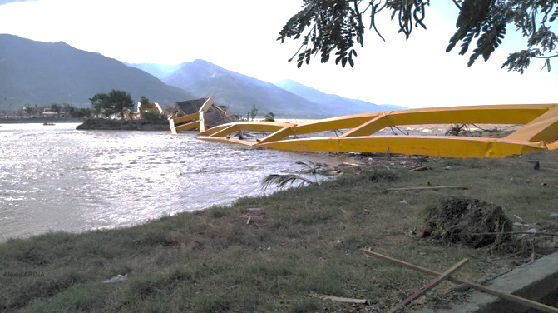

Figure 1 - Damage to infrastructure in Palu, Indonesia following a M7.5 earthquake and associated tsunami in 2018. Palu has a history of tsunamis and understanding the recurrence interval of such events is key to developing resilient coastal infrastructure. Image: Caritas Indonesia

Despite an increase in the understanding and awareness of coastal hazards they are still causing significant socio-economic damage, in some cases more serious than ever before (e.g., Tōhoku Tsunami of March 2011). To prepare for future coastal change and manage the coasts of today, scientists, consultants, engineers and decision-makers have been forced to rethink hazard response and adaptation strategies for sustainable coastal living.

THE ROLE OF GEOSCIENTISTS IN ASSESSING RISK
Coastal vulnerability assessments have emerged as a key concept for understanding the impacts of climate change, rising sea levels and natural hazards. Such assessments are essential for developing adequate risk-management strategies for both natural and engineered systems to these hazards. Assessing coastal vulnerability is an important prerequisite to determine the ‘where’, ‘why’ and ‘how’ questions related to designing coastal engineering adequate to address risk. There are a variety of coastal vulnerability assessment methods available, often encompassing a broad range of sectorial or multidisciplinary applications at a variety of spatial scales.

Despite huge advances in the quality of data (e.g., tidal data, wave models, satellite imagery, digital terrain models) and assessment (e.g., sophisticated flooding models), there remains a limited usefulness for integrated assessment methods of extreme events. Most coastal hazard records are limited by their short temporal resolution (most are limited to less than 50 years) and disparate spatial resolution. Further limitations come from the need to integrate uncertainties associated with changes in environmental variables like rainfall, future development and sea level change.

OBTAINING LONG TERM RECORDS
The history of a coastal site, or the prehistoric record preserved in the geological record can aid greatly with the analysis of recurrence intervals of rare past coastal hazard events (Figure 2). Whilst the occurrence of tropical storms and cyclones is seasonal, and hence reasonably predictable, information on the biggest storm (cyclone) to ever have affected a coast is still valuable (e.g., Terry et al. 2012; Soria et al., 2016). On many coasts, similar research can and should be applied to past tsunamis (e.g., Li et al., 2015; Martin et al., 2019).

At almost all locations on the planet, the only way to adequately answer these questions is to turn to the geological record, although historical documents can also provide complementary and supplementary information.

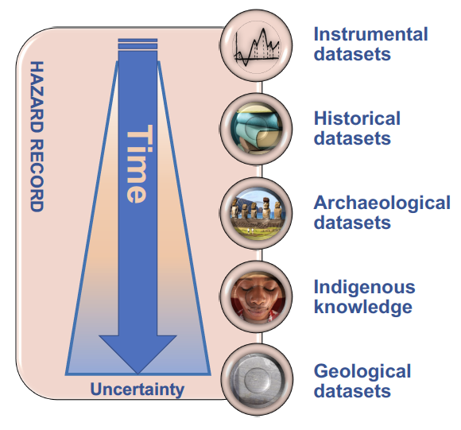
Figure 2. Schematic summary of available archives for reconstructing past hazard events and examining long-term recurrence interval. Such work is often overlooked in engineering-based risk analysis due to increasing uncertainty with time. Integrated records provide important information on high-impact, low probability events that can cause significant socio-economic impact should they reoccur.

CLIMATE PROJECTIONS AND SEA LEVEL CHANGE
With increasing global temperatures and changing climate, the melting of glacial ice is accelerating sea-level rise. Rising sea levels, coupled with the increasing frequency of climate change-induced weather events, poses an existential threat to many coastal regions. It is anticipated that global sea levels will rise 0.44 to 0.76 m under the IPCC intermediate GHG emissions scenario (SSP2-4.5) by 2100, and this is predicted to exacerbate the flooding of coastal areas when a storm surge and high tide occurs simultaneously. With densely populated, and with coastal business districts and critical infrastructure at risk, there is an urgent need for integrating state-of-the-art scientific methodologies to track climate change including sea level rise using remotely sensed data, data analytics and assimilation and physics-based modelling to support engineers to manage uncertainties and complexities.
CONCLUSION
Modelling of extreme coastal hazard events using physics-based models must be informed by the hindsight of long term non-instrumental records and foresight informed by multi-faceted geoscientific information on past environmental change.

REFERENCES

Terry, J. P., Winspear, N., & Cuong, T. Q. (2012). The ‘terrific Tongking typhoon’of October 1881–implications for the Red River Delta (northern Vietnam) in modern times. Weather, 67(3), 72-75.

Li, L., Switzer, A. D., Wang, Y., Weiss, R., Qiu, Q., Chan, C. H., & Tapponnier, P. (2015). What caused the mysterious eighteenth century tsunami that struck the southwest Taiwan coast?. Geophysical Research Letters, 42(20), 8498-8506.

Martin, S. S., Li, L., Okal, E. A., Morin, J., Tetteroo, A. E., Switzer, A. D., & Sieh, K. E. (2019). Reassessment of the 1907 Sumatra “tsunami earthquake” based on macroseismic, seismological, and tsunami observations, and modeling. Pure and Applied Geophysics, 176(7), 2831-2868.

Soria, J. L. A., Switzer, A. D., Villanoy, C. L., Fritz, H. M., Bilgera, P. H. T., Cabrera, O. C., ... & Fernandez, I. Q. (2016). Repeat storm surge disasters of Typhoon Haiyan and its 1897 predecessor in the Philippines. Bulletin of the American Meteorological Society, 97(1), 31-48.

