SUBMESOSCALE SURFACE TIDAL, VORTICAL, AND RESIDUAL CIRCULATIONS IN A SEMI-ENCLOSED BAY

Sung Yong Kim, Korea Advanced Institute of Science and Technology, syongkim@kaist.ac.kr
S. I. Won, Korea Advanced Institute of Science and Technology, efml.kaist@gmail.com
K. O. Kim, Korea Institute of Ocean Science and Technology, kokim@kiost.ac.kr

ABSTRACT
We scrutinize three different components of submesoscale surface tidal, vortical, and residual circulations in a semienclosed bay using (1) observations of high-frequency radar-derived surface current maps and (2) numerical model simulations run under realistic vertical stratification and boundary conditions at O(1)-km spatial and 1-hourly temporal resolutions over a 2-year period. The tidal circulation is characterized by (1) the tidal ellipses and spectral contents having more baroclinic motions at the M2 and S2 frequencies and more barotropic motions at the K1 frequency and (2) the temporal and spatial variability in the tidal fronts appearing as tidal ellipses with clustered shapes and opposite rotational directions. The regional vortical circulation is presented with the submesoscale eddies at
diameters ranging from 3 to 12 km and normalized vorticity magnitudes of 0.2 to 2 for both clockwise and counterclockwise rotations. Based on the spatial statistics of the identified submesoscale eddies and eddy kinetic energy budget analysis, the submesoscale eddies are primarily generated by the detachment of shoreline-following tidal currents at the coastal boundaries, persist for less than 1.5 days, and are dissipated dominantly via vertical buoyancy fluxes associated with bottom bathymetric interactions of the tidal currents. The residual circulation is clearly shown with the nontidal geostrophic currents associated with the pressure gradients generated by wind-driven Ekman transports against the coast and the ageostrophic low-frequency currents.

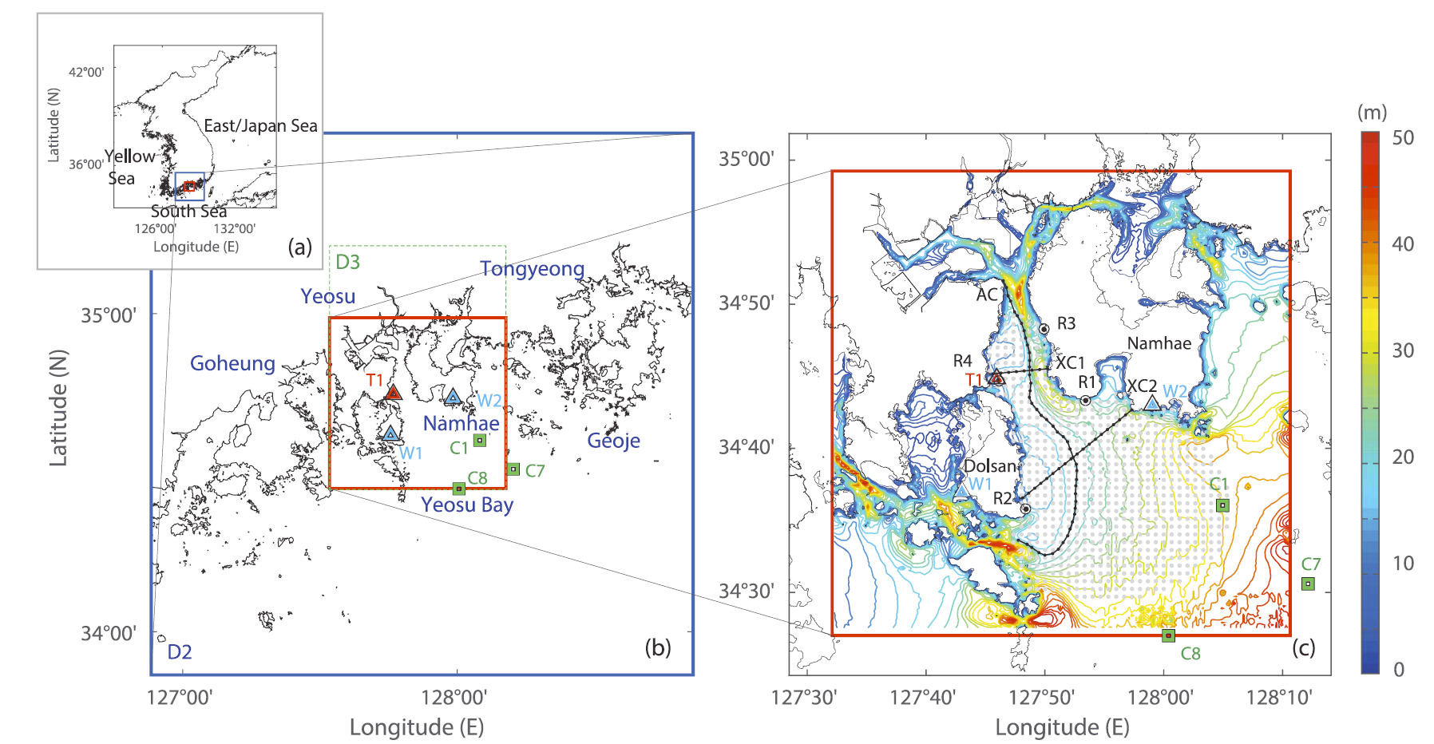
Figure 1 – (a–c) A cascade view of the study domain (Yeosu Bay) for the surface tidal circulation in the southern tip of the Republic of Korea. (b) A close-up showing the regional coastline and islands. Yeosu Bay is a semi-enclosed bay located between two regions of Namhae and Dolsan. A nested Modelo Hidrodinamico (MOHID) numerical model domain (D3; 1.5-km grid resolution) is marked with a dotted green box within the outer domain (D2; 5-km grid resolution; blue boxes in Figures 1a and 1b) and is subsampled into red boxes in Figures 1b and 1c. (c) An array of four high-frequency radars (HFRs) of R1 (NAM4), R2 (HYIL), R3 (NHSP), and R4 (ODNG); three hydrographic survey stations of C1, C7, and C8 on line 400; a single tide gauge station of T1; and two wind stations (W1 and W2) are marked with black dots, green squares, a red triangle, and blue triangles, respectively. An effective spatial coverage of the HFR-derived surface vector currents on a 1-km resolution is denoted with gray dots (at least 70% spatial data availability for a 2-year period

