ON-DEVICE MACHINE LEARNING FOR IDENTIFYING THE SPATIAL EXTENT OF CHRONIC COASTAL FLOODS

Katherine Anarde, North Carolina State University, kanarde@ncsu.edu
Evan Goldstein, University of North Carolina at Greenboro, ebgoldst@uncg.edu
Joe Bolewitz, North Carolina State University, jmbolewi@ncsu.edu
Ryan McCune, North Carolina State University, rmccune@ncsu.edu
Adam Gold, University of North Carolina at Chapel Hill, gold@unc.edu
Miyuki Hino, University of North Carolina at Chapel Hill, mhino@unc.edu

INTRODUCTION
Coastal communities around the world are experiencing flooding due to sea level rise (SLR). Tides now rise and fall on higher average sea levels and flood low-lying roadways and infrastructure. Aging stormwater networks, designed for lower sea levels, are impeded at even low tidal levels such that ordinary rainstorms lead to flash floods. Although these floods are often shallower than those experienced during extreme events, their cumulative impact on communities and individuals – through daily disruptions to activities, loss of business revenues, and degradation of critical infrastructure – can be substantial (e.g., Hino et al., 2019).

At a local level, flood hot spots are often well known, but the causes and frequency of flooding are not well understood. This is in part because the floods are hyper-local and therefore difficult to monitor, and in part because there are many drivers that contribute to flooding. Data on flood incidence, spatial extent, and frequency are needed to better understand the causes and social consequences of chronic coastal flooding.

OBJECTIVES
The objective of this study is to develop smart, low-cost sensors with onboard machine learning (ML) for automated detection of flood incidence and spatial extent along roadways. By automating detection of flood incidence and extent, we will be able to gather fine-grained measures of human exposure to flooding at high spatial resolution. This sensor-based exposure data will eventually be compared to 1) survey data to better understand migration intentions and behaviors, and 2) data on road closures.

MODEL DEVELOPMENT & PRELIMINARY RESULTS
Here we retrofit an existing low-cost, open-source sensor framework – the Sunny Day Flood Sensors (“SuDS”) – with an onboard image segmentation model. The SuDS consist

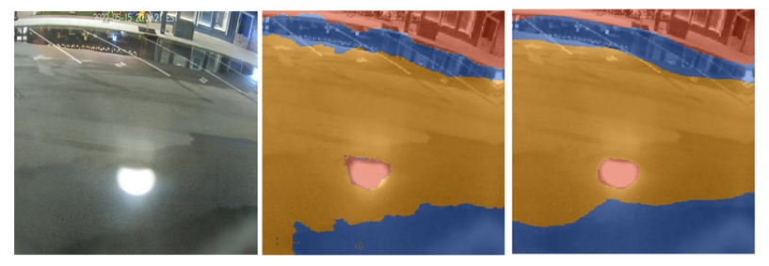
Figure 1. (left) Image of roadside flooding during inundation of the stormwater network in Beaufort, North Carolina, USA; (center) human labeled image; (right) the ML prediction of labels. Blue is water, yellow is road, red is other (buildings, car, sidewalk, glare).

of a pressure logger deployed at the bottom of a storm drain and a subaerially mounted (Raspberry Pi) camera and communications gateway (Gold et al., 2022). The gateway was originally designed to transmit water-level data and photos in real-time to an online web app (go.unc.edu/sunny). A goal of this project is to replace transmission of real-time imagery with ML-derived predictions of flood extent to 1) preserve privacy by transmitting numerical data and not images, and 2) reduce cellular data transmission costs.

The image segmentation model is trained using images from a single SuDS installed in Beaufort, North Carolina, USA. We use Doodler (Buscombe et al., 2022) to classify each image pixel into 6 classes – water, road, building, sidewalk, people, other – which are then remapped to 3 classes – water, road, other. This labeled data is then used to train a deep learning model using Segmentation Gym (Buscombe and Goldstein, 2022). Figure 1 is an example model output with a Dice score of 0.953, which indicates good model performance. To calculate flood extent – here, the percent of the roadway that is flooded – pixel labels are compared to a baseline image with no flooding. Ongoing work is focused on deploying this deep learning model on the SuDS.

FUTURE WORK
SuDS are currently deployed in several communities across coastal North Carolina and our network of sensors is expanding. Future work will include exploring other onboard ML applications, such as using various data streams – i.e., in situ, local meteorological, and tide gauge data – to train a long short-term memory model for real-time prediction of storm drain water levels.

REFERENCES
Buscombe et al., (2022): Human-in-the-Loop Segmentation of Earth Surface Imagery, Earth and Space Science, https://doi.org/10.1029/2021EA002085
Buscombe & Goldstein (2022): A Reproducible and Reusable Pipeline for Segmentation of Geoscientific Imagery, EarthArXiv, https://doi.org/10.31223/X5HS81
Gold et al., (2022): Data from the drain: a sensor framework that captures multiple drivers of chronic floods, EarthArXiv, https://doi.org/10.31223/X5CH1C
Hino et al., (2019): High-tide flooding disrupts local economic activity, Science Advances. https://doi.org10.1126/sciadv.aau2736

