Incorporating a risk assessment procedure into submarine outfall projects and application to Portuguese case studies

A. Mendonça, Laboratório Nacional de Engenharia Civil, amendonca@lnec.pt
M.A. Losada, Universidad de Granada, mlosada@ugr.es
S. Solari, Universidad de la República, ssolari@ugr.es
M.G. Neves, Laboratório Nacional de Engenharia Civil, gneves@lnec.pt
M.T. Reis, Laboratório Nacional de Engenharia Civil, treis@lnec.pt

Submarine outfalls are built as significant elements of an integrated environmental protection system for coastal areas facilitating and/or creating possibilities for economic activities within its immediate context.
The aim of this study is to present a risk assessment methodology to submarine outfall projects that provides information about the conditions of the receiving medium, predicting a long-term behaviour of the plume near the coastline, which allows a multicriteria and an adaptative design of these structures assuring that they will remain operational during their useful life.
The procedure for calculating target design levels determines if a project satisfies the safety, serviceability, and exploitation requirements for the recommended levels of reliability, functionality, and operationality during all of the project phases [Losada and Benedicto, 2005] by defining the general and operational intrinsic natures of the structure [Mendonça et al, 2012a].
The main failure modes regarding operational limit states are identified and described. The study focus on the environmental failure effects of submarine outfalls related to the inefficient plume dispersion. The environmental values considered are aquatic ecosystem and recreational activities.
The developed methodology focus on three main aspects (Figure 1):
- Accomplish the environmental limitations established in Portuguese and EU Directives;
- Provide a probabilistic approach of the project of submarine outfalls, implementing a Monte Carlo simulation methodology that considers climatic variability and mid long term trends;
- Implement procedures to predict plume temporal and spatial variability (yearly).
For modeling the effluent fate it is required to have the boundary conditions that force the hydrodynamic model. After the astronomical tide, that is a deterministic variable, the main forcing agent is the wind. Then, for applying the probabilistic verification and design procedure proposed in this work it is necessary to implement a Monte Carlo simulation methodology for wind time series, accounting for both wind speed and wind direction.
In this work a simulation methodology is proposed that is based on the use of mixture non-stationary distributions for deseasonalization of the data, and a combination of copula-based and autoregressive models for modeling auto and crosscorrelation of the series. The proposed methodology is based on Solari and Losada (2011).
For modeling the effluent fate TELEMAC [Hervouet and Bates, 2000] is applied. The main goals of implementing TELEMAC are: (i) to simulate 1000 statistically independent events (yearly) scenarios in feasible computation times, using simulated wind time series as boundary conditions, while (ii) representing the typical annual wave–current conditions.
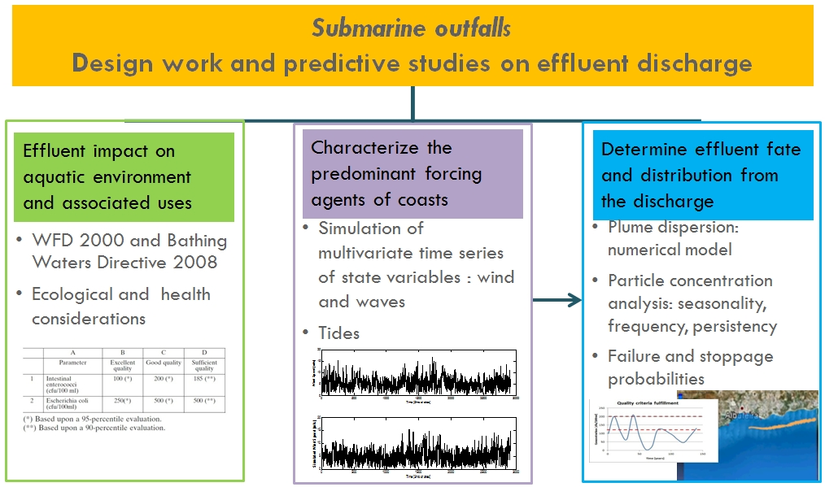Figure 1 – Developed methodology scheme
The methodology will allow verifying/adapting the design operational target levels defined in Mendonça et al. (2012a) and analyzing management strategies and their consequences for loss of operationality applying multi-criteria assessment. The methodology results are expected to help identifying the structure’s probability of failure or stoppage and the definition of operational target design levels enabling decision on project design alternatives.

REFERENCES
Hervouet and Bates (2000). “The TELEMAC modelling system Special issue." Hydrol. Process, 14: 2207–2208. doi: 10.1002/1099-1085(200009)14:13.
Losada, Benedicto, Izaskun (2005). “Target Design Levels for Maritime Structures”. J. Waterway, Port, Coastal, and Ocean Eng. 131, pp. 171-180.
Mendonça, Losada, Reis, Neves (2012a) “Risk Assessment in Submarine Outfall Projects: the Case of Portugal.” Journal of Environmental Management (in press).
Mendonça, Losada, Neves, Reis (2012b) “Operational forecast methodology for submarine outfall management: application to a Portuguese case study.” MWWD & IEMES 2012 7th International Conference on Marine Wastewater Discharges and Coastal Environment, Montenegro, 21-16 October.
ROM 0.0 (2002). “General Procedure and Requirements in the Design of Harbor and Maritime Structures. Part I: Recommendations for Maritime Structures”, Ministerio de Fomento, Puertos del Estado, Spain.
Solari and Losada (2011). “Non-stationary wave height climate modeling and simulation.” Journal of Geophysical Research, Vol. 116, C09032, doi: 10.1029/2011JC007101.

