beach memory
Turki Imen^{.2}, Raúl Medina¹, Mauricio Gonzalez¹
A new concept of beach memory is investigated in this research. Using a Beach Evolution Model developed for beach rotation, we define a function of beach memory able to describe the weight of the preceding wave conditions and their contribution in the current beach response. The time beach memory time is also defined as the period of time required for the beach memory function to be dissipated in the previous time to negligible values. The Beach Memory Function and the Beach Memory Time can be used to determine the influence of the preceding energy in the current coastal changes. Both new concepts were applied to quantify the Weighted Energy Flux Direction required for the beach planform to be estimated based on the parabolic approximations. Modeled results reproduce successfully observed planform positions.
Keywords: beach rotation; beach evolution model; Beach Memory Function; Beach Memory Time; weighted energy flux direction.

INTRODUCTION
Prediction of shoreline response is probably the most relevant variable which dealing with the coastal zone management and is usually obtained through an analysis of field data and/or aerial surveys. This response depends on environmental setting and coastal factors. For energetic conditions, changes in sea states can be observed while recovery generally associated to low-energy conditions takes longer time. Therefore, the time required for the shoreline response depends on the energy intensity, its duration and the pre-existing morphology before wave effects. Consequently, beaches have a certain memory in their response, and their morphology may be best related to wave conditions determined in previous time ranges (from some days to even months) rather than the immediately preceding conditions. Wright y Short (1984) developed a conceptual model which evolves through six morphologic states based on the fall velocity parameter and the antecedent energy which depends on the memory of the beach. Turki and Medina (2008) have analysed the shoreline position of artificial embayment’s of Barcelona beaches together with energy conditions averaged over the preceding days. It is worth noting that the influence of these conditions should be weighted in time (Davidson et al., 2011). How can we quantify this weight and consequently the beach memory? The present investigation aims to address this question.
In this study, we define the memory of the beach as function that describes the weight of the preceding energetic conditions and their contribution in the current state of the beach. The beach memory is investigated basing on beach evolution model developed by Turki et al. (under review.b). This new concept is explored to define a new application for the beach planform position. We conclude by overall conclusions and some further researches.

FIELD OBSERVATIONS
Wave Data
Three artificial embayed beaches of Barcelona, on the north-eastern coast of Spain (NW Mediterranean) (Figure 1.a) were studied in the present work. These sandy beaches are affected by the same wave conditions but have different morphological characteristics. Bogatell and Nova Icaria are characterized by a coarser mean grain size (0.75 mm) while the beach length is 600 m at Bogatell and 400 m at Nova Icaria. The length of the third beach studied, Somorrostro, is the same as Nova Icaria even though the sediment is finer (mean grain size of 0.45 mm).

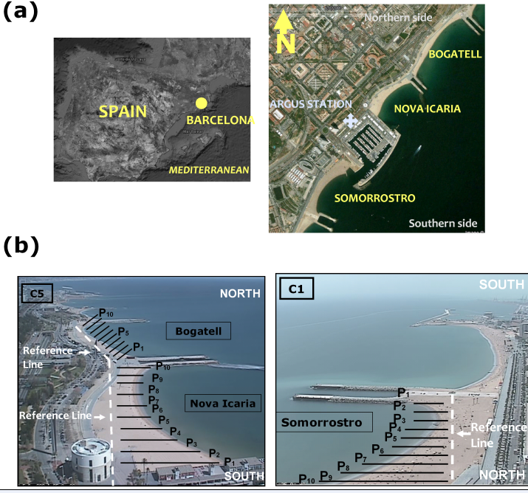

Figure 1. (a) localization of the study site: Barcelona city beaches (Image source: Google Earth imagery © DigitalGlobe and GeoEye ). (b) Oblique video images: Camera 1 (C1) shows Somorrostro beach. Camera 5 (C5) shows Bogatell and Nova Icaria beaches.

Hourly wave data were obtained from a hindcast analysis for the period between 1991 and 2008 (Reguero et al., 2012). Atmospheric forcing was taken from the dynamic regional downscaling Sea Wind generated by IH Cantabria (Vidal et al.,2010). The hindcast wave database has a temporal resolution of 1 hour and provides spectral sea state parameters in deep water including significant wave height mean period peak period and mean direction with respect to the North, Dir. Hindcasts were calibrated with instrument data and was propagated to the breaking using the SWAN model. A detailed description of this analysis can be seen in Reguero et al. (2012). The dominance of these waves is illustrated on the left side of Figure 2, with approximately 50% of all waves coming from the easterly (90 from the north) to south-easterly (135 from the north) directional sectors. 35% of waves are between south-east (135 from the north) and the south (180 from the north). Figure 2 indicates also a degree of seasonality in Barcelona wave climate. During winter months (middle side), wave distribution shows a dominance of waves coming from east to east-south-east. Between east-south-east and south, the influence of waves is less than 40%. However, it is more than 60% during summer months (right side).
Once propagated, the wave height and the wave direction at breaking were determined.

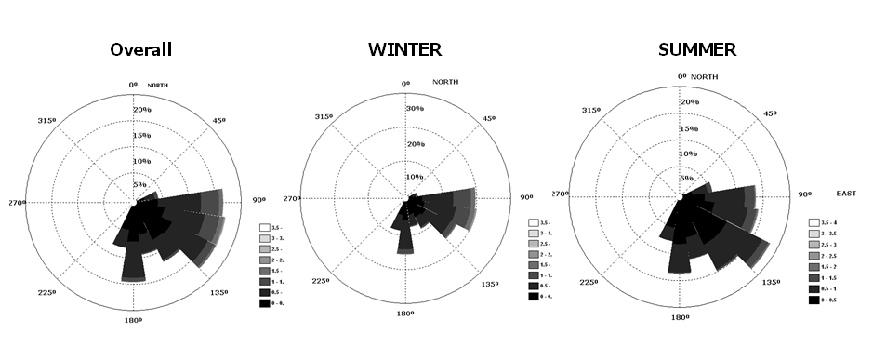
Figure 2. Wave roses based on hourly data from Barcelona buoy for all months, winter months (December, January and February) and summer months (June, July, and August).

Shoreline Position

Daily mapping of the shoreline position at the three embayed beaches of Barcelona was performed by Turki et al. (under review.a) using a video system (Holman and Stanley, 2007) installed on October 2001 in a nearby building at a height of 142 m (Figure 1.a). The system is composed of five cameras but in this study only camera C1 and C5 are considered. Camera C5 covers the Bogatell and Nova Icaria beaches while Somorrostro is captured by camera 1. Images were provided by the Coastal Ocean Observatory at ICM (CSIC) in Barcelona (Spain). Shorelines, all related to the same tide level (0.2 m), were extracted from the time-exposure video images, and the shoreline position was measured at a series of cross-shore profiles (from P₁ to P₁₀ , see Figure 1.b). Results of video-derived shorelines were compared by Turki et al. (under review.a) to the shoreline positions obtained through differential Global Positioning System survey and showed differences less than 1.2 m.

Shoreline rotation was studied at Barcelona beaches during a period of two years (March 2005 - March 2007) when human activities (beach nourishments and sand redistribution along the beach after storms) were carried out. Daily measurements were obtained by Turki et al. (under review.a) combining data from video images to a simplified model which separates the contributions of rotation and translation to the overall shoreline movement. This conceptual model assumes two basic simplifications such as the linear form of the beach and its constant profile explained by a same energy along the beach (Turki et al., under review.a).
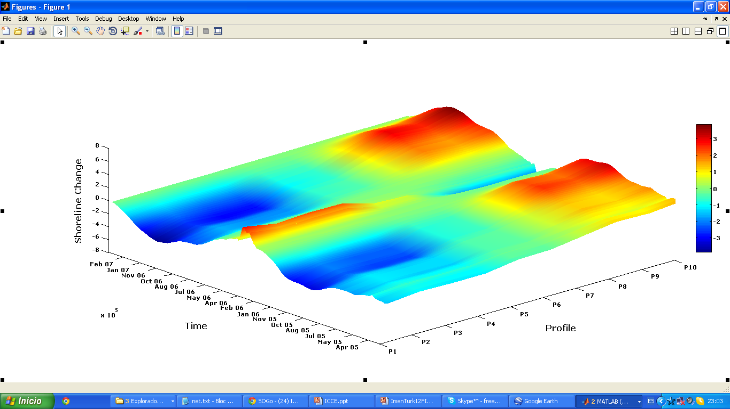

Figure 3. Beach rotation, evaluated using the conceptual model (Turki et al., under review.a), along Nova Icaria beach (from P₁ to P₁₀) and during 2 years (2005-2007).

METHODOLOGY
Beach Evolution Model

Hourly estimates of incident wave energy at breaking and weekly to monthly surveys of the shoreline location provided by video images were used to develop an equilibrium-beach-evolution model in pocket beaches (Turki et al., under review.b). Following Kriebel’s (1985) hypothesis, it is assumed that the shoreline change rate depends on both the wave energy and the wave energy disequilibrium with the shoreline location.
Based on this assumption, a 1-D approach was developed to compute the instantaneous shoreline response R(t) as a function of the initial shoreline response R_{t0} and the terms, P(t) and Q(t), which depend on the wave energy and the physical characteristics of the beach (Equation 1).

(1)

where P(t) and Q(t) are function of wave energy and beach characteristics, as given by Equation 2 and 3:

(2)

(3)

where is the angle between the shoreline position and the wave direction. and function of beach characteristics (length and sediment grain size) and the wave energy, respectively.

Wave energy time series in Barcelona beaches (Bogatell, Nova Icaria and Somorrostro) were used to test the model which successfully reproduces the shoreline position as provided by video systems. An example at Nova Icaria is shown in Figure 4.

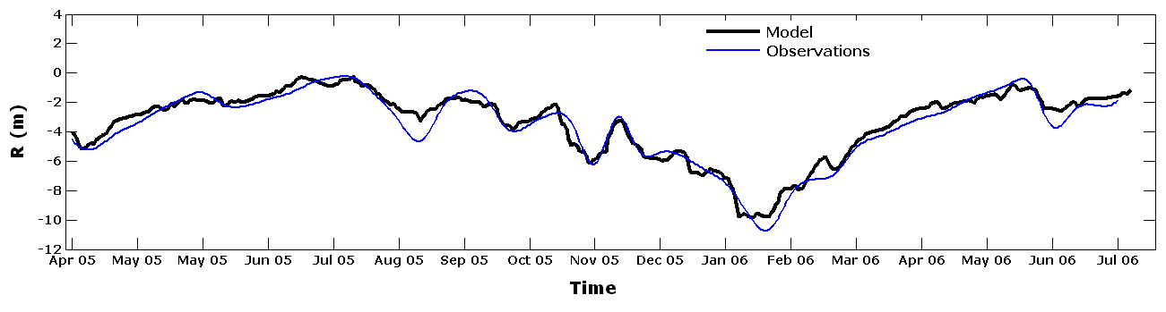

Figure 4. Shoreline response R computed during April 2005 - July 2006 at Nova Icaria.

Beach Memory

The new beach evolution model was used to analyse the memory of the beach. In fact, equation (1) can be developed in discreet domain described as the following:

(4)

R(t_{n}) is expressed function of:
- The contribution of the initial beach state
- The contribution of the preceding energy in the current shoreline response (R(t_{n})).
Both R₀ and Q(t) are pondered by a function of weight (where i is the number of sea states and varies between 1 and n).
In this research, we define a function of beach memory B_{m}F(t_{n},k) as a function of weight required for the beach to quantify the influence of the k^{th} preceding energy conditions and their contribution in the instantaneous response R(t). This function can be expressed in Equation 5:

(5)

The Beach Memory Function decreases exponentially with the preceding time; it reaches its maximum (unity) when the most recent sea states contributes with 100% in the current shoreline response. The Beach Memory Time B_{m}T(t_{n}) is defined as the period of time beyond which the B_{m}F(t_{n} ,k,) is negligible; it is taken as 0.01 in this investigation. Figure 5 shows the Beach Memory Function in 1-March-2007 at Nova Icaria using equation 5. As seen, the weight of the preceding energy conditions takes unity in 1-March-2007 and decreases over the previous time; it is of 0.01 in July-2004 where the 99% of the weight is dissipated. The time elapsed between March-2007 (t_{n}) and July-2004 (t_{n}-B_{m}T(t_{n} )) is defined as the Beach Memory Time which accounts for 945 days.
This period of time is higher in Bogatell where the beach length is bigger and the sediment grain size is coarser than Nova Icaria and Somorrostro, the smallest beach with fine sediments.

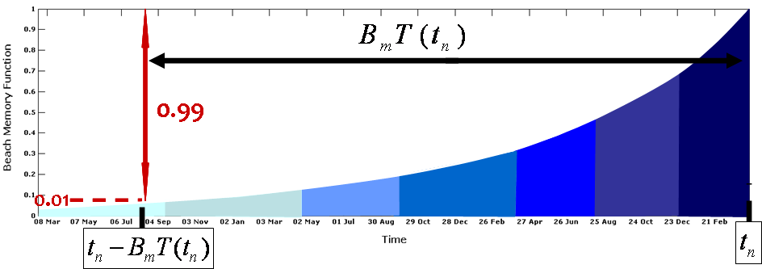

Figure 5. Beach Memory Function evaluated in 1- March-2007). It is more than 0.5 (dry-blue color) at the beginning (March 2007 – August 2006) and decreases significantly over the previous time (clear-blue color). The Beach Memory Time B_{m}T (t_{n}) is the time elapsed between t_{n} and t_{n} -B_{m}T (t_{n}) when B_{m}F (t_{n}) reaches 0.01.

RESULTS

The Beach Memory Function and the Beach Memory Time can be used for several applications in order to determine the weight of the previous energy conditions and their contribution in beach changes. They were used in this research to quantify the Weighted Energy Flux Direction, WEF_{D}, required for the application of Hsu and Evans (1989) parabolic approximation and, consequently, the estimation of the plan-form position in pocket beaches. An example of this application is shown in Figure 6 where a series of beach planform positions at Nova Icaria were extracted from the time-rotation of the beach between maximum and minimum positions produced in 30-July-2005 and 28-February-2006, respectively (Figure 6.a). Extracted positions show a counter-clockwise beach rotation from 30-July-2005 (yellow color) to 28-Februaru-2006 (red color) around a pivotal point located at the center of the beach. This seasonal movement is explained by a counter-clockwise rotation of the energy flux direction (Figure 6.b). The determination of these quantities was conducted using the concepts of memory previously developed and weighting the energy flux direction over the Beach Memory Time. The weighted energy flux direction was modeled in 30-July-2005, 29-september-2005, 30-November-2005, 14-January-2006 and 28-February-2006 and applied to estimate the associated beach planform using the parabolic approximation of Hsu and Evans (1989) (Figure 6.c). Modeled results of Weighted Energy Flux Direction were validated basing on field data obtained from the best fitting of the different forms of the beach (from 30 July 2005 to 28 February 2006). As shown in Figure 7, observed and modeled results show good agreement.

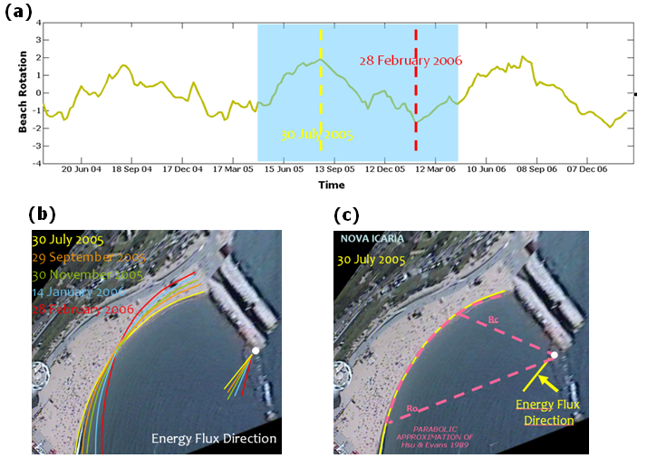

Figure 6. (a) Two-year beach rotation at Nova Icaria beach showing a seasonal variability between summer (maximum position with clockwise rotation) and winter periods (minimum position with counter-clockwise rotation). (b) Counter-clockwise planform rotation between 30 July 2005 (yellow color) and 28 February 2006 (red color) du to the rotation of the associated energy flux direction (yellow and red lines). (c) The weighted energy flux direction required for the beach planform estimation using Hsu and Evans (1989) the parabolic approximation.

CONCLUSIONS

The concept of beach memory was defined and quantified in this research basing on the beach evolution model which was developed by Turki et al. (under review.b) to predict the beach rotation. Two new concepts, beach memory function and the beach memory time, were determined to quantify the influence of the preceding energetic conditions and their contribution in the current shoreline response. Both quantities can be used to measure any coastal factor governing the beach planform change and depending on the preceding wave conditions. They are function of beach characteristics (sediment grain size and beach length) and energy conditions.
The Beach Memory Function and the Beach Memory Time were applied to determine the Weighted Energy Flux Direction able to estimate the planform position. This finding lets us to understand some beach physical processes and presents a useful tool for the design of pocket beaches. Further researches are in process in order to define different engineering applications of beach memory.

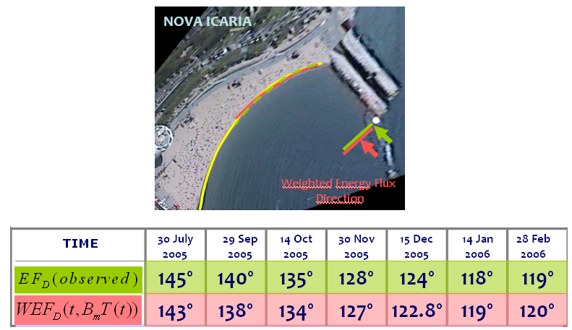

Figure 7. Comparison between the modeled (WEF_{D}) and the observed (EF_{D}) energy flux direction using Hsu and Evans (1989). Modelled directions (red color) were quantified using the beach memory using the function and the time of the beach memory. Observed directions were obtained from the best fitting of the beach planform (green color).

ACKNOWLEDGMENTS
This work partially funded by the Spanish Ministry of Science and Technology within the project “Modelado de la Evolución Morfodinámica de Playas en Medio Plazo” (CTM2008-06640). Video images were provided by the Coastal Ocean Observatory at ICM (CSIC) in Barcelona (Spain). Finally, many thanks to Giovanni Coco for providing useful suggestions.

REFERENCES

Davidson, M. A., Lewis, R. P. and Turner, I. L (2010), Forecasting seasonal to multi-year shoreline change, Coastal Engineering, 57, 620 - 629.
Holland, R. A., and J. Stanley, The history and technical capabilities of argus (2007), Coastal Engineering, 54, 477-491.
Hsu, J. R. C., and C. Evans (1989), Parabolic bay shapes and applications, in Proceeding of the Institution of Civil Engineers, 87, pp. 55 -570.
Kriebel, L. D., and. Dean, R. G (1985), Numerical simulation of time-dependent beach and dune erosion, Port Coastal Ocean Engineering, 9, 221 - 245.
Reguero, B. G., F. J. Mendez., R. Minguez, and I. J. Losada (2012), A global ocean wave (GOW) calibrated reanalysis from 1948 onwards, Coastal Engineering,doi:10.1016/j.coastaleng.2012.03.003.
Turki. I., Medina, R. 2008. Variability of equilibrium beach planform at different time-scales. Master’s Thesis, Cantabria University.
Turki, I., R. Medina., M. Gonzalez, and G. Coco (under review.a), Natural variability of shoreline position: observations at three pocket beaches, Marine Geology.
Turki, I., R. Medina., M. Gonzalez, and G. Coco (under review.b), An equilibrium model to predict shoreline rotation of pocket beaches, Marine Geology.
Vidal, C., I. J. Losada., F. J. Méndez., P. Camus, and C. Izaguirre (2008), Nearshore wave energy resources along Spain : seasonal-to- interannual variability and long term trend, Analysis, 1-5.
Wright, L. D., and A. D. Short (1984), Morphodynamic variability of surf zones and beaches: A synthesis, Mar. Geol., 56, 93-118.

Environmental Hydraulics Institute “IH Cantabria”, Universidad de Cantabria, c /Isabel Torres nº 15, Santander, 39011, Spain. 2 Laboratoire M2C, Université de Rouen, Campus de Mont-Saint Aignant, 76000 CEDEX, France

