DETERMINATION OF WAVE CREST ELEVATIONS FOR SLAMMING FORCES
ON JETTY WITH VERTICAL WALL END
E. Çevik, Y. Yüksel¹, B. Aydoğan¹, B. Ayat¹ and Z.T. Yüksel
Wave disturbance study for a closed end jetty conducted both in laboratory and through a numerical model is presented in this study. Shore protection structures and the structures at the end of the piers are considered for the calculation of the wave disturbance map. The connection locations of the jetties have been designed as vertical walls. These vertical structures and armored waterfront structures would affect the wave behavior in the study area along jetty axis causing reflection of waves and therefore the wave height in front of the structures might increase. This study intends to clarify wave agitation problem by using a numerical model with the help of physical model study.
Keywords: wave agitation; wave crest elevations; vertical wall; numerical modeling; physical study

INTRODUCTION
The project area is sheltered from North-Eastern directions and exposed to wave effects in the Northwest to South directions. In the study area jetties were planned for loading/unloading activities. The piers aligned in the East-West direction. Along the coastline both shore protection structures of rubble mound type and vertical walls at the end of jetties and vertical walls with bullnose just close to the vertical walls were decided to plan. However, due to vertical and impermeable front surface of vertical walls, strong wave reflections will occur, leading to greater disturbances near these structures and causing mooring and loading/unloading problems. The shoreline as a whole consists of different types of structures. Since reflection characteristics of these structures were different, wave characteristics in the study area will be expected to be complex. This study intends to clarify wave crest elevations along the loading/unloading jetties in the project area for the calculation of slamming forces on jetty decks.
The study was carried out in two steps. First the reflection coefficients of rubble mound reclamation, vertical wall with bullnose and vertical wall without bullnose were determined separately by conducting physical model tests. Later the reflection coefficients obtained from physical model tests were used as inputs to model the wave agitation of the study area by using a numerical model. Shore protection structures and the structures at the end of the piers were considered for the calculation of the wave disturbance map. The numerical model used to calculate the wave disturbance within the study area is based on the numerical solution of time domain formulations of Boussinesq type equations. These equations include both frequency dispersion and nonlinearity.

PHYSICAL STUDY
The experiments were carried out in the wave flume of the Hydraulic and Coastal Engineering Laboratory of the Civil Engineering Department at Yıldız Technical University. The flume is 26 m long, 1 m wide and 1 m deep. Both sides of the channel were made of glass along 20 m length. The channel is equipped with a displacement piston type wave maker which generates regular/irregular waves. The wave maker measures the incoming wave, and in the meantime it corrects the paddle motion to absorb the reflected wave. The resultant wave field is totally predictable even with highly reflective models. The wave generator produces wave heights between 5 cm to 17 cm in the water depths of 50 cm to 70 cm.
HR (DAQ) system software was used for the wave data acquisition and analysis. HR Wave Data is a spectral analysis program that produces the wave spectrum and associated spectral parameters (significant wave height; H_{m}, peak period; T_{p}, mean period; T_{m}, energy period; T_{m,-10}); in addition it includes a wave counting technique by using wave zero crossing technique which gives some statistical values (H_{1/3}, H_{1/10}, H_{rms}, H_{mean}, T_{1/3}, T_{1/10}).
Reflection analysis is conducted by measuring the wave height at four probes at known spacing and all in a constant water depth (HR Wallingford, 2005). Reflection analysis calculates the incident and reflected wave, spectral energy and the reflection coefficient at frequencies spread over the valid frequency range. It also calculates the bulk reflection coefficient as the average of the reflection coefficients in a wave train.
Length scales used in physical hydrodynamic models vary widely but typical scale ranges for wave reflection and armor stability analysis are 1:30 to 1:50 (Hudges, 1993). Model dimensions were obtained by considering the limits of wave channel and wave generator, so 1/30 length scale was chosen in this study.

Vertical Wall
The vertical wall model was placed on a 1/10 sloping rigid bottom (Fig. 1). The vertical seawall model used in the experiments was made of 8 mm thick plexiglas plate. It was placed 24 m away from the wave generator. The crest height of the vertical wall is 21.6 cm above High Water Level (HWL). The water depth in front of the wall is 21 cm. Different water depths considering the water level variation, Δh, due to climate change and wind and wave set up were tested. These HWL values were obtained from hydrodynamic modelling study for 50 and 100-year return periods. Reflection analysis tests were conducted for both vertical wall with bullnose and vertical wall without bullnose considering water level variations and regarding different return periods. The test conditions for different return periods are given in Table 1. Since the wave train was simulated with irregular wave train, reflection coefficients vary with frequency. Fig. 2, shows an example for both spectral densities of incident and reflected waves and reflection coefficients of vertical wall. Bulk reflection coefficients (average of reflection coefficients obtained for each frequency) are seen for different test conditions and different return periods in Table 2. As seen from the table, reflection coefficients of vertical wall with and without bullnose for two different wave conditions are very close values and around 0.89. So, it is concluded that the bullnose has no significant effect on wall reflection coefficient.

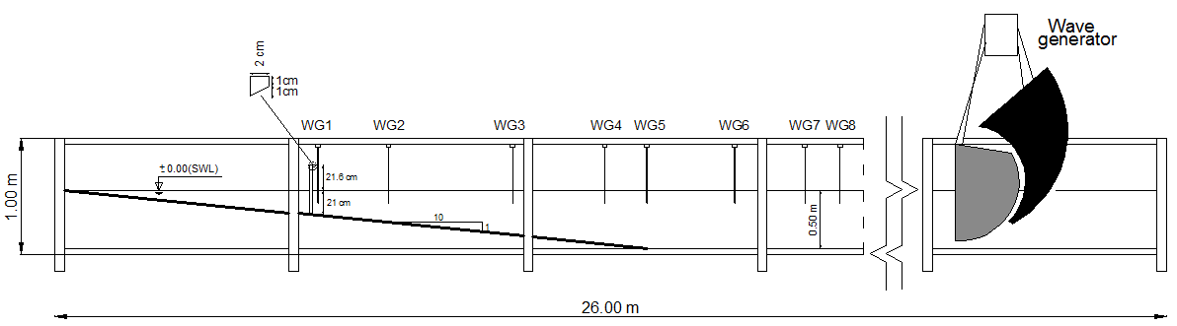

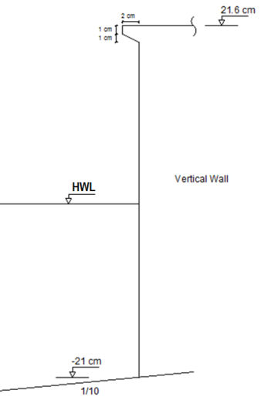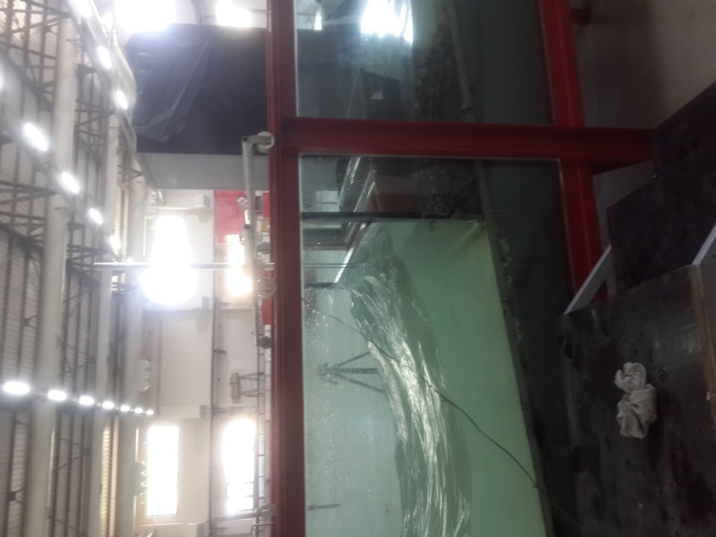
Figure 1 Schematic description of the wave flume and vertical wall model

Table 1 Wave conditions for different return periods at vertical wall
Return period  TR (year) | Prototype d=-6.3 m |  | Model d= -21 cm
Return period  TR (year) | H_{stoe}  (m) | T_{s}  (s) | H_{stoe}  (cm) | T_{s}  (s)
50 | 3.10 | 8.05 | 10.3 | 1.45
100 | 3.40 | 8.28 | 11.3 | 1.49

Figure 2 Spectral density and reflection coefficients of vertical wall

Table 2 Reflection coefficients of the vertical wall for different test conditions
Test  No | Bullnose | Return period  TR  (year) | Water depth  d  (cm) | Δh  (cm) | Total water depth HWL  (cm) | Bulk  reflection coefficient
1 | No | 50 | 50 | 2.5 | 52.5 | 0.883
1b | Yes | 50 | 50 | 2.5 | 52.5 | 0.890
2 | No | 100 | 50 | 2.7 | 52.7 | 0.891
2b | Yes | 100 | 50 | 2.7 | 52.7 | 0.890

Maximum water surface elevation (η*) definition sketch is shown in Fig. 3. In Fig. 3 elevations are referenced to TUDKA datum (± 0.00) (Turkish National Vertical Control Network; TUDKA-99, shortly will be called TUDKA here). From wave measurements, observed maximum water surface elevations from HWL at different water depths and the corresponding prototype conditions were tabulated for 50-year return period and 100-year return period (Table 3). Test results showed maximum water surface elevation from HWL is 6.34 m just in front of the vertical wall for 50-year return period.

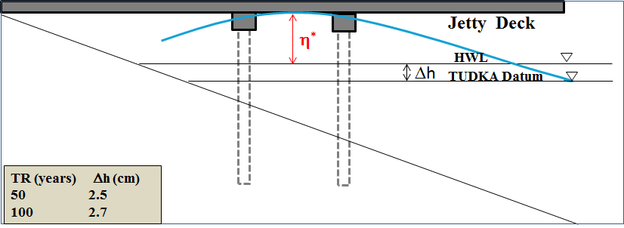
Figure 3 Maximum water surface elevation (η*) definition sketch

Table 3 Maximum water surface elevations at different locations along jetty axis in front of the vertical wall with respect to HWL
Return period  TR (year) | Model wave crest height (η*)  (cm) |  |  |  | Prototype wave crest height (η*)  (m)
Return period  TR (year) | d=21cm | d=35.5cm | d=42.5cm | d=50cm | d=6.3m | d=10.65m | d=12.75m | d=15m
50 | 21.14 | 17.37 | 20.34 | 14.78 | 6.34 | 5.21 | 6.10 | 4.43
100 | 20.91 | 15 | 16.29 | 16.72 | 6.27 | 4.50 | 4.89 | 5.02

Rubble Mound Reclamation
Schematic description of the wave flume and the rubble mound reclamation model is seen in Fig. 4. The rubble mound reclamation model was placed on a 1/10 steel ramp sloping bottom.
Rubble mound reclamation model used in the experiments consists of three layers, as an armour layer, a filter layer and a core. It is placed 24 m away from the wave generator and the water depth at the toe of the structure is 27 cm. The slope angle with cotα=2 is used in the model. The crest height of the armour layer and the wall are 16 cm and 21.6 cm above HWL, respectively. The armour layer extends downslope to -18.2 cm. The thickness of this layer is 8.4 cm. M₅₀ of the armor stone is 195 gr. At the crest 4×D_{n50} width was constructed. Weight of the stone at the filter layer M₅₀ is 20.4 g. Core material grading is in between 0.25-0.72 cm. Porosity of the model was obtained as 37% in armour layer for all tests. During the construction of the model, first the core material and filter was placed and then the armour units were placed by hand with the random placement method to simulate the prototype.
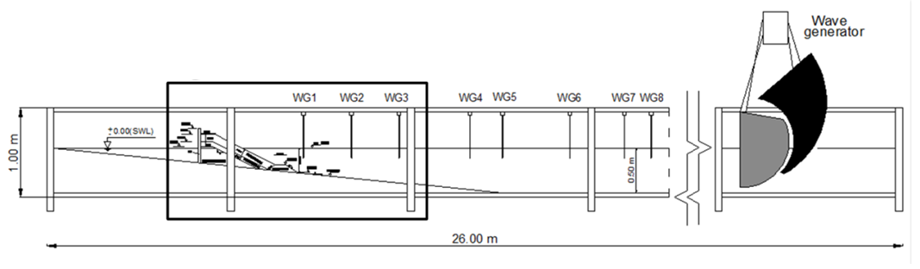
Figure 4 Schematic description of the wave flume (above) and details of rubble mound reclamation in the wave flume (below)

Wave characteristics for rubble mound reclamation for 50 and 100-year return period are shown in Table 4. Bulk reflection coefficients are given in Table 5 for 50 and 100-year return period.

Table 4 Wave conditions for different return periods for rubble mound reclamation model
Return period  TR (year) | Prototype d= -8 m |  | Model d= -27 cm
Return period  TR (year) | H_{stoe}  (m) | T_{s}  (s) | H_{s}  (cm) | T_{s}  (s)
50 | 2.95 | 8.05 | 9.8 | 1.45
100* | 3.25 | 8.28 | 10.8 | 1.49

Table 5 Reflection coefficients of the rubble mound reclamation for different wave conditions
Return period TR (year) | Bulk reflection coefficient
50 | 0.313
100 | 0.300

From wave measurements, observed maximum water surfaces from HWL at different water depths and the corresponding prototype conditions were tabulated in Table 6 for 50 and 100-year return periods. Test results showed maximum water surface elevation from HWL is 4.04 m just at the toe of rubble mound for 100-year return period in the prototype.

Table 6 Maximum water surface elevations at different locations in front of the rubble mound reclamation
Return period  TR (year) | Model wave crest height (η*)  (cm) |  |  |  | Prototype wave crest height (η*)  (m)
Return period  TR (year) | d (cm) |  |  |  | d (m)
Return period  TR (year) | 27 | 35.5 | 42.5 | 50 | 8.1 | 10.65 | 12.75 | 15
50 | 11.91 | 9.49 | 10.83 | 10.22 | 3.57 | 2.85 | 3.25 | 3.07
100 | 13.47 | 9.40 | 9.77 | 9.93 | 4.04 | 2.82 | 2.93 | 2.98

NUMERICAL MODEL STUDY
The numerical model used to calculate the wave disturbance within the study area is based on the numerical solution of time domain formulations of Boussinesq type equations. These equations include both frequency dispersion and nonlinearity. The frequency dispersion is taken into consideration in the momentum equations by considering the effect of vertical accelerations on the pressure distribution. This numerical model is able to reproduce the combined effects of all important wave phenomena within the study area. These phenomena include; wave shoaling, wave refraction, diffraction, wave breaking, bottom friction, moving shoreline, partial reflection and transmission, non-linear wave-wave interaction, frequency and directional spreading of waves. Some further analysis including phenomena such as wave grouping, surf beats, generation of bound sub-harmonics and near-resonant triad interactions can also be taken into account. Model uses a flux formulation with linear dispersion characteristics to solve governing equations for simulation of the propagation of directional wave trains from deep water to shallow water.
Although for the classical Boussinesq equations the ratio of water depth to deep-water wave length ratio (h/L₀) is 0.22, for the extended Boussinesq equations improves this ratio to a value of 0.5. If this value is exceeded the errors in celerity calculations would increase.
For the model the Still Water Level (SWL) was set as the High Water Level (HWL) which takes into account the wind setup, tide and global sea level rise based on the hydrodynamic simulations. These values represent the offshore values of the HWL. Model bathymetry was created for the most critical direction (west) with constant rectangular grid size of 4 m. Wave parameters were introduced into the model from an internal boundary and a sponge layer was formed behind it to avoid wave reflections. Structures were defined in the boundary by their reflection coefficients obtained from physical model tests given in the previous part.
Different wave conditions (random) as shown in Table 7 were tested from West direction for both 50-year and the 100-year return period waves based on wave hindcasting study. Bathymetric data were combined with structural modifications, that are the new shoreline and the reclamation bathymetry, and together they were interpolated inside the computational domain using bilinear interpolation technique. Two numerical tests were conducted for 50-year and 100-year of return periods. Each model was run for 150 minutes.

Table 7 Model input waves
Return Period  TR (year) | H_{s}  (m) | T_{p}  (s)
50 | 3.27 | 8.35
100 | 3.58 | 8.63

Wave crest elevations along the jetty were analyzed. Wave crest heights obtained from wave agitation model was plotted along jetty axis which is used in slamming force calculations and jetty free boards. Figures 5 and 6 show comparisons of wave crest elevations with the jetty elevation for TR= 50 and 100-year return period waves. In the jetty axis, 0 is the location of the vertical wall. All elevations are referenced to TUDKA datum (± 0.00) (Turkish National Vertical Control Network; TUDKA-99, shortly will be called TUDKA here). In Figs. 5 and 6 straight lines show the jetty deck and dashed lines show the maximum wave crest elevation along the jetty.

Figure 5 Wave crest elevations with respect to TUDKA Datum from numerical model along jetty axis (TR=50-year)

Figure 6 Wave crest elevations with respect to TUDKA Datum from numerical model along jetty axis (TR=100-year)

Evaluation of the results for vertical wall exposed to waves from west indicated that the wave heights in front of the wall are increasing in East-West direction.
Wave crest elevations along the jetty were evaluated. Longitudinal variation of surface elevation due to wind and wave setup, global sea level rise, MSL, and tidal elevations were combined with the wave crest elevations to obtain total crest elevations. The line series were presented along the axis of the jetty.
As expected, vertical walls caused increasing of the wave heights and wave crest elevations in front of them. Wave crest elevations reached 6 m for TR=50-year and slightly above 7 m TR=100-year at the axis of the jetty relative to TUDKA datum. These results are found to be consistent with physical model tests which were conducted for the vertical wall at the end of the Jetty (Table 3).
Table 7 shows wave crest height with respect to HWL along the jetty axis with vertical wall end from physical model tests together with point results from wave agitation model. Model results are smaller than physical model test results. Physical model test results give higher results as the model simulates an infinite length vertical wall without rubble mound sections, while in numerical model (also in reality) there are rubble mound sections both sides of the vertical wall.

Table 7 Comparison of physical model test results along the jetty with results from wave agitation model. Results are relative to HWL
Return period  TR (year) | Wave agitation model wave crest height (η*)  (m) |  |  |  | Physical model test wave crest height (η*)  (m)
Return period  TR (year) | x=0m* | x=43.5m | x=64.5m | x=87m | x=0m* | x=43.5m | x=64.5m | x=87m
50 | 5.2 | 3.72 | 2.82 | 3.55 | 6.34 | 5.21 | 6.10 | 4.43
100 | 6.41 | 4.4 | 2.9 | 4 | 6.27 | 4.50 | 4.89 | 5.02
*Refers to location in front of the vertical wall

CONCLUDING REMARKS
Wave disturbance study for the chosen area was conducted and the results were presented here. Rubble mound protection structures and vertical walls in series were designed along the project area shoreline. This study aimed to define the wave crest elevations along the loading / unloading platform (jetty) due to different reflection characteristics of these different structures. Both physical model tests and Boussinesq wave modeling methodology were applied to clarify effects of these planned structures on the environmental features of the project area. Although the results are consistent, physical model test results give higher crest elevations as the model simulates an infinite length vertical wall without rubble mound sections, while in numerical model (also in reality) there are rubble mound sections in between vertical sections.

REFERENCES
Hudges, S.A. 1993. Physical Models and Laboratory Techniques in Coastal Engineering, World Scientific.
HR Wallingford, 2005. HR WaveData-Data acquisition and analysis software program, User Manual.

Department of Civil Engineering, Yildiz Technical University, Istanbul, Turkey
Project Company, MAG Engineering Services, Tugay Yolu Street (Ofisim İstanbul Plaza), İstanbul, 34865, Turkey

