EFFECT OF FUTURE STORM CLUSTERING ON BEACH/DUNE EVOLUTION AND COASTAL FLOODING
Pushpa Dissanayake, Jennifer Brown² and Harshinie Karunarathna³
Future storm impacts on dune evolution due to changing storm frequency were simulated in XBeach at an exemplary dune system, Formby Point, UK. Probabilistic approaches were used to establish the future storm clusters from 2015 to 2065 in three scenarios, using measured data in Liverpool Bay. Cross-shore profile simulations were carried out in two series: Recovery and Cluster. Recovery used the same initial profile assuming that the profile is fully recovered when the subsequent storm event occurs. Cluster used the modified profile from the previous storm event. Within a single event, the maximum erosion and accretion of the profile occurred under the Recovery conditions due to the presence of a pronounced nearshore ridge-runnel pattern that evolved during severe storm events. Only a few storm events impacted on the upper dune area resulting in a bed level change, which under the Cluster approach was more noticeable when compared with the Recovery approach. The inter-tidal area experienced erosion while the sub-tidal area showed accretion in both the Recovery and the Cluster approaches, and the agreement of bed level change was considerably higher than that in the upper dune area. Vulnerability of the upper dune area increases in the Cluster approach as the initial storm events flatten the nearshore ridge-runnel pattern, and then the severe storm events directly impact on the dune front. High dune elevation at Formby Point prevents lowering of the dune crest due to the storm cluster erosion and therefore it can still withstand against flooding. Spatial modelling of the dune system is required to gain more insights of erosion and flood prone areas along this coast.
Keywords: Formby Point; storm cluster; future storm; dune erosion

INTRODUCTION

Objective
Storm events in recent decades have occurred with increased intensity and frequency causing catastrophic environmental damages and high mortality in coastal areas (Wadey et al., 2014). Several examples are found worldwide. Hurricane Sandy (October 2012) devastated the coastal areas of New York and New Jersey (USA) causing overwash and breaching several urbanized barrier islands (Smallegan et al., 2016) and killing more than 100 people and affecting property damages of about USD 50 million (Neria and Shultz, 2012). The French Atlantic coast was impacted by the event Storm Xynthia in February 2010. This event left more than 50 people dead and extensive damages on the properties (Kolen et al., 2010). The islands of the central Phillipines were affected by the most intense storm event in November 2013 (Typhoon Haiyan) causing more than 8000 death penalties and property damages over 1 million houses (LeComte, 2014). After the catastrophic North Sea event in 1953 (Steers, 1953) the most severe event, associated with the significant coastal erosion and the vast property damage in the northern Europe and particularly in UK, occurred in the winter period 2013/2014 (UK MetOffice, 2014).

Due to the high uncertainty associated with the climate change effects (e.g. sea level rise and intensity, frequency and orientation of storm events), the occurrence of storm events is also highly variable. The objective of this study is to investigate the potential beach/dune erosion and the potential flood vulnerability due to lowering of the dune crest elevation by the impacts of future storm events.

Study area
The example study area selected in this study is Formby Point which is located at the most seaward point of the Sefton coast (Liverpool Bay) and occupies the large coastal dune system in UK (Figure 1). The dune area covers about 2100 ha and extends about 16 km alongshore and 4 km landward reaching approximately 30 m in height (Esteves et al., 2012). This system accommodates a diverse range of habitats (Edmondson, 2010). The nearshore area is characterised by a series of symmetrical sand ridges and runnels which are separated from the dune complex. These features are formed due to hyper-tidal conditions and wave dominance in shoreline evolution and flattening during storm events (Plater and Grenville, 2010). Extreme waves in Liverpool Bay reach more than 5 m while the surge levels exceed 2 m (Brown et al., 2010b). The mean spring tidal range is about 8.2 m at Liverpool Bay (Dissanayake et al., 2015b). If the spring-tide coincides with veering winds from SW to W, the severest combination of water level and waves occurred in Liverpool Bay (Brown et al., 2010a). The wind climate in this region together with the convex shape of the coastline poses Formby Point to increased storm impacts. Onshore tidal driven sediment transport diverges at this location towards north and south (Pye and Neal, 1994). Formby Point therefore experiences a negative sediment supply increasing the vulnerability to storm impacts (Pye and Blott, 2008).

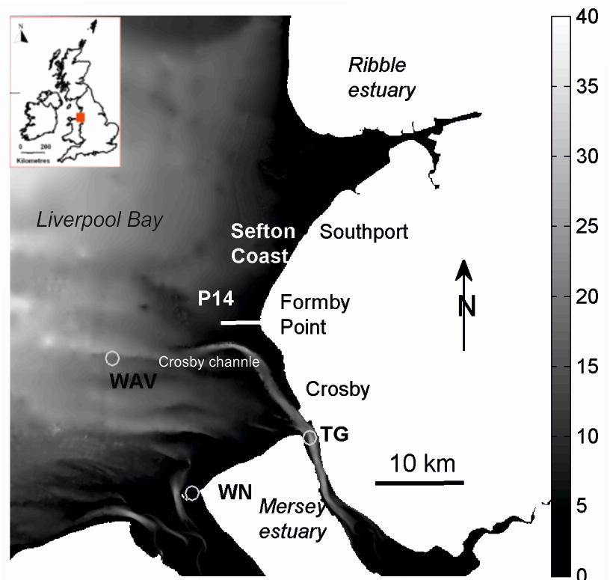

Figure 1. Location of the modelled cross-shore profile (1DH) at Formby Point on the Sefton coast and the monitoring stations in Liverpool Bay (WAV: Wave buoy, TG: Tidal gauge, WN: wind station)

Liverpool Bay and in particularly the Sefton coast have been continuously monitored for hydrodynamic data and morphodynamic changes (Howarth et al., 2006). Sefton coastline is measured by Sefton Metropolitan Borough Council (SMBC) for more than 20 years. Wave data is available at an offshore wave buoy location WAV (Figure 1) which is part of the UK WaveNet system, maintained by Centre for Environment, Aquaculture and Fisheries Science (Cefas). A long-term tide gauge has also been maintained as part of the UK tide gauge network at Gladstone Dock, Liverpool (TG). Wind data is available at a land based meteorological station on Hilbre Island (WN).

APPROACH
The numerical approach used here provides insights on the potential erosion trends at a beach/dune system controlled locally by cross-shore sediment fluxes to reduce the uncertainty related to the future storm impacts. A one-dimensional horizontal (1DH) modeling approach was used to investigate the beach/dune erosion by the impacts of future storm occurrence at Formby Point of the Sefton coast. Analysis of a cross-sectional transect will also enable detailed analysis of how sediment is redistributed across the beach/dune profile in response to storms of varying strength. It is suggested that sediment lost from the dune system enhances bar growth on the beach face forcing waves to break further offshore preventing further degradation of the dune system (Hanley et al., 2014). Future storm events were derived using a probabilistic approach and then applied within the model to investigate the storm driven morphodynamics considering the local recovery rate at Formby Point. The recovery rate (about -1.4 m/year) was estimated from the measured profile data from 1996 to 2013 and that indicates gradual erosion at Formby Point. This rate is consistent with the previous studies (Pye and Neal, 1994; Pye and Blott, 2008). Understanding the likely response of the beach/dune profile to a sequence of storms is crucial for the development of appropriate and sustainable strategies to manage coastal erosion and flooding risks. Such information is therefore of importance to enable researched-informed shoreline management planning.

Model bathymetry
The selected cross-shore profile at Formby Point (P14 in Figure 1) is located at the apex of the Sefton coast, where there is a sediment divergence pattern and thus experiencing the minimal alongshore transport compared with the other locations along this coast. As this cross-shore profile is centrally located on the Sefton coast, it is highly susceptible to the storm wave impact which enables us to assess the most vulnerable section of the beach/dune system. Therefore, Formby Point is ideally suitable for the 1DH simulation as it experience cross-shore sediment exchanged without the complication of along-shore exchanges, which are important for the coastline north and south of this point. This profile has already been implemented in the 1DH XBeach simulations and therefore a calibrated and validated model was established by Dissanayake et al. (2015c). We used this model in the present study with the same calibrated parameters therein. The offshore grid resolution of the model bed is 10 m while the minimum resolution along the beach/dune area is about 2 m, which is sufficient to represent the local bed topography (Figure 2). The dune toe level is located at around 4.8 m ODN on this profile (Pye and Blott, 2008). Therefore, the dune profile was divided into three segments representing, 1) Upper dune area (above 5 m ODN), 2) Inter-tidal area (between -5 m and 5 m ODN) and 3) Sub-tidal area (below -5 m ODN) for the analysis of storm impacted beach/dune evolution. The subpanel in Figure 2 shows these profile segments.

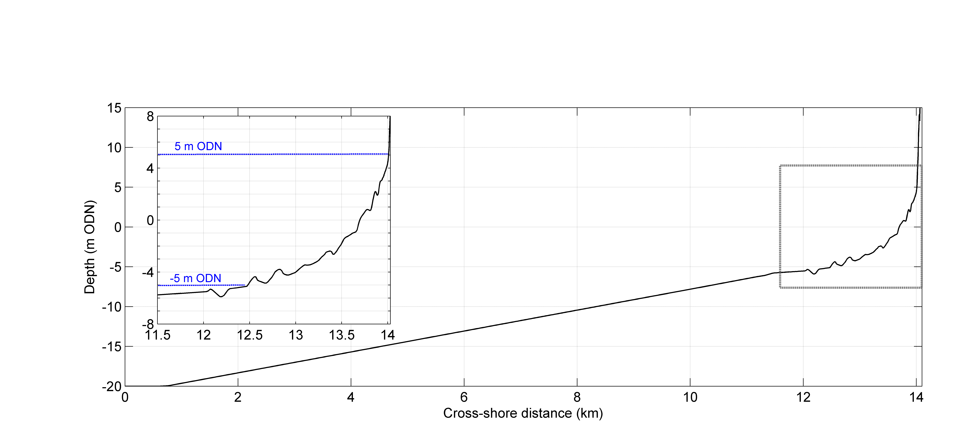
MSL

Figure 2. The 1DH model domain based on the measured data at the location P14 of Formby Point (see Error: Reference source not found), cf from Dissanayake et al. (2015c). The subpanel shows the area analysed, Upper dune (> 5 m ODN), Inter-tidal area (between -5 m and 5 m ODN) and sub-tidal area (< -5 m ODN).

Future Storm occurrence
Future occurrence of storm events and storm clusters were predicted using the probabilistic modelling approach: Generalised Additive Models for Location, Scale and Shape (GAMLSS). GAMLSS is a modern distribution based approach to regression analysis in which a parametric distribution is assumed for the target variable (Serinaldi and Cuomo, 2011; Robert and Stasinopoulos, 2005). The parameters of this variable can vary according to explanatory variables using linear, non-linear or smooth functions.

Initially, the GAMLSS model was fitted to the measured storm events in Liverpool Bay. Wave characteristics at the location WAV (see Figure 1) have been measured from 2002 to 2012 (Brown et al., 2010b). This wave record was used to identify the historical storm occurrence using the storm definition of threshold wave height (2.5 m for Liverpool Bay). From these storm events, storm parameters such as peak storm wave height, peak storm wave height period, storm duration, inter-storm arrival period, wind speed and direction were obtained for the period from 2002 to 2012. The inter-storm arrival period was then fitted using a Beta distribution of GAMLSS with the year fraction as the explanatory variable of its two parameters. Three versions of the Beta distribution were adopted of which each has one (S1), two (S2) and three (S3) harmonic functions. Resulting probability agreement between the measured data and the probabilistic models for the inter-storm arrival period is shown in Figure 3 for the three versions of the Beta distribution. Parameters of these three models were then used to forecast the future storm occurrence for a 50 year period spanning from 2015 to 2065.

b. S2
a. S1
c. S3
GAMLSS model
Measured data

Figure 3. Agreement in inter-storm arrival time between probabilities of the measured data and the GAMLSS model using three harmonic functions (S1: one-harmonic, S2: two-harmonic and S3: three-harmonic). x-axis is probability of GAMLSS model and y-axis is probability of measured data.

The predicted future storm occurrence provides the time and the period of future storm events. Occurrence of storm clusters was identified by the length of the inter-storm arrival period (see Dissanayake et al., 2015a). This information was combined with the measured storm wave parameters (height, period and direction) using a resampling analysis (Serinaldi and Cuomo, 2011) to identify the future storm wave parameters for the three analyses S1, S2 and S3. For example, the wave height variations of the future storm events are shown in Figure 4 for the three cases. In the 50 year period, the S1 results in 883 storm events while the S2 and the S3 develop 886 and 894 storm events respectively.

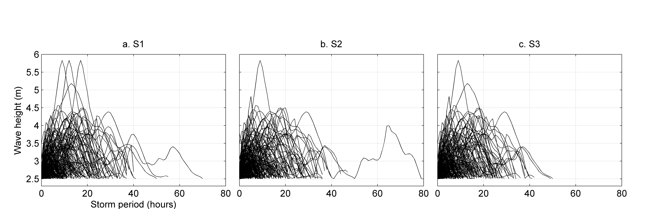
a. S1
b. S2
c. S3

Figure 4. Wave height variation of the forecasted storm events in the period from 2015 to 2065 within the three scenarios (S1, S2 and S3)

Similarly, surge and wind (speed and direction) characteristics were derived for the storm events within the three scenarios. The Astronomical tide was derived using an operational tide model in Liverpool Bay (Brown et al., 2010a). This information of each storm event was separately used to establish the boundary forcing for the numerical experiments.

Numerical experiments
The numerical experiments were carried out using the dune erosion model XBeach (Roelvink et al., 2009), which has been proven to be capable of predicting storm impacts on the beach/dune morphodynamics in numerous case studies (e.g. Smallegan et al., 2016; Dissanayake et al., 2014, 2015a; Souza et al., 2013; Harley and Ciavola, 2013 and the references therein) and it is being continuously improved with the feedback of the user community. Therefore, we used the XBeach model to investigate the storm impacted morphodynamics at Formby Point during the predicted future storm events from 2015 to 2065.

Two series of model experiments were performed using the 1DH profile for the three scenarios S1, S2 and S3. In the first series (Recovery), it was assumed that the profile is fully recovered when the subsequent storm event occurs irrespective to the inter-arrival period of the storm events. In the second series (Cluster), the profile is partially recovered depending on the inter-arrival period of the storm events when the subsequent event occurs.

RESULTS

Profile envelope
An envelope of the bed profile evolution within the 50-year period is shown in Figure 5 for the Recovery and the Cluster applications of the three scenarios (S1, S2 and S3). It should be noted that the profile envelope provides the minimum and the maximum bed level change that occurred along the profile during each storm event for the 50 year period. In the Recovery application, the impacts of each storm event were simulated using the same initial profile (i.e. fully recovered). Therefore, the profile envelope (red-dash-line) was estimated considering the evolution of the same profile under different storm events in the three scenarios (Figure 4a,b,c). During the storm impacts, the ridge-runnel in the inter-tidal area, particularly above MSL tends to move landward. The magnitudes of the erosion and the accretion patterns are marginally different among the three scenarios as the inter-arrival period of storms is not important for the bed evolution and hence no cumulative effect. Strong erosion/accretion of the ridge-runnel pattern is mainly determined by the occurrence of high water during the peak storm wave height (note. during low water, the ridge-runnel pattern remains dry). For example, the runnel at 13.9 km cross-shore distance experienced accretion of 0.81 m, 0.90 m and 0.83 m in the S1, S2 and S3 scenarios (a, b and c) respectively due to erosion of neighbouring ridges. Also, it is noted that the strongest bed level change along the profile is found at this runnel pattern. These results indicate, if a storm event occurs after the profile being fully recovered from the previous event, the experienced erosion and accretion only depend on the severity of the impacted storm event itself and the simultaneous occurrence of high water.

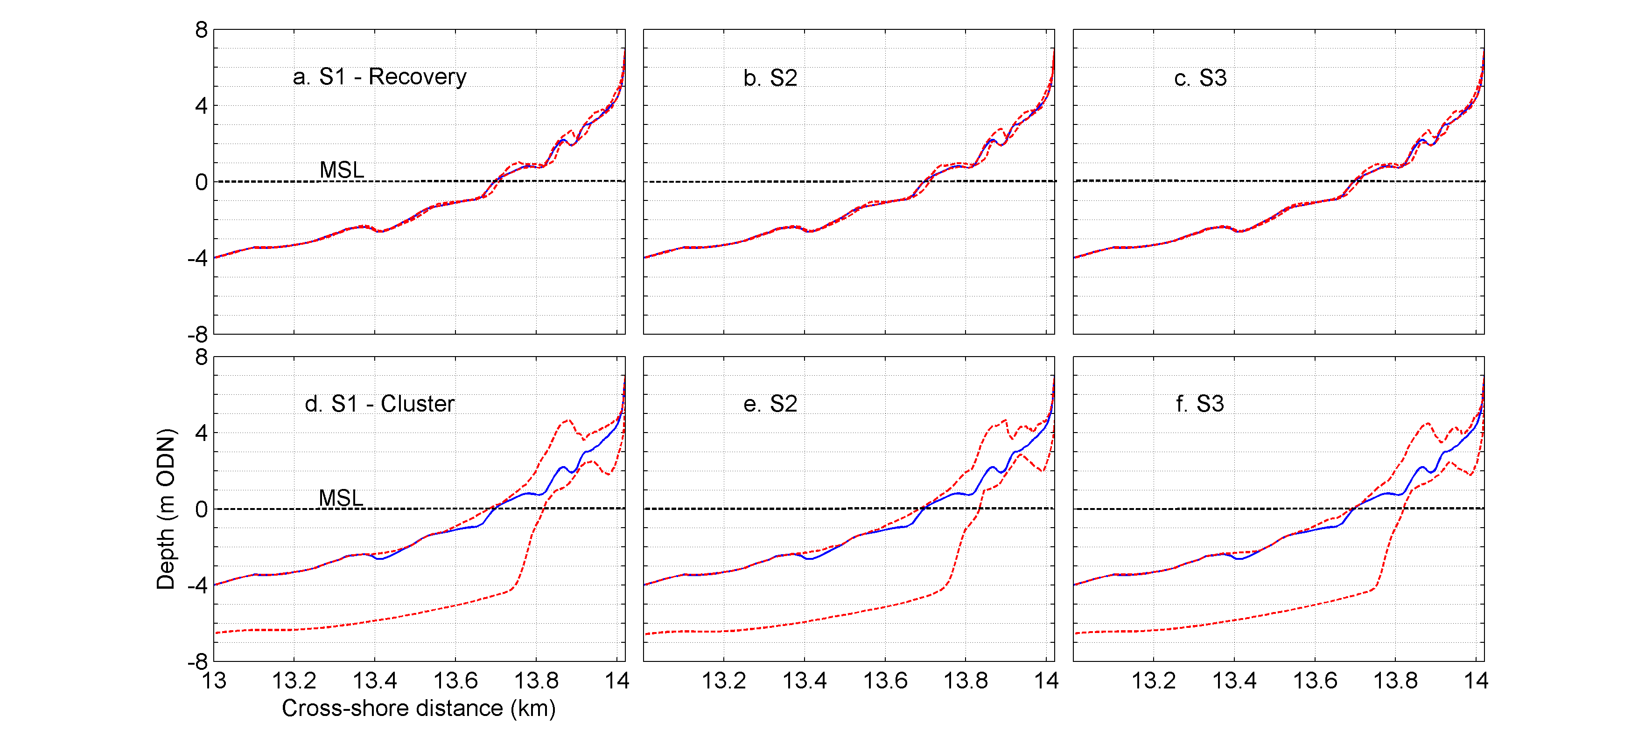
Figure 5. Envelope of bed profile evolution within the three scenarios (S1, S2 and S3) in Recovery (a,b,c) and Cluster (d,e,f) applications by considering the minimum and maximum bed level change within each storm event during the 50 year period.

The profile envelops (red-dash-line) of the Cluster application show the minimum and the maximum bed level changes that occurred along the profile with the cumulative effect of bed evolution during the 50 year period (Figure 5d,e,f). The difference among the three scenarios is marginal compared to that of the difference with the initial profile of the clusters (blue-line). It should be noted that this profile is located at the apex of the Sefton coast which acts as a sediment divergence system. Therefore, in addition to the storm impacted erosion on this profile, the chronical sediment divergence rate which was estimated at the dune toe level using the measured profiles from 1996 to 2013 (i.e. -1.41 m/year), was also applied based on the inter-arrival storm periods. The profile envelops indicate that the maximum erosion within the 50 year period (from 2015 to 2065) occurred at around MSL on the initial profile and it is about 5 m while the maximum accretion is found to be 3 m at the 2 m ODN on the initial profile. It is emphasised that these values are realistically acknowledged because a catastrophic erosion of this magnitude could be expected on this coast even during a single storm cluster (e.g. 2013/2014 winter storm cluster, see Dissanayake et al., 2015b).

Bed level change
Bed level change (black-line) along the cross-shore distance during each storm event is shown in Figure 6 for the Recovery and the Cluster applications in comparison to the initial profile (red-line) of the simulations (left-y, bed level change and negative: erosion, positive: accretion, and right-y, bed level and negative: below MSL, and positive: above MSL). The Recovery application developed oscillatory patterns which correspond to the locations of ridges and runnels. The ridges experienced erosion and then the runnels are filled up. This trend is found within the three scenarios in the Recovery. There exist marginal differences in erosion and sedimentation among the scenarios due to the occurrence of different storm events. The highest erosion and the accretion within a storm event occurred in the S2. The highest erosion is about -0.6 m and occurred at 13.85 km cross-shore distance which has an elevation of 1.87 m ODN on the initial profile. And the highest accretion is about 0.8 m and found at 13.88 km cross-shore distance which corresponds to 1.91 m ODN elevation on the initial profile. The distance between the erosion and the accretion areas indicated that sediment has moved about 300 m landward during the 50 years period. In the Cluster application, there are no oscillatory erosion and sedimentation patterns, and the ridge-runnel features on the initial profile do not correspond with the resulting bed level changes. This clearly indicates that these features have gradually disappeared during the impacts of the initial storm events of the clusters. The highest erosion and the accretion within a single storm event were found in different scenarios, erosion in the S3 (~ -0.5 m) and accretion in the S2 (~ 0.8 m). In contrast to the Recovery application, storm events in the Cluster application have developed erosion and accretion areas irrespective to the locations of ridge and runnel patterns. Therefore, higher bed level changes are found along the profile (see the profile segment from 13.5 – 14.0 km) than in the Recovery application. Furthermore, as found in the Recovery application, the difference among the scenarios is marginal, however it is still shown different erosion/accretion occurs depending on the individual storm events.

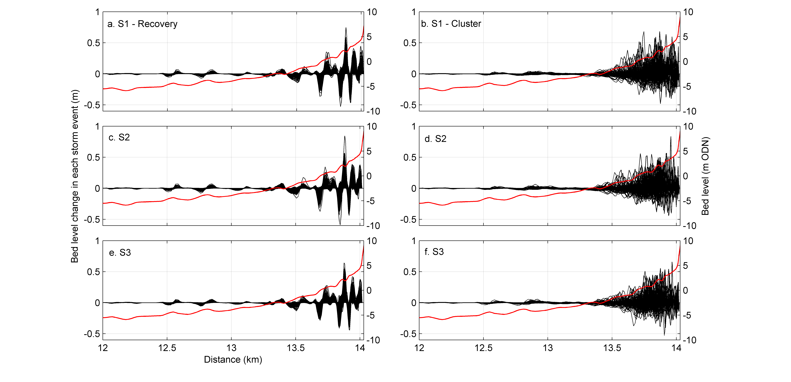
Figure 6. Bed level change in each storm event along the cross-shore distance during 50-year period in Recovery (a,c,e) and Cluster (b,d,f) applications within the three scenarios (S1, S2 and S3). Distance increases towards landward.

In the Cluster application, there is a more noticeable bed level change close to the dune front than that in the Recovery application. This implies, storm waves have impacted the upper dune area after flattening the nearshore ridge and runnel pattern from the initial storm events. Therefore, occurrence of the storm clusters increases the vulnerability of this dune system by direct exposing of the dune front to the storm impacts. The change in bed level in all scenarios reduces at the dune face due to water levels limiting wave impact in this hypertidal region. If sea level rise were to be considered then greater erosion may be seen at the dune toe.

Volume change of different segments along the profile
Volume change within the storm events in the Recovery and the Cluster applications was estimated for the three scenarios (i.e. S1, S2 and S3) along the previously defined three segments of the profile: Upper dune area (above 5 m ODN), Inter-tidal area (between -5 m and 5 m ODN) and Subtidal area (below -5 m ODN). The comparison was carried out with the respective volume change of these areas between the two applications (Figure 7).

In the upper dune area (Figure 7a), volume change is vertically aligned at x=0 for the three scenarios (note. x: Recovery and y: Cluster). Only a few points are found away from this trend and thus only few events were able to impact the upper dune area in the Recovery application. It is further found that the majority of the points is below y = 0. Therefore, strong erosion (negative) has occurred during the storm events within the Cluster application. These trends are consistent in the three scenarios. However, the storm events in the scenarios individually show different magnitudes of erosion and accretion. For example, the number of events showing accretion (positive) in the Recovery application increases from S1 to S3. The R² value indicates the agreement between the volume change (dash-line) of these two applications. The highest R² of 0.28 is resulted in S3 while the lowest (0.02) is in S1. Therefore, the higher the number of events showing accretion, the higher the R² (S3) and vice versa.

Volume change in the inter-tidal area (Figure 7b) shows that the number of storm events impacted in this region is higher in all scenarios compared with that of the upper dune area. The majority of the storm events resulted in erosion, of magnitudes noticeably larger than that occurring in the upper dunes. The scatter of points indicates that they are aligned with the dashed-line and therefore the volume change between the Recovery and the Cluster applications have a higher agreement in the inter-tidal area. All three scenarios (S1, S2 and S3) resulted in an almost similar agreement (R² ~ 0.8) between the Recovery and Cluster storm impacts. However, the events with the extreme erosion values (e.g. < -1.5 m³/m) show higher erosion in the Cluster application than in the Recovery application, and the number of storms with impact has increased from S1 to S3. Therefore, in the inter-tidal area, the occurrence of severe events appears to have increased from S1 to S3 while the weak events commonly occur in all scenarios. Resulting erosion from these weak events dominates the R² value.

In the sub-tidal area (Figure 7c), most of the storm events caused accretion and the volume change during accretion events is considerably higher than that during erosion events. This trend is noticeable in all three scenarios. The scatter of points tends to follow the dashed-line and that indicates a higher agreement (R² >0.7) between the storm impacts in the Recovery and the Cluster applications. The agreements in S1 and S3 are relatively high than S2. As found in the inter-tidal area, the R² value is mainly determined by the impacts of a large number of weak storm events, which results in accretion in this profile segment. In comparison to the high accretive events (higher positive values), the majority of points is located above the dashed-line indicating higher accretion in the case of the Cluster application than the Recovery application. Therefore, the occurrence of severe storm events in the Cluster application resulted in increased accretion compared with that in the Recovery application, while the low severity events caused similar accretion pattern in both the Cluster and the Recovery applications.

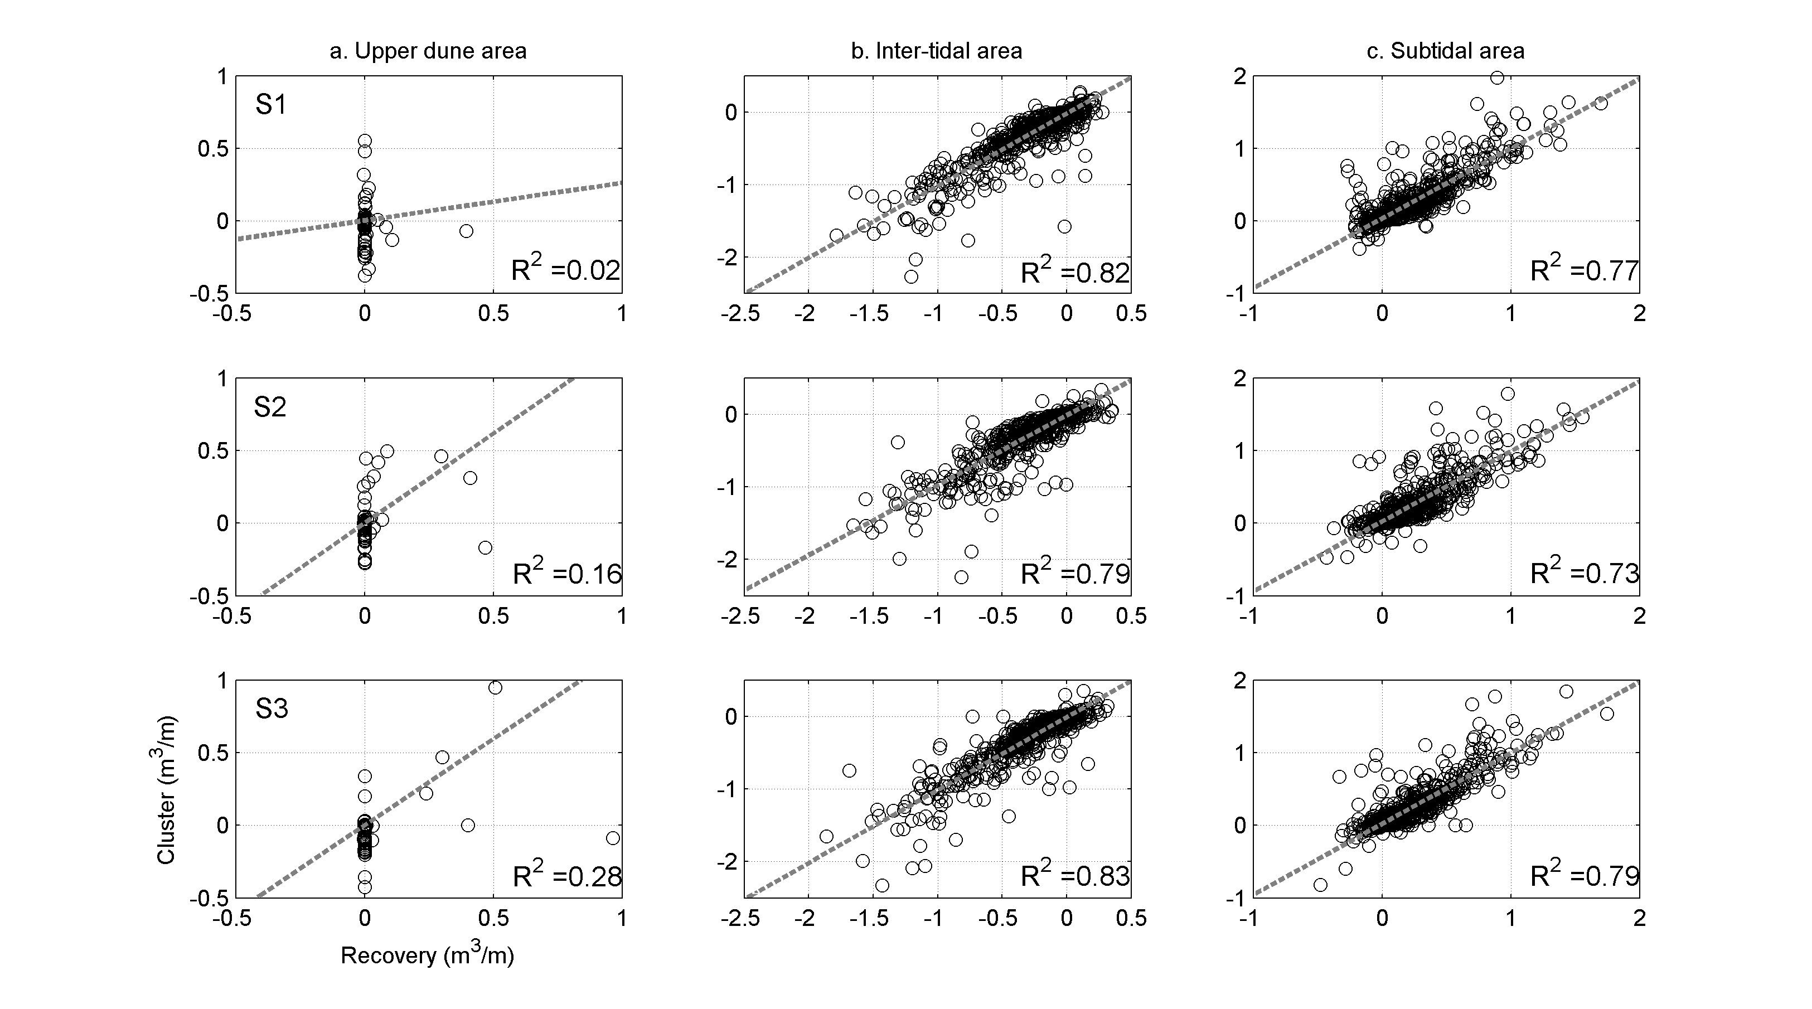
Figure 7. Volume change along the profile segments, a. Upper dune area (above 5 m ODN), b. Inter-tidal area (between -5 m ODN and 5 m ODN) and c. Sub-tidal area (below -5 m ODN) under three scenarios (S1, S2 and S3) in the Recovery and Cluster applications (negative values indicate erosion and positive values indicate accretion). Note that different axis-scales were used to better visualize the bed level change within the segments.

CONCLUSIONS
The following conclusions are drawn based on the analyses of the profile evolution within the three scenarios of future storm occurrence in the two series of applications: Cluster and Recovery.

- In the Recovery application, storm events always impacted on the nearshore ridge-runnel pattern while this pattern was gradually diminished in the Cluster application and therefore the storm events within the Cluster can directly impact the dune frontage increasing the vulnerability to erosion.
- All three scenarios resulted in similar trends of bed level change whereas individual events showed discrepancies between the Recovery and the Cluster applications.
- Only a few storm events impacted on the upper dune area and the corresponding evolution in the Cluster application is noticeably higher compared with that of the Recovery application. Increased erosion was found in the inter-tidal area in both applications. Particularly during the severe storm events, the Cluster application resulted in the highest erosion. The sub-tidal area experienced accretion, which is higher during the extreme events in the Cluster application.
- At Formby Point, the upper dune area maintains its resilience as a defence against the coastal flooding under the impact of the formulated storm clusters due to its high elevation. However, the occurrence of high severity events after flattening the nearshore ridge-runnel pattern increases the vulnerability to hinterland flooding.

ACKNOWLEDGMENTS
The work presented in this paper was carried out under the project ‘FloodMEMORY (Multi-Event Modelling Of Risk and recoverY)’ funded by the Engineering and Physical Sciences Research Council (EPSRC) under the grant number: EP/K013513/1. The UK Met Office is acknowledged for providing the hindcasted wave information. Sefton Metropolitan Borough Council is greatly appreciated for the access of other relevant data used in this study.

REFERENCES

Brown J.M., V. Holden, G. Lymbery and C. Pugh, 2010a. CoFEE Project end users report: Potentially damaging offshore storm conditions along the Sefton Coast, National Oceanography Centre, Liverpool, UK, Internal report number 200.
Brown, J.M., A.J. Souza and J. Wolf, 2010b. An investigation of recent-decadal storm events in the eastern Irish Sea, Jr. Geophysical Research 115, C05018, doi:10.1029/2009JC005662.
Dissanayake, P., J. Brown and H. Karunarathna, 2014. Modelling storm-induced beach/dune evolution: Sefton coast, Liverpool Bay, UK, Marine Geology 357, 225 -242.
Dissanayake, P., J. Brown, P. Wisse and H. Karunarathna, 2015b. Comparison of storm cluster vs isolated event impacts on beach/dune morphodynamics, Est., Coast. and Shelf Sci. 164, 301-312.
Dissanayake, P., J. Brown, P. Wisse and H. Karunarathna, 2015c. Effects of storm clustering on beach/dune evolution, Marine Geology 370, 63-75.
Edmondson, S.E., 2010. Dune Slacks on the Sefton Coast, Sefton’s Dynamic Coast, Proceeding of the conference on coastal and geomorphology, biogeography and management, 178 -187.
Esteves, L.S., J.M. Brown, J.J. Williams and G. Lymbery, 2012. Quantifying thresholds for significant dune erosion along the Sefton Coast, Northwest, England, Geomorphology 143 -144, 52 - 61.
Howarth, M. J., R. Proctor, P.J. Knight, M.J. Smithson and D.K. Mills, 2006. The Liverpool Bay 674 Coastal Observatory: to-wards the goals, Proceedings of Oceans ’06, MTS/IEEE, Boston, p. 6, doi:10.1109/OCEANS.2006.307095.
Harley, M.D. and P. Ciavola, 2013. Managing local coastal inundation risk using real-time forecasts and artificial dune placements, Coastal Engineering 77, 77-90.
Kolen, B., R. Slomp, W. van Balen, T. Terpstra, M. Bottema and S. Nieuwenhuis, 2010. Learning from French Experiences with Storm Xynthia – Damages After a Flood, HKV LIJN IN WATER and Rijkswaterstaat, Waterdienst.
LeComte, D., 2014. International weather highlights 2013: super typhoon Haiyan, super heat in Australia and China, a long winter in Europe, Weatherwise, 67, 20–27.
UK Met Office Report, 2014.
http://www.metoffice.gov.uk/media/pdf/n/i/Recent_Storms_Briefing_Final_07023.pdf
Neria, Y. and J.M. Shultz, 2012. Mental health effects of Hurricane Sandy: characteristics, potential aftermath, and response, JAMAJ. Am. Med. Assoc., 308, 2571-2572.
Plater, A.J. and J. Grenville, 2010. Liverpool Bay: linking the eastern Irish Sea to the Sefton Coast, Sefton’s Dynamic Coast, Proceeding of the conference on coastal and geomorphology, biogeography and management, 41-43.
Pye, K. and S.J. Blott, 2008. Decadal-scale variation in dune erosion and accretion rates: an investigation of the significance of changing storm tide frequency and magnitude on the Sefton Coast, UK. Geomorphology 102, 652-666.
Pye, K. and A. Neal, 1994. Coastal dune erosion at Formby Point, north Merseyside, England: causes and mechanisms. Marine Geology 119, 39-56.
Robert, R. A. and D. M. Stasinopoulos, 2005, Generalized additive models for location, scale and
Shape, Journal of the Royal Statistical Society: Series C (Applied Statistics) 54, 3: 507-554.
Roelvink, D., A. Reniers, A. van Dongeren, J. Van Thiel de Vries, R. McCall and J. Lescinski, 2009. Modelling storm impacts on beaches, dunes and barrier islands, Coastal Eng. 56, 1133-1152.
Serinaldi, F., and G. Cuomo, 2011. Characterizing impulsive wave-in-deck loads on coastal bridges by probabilistic models of impact maxima and rise times, Coastal Engineering 58,9, 908-926.
Smallegan, S.M., J.L. Irish, A.R. Van Dongeren and J.P.D. Bieman, 2016. Morphological response of sand barrier island with a buried sea wall during Hurricane Sandy, Coastal Eng. 110,102-110.
Souza, A.J., J.M. Brown, J.J. Williams and G. Lymbery, 2013. Application of an operational storm coastal impact forecasting system, Journal of Operational Oceanography, Vol. 6, 23 – 26.
Steers, J. A., 1953. The East Coast floods, january 31 - february 1 1953. Geogr. J. 119, 280-295. doi: 10.2307/1790640.
Wadey, M.P., I.D. Haigh and J.M. Brown, 2014. A century of sea level data and the UK's 2013/14 storm surges: an assessment of extremes and clustering using the Newlyn tide gauge record, Ocean Science, Discussion, 11, 1995-2028.

University of Konstanz, 78464 Konstanz, Germany 2 National Oceanographic Centre, Liverpool L3 5DA, United Kingdom 3 College of Engineering, University of Swansea, Swansea SA1 8EN, United Kingdom

