Sediment Discharge of the Nakatsu Intertidal Flat and the Yamakuni River and the Numerical Forecasting of the Morphodynamic Change
Ken-ichi Uzaki, Masashi Yoneyama, Shiori Okuma, Akira Tai and Yoshito Ikehata
Fishermen and citizens of the Nakatsu City fear effects of expansion work of the Nakatsu Port on the erosion of the Nakatsu Intertidal flat. However, Even the fact of erosion/deposition of the intertidal flat has not been cleared yet. In this study, field observations of bottom survey and of sediment discharges from the Yamakuni River were conducted in order to investigate the erosion/deposition of the flat and the mechanism of morphodynamic changes. Numerical simulations were also conducted in order to forecast the morphodynamic change and to propose the effective countermeasures to maintain the intertidal flat.
Keywords: intertidal flat; field observation ; ADCP; bottom survey ; sediment discharge from river ; numerical simulations

INTRODUCTION

Backgrounds and Purposes of This Study
The catch of fish of the Nakatsu Intertidal Flat in Oita Prefecture in Japan decreased to the half of that in 10 years ago. Figure 1 shows the photo. of Nakatsu Intertidal Flat. As the cause of this decrease, changes of the intertidal flat, which are the erosion of flat and the increase of muddy sediments, are suspected. For the reasons of these changes, effects of the expansion of the Nakatsu Port, which is located in the middle part of the Nakatsu Intertidal Flat, and the construction of Heisei Dam and the Yabakei Dam of Yamakuni River are doubted. However, what is the truth about the erosion/deposition has not been cleared yet. In general, the sediment behavior on intertidal flat and the sediment budget from the river to the flat have not been well known, so that effective countermeasures to maintain the intertidal flat have not been also proposed. In these days, the proposition of effective countermeasures is very important because it comes to be recognized that intertidal flats play an important role on the water quality of inner bays.
In this study, the morphodynamic change of Nakatsu Intertidal Flat and the sediment budget from the Yamakuni River to the flat were observed. In addition, numerical simulations of morphodynamic change in the future were conducted. Results of this study give the truth of morphodynamic change of Nakatsu Intertidal Flat and effective countermeasures will be proposed by using these numerical simulations. Furthermore, the way to evaluate the morphodynamic change of flat and clear the mechanism of change are given.

FIELD OBSERVATIONS
Filed observations of bottom survey over the Nakatsu Intertidal Flat by using the high accuracy tools have been conducted before and after flood periods of the Yamakuni River for a several years. Figure 2 shows the M9 which is composed of the ADCP and the RTK-GPS. It was used to make the bottom survey. Figure 3 shows observation lines. Nearshore observation lines, whose interval was about 500m, indicate the lines by using a small boat and M9, and offshore observation lines, whose interval was also 500m, the lines by using a fishing boat and the ADCP. Furthermore, filed observations of water sampling were conducted at the Yamakuni Bridge of Yamakuni River at the flood. The suspended load concentration was obtained by using from the SS analysis of water samplings. The bedload transport rate was estimated by using the river discharge data and the Ashida-Michiue formula.

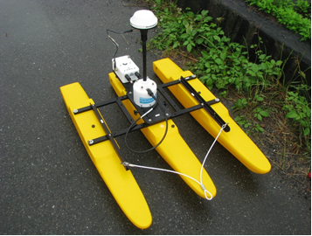
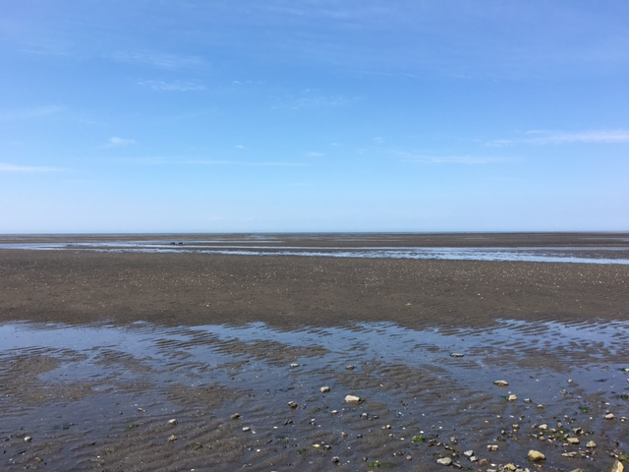

Figure 1. Photo. of the Nakatsu Intertidal Flat. Figure 2. Photo. of M9 (=ADCP+RTK-GPS).

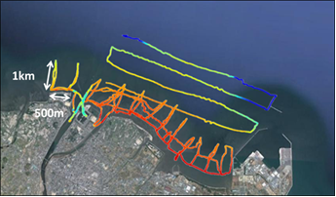

Figure 3. Observation lines.

OBSERVATION RESULST AND DISCUSSIONS
Figure 4 shows an observation result of bottom topography of the Nakatsu Intertidal Flat of 2015 spring. From this figure, we can see the ship route at rivermouth of Yamakuni River, the overhang of flat to the offshore and the deep point around the entrance of Nakatsu Port. Figure 5 shows the results of the morphodynamic change from 2014 spring to 2015 spring. This figure shows the heavy erosion of about 4,800,000 m³ thorough a year uniformly over the whole tidal flat. The sediment discharge from the Yamakuni River was estimated by using the SS analysis of water samplings, the river discharge data and the Ashida-Michiue formula as shown in equs.(1). In conclusion, amount of sediments of 142,345 m³ (suspended load : 5,820 m³, bedload : 136,525 m³) through a year was supplied from the Yamakuni River to the Nakatsu Intertidal Flat. In total, amount of sediments of about 5,000,000 m³ was flowed out from the intertidal flat. Figure 6 shows the time-series of amount of erosion/deposition Δh accumulated since 2000, which is cited from the report published by the Ministry of Land, Infrastructure, Transport and Tourism. Figure 7 shows the time-series of rainfall since 2000. From Figures 6 and 7, we can see the correlation closely between the deposition and the heavy rainfall. Form these figures, it is suggested that the rainfall may be the dominant factor to control the erosion/deposition of this intertidal flat. In addition, from the results of estimation of sediment budget from the Yamakuni River to the Nakatsu Intertidal Flat, effects of the longshore sediment transport are recognized to be very important on the erosion/deposition of the flat because the total value of yearly erosion is temporally far larger than the amount of sediment discharge from the Yamakuni River. The amount of sediments due to longshore sediment transport may increase as the increase of the rainfall as well. Then, it is assumed that sediments of the intertidal flat are supplied due to the rainfall and the erosion is occurred by high waves with linear relations, respectively. By using the data in Figure 6, the multiple regression analysis due to r : the rainfall at the Yabakei Dam of Yamakuni River and H_{1/3} : the significant wave height at the Kanda Port to the northwest of the Nakatsu Intertidal Flat was conducted. Figure 8 and equ.(2) show the
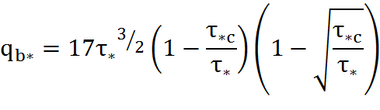
equs.(1)
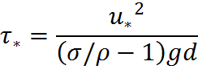

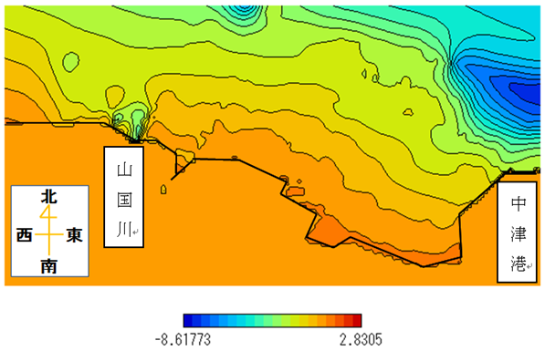
Yamakuni River
Nakatsu Port
N
W
E
S
m
(a) May, 2014.

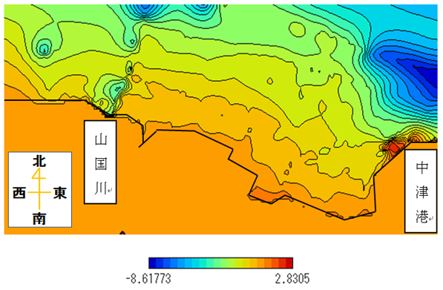
Yamakuni River
Nakatsu Port
N
W
E
S
m
(b) May, 2015.
Figures 4. Bottom Topography.

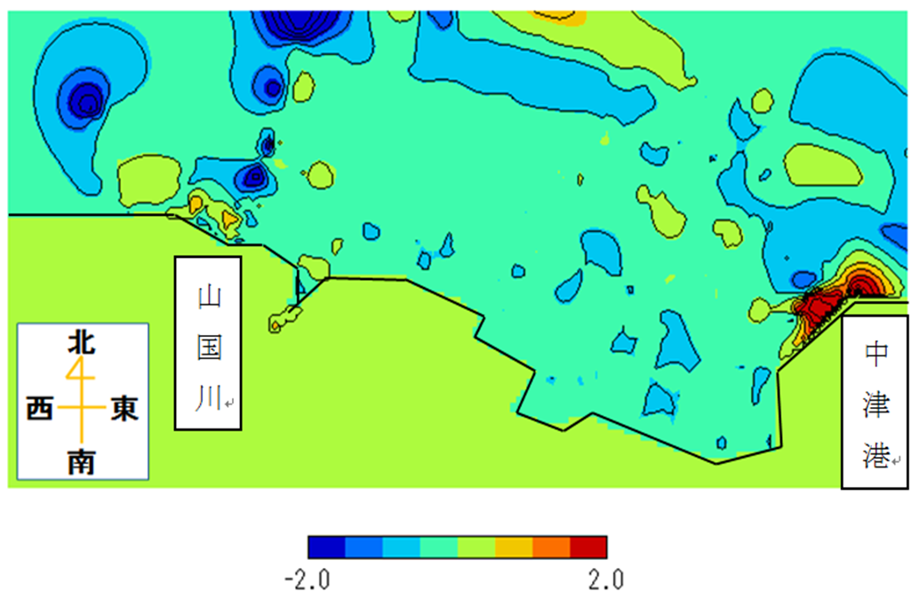
Yamakuni River
Nakatsu Port
N
W
E
S
m
Figure 5. Morphodynamic change May, 2014 –May, 2015.

Figure 6. Accumulated Amount of Erosion/Deposition obtained by MLIT.

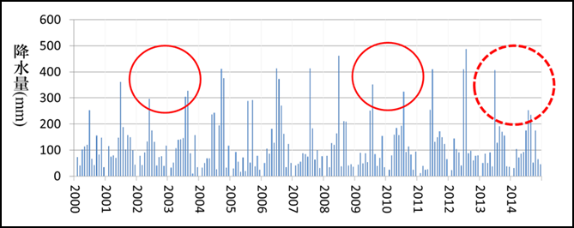
rainfall

Figure 7. Time-Series of the Rainfall at the Yabakei Dam.

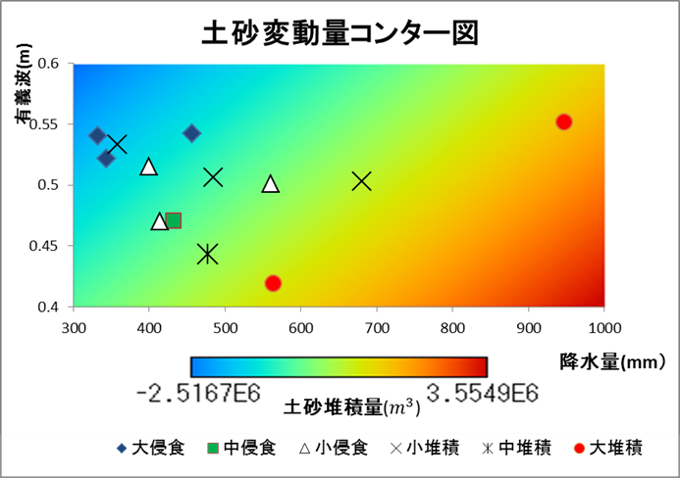

H_{1/3} (m)

r (mm)
Erosion/Deposition
Large Er.
Semi Er.
Small Er.
Small Dp.
Semi Dp.
Large Dp.

Figure 8. Results of the Multiple Regression Analysis.

⊿h = 5.51×10³ r - 1.11×10⁷H_{1/3}+2.46×10⁶ equ.(2)

 | Large Scale | Small Scale
dx (m) | 450 | 55.7
dy (m) | 550 | 46.3
dti (s) | 1.0 | 0.1
dte (s) | 0.1 | 0.01
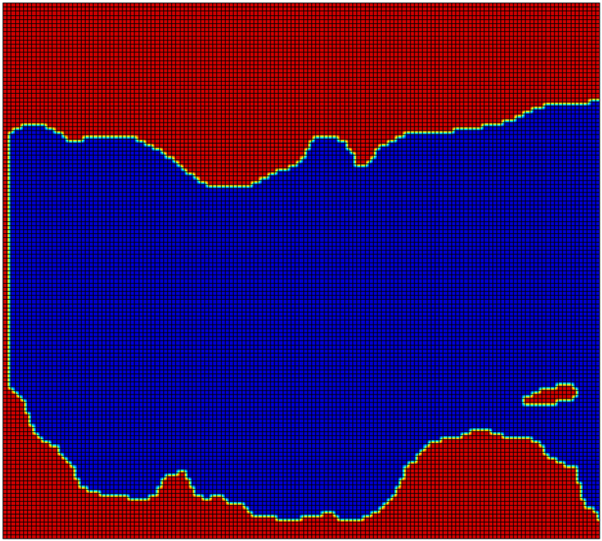
Table 1. Numerical Conditions.

Figure 9. Numerical Domain for Simulations of the Suonada Sea.

results of multiple regression analysis. In this figure, blue plots indicate large erosions and red ones large depositions. The background contour indicates equ.(2). From this figure, we can see the good agreement between equs.(2) and the plot data. It leads to the validity of equ.(2) and the assumption of linear relationships between r and Δh , H_{1/3} and Δh. In addition, a large value of the constant term in equ.(2) suggests an another constant effect of the sediment supply.

NUMERICAL SIMULATIONS
Finally, numerical simulations were conducted in order to clear the mechanism of morphodynamic change of the intertidal flat, to forecast them in the future and to propose countermeasures to maintain the flat. Numerical simulations were conducted by using the 3-dimensional and regional sediment transport and morphodynamic change model of intertidal flats considering tidal currents and coastal currents, named “WD-POM” which was established by authors. It is based on the POM (Princeton Ocean Model) and composed of the energy balance equation for the wave field, the radiation stress model for coastal currents, the Bailard model for sediment transport of sand, the advection diffusion equation for mud transport and the sediment budget equation for the morphodynamic change. Details of this model were mentioned in Uzaki et al. (2007). In this study, only numerical results of yearly tidal residual currents in Suonada Sea and tidal current field of the Nakatsu Intertidal Flat in summer of 2015 are shown. Figure 9 shows a numerical domain of the Suoanada Sea. Table 1 indicates numerical conditions. Parameters for a large area was used in the calculation of Suonada Sea and ones for a small area in the calculation of Nakatsu Intertidal Flat. The large area simulation and the small area one were connected by the nesting method.

NUMERICAL RESULTS AND DISCUSSIONS
Figure 10 shows numerical results of yearly tidal residual currents in the Suonada Sea. Numerical simulations were conducted for 2 weeks from a neap tide to a spring tide in spring, winter, summer and winter of 2015. Yearly tidal residual currents were obtained by the average of these currents in 4 seasons. According to Nakajima et al. (2010) and Yagi et al. (2011), the unti-clockwise residual currents occur in the Suonada Sea. From this figure, we can also see the unti-clockwise tidal circulation, so that, around the Nakatsu Intertidal Flat, residual currents from the northwest to the southeast along the shore exist. Due to these currents and winter waves from the northwest, longshore sediment transport from the Kanmon Straight to the Nakatsu Port occurs and it suggests effects of them on the morphodynamic change of Nakatsu Intertidal Flat.

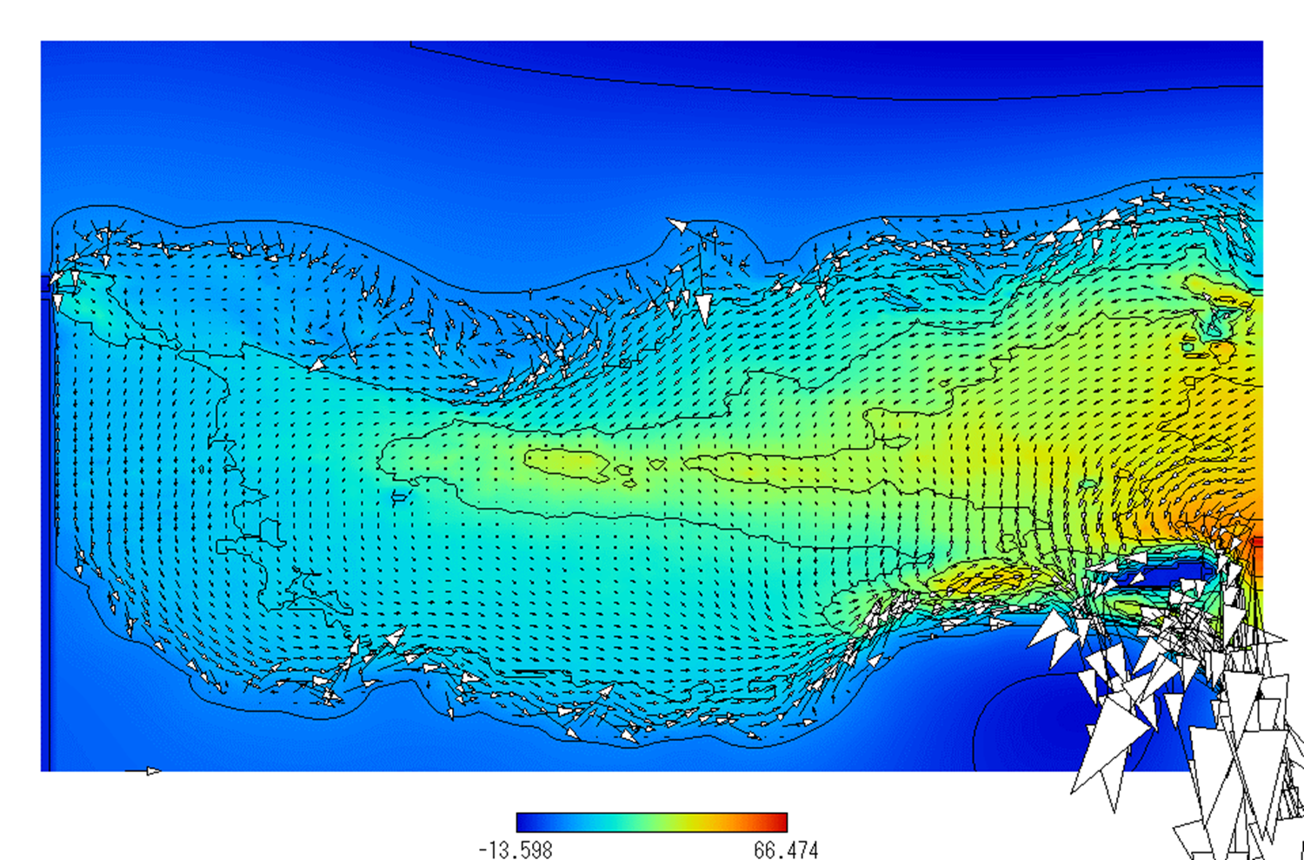

Figure 10. Numerical result of yearly tidal residual currents of the Suonada Sea.

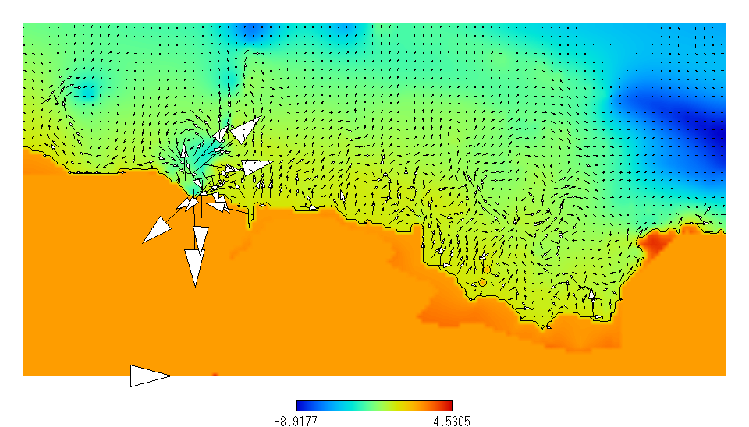
1.0 m/s

Figure 11. Numerical result of coastal and tidal currents of the Nakatsu Intertidal Flat.

Figure 11 shows tidal currents on the Nakatsu Intertidal Flat at the flood of 21th. June at the ebb tide. Around the rivermouth, a clockwise circulation can be seen. The reason of this circulation has not been cleared. This figure shows an example of present simulation progress. In the future work, the
forecasting of morphodynamic change of this flat will be made and effective countermeasures will be proposed by using this numerical model.

CONCLUSIONS
In order to investigate the fact of morphodynamic change of Nakatsu Intertidal Flat and to clear the mechanism of the change, field observations of bottom survey and the estimation of sediment budget from the Yamakuni River were made. These results lead us to (1) Erosion/deposition are yearly changed, (2) It may depend on the rainfall and the significant wave height, (3) Total value of erosion temporally far excess the sediment discharge from the Yamakuni River. It suggests an another factor of sediment supply to the flat, (4) From the multiple regression analysis of long period bottom survey data by MLIT and authors, the erosion/deposition of this flat is estimated by using the rainfall and the significant wave height. This result also suggests an another constant effect of sediment supply to the flat, (5) Numerical results of tidal residual currents of the Suonada Sea shows the longshore residual currents from the mouth of Kanmon Straight toward the Nakatsu Port. It suggests the sediment supply due to the longshore sediment transport. In the future work, the mechanism of morphodynamic change of Nakatsu Intertidal Flat will be cleared. Furthermore, the forecasting of the change and effective countermeasures will be proposed by using this numerical model.

ACKNOWLEDGMENTS
I represent the special thanks to the Yamakunigawa River Office and the Beppu Port Office of MLIT. I also represent them to the NPO organization “Mizubeni Asobu Kai” and the fishermen of the Koiwai Port in the Nakatsu City.

REFERENCES
Nakajima, S., S. Kanayama., T. Sekimoto. and K. Iseki. 2010. A study on the formation mechanism of isolated cold dome and physical environment near the bottom of Suo-Nada in summer., 2010., Jour. of Japan Society of Civil Engineers, Series B2(Coastal Engineering), JSCE., Vol. 66, No.1, 951-955.
Uzaki, K. and Y. Kuriyama. 2008. Numerical and field study of sediment budgets on an intertidal flat at the mouth of the Shirakawa River., River, Coastal and Estuarine Morphodynamics : RCEM 2007, ASCE., 427-434.
Yagi, H., T. Nakayama., M. Hamaguchi., T. Sano., Y. Fujii. and K. Sugimatsu. 2011., Jour. of Japan Society of Civil Engineers, Series B2(Coastal Engineering), JSCE., Vol.67, No.2, I-966-I-970.

Dept. of Environmental and Engineering Science, Gunma University, Tenjin-cho 1-5-1, Kiryu City, Gunma, 379-8515, Japan
Penta Ocean Construction, Co., Ltd. Koraku 2-2-8, Bunkyo-Ku, Tokyo, 112-8576, Japan
Dept. of Environmental and Engineering Science, Gunma University, Tenjin-cho 1-5-1, Kiryu City, Gunma, 379-8515, Japan
Institute of Advanced Study, Kyushu University, Motooka 744, Nishi-Ku, Fukuoka City, Fukuoka, 819-0395, Japan
Dept. of Architecture, Nippon Bunri University, Ichigi 1727, Oita City, Oita, 870-0397, Japan

