A STUDY FOR THE HENERATION MECHANISM OF THE RIP CURRENT
AT THE ENCLOSED BEACH BY THE GROIN
Naoyuki Inukai, Yoshifumi Ejiri, Takeshi Ootake, Hiroshi Yamamoto¹, and Tokuzo Hosoyamada¹
This study tried to comprehend the generation mechanism of the rip current at the enclosed beach by the groins. Firstly, this study did field survey and comprehended the large scale and velocity of the rip current. In this method, the rip current was pigmented by the sea water colorant, and the pigmented current was recorded as the aerial photograph by the multi-copter. Secondly, this study simulated the rip current in accordance with the results of field survey, and the results of simulation and filed survey ware compared.
Keywords: Wave run up, cusp topography; Drone, aerial photograph; numerical simulation; Niigata Prefecture, Japan Sea

INTRODUCTION
The rip current occurs at the wave breaking area near the beach, and the accident that is related to the rip current occurs every year in the world. Some generation mechanisms of the rip Current are known. For example, the rip current occurs at the sand beach that has the cusp topography, or the rip current occurs near structures such as groins.
The beach in Niigata Prefecture, faces the Japan Sea, does not have many large sand beach, furthermore many beaches are enclosed the groins those were built due to protect from the coastal erosions. In this area, some beach has the cusp topography and the beach is enclosed by the groins. In this case, the current sometimes make the complicated current due to under the influence of the cusp topography and the groins.
This study tried to comprehend the generation mechanism of rip current at the enclosed beach by the groins.
Firstly, this study comprehended the scale and the velocity of rip current by the filed survey. In this method, the rip current was pigmented by the sea water colorant, and the pigmented current was recorded as the aerial photograph by the multi-copter. As the result, the study confirmed the strong rip current that was developed near the cusp top, furthermore decreased and meandered near the head of breakwater area.
Secondly, this study simulated the rip current in accordance with the results of the field survey, and the results of simulation and the filed survey were compared. As the result, the velocity scale and the meander of rip current ware same as the results of the field survey. Therefore, this study confirmed the accuracy of numerical model. After confirm the accuracy of numerical model, this study simulated under the two type conditions. At first, this model simulated the current at the linear shoreline topography that was enclosed by the groins. As the result, the circulation current occurred in the enclosed area, and the alongshore current occurred near the beach. And the second, this study simulated the current at the cusp topography beach that was not enclosed by groins. As the result, the rip current occurred from near the cusp top and decreased at the head of breakwater, however no meander.
According the above results, this study reached the conclusion, that is, the rip current at the cusp topography beach, enclosed by the groin, is compounded with two type rip current, one is under influence of the groin and the other is with the cusp topography.

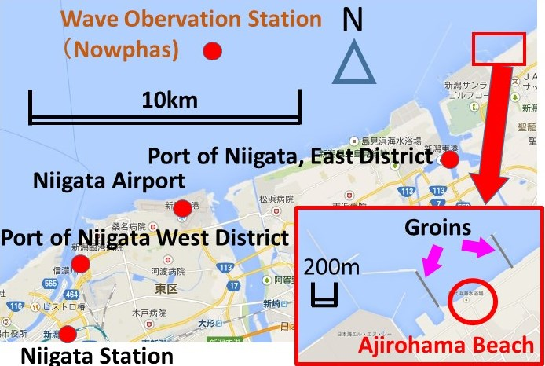
Figure 1. Location of the field

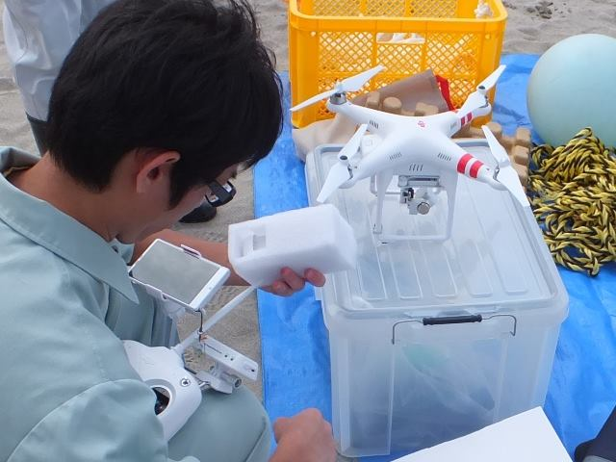

Photo 1. UAV Multi-copter for the aerial photography (DJI Phantom2 Vision Plus)

FIELD SURVEY
This study did filed survey about the rip current at Ajirohama Beach,,Niigata Prefecture, Japan on 17th September in 2014. The place was shown in Figure 1. This beach places are located east of Niigata Port, East District. This beach has cusp topography and enclosed the groins. According the survey, the interval spacing of cusp topography was about 200m, and the slope of the bottom was about 1/80. The significant wave height was 0.98m and the period was 6.5 seconds by NOWPAS, this station is located 10km west of this beach. This wave heights was bigger than the prevalent height in summer. In summer, the prevalent height is lower than 0.5m or less. The wave direction was NNW. In Photo 4, the wave entered from upper right corner, and the rip current occurred at the cusp top and flowed to upper left in the picture. At the top of cusp, many seaweeds were launched to the beach. Furthermore, the rip current occurred along the groin in the left side of Photo 4.
The rip current was pigmented by the sea water colorant, and the pigmented current was recorded as the aerial photograph by the multi-copter. The multi-copter what this study use in this case was DJI Phantom2 Vision Plus, as shown in Photo 1. And the sea water colorant what this study use in this case was shown in Photo 2. Furthermore, this study use the memory type GPS what was shown in Photo 3, and drew off this GPS to the current of Rip Current.
The aerial photograph before discharge the sea water colorant was shown in Photo 4. In this photograph, the rip current occurred at the bottom right hand and flowed to the left upper hand.
The sea water colorant was discharged into the Rip Current in Photo 5.
Furthermore, Photo 6 shows the sea water colorant diffusion after the lapse of 2 minutes, Photo 7 shows the profile after 2 minutes and 30seconds after discharge the colorant.
According to these photos, the top of rip current moved about 27m in30seconds. In this case, the average velocity was 0.9m/s. The average velocity in every 30seconds were calculated in this way. In photo 8, the top of rip current moved 120m in 4minutes and 30 seconds. The average velocity and current vectors at every points were shown in Photo 8. According to the results, the average velocity at the shoreline was about 0.9m/s, and less than 0.4m/s at offshore, that is, the velocity at shoreline was faster than at the offshore. Furthermore, the current meandered in onshore and offshore at the break water zone.
The length of rip current can be predicted by measuring the width of break water zone. The width was about 100m when the survey was done, therefore the length of rip current ware predicted over 100m. Matter of fact, the length was 120m, and the result was as expected.This study comprehended the length and speed of the rip current. However, it is important, that is, the speed which surveyed this time means the average speed of the offshore current and the onshore current, and the maximum speed was faster than the average speed.
According the above results, this study confirmed the strong rip current that was developed near the cusp top, furthermore decreased and meandered near the head of breakwater area.

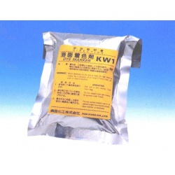
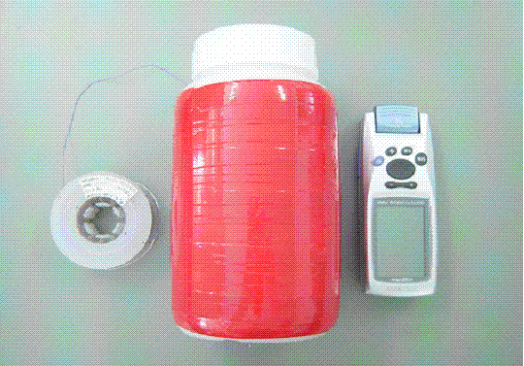

Photo 2. Sea Water Colorant Photo 3. GPS and Float

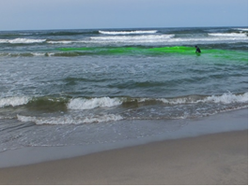

Photo 4. Diffusion of Sea Water Colorant

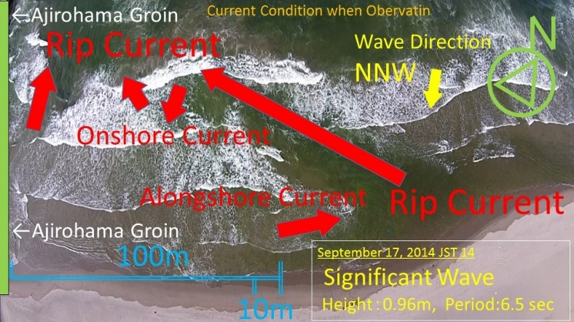

Photo 5. Topography and Current at Ajiro Beach

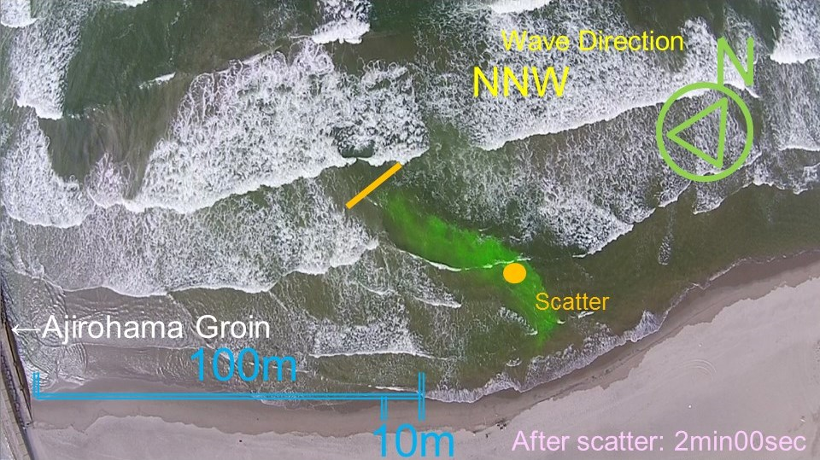

Photo 6. Diffusion of Sea Water Colorant (After Scatter 2min)

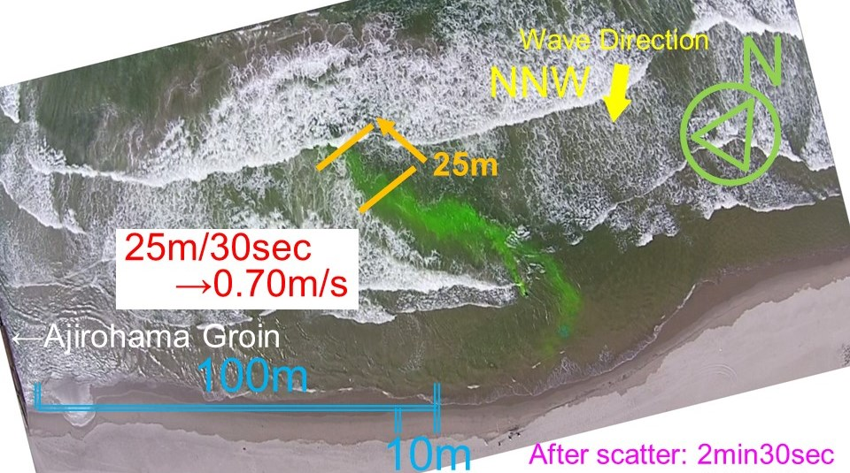

Photo 7. Diffusion of Sea Water Colorant (After Scatter 2min30sec)

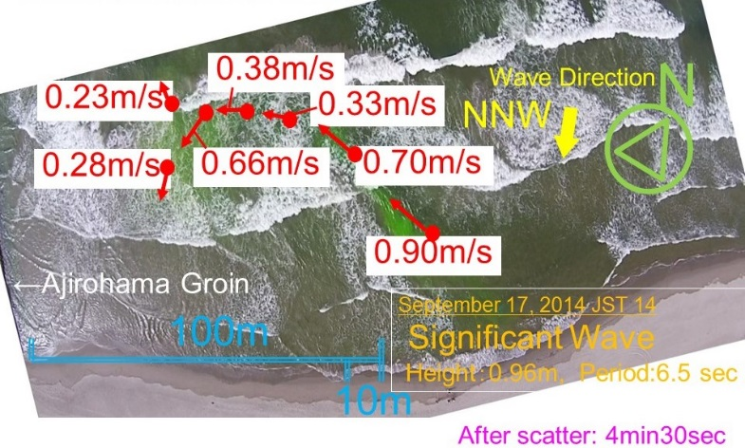

Photo 8. Velocity and Vector of the Current

NUMERICAL SIMULATION MODEL
This study confirmed the strong rip current that was developed near the cusp top, this study simulated the rip current in accordance with the results of the field survey, and the results of simulation and the filed survey ware compared.
This study use the following momentum equations and continuity equation. The momentum equation used the modified Boussinesq equation. The wave moments calculated by the differential equations,

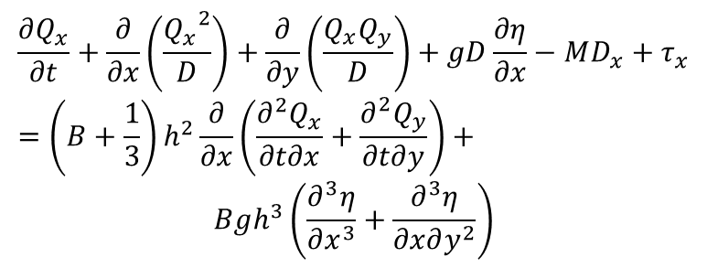(1) 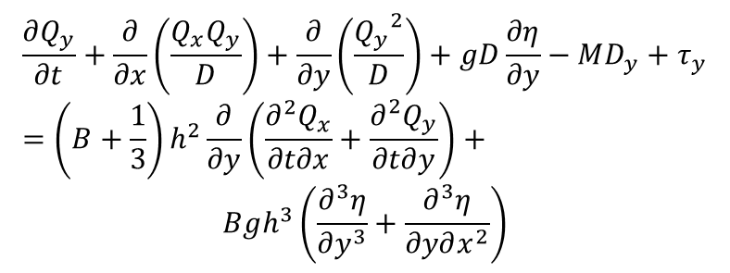(2)
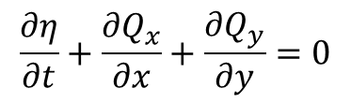
(3)

where, MDxy: break water reduce term, D: depth, Qxy: current volume, h:hydrostatic pressure,η: change of water level, B:constant(1/21), g: gravitational acceleration.

Furthermore, in this study, the diffusion equation was added to calculate the dispersion process of sea water colorant. The diffusion equation is shown as follows;
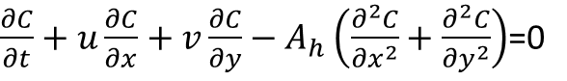 (4)

where, x: Direction of East-West, y:North-South, u:velocity of East-West Direction, v:velocity of North-South Diretion, C:concentration, Ah: horizontal eddy viscosity coefficient.

This study made the topography for the numerical simulation in accordance with Ajirohama Beach by referring the map. The grid space was 2m, the cusp topography were set in 200m intervals. The bottom slope was set as 1/80, and the groins were set at right end and left end in this topography. The length of groins were set as 500m. The waves were inputted at offshore. The wave heights was set as 1m, and the Period was set 6 seconds. The wave direction was set as NNW, this mean, the wave were entered from right upper of this domain.

RESULTS OF SIMULATION
The profiles of water level are shown in Figure 2. The wave incidents from upper right corner, and, the local water level rise occurs at top of the cusp. The profiles of current vector are shown in Figure 3. This vectors are averaged over one wave period. As shown in the figure, the rip current occurs at top of the cusp and flows to the upper left corner (see (1)). Furthermore, another rip current occurs at right side of left groin, and flow to offshore along the groin (see (2)). These results are qualitatively same with the observation results.
The profiles of current velocity are shown in Figure 4. As shown in the figure, the velocity increases where the rip current occurs. The results are same with the Figure 3. The velocity became be almost 1m/s at the top of the cusp. These results are same with the observation.
The diffusion of Sea Water Colorant after scatter 30seconds shows in Figure 5, and after 5 minutes in Figure 6. According to these results of Figure 5, the top of colorant in the rip current moved about 20m in 30 second. In this case, the average speed is 0.7m/s, and this result is same with the observation. Furthermore, according to the Figure 6, the top of dispersion area meandered, and this result is same with the observation.
Therefore, according to the above results, this study confirmed that the numerical model could simulated with accuracy.
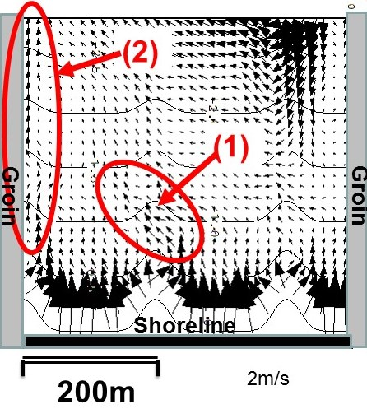
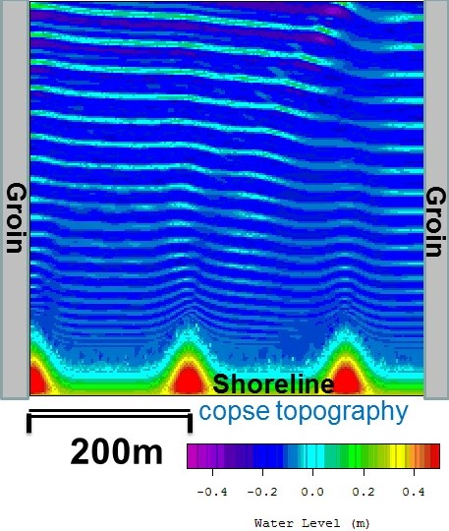
Figure 2. Water Level Figure 3. Profiles of Current Vectors (Average over
One Period)

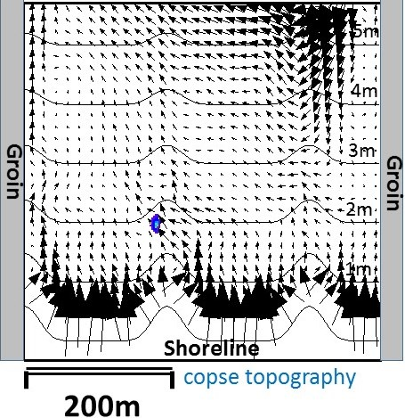
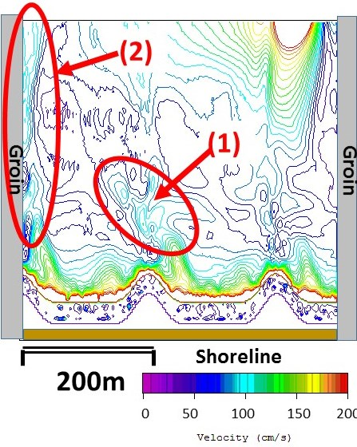

Figure 4. Profiles of Current Velocity (Average over One Figure 5. Dispersion of Assumed Water Colorant
Period) (After scatter 30seconds)

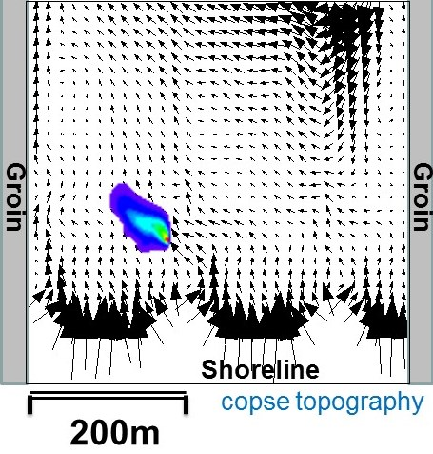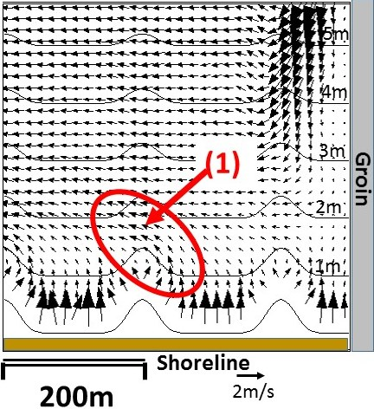

Figure 6. Dispersion of Assumed Water Colorant Figure 7. Profiles of Current Vectors (Average over
(After scatter 5 minutes) One Period) (case: Open Boundary at Left Side)

GENETATION MECHANISM
After confirm the accuracy of numerical model, this study simulated under the two type conditions. At first, this model simulated the current at the linear shoreline topography which was enclosed the groins. And the second, this study simulated the current at the cusp topography beach that was not enclosed by groins. In the uniform bottom slope case, the slope was set as 1/80. The entered wave condition did not change in all cases.
The profiles of current vectors in left open boundary case are shown in Figure 7. And the profiles of current velocity are shown in Figure 8. These vectors were averaged over one period of wave. As shown in the figure, the rip current occurred from near the cusp top (see (1)). However, there were no current meander at the head of breakwater zone. The velocity increased over all area (see Figure 8).
The profiles of current vectors in uniform bottom slope case are shown in Figure 9. As the result, the circulation current occurred in the enclosed area, and the alongshore current occurred near the beach. This case did not same with Figure 3 and Figure 7.
According the above results, this study reached the conclusion, that is, the rip current at the cusp topography beach, enclosed by the groin, is compounded with two type rip current, one is under influence of the groin and the other is with cusp topography.
If this beach was enclose by two groins however the topography has uniform bottom slope, then the current forms the uniform circulation flow.

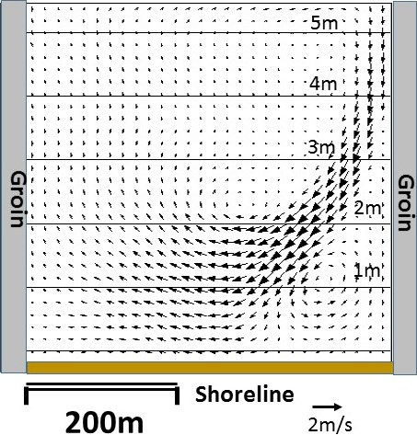
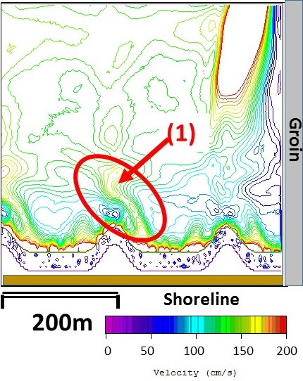
Figure 8. Profiles of Current Velocity (Average over Figure 9. Profiles of Current Vectors (Average over One Period) (case: Open Booundary at Left Side) One Period) (case: Two Groins and Uniform Bottom
Slope)

CONCLUTSIONS
This study did the field survey at Ajirohama Beach in Niigata Prefecture, and comprehend the scale and the velocity of the rip current. The generation mechanism of rip current at the enclosed beach by groins are elucidated. The current could be visualized by the sea water colorant, and the visualized current was recorded as the aerial photograph by the UAV multi-copter. The results of numerical simulation and the field survey are compared. Therefore, this study confirms accuracy of the numerical model. The rip current at the cusp topography beach, enclosed by the groin, is compounded with two type rip current: one is under influence of the groin and the other is with cusp topography. The conclusions of this study will be useful to prevent the occurrence of sea bathing accident.

REFERENCES
Hino M. 1974. Theory on Generation of Shore-current system. Journal of JSCE, JSCE, 225, pp.17-29.
Hino M. 1975. Theory on Generation of Shore-current system. Journal of JSCE, JSCE, 237, pp.87-98.
Hosoyamada T, Murakawa H and Inukai N. 2011. Interactions of rip currents and coastal bathymetry change. Journal of JSCE, Ser. B2 (Coastal Enginnering), JSCE, 68(2), I_556-I_560.
Inukai N, Kinoshita S, Hashimoto Y and Yamada F. 2007. Analysis of Wave Characteristic for Prevention of Seashore Accidents in Niigata Coastal Zone. Annual Journal of Civil Engineering in the Ocean, JSCE, 23, pp.667-672.
Marin Guard and Rescue Office. 2012. Report of Accident Occurrence for Fishing. Japan Coast Guard, 7. http://www.kaiho.mlit.go.jp/marine/figure/2013fishing.pdf .
Marin Information Group. 2012. NOWPHAS –The Nationwide Ocean Wave information network for Ports and HArbourS. Port and Airport Research Institute, online,
http://www.mlit.go.jp/kowan/nowphas/index_eng.html．
Nishi R, Hagino K, Yamaguchi H, Iwate S and Sugino T. 2003. Research on a Rip Current to Reduce the Number of Drowning in Coastal Water. Proceedings of Coastal Engineering, JSCE, 50(1), pp.156-160.

Civil and Environmental Engineering, Nagaoka University of Technology, 1603-1 Fukasawa, Nagaoka, Niigata, 940-2188, Japan
Headquarters, Penta-Ocean Construction Co., Ltd., 2-2-8 Koraku, Bunkyo-ku, Tokyo 112-8576, Japan
Survey and Analysis Department, Ecoh Corporation, 2-6-4 Kitaueno-Takeuchi Bldg., Taito-ku, Tokyo, 110-0014, Japan

