Study and Analysis of Siltation at Nahre Ghasr Fishery Port
Mehrdad Orooghi Amidi, Mohsen Soltanpour¹, Zahra Ranji¹
The discharge of Arvand River and tidal currents affect the large siltation at Nahre Ghasr Fishery Port, located at the Nahre Ghasr channel, the Persian Gulf. Using 2DH and 3D numerical models, the flow pattern at the channel was investigated to study the details of siltation problem. The local model was calibrated by the measured data of water surface and suspended sediment rate. The main flow mechanisms that can affect the rate of siltation including the horizontal exchange, the vertical exchange and tidal filling, were analyzed. The study showed that tidal filling plays the dominant role on the sedimentation at Nahre Ghasr channel. Different scenarios were also examined for reducing the siltation rate at the port.
Keywords: Siltation analysis, Flow pattern, Sill, Current Deflecting Wall

INTRODUCTION
Siltation is defined as the transportation of the silt by streams or currents which can contribute in water turbidity. Siltation in river ports can cause many difficulties in marine transportation resulting to the necessity of costly dredging operations. Using periodic dredging, the port can be preserved in its draft depth ensuring the desirable navigation. However, this can highly affect the port productivity by reducing its economic and trading efficiency, which might even force the authorities to abandon the port after few years. Therefore, sediment control practices are necessary to cut down dredging costs at ports in order to reduce the undesirable siltation effects.
Siltation of muds and silts in port basins is a known problem that goes back to the history of building the ports and it is related to their basic function, i.e. providing shelter by creating quiescent conditions (Van Rijn, 2004). It is also important to know that port siltation in fresh water is much less than in salt and brackish water conditions (Nasner 1992). As much as rivers’ water become salty, they can play significant role in siltation. The siltation at a river port consists of the following major factors (Winterwerp 2005 and Van Rijn 2004):
- Tidal filling (filling and emptying of the tide)
- Horizontal eddy circulation generated at the entrance by the main river flow
- Vertical circulation at the entrance, generated by density differences, inside and outside of the basin
These mechanisms can affect the siltation rate depending on the geometry of port entrance. Thus, understanding the effective mechanisms and their contributions should be considered at the first step to evaluate suitability of different methods for the reduction of siltation rate. Geometry and conditions of river stream as well as tidal regime needs to be carefully studied to control the imposed sedimentation. Different methods have been purposed for the reduction of siltation at a port:
- Improvement of the port geometry
- Current Deflecting Wall (CDW)
- Sill in the entrance
- Upstream pile screen
- Mechanical gate in the entrance
- Silt curtain
- Re-suspending systems
- Chemical methods
- Biological methods
CDWs are curved vertical walls in horizontal plane that are extended to the top of water. Construction of a CDW is an effective method to control the horizontal exchange and flow separation. On the other hand, sill is used to control the vertical exchange and tidal filling at the entrance. The main purpose of the CDW construction can be classified as (Winterwerp 1994; Schewarze 1995; Christiansen and Kirby 1991):
- Prevent flow separation at the upstream corner of the entrance
- Reduce the exchange volume related to horizontal circulation
- Reduce the retention time of the sediments in the basin
- Suppress the generation of eddies in the entrance region
Parkhafen basins of the Port of Hamburg is an example of the design of the CDWs (Delft Hydraulics 2001). A curved wall with a length of 150 m was also constructed near the entrance of the Köhlfleet harbor basin, located seawards of the Parkhafen, with the purpose of minimizing sediment input to the basin. Its design was based on extensive hydraulic scale model tests at Franzius Institute in Germany. This CDW proved its worthiness over the years, reducing the dredged quantities in the Köhlfleet by approximately 40% (Winterwerp et al. 2005), resulting in a 30% reduction of the deposition volume at the entrance of that basin. The effect of a CDW critically depends on the local hydraulic conditions and the geometry of the entrance. The proper design of a CDW should be based on experiments in a laboratory scale model (Delft Hydraulics 1992 and 2001; Van Leeuwen and Hofland 1999; Crowder 2001 and 2002). An incorrect design may even cause deterioration of the flow patterns by generating additional eddies and more siltation.

STUDY AREA
Arvandkenar is part of Abadan County in Khuzestan Province, Iran, where the natural tidal inlet of Nahre Ghasr, branches Arvand River near the Persian Gulf, see Fig. 1. Nahre Ghasr Fishery Port is located at Nahre Ghasr channel, about 10 km upstream of Arvand River mouth. The port, opened after dredging the branch in 2009, has been encountered by a siltation, resulting to the reduction of the navigability of fishery boats. Fig. 2 shows the large siltation at the port pier in 2014.

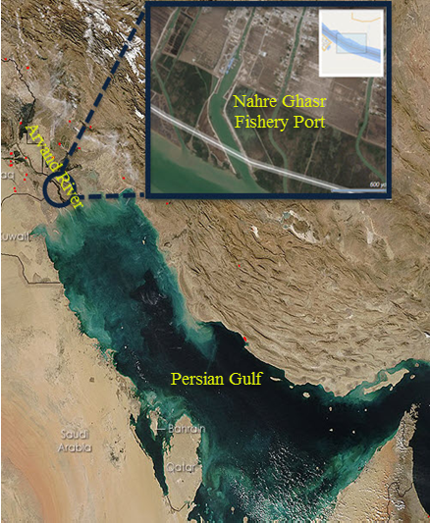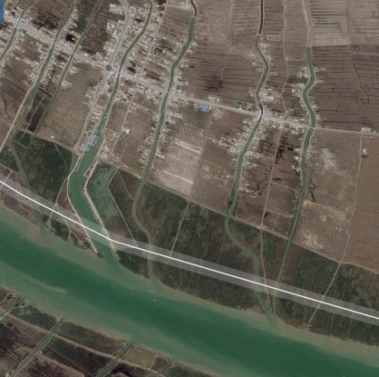

Figure 1. Nahre Ghasr Fishery Port in a branch of Arvand River, North-West of the Persian Gulf and the natural tidal inlet of Nahre Ghasr (left), branches of Arvand River near the Persian Gulf (right)

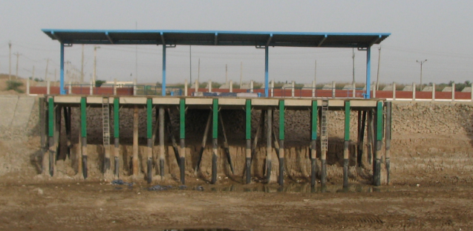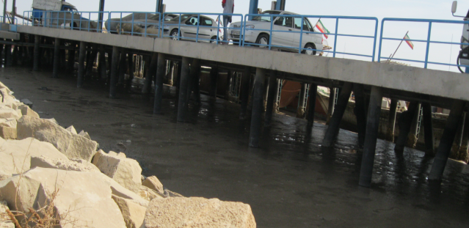

Figure 2. Nahre Ghasr pier (left: 2009 after dredging, right: 2014)

FIELD MEASUREMENTS
Three series of bathymetric surveys in 2001 (natural channel condition), 2009 (after dredging) and 2014 have been conducted at the site (Fig. 3). 3-days measurements of the water level and suspended sediment concentration during neap and spring tides have been performed at the beginning (ST1) and the end (ST2) of Nahre Ghasr channel, respectively (SPI 2003). Sediment samples were also taken from three locations along the channel. Fig. 4 shows the locations of sediment samples and two measuring stations ST1 and ST2. The distributions of grain sizes of sediment samples are shown in Fig. 5. It is observed that more than %95 of the particles consist of fine silt and clay particles. The figure also reveals the higher percentage of finer materials in front of the berth (sample 1) and along the channel (sample 2) in comparisons to the collected sample at the entrance of the Nahre Ghasr channel (sample 3), as expected.

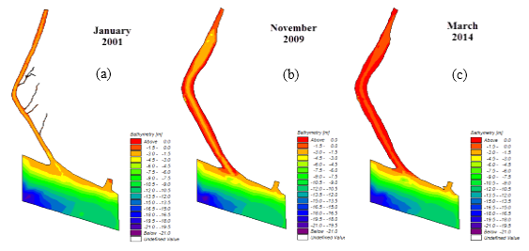

Figure 3. Hydrographic surveys: a) 2001 (before the port construction), b) 2009 (after dredging the channel), and c) 2014

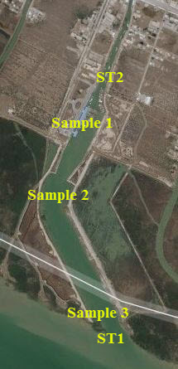

Figure 3. Locations of sediment samples and stations of measured water levels and suspended sediment concentrations (ST1 and ST2) along Nahre Ghasr channel

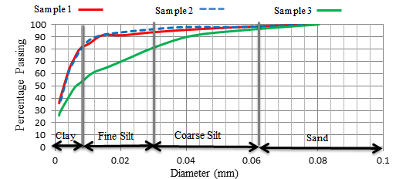

Figure 4. Grain size distributions of sediment samples

Fig. 6 shows the continuous increase of the salinity of Arvand River during past 40 years based on the data in literature. Constructions of dams, which have resulted in the decrease of upstream fresh water, are blamed for this rapid change. The measurements of surface salinity of Arvand River at the entrance of Nahre Ghasr in 2007 and 2014 also confirm a clear increase of the water salinity, which can result in the significant vertical exchange.

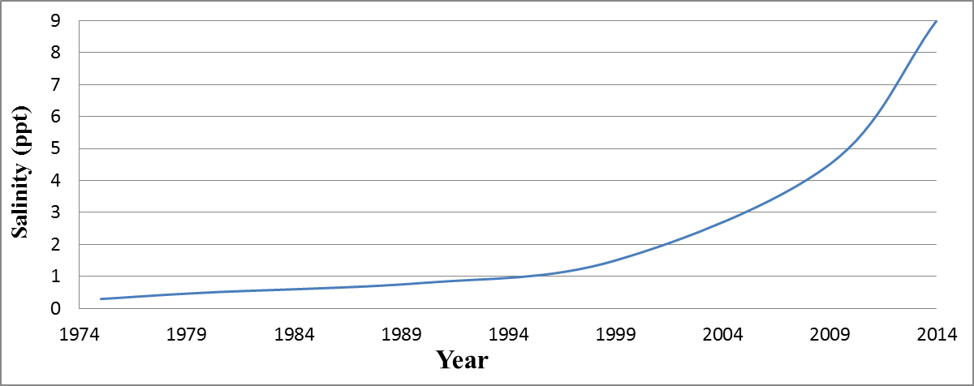

Figure 5. Changes of Arvand River salinity with time

NUMERICAL MODELING

Regional and Local Models
Regional modeling of the Persian Gulf and local modeling of Nahre Ghasr have been performed by DHI MIKE software (DHI 2011). The water surface elevation at the open boundary of regional model at Strait of Hormuz was adopted from TPXO 8 global tide model (Egbert and Erofeeva 2002) and the upper boundary was located at the Arvand River mouth with discharge of 1500 m³/s (Fig. 7). Various bed roughness coefficients at different locations of the domain have been examined to minimize water level differences between the model outputs and observations along the north and south coastlines of the Persian Gulf.
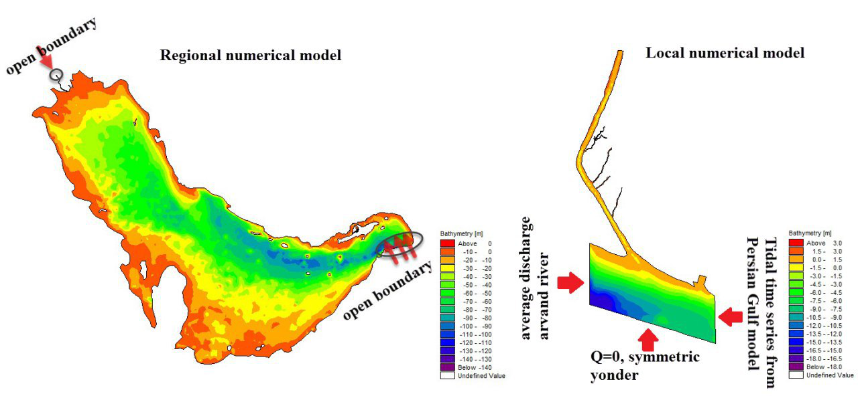

Figure 6. Regional and local numerical models

The lateral and south boundaries of the local Nahre Ghasr model were adopted from the regional model. The upper boundary of local model is set at upstream of Arvand River. The average discharge at upstream, water level at downstream (output of regional model), which was linearly applied to the boundary, and zero discharge at the middle of River's cross section, were applied as the boundary conditions of local model (Fig. 7). Annual and monthly average discharges of Arvand River in October and November of 1980 were estimated based on the discharges of three main incoming rivers of Karoon, Tigris, and Euphrates. It should be noted that the average discharge at the intermediate longitudinal section of the river is not zero, considering the slight curvature along the river, but the small effect of assuming no cross river discharge on the modeling results was neglected. Moreover, 20 layers were considered in the three-dimensional local modeling using sigma method. Smagorinsky and k-ε models were also adopted for horizontal and vertical simulations of turbulence, respectively.

Model Calibration
Different values of roughness and mesh size have been evaluated in regional model to verify the measured data near Arvand River mouth. Unstructured triangular grids with a size of 5×107 m2 for the regional model and 105 m2 for the river were finally selected. Model results with constant and varying bed roughness were evaluated and a varying bed resistance, with a roughness of 50 m1/3/s at the boundary and 85 m1/3/s near Arvand River, was chosen (Fig. 9).

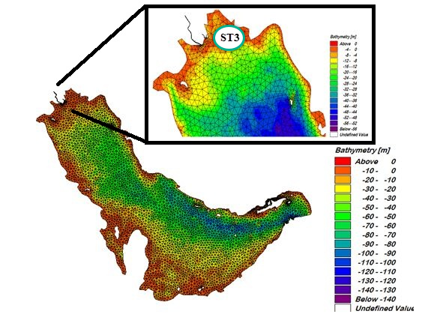 | 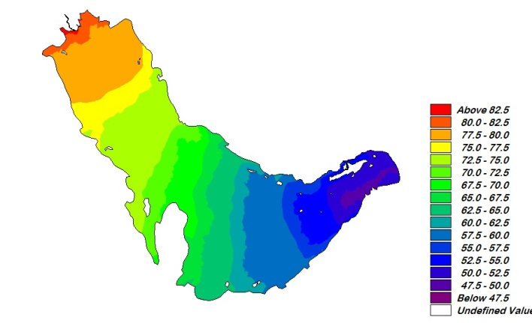
Figure 7. Regional model computational grid (left) and selected varying bed resistance (right)

shows the comparisons at ST3 station (see Fig. 9) using a variable roughness in regional modeling, with the correlation and RMS coefficients of 0.95 and 0.17, respectively.

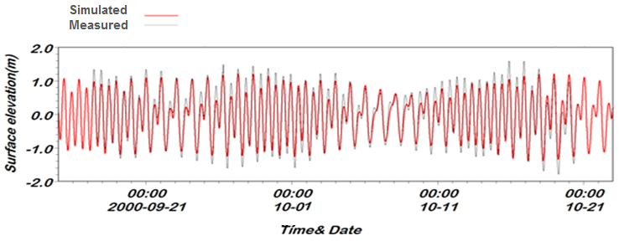
Figure 8: Verification of regional model at ST3 station with varying bed resistance

The local modeling before port construction was performed applying Hydrodynamic (HD) and Mud Transport (MT) Modules of MIKE (DHI 2011). The outputs were verified using observed water levels and suspended sediment concentration data, respectively, in November and October 1980 during neap and spring tides. The input data at ST1 station was introduced to the model and the outputs at ST2 station were compared with the observations. An unstructured grid with a size of 300m was selected for Nahre Ghasr channel. Fig. 11 shows the comparisons between 3-days outputs of neap and spring tides with observed data at ST2.
The local model was calibrated assuming 2 layers (Layer1: soft mud and Layer2: hard mud) with a time step of 600 s, upstream discharge of 650 m³/s. The boundary conditions were selected from the outputs of the regional model of the Persian Gulf. Table 1 shows the parameters of the numerical simulation.

Table 1. Selected parameters for local model simulation (HD and MT)
Parameters of MT module |  | Parameters of HD module
Parameters | Value | Parameters | Value
Density of sediment | 2637 kg/m³ | No. time step (Oct & Nov) | 2000
Settling velocity | 0.018 m/s | Bed resistance | 85 (m^{1/3}/s)
Critical shear stress | 0.05 N/m² | Salinity (1980 model) | 0.5 ppt
Density of bed layer | Layer1:180 kg/m³  Layer2:450 kg/m³ | Salinity (2009 model) | 5 ppt
Bed roughness | 0.001 m | Upstream average discharge | 650 (m³/s)
Horizontal dispersion | 1 (Constant) | Horizontal Eddy viscosity (Smagorinsky formulation) | 0.28

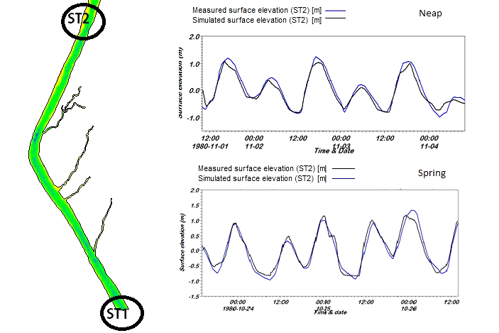

Figure 9. The comparisons of water levels at ST2 with the data during spring and neap tides

In order to calibrate the hydrodynamic and mud transport models, the sensitivity analysis was conducted on the grid size and roughness for HD and fall velocities of sediment particles for MT, respectively. A roughness value of 85 m^{1/3/s} and a grid size of 100 m² for the Nahre Ghasr channel and a grid size of 1800 m² for Arvand River were finally selected (Fig. 12) . The fall velocity of 0.018 m/s was also chosen. Fig 13 presents the comparisons of model results of HD and MT modules with measured data. Table 2 offers the correlation and RMS coefficients of the simulated water surface elevation and suspended sediment concentration at two stations.

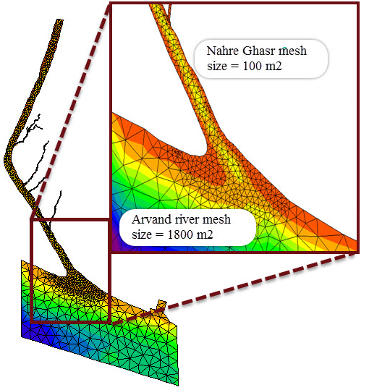

Figure 10. Computational grid of the local model
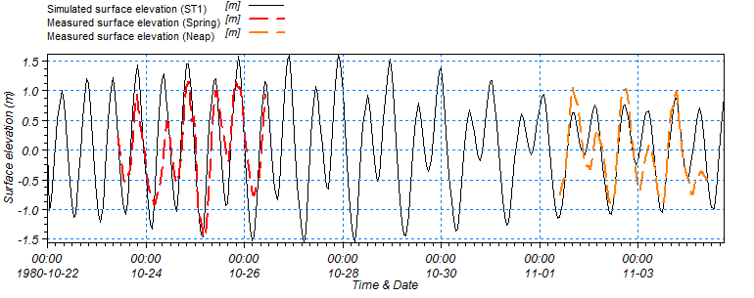
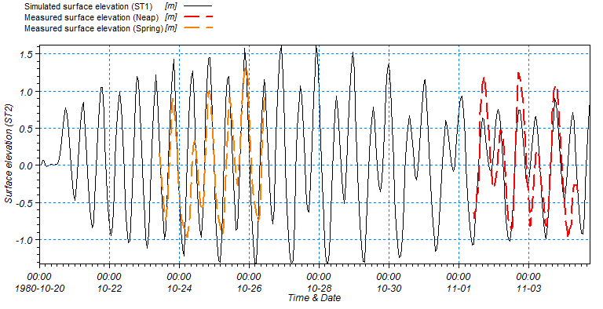
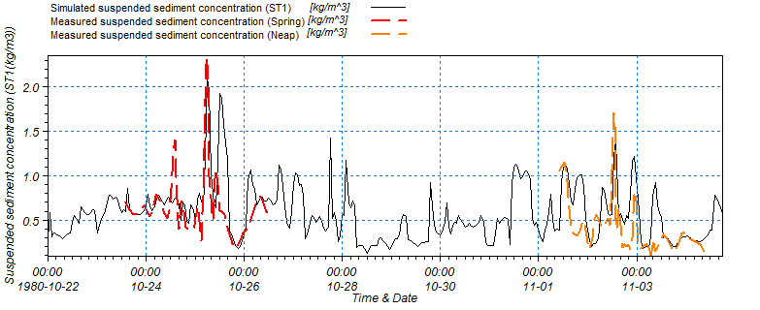
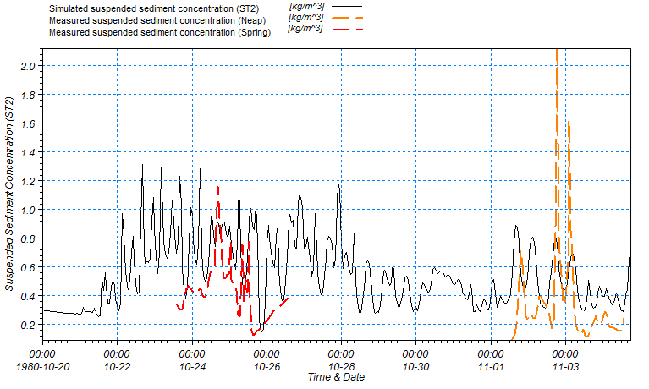

Figure 11.Comparisons of water surface elevations and suspended sediment concentrations at ST1 (left) and ST2 (right) with measured data
Table 2. Statistics indices of local model simulation results
Suspended sediment concentration |  |  |  |  | Water surface elevation
Tide | Correlation |  | RMSE (kg/m³ ) |  | Correlation |  | RMSE (m)
Tide | ST2 | ST1 | ST2 | ST1 | ST2 | ST1 | ST2 | ST1
Spring | 0.66 | 0.15 | 0.29 | 0.35 | 0.86 | 0.86 | 0.42 | 0.42
Neap | 0.71 | 0.64 | 0.24 | 0.59 | 0.83 | 0.77 | 0.34 | 0.42

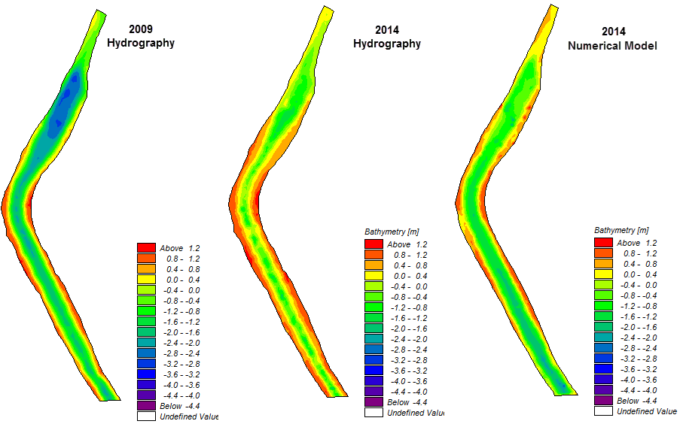

Figure 12. Comparison between model prediction and measured hydrography in 2014

After calibration, MT module was run to calculate the total siltation volume from 2009 (immediately after port dredging) to 2014. Figure 12 shows the comparison between hydrography data and calculated bathymetry at 2014, with an error of %9.2.

SILTATION REDUCTION
The rate of siltation at a river harbor is governed by the suspended sediment concentration and factors that affect the flow pattern (PIANC working group 2008). Two main strategies of “keeping the sediment out” or “keeping the sediment moving” can be considered to minimize the siltation (Krone 1987). Different mechanisms can cause the formation of vortices and flow exchange between the river/channel and port including horizontal exchange, vertical exchange, tidal filling, tidal flood and river flow interactions (Figure 13).
Numerical modeling of these mechanisms shows that the horizontal exchange between Arvand River and channel causes a flow separation zone near the entrance at some time intervals. The conflict of river flow and flood tide also leads to a calm zone and the increase of the siltation at the entrance in some time steps. Three-dimensional modeling by MT module MIKE3 (DHI 2011) reveals that the differences of flow densities are also effective, resulting to a vertical circulation which brings high concentration sediment into the port.

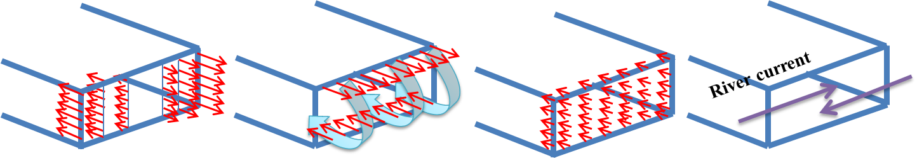
Flood tide
Horizontal exchange
Vertical exchange
Tidal filling
Conflict of river current and flood tide
Figure 13. Four mechanisms of flow pattern and siltation at a river port

Different scenarios were examined for the reduction of siltation rate at Nahre Ghasr channel including active measures such as constructing CDWs and submerged sills to change the flow patterns and horizontal eddies at the port entrance.
16 and 17 show two modeling scenarios of CDW applications and their effects on velocity vectors at the entrance of Nahre Ghasr channel, respectively. The first one is a long 200 m CDW. The second scenario was performed with a standard CDW, where its total length should be about 30% to 40% of entrance width and need to be located at a distance of 10-15% of main river channel from the riverbank. Modeling of these two CDWs resulted in 3.2 % and 2% reductions of siltation, respectively.

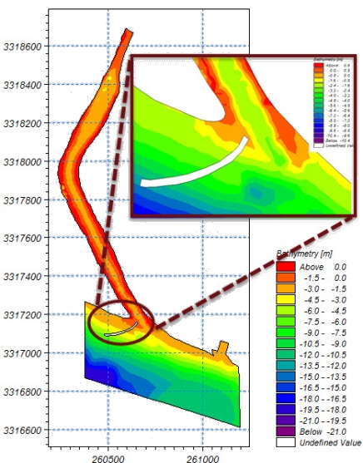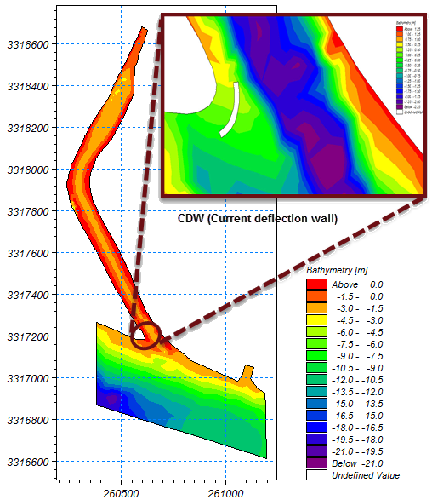

Figure 16. Modeling of standard CDW and long CDW at the entrance of the channel

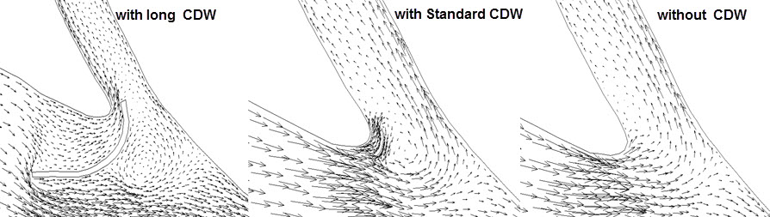

Figure 14. The effect of standard and long CDW on the flow pattern and siltation

Figure1818 presents the modeled results of a 1 m height submerged sill, i.e. about 30% of the local water depth, showing a 7.3% reduction of siltation. The higher reduction, in comparisons to construction of CDWs, can be related to the high sediment concentration near the bed. This solution is also effective on the vertical exchange and tidal filling of the harbor. However, construction of a sill has a major negative impact on the navigation.

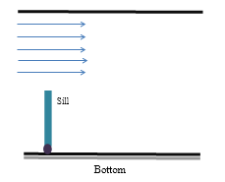 | 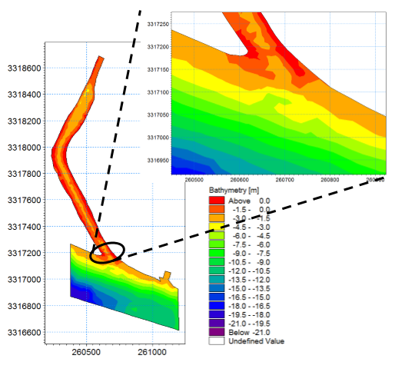
Figure18. The effect of constructing a sill at the entrance of Nahre Ghasr channel

SUMMERY AND CONCLUSION
Nahre Ghasr Fishery Port is affected by the suspended sediments in Arvand River, which mostly consists of silt and clay. Modeling results by the flow model and mud transport revealed that different phenomena, such as tidal filling, vertical circulation as density differentiation on the sea surface and seabed, horizontal circulation as flow separation, and the interaction of tides and river flow, are affecting the high siltation at the Nahre Ghasr channel.
In addition to tidal filling, the discharge of Arvand River causes the horizontal entrainment (through formation of horizontal eddies) at the entrance of channel. The vertical exchange due to the sharp density gradient, which results in vertical circulation and carrying the high concentration mud bed into the port is also effective in the siltation rate. Additionally, interaction between river flow and tidal flow at some times leads to high deposition at stagnation points.
Modeling of different scenarios proved that although constructions of CDWs and sills have positive impacts on horizontal/vertical exchanges, their impacts on the reduction of siltation at the channel are both limited. This is mainly due to the high importance of the tidal filling at Nahre Ghasr channel, because of the vicinity of the port entrance to the coastline. It can thus be concluded that none of these two active countermeasures are feasible solutions to reduce the siltation rate at the port.

ACKNOWLEDGMENTS
The authors are grateful to the secretary of the Technical Committee, Mr. Bahirayy, and Head of Design and Construction Department, Mr. Beheshtian, of Iranian Fisheries Company for their support of the study and providing parts of the field data.

REFERENCES
Christiansen, H. and Kirby, R., 1991. Fluid mud intrusion and evaluation of a passive device to reduce mud deposition, Proceedings of CEDA-PIANC Conference “Accessible Harbours”, E1-E14.
Crowder, R.A. 2001. Study of the design and operation of current deflecting walls to reduce siltation in harbours. Delft Hydraulics, The Netherlands, LIP III report, 8 pp.
Crowder, R.A. 2002. Study of current deflecting walls to reduce siltation in coastal basins, University of Bradford, Great Britain, Doctoral thesis, 201 pp.
Delft Hydraulics. 2001. Design of a current deflection wall for the Parkhafen in Hamburg, Delft, Report Z2666, 47 pp.
DHI (Danish Hydraulic Institute). 2011. MIKE 21 & MIKE 3 Flow model FM, Hydrodynamic and transport module, Hørsholm, 58 pp.
Egbert G.D. and S. Y. Erofeeva. 2002. Efficient inverse modeling of barotropic ocean tides, Journal of Atmospheric and Oceanic Technology, 19, 183-204.
Krone R.B. 1987. Reducing sedimentation rates in harbor facilities: Sedimentation control to reduce maintenance dredging of navigational facilities in estuaries, National Academy Press, 128-140.
Nasner, H. 1992. Siltation in tidal harbours, part I (in German), Die Küste, 127-170.
PIANC working group. 2008. Minimizing harbor siltation, PIANC report No. 102, 75 pp.
SPI (Sazeh Pardazi Iran) Consulting Engineers Company. 2003. Study report of Nahre Ghasr Fishery Port-phase 1, Iranian Fisheries Company, 274 pp.
Van Rijn, L.C. 2004. Harbour siltation and control measures, online resource, URL: www.leovanrijn-sediment.com.
Van Leeuwen, S. and B. Hofland. 1999. The current deflecting wall in a tidal harbor with density influences. Technical University of Delft, Master thesis, 161 pp.
Winterwerp, J.C., W.D. Eysink, F.E. Van Kruiningen, H. Christiansen, R. Kirby and T.J. Smith. 1994. The current deflection wall: a device to minimise harbour siltation. Dock and Harbour Authority, 74, 243-246.
Winterwerp, J.C. 2005. Reducing harbor siltation. I: Methodology, Journal of Waterway, Port, Coastal, and Ocean Engineering, 131, 258-266.
Winterwerp. J.C., C. Kuijper, H. Christiansen and J.M. Cornelisse. 2005. Reducing harbor siltation. II: Case study of Parkhafen in Hamburg, Journal of Waterway, Port, Coastal, and Ocean Engineering, 131, 267-276.

K. N. Toosi University of Technology, Tehran, Iran

